Assigning New Direct Reports

Log into IC Manager Self Service in one of the following ways:

(i) If you are accessing ICIS from a computer with a wired connection on the College network (not halls, wireless or VPN), log in as normal http://icis.imperial.ac.uk/and look for “IC Manager Self Service” in your list of responsibilities. You are particularly urged to adopt this route, rather than following the link which appears in the next paragraph.

(ii) If you are accessing ICIS from home, wirelessly, from halls or via VPN, please click on the following link and follow the instructions:
https://icisremote.ad.ic.ac.uk/dana-na/auth/url_1/welcome.cgi

Expand your responsibility IC Manager Self Service, and select Maintain Line Managers.

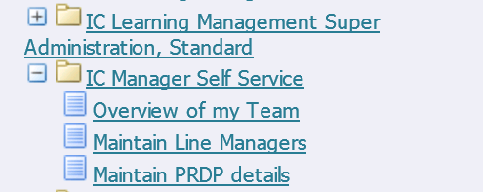

As a Line Manager, you now have the ability to assign new direct reports to employees who currently sit within your person tree. Essentially, this action is used to either give new or additional line management responsibility to employees. Please refer to the Business process maps for scenarios in which you would now be expected to make changes to line management information.

NB. If you are assigning new direct reports to someone who is not currently a line manager, the changes you request will trigger a process to run overnight. The new line manager can expect to see their IC Manager Self Service responsibility from the following morning.

Select one of your direct or indirect reports from your people tree. Click on the Action icon in the column labelled “Action” next to the name of the employee you wish to update.

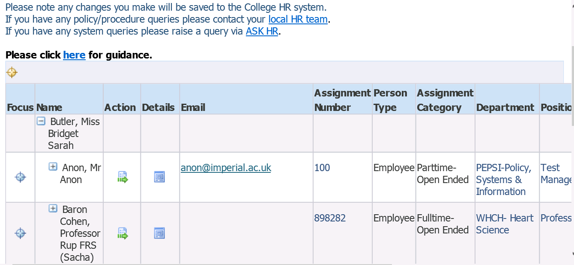

You will be taken through to the Maintain Line Managers: Effective Date Options page;

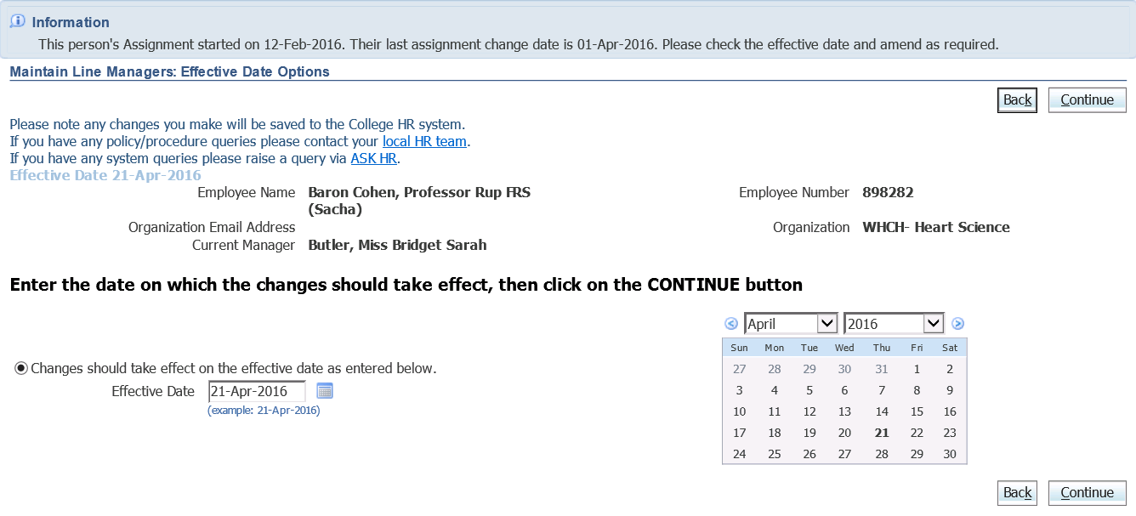

Please see guidance document “Maintain Line Managers: Effective Date Options” page for further details about the options and scenarios for this page.

Once you’ve entered the appropriate date, click on Continue.

The Maintain Line Manager page will be displayed. The details of the person you are assigning direct reports to will be detailed at the top of the page. If you have selected one of your direct reports you would see your own name in the Manager field. If you’ve selected an indirect report, the manager field will be completed with the current line manager’s details;

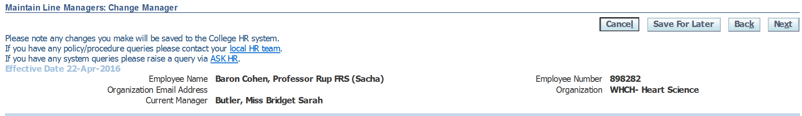

To assign new direct reports you will need to scroll to the bottom of this page to the section titled “Assign New Direct Reports”

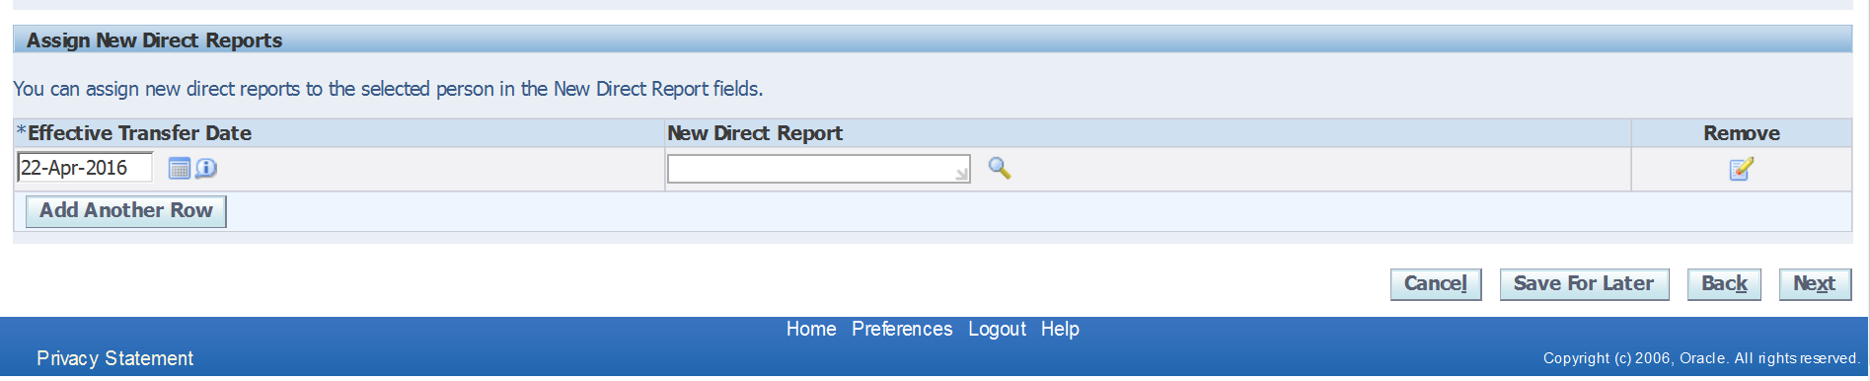

Click into the field for “New Direct Report” and type in the surname of the person you wish to assign to them. Alternatively, use the magnifying glass icon next to the field to search for the individual you wish to assign;

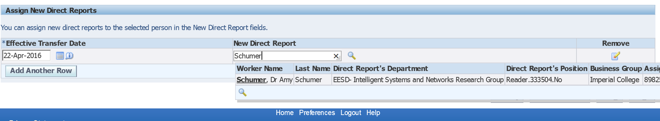

Using the magnifying glass – You would then need to click “Quick Select” or the select radio button to enter this information into the field.

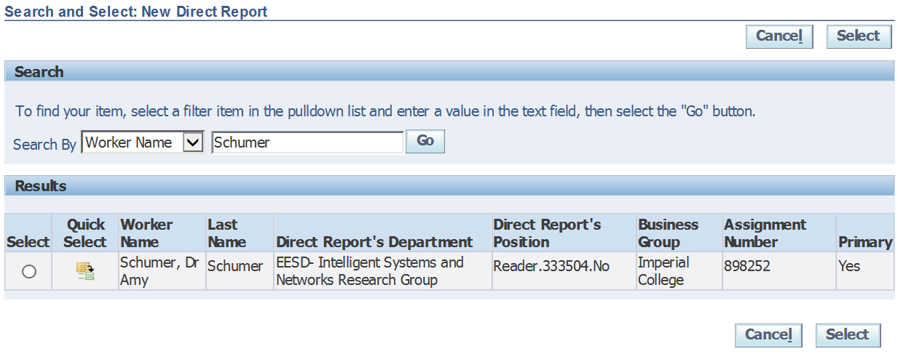

The new direct report’s details are then populated into the field;

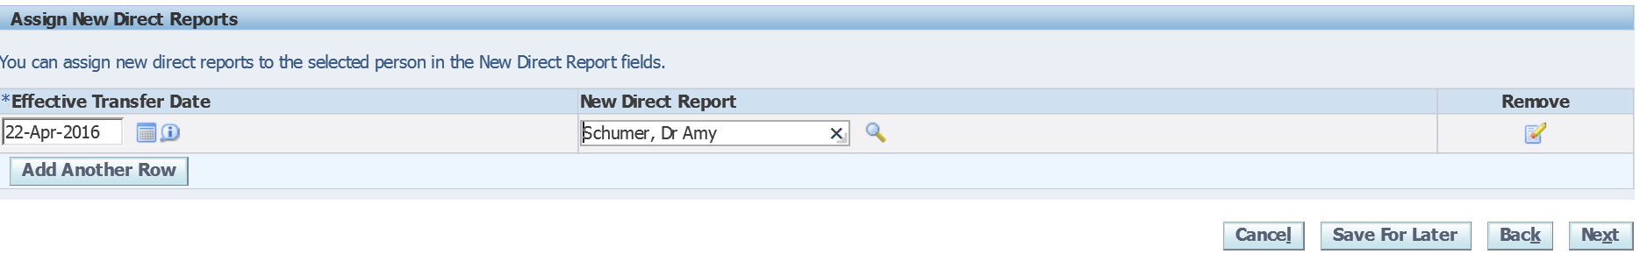

If you’ve entered incorrect details, you can use the “Remove” icon to delete the information you’ve entered and then search again.

NB. When assigning new direct reports, your search is limited to those within your person tree. Therefore if the person you’re searching for does not come up as an option it will be because they don’t currently sit in your person tree, i.e. they are not a direct or indirect report of yours.

Once you’re happy with the information you’ve entered, click on next.

An overview of the change you’ve requested will be displayed. The blue circle icon shows against the new information you have entered.

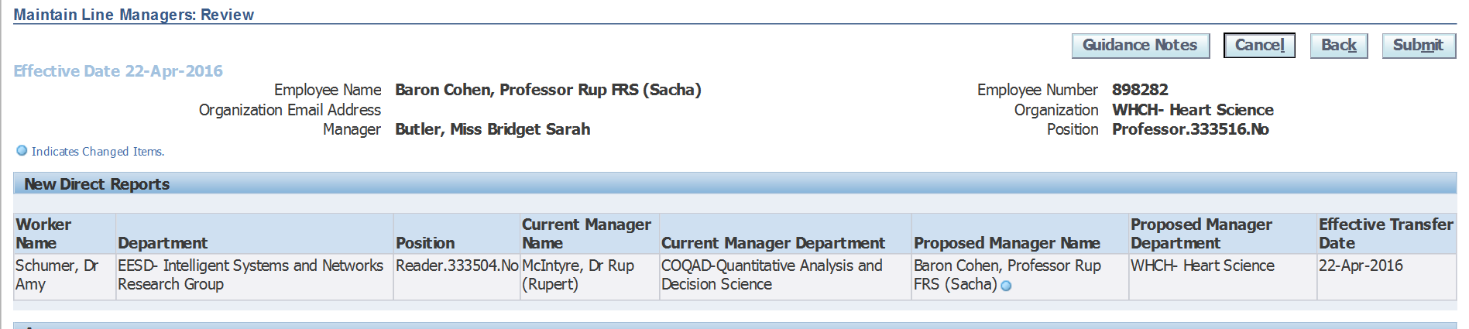

Any change in line management information is automatically routed to your own line manager before it is updated in the system.

This screen also gives you the option to add comments to your request which will be visible to your line manager when they are reviewing the changes. You can enter any information in this box which you think is relevant, and will help your line manager understand why you are requesting this change.

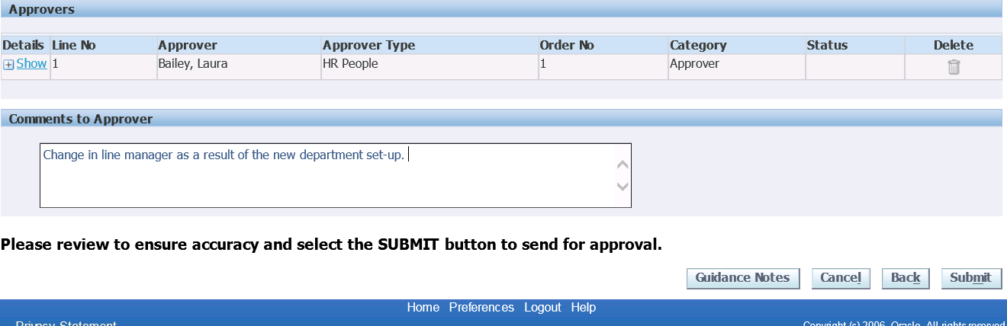

Once you are happy with your change, click on Submit. You will see confirmation that your change has been submitted for approval;

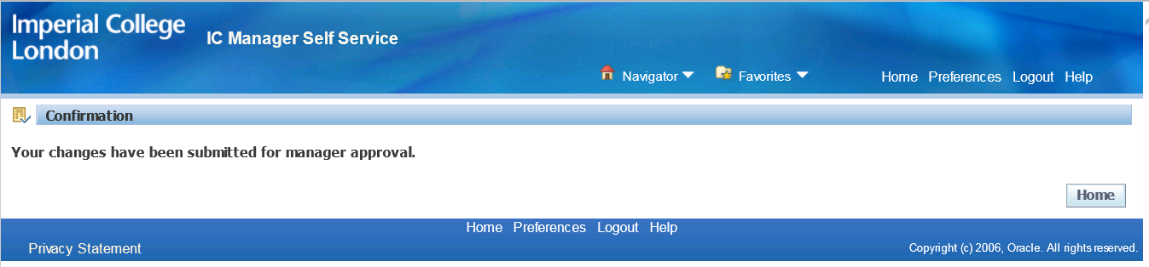

The action is now completed, pending approval from your line manager.

As the person who raised the change request, you will receive the following email notification informing you that your change has been submitted for approval;

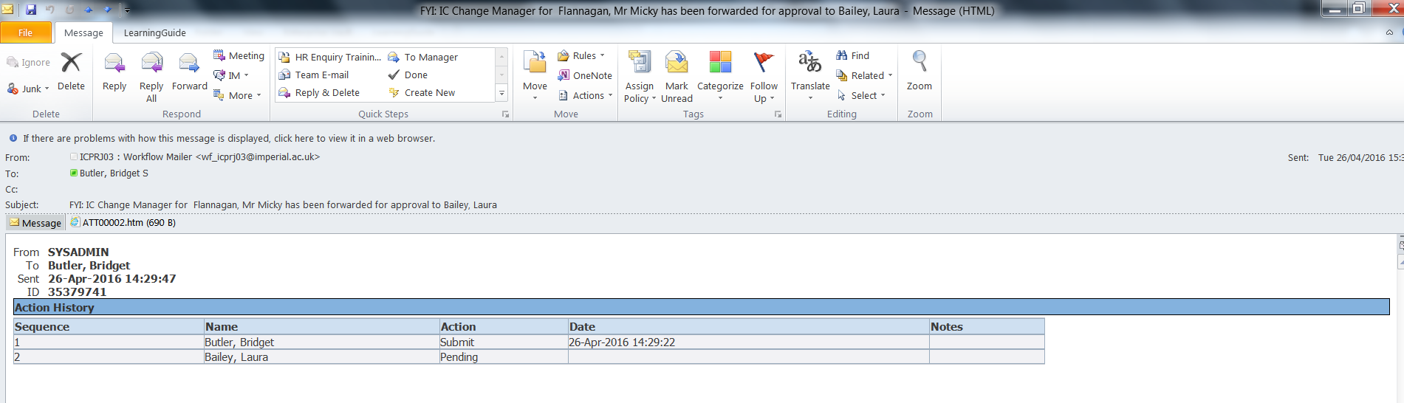

Once your line manager has approved the change, you will receive a final notification;

