Future Dated Changes

If future dated changes exist against an individual’s record, it will have an impact on the 3 actions that you can carry out through “Maintain Line Manager”

Future Dated Changes: Assign New Manager

When assigning a new manager to an individual with a future dated change, you will be made aware that a future change exists on the Maintain Line Managers: Effective Date Options page. The information bar at the top will tell you the date of the future change, and the Effective Date field will default to the date of this future change.

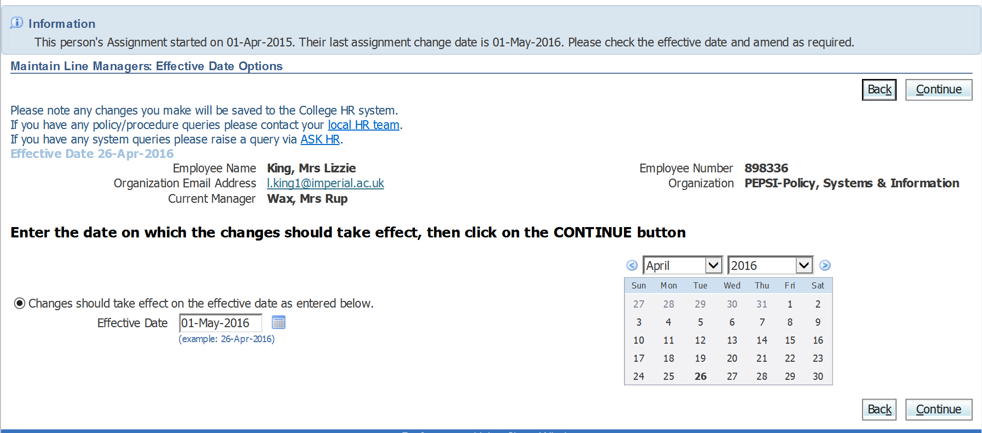

N.B. You can still update the Effective Date field as required.

Click Continue.

Enter the name of the new Line Manager in the Manager field.

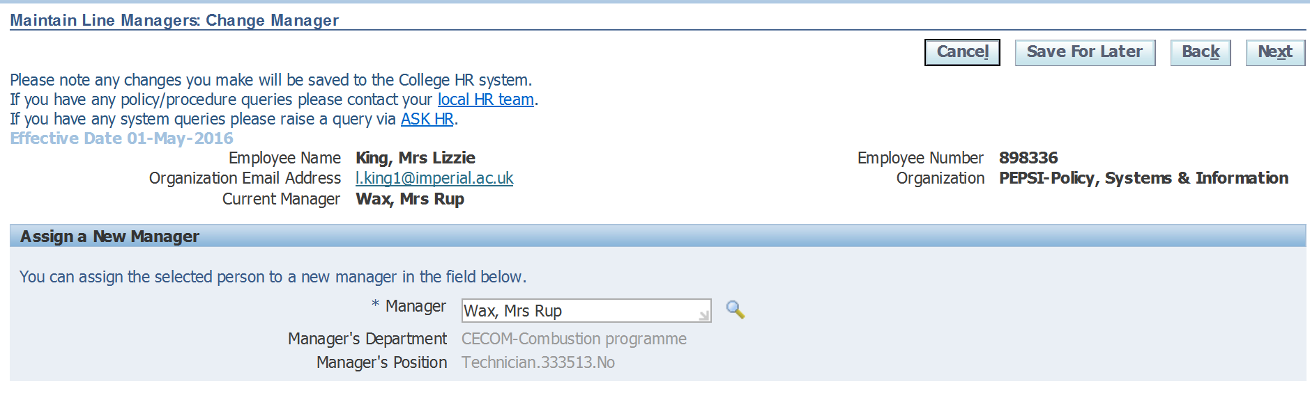

Click on Next when you’ve entered the new manager’s details.

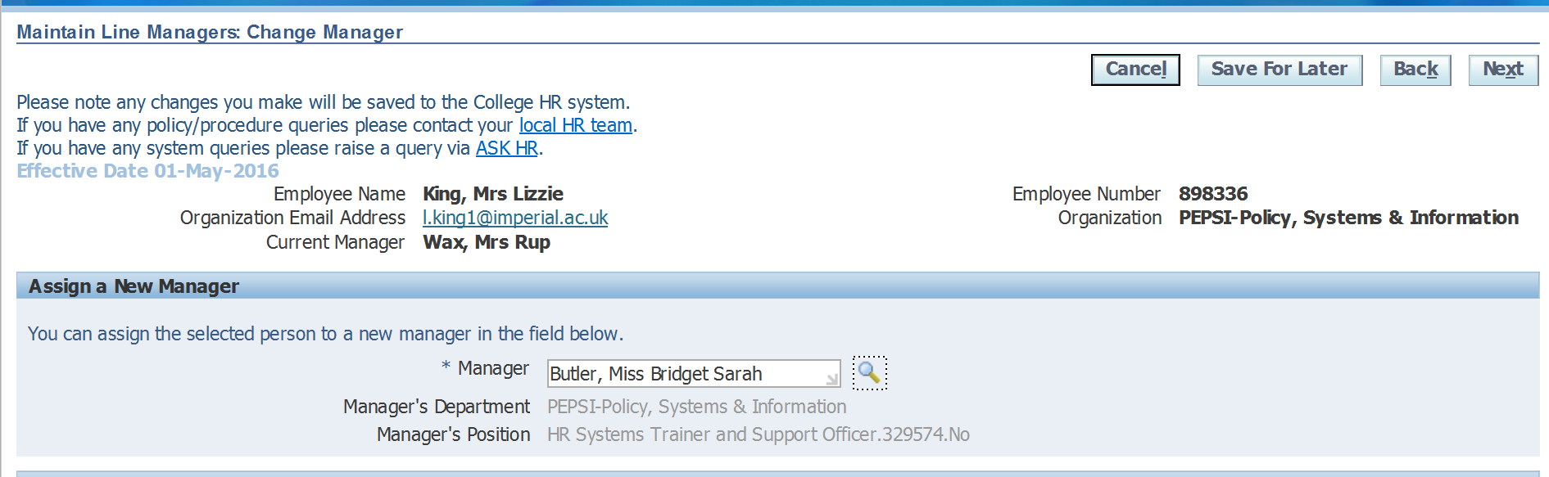

A summary of the change you’ve requested will be displayed. Click on Submit to send the change request through to your line manager for approval.

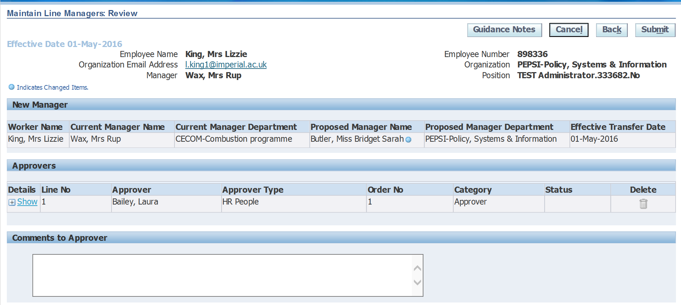

You will see confirmation that your changes have been submitted for approval.

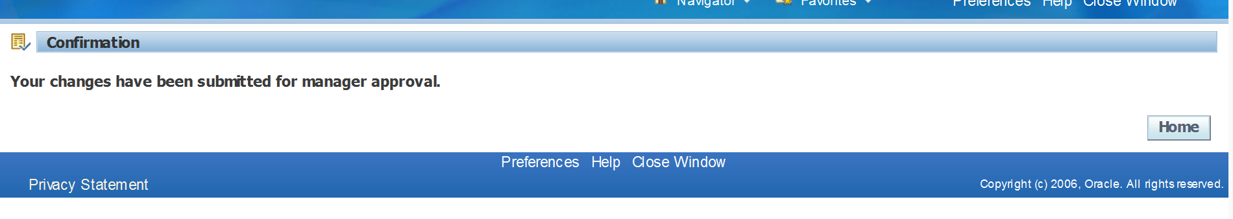
NB: The change will not be visible to you once approved. Instead, the change will be routed to HR for action before the change is visible to you in Manager Self Service.

Future Dated Changes: Re-assigning Direct Reports

If any of the direct reports that you wish to re-assign to a new line manager have a future dated change against them, you will receive an error message.

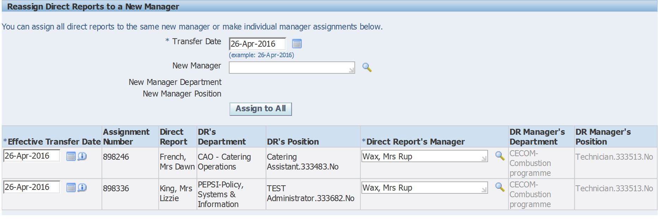

Enter the name of the new or interim manager into the New Manager field, and click on Assign to All.

The new manager’s details are populated into the Direct Report’s Manager field.

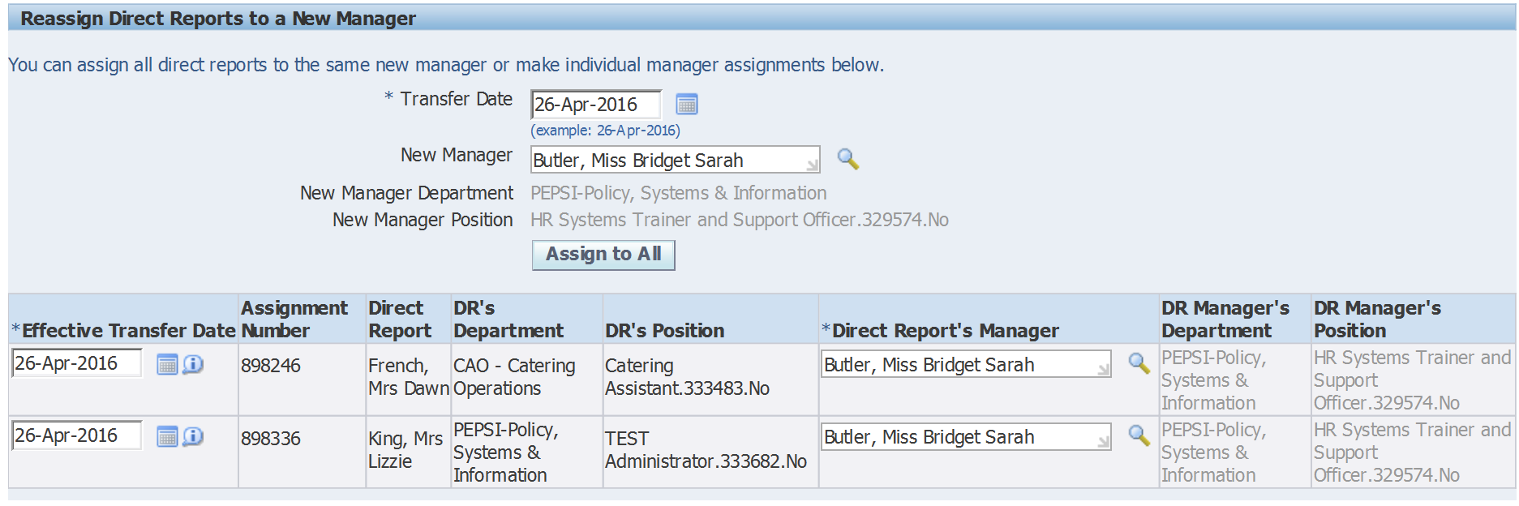

Click on Next to submit this data;

If there are future dated changes recorded against any of the direct reports you are re-assigning, you will see an error message at the top of the screen containing the name of the individual concerned.

You will not be able to re-assign the named direct report/s quoted in the error message using your manager self service responsibility. Instead you would need to contact your local HR team to update the record on your behalf.

If you are re-assigning multiple direct reports, and only one or some of them are listed in the error message, delete out the new manager that you’ve entered in the Direct Report’s Manager field for those people and re-enter the current line manager again;

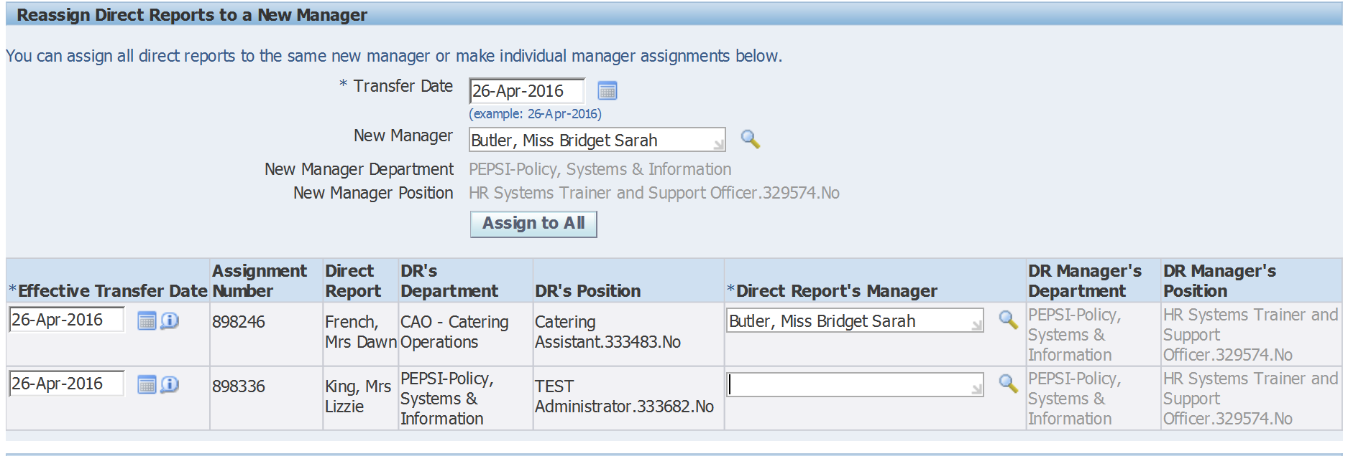

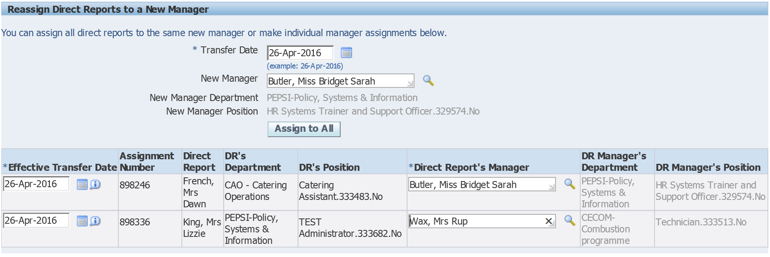

Click on next.

An overview of the change you’ve requested will be displayed. The direct report with the future dated change should still show as reporting to the original line manager;

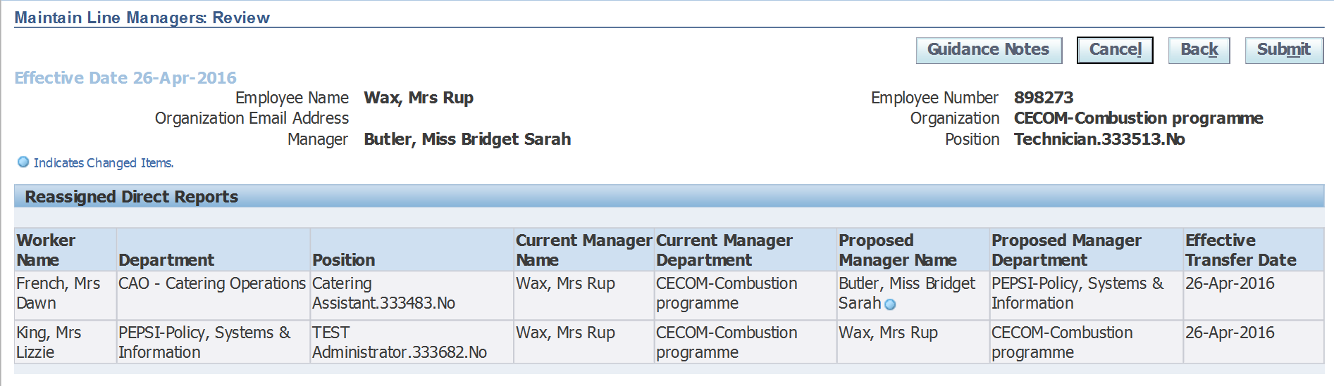

Submit your change for approval from your line manager.

You must now contact your local HR team for help with updating the line management information for the direct report/s that had future changes registered.

Future Dated Changes: Assigning New Direct reports

When assigning new direct reports, if any of the new reports have future dated changes registered against them, you will receive an error message.

Enter the name of the person you wish to assign as a new direct report into the field labelled “New Direct Report”;

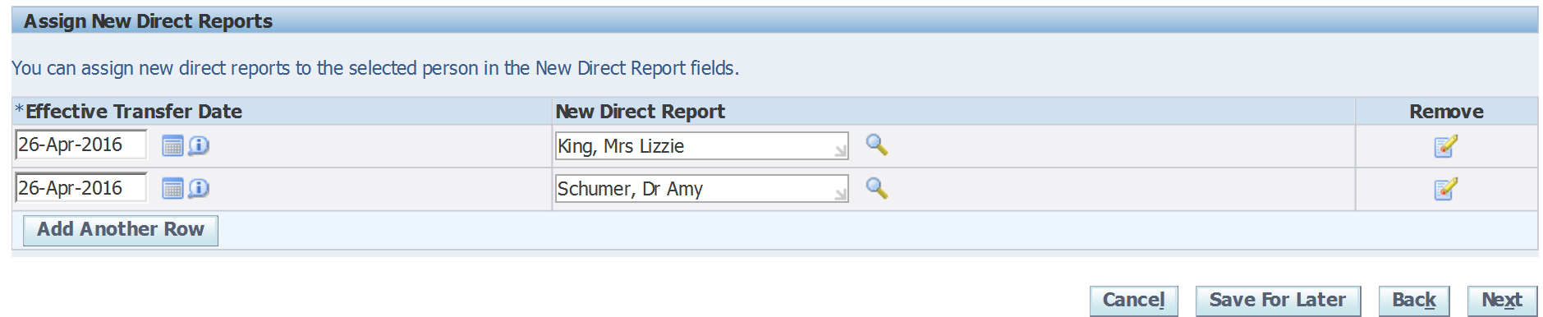

Click on next.

If there are future dated changes held against any of the new direct reports, an error message will be displayed at the top of the page;

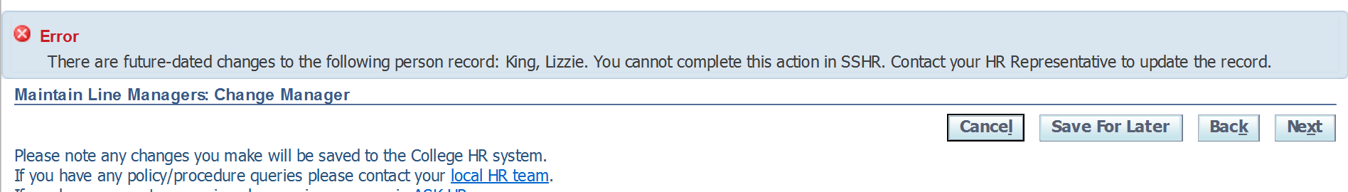

The error message will name the individual concerned. You will not be able to carry out the action for the named person using your manager self service responsibility. Instead you would need to contact your local HR team to update the record on your behalf.

If you are assigning multiple new direct reports, and only one of them is listed in the error message, remove that particular direct report.

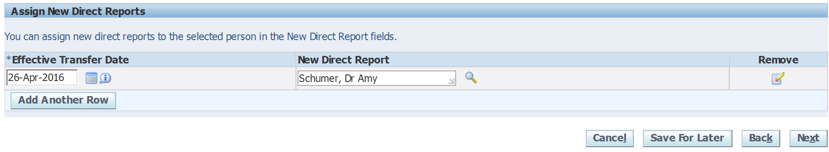
Click on Next.

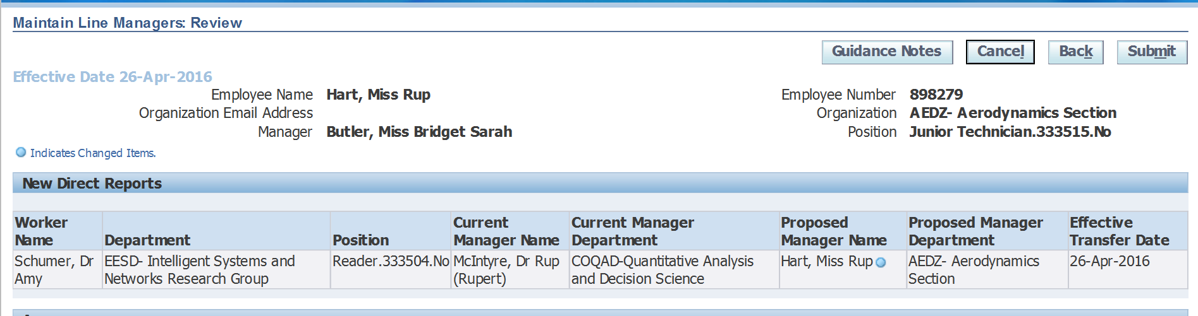

Submit your change for approval from your line manager.

You must now contact your local HR team for help with updating the line management information for the direct report/s that had future changes registered.

