**Re-assign Direct Reports**

Log into IC Manager Self Service in one of the following ways:

(i)        If you are accessing ICIS from a computer with a wired connection on the College network (not halls, wireless or VPN), log in as normal <http://icis.imperial.ac.uk/>and look for “IC Manager Self Service” in your list of responsibilities.  **You are particularly urged to adopt this route, rather than following the link which appears in the next paragraph.**

(ii)        If you are accessing ICIS from home, wirelessly, from halls or via VPN, please click on the following link and follow the instructions:

<https://icisremote.ad.ic.ac.uk/dana-na/auth/url_1/welcome.cgi>

Expand your responsibility IC Manager Self Service, and select Maintain Line Managers.

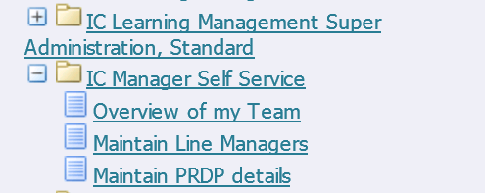

If you have direct reports that are line managers themselves, i.e. you have direct and indirect reports, you will be able to carry out an additional action with the Maintain Line Managers section of your responsibility. Re-assigning direct reports can be used to move the direct reports of an individual so that they are line managed by someone else. Essentially it is a way of assigning a new manager to them. If someone line manages a number of people, all of their direct reports can be moved in one go. Alternatively you can select different line managers for each of the reports.

To re-assign direct reports, select an appropriate employee using the action icon in the column labelled Action. Someone in your person tree with the + symbol next to their name, indicates that they have people reporting directly to them;



You will be taken through to the Maintain Line Managers: Effective Date Options page;

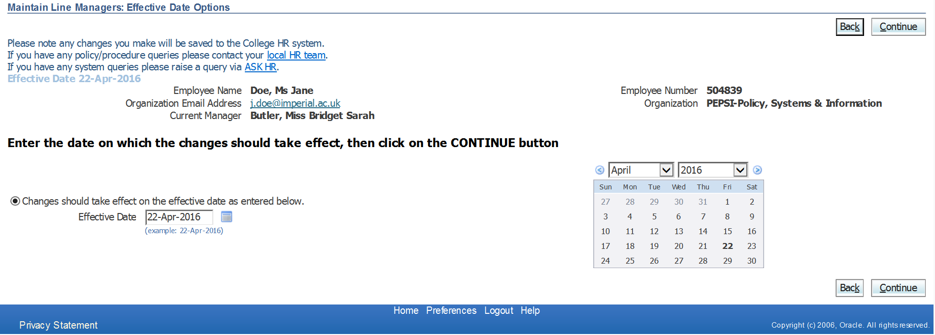

Please see guidance document “Maintain Line Managers: Effective Date Options” page for further details about the options and scenarios for this page.

Once you’ve entered the appropriate date, click on Continue.

The Maintain Line Managers page will be displayed. The details of the person you are assigning direct reports to will be detailed at the top of the page. If you have selected one of your direct reports you will see your own name in the Manager field. If you’ve selected an indirect report, the manager field will be completed with the current line manager’s details.

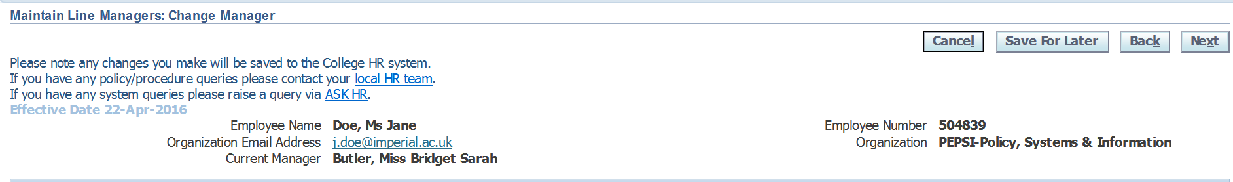

To re-assign the direct reports of this individual you will need to use the middle section of this form, labelled “Re-assign Direct Reports”

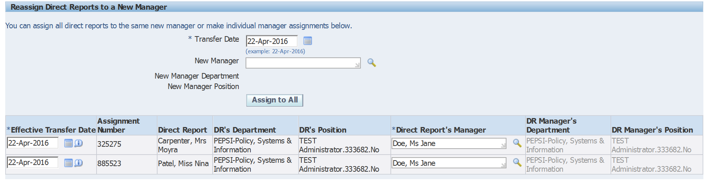

The direct reports that are currently line managed by this person will be listed. To assign the same new manager to everyone listed, click into the New Manager field. Either start typing the name of the new line manager and a list of matching results will start to populate, or use the magnifying glass to search.

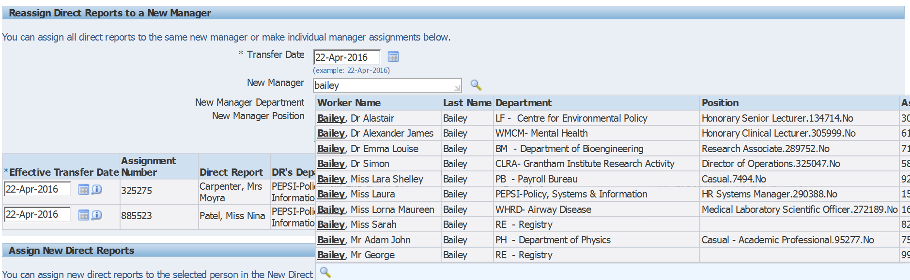

If using the magnifying glass – You would then need to click “Quick Select” or the select radio button to enter this information into the field.

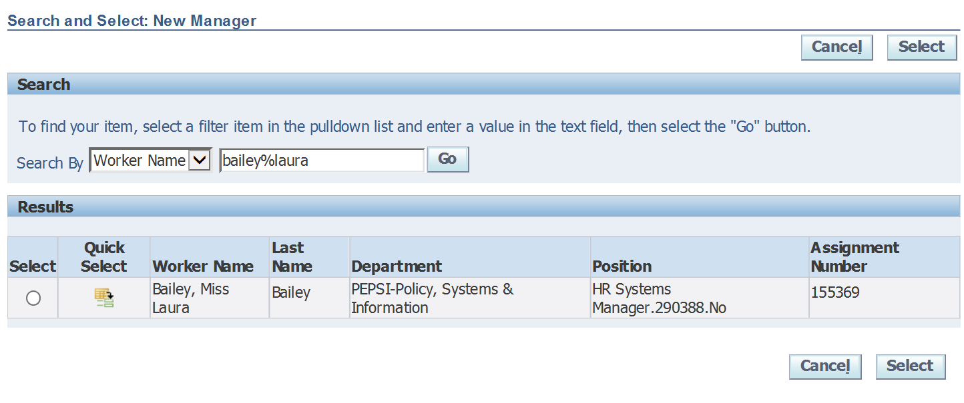

To assign the new manager to all direct reports, click on the “Assign to All”  button underneath the name of the new manager.

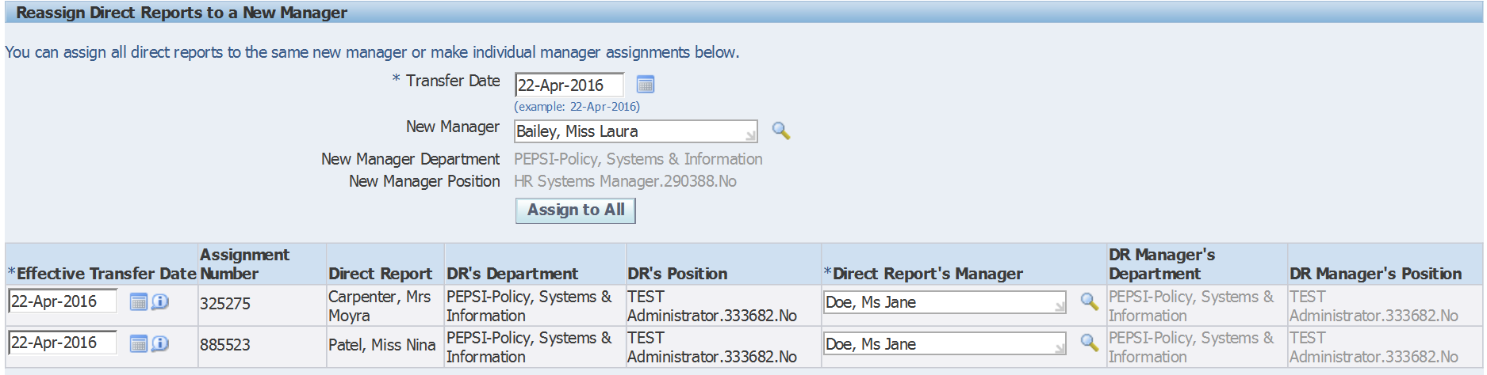

This will update the “Direct Report’s Manager” field to the new manager you’ve entered.

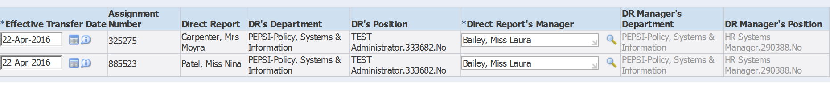

If you need to assign a different new manager to each of the direct reports, you can delete out the name of the new manager for that particular direct report and search again by entering the name of the new manager in the Direct Report’s Manager field against the relevant individual.

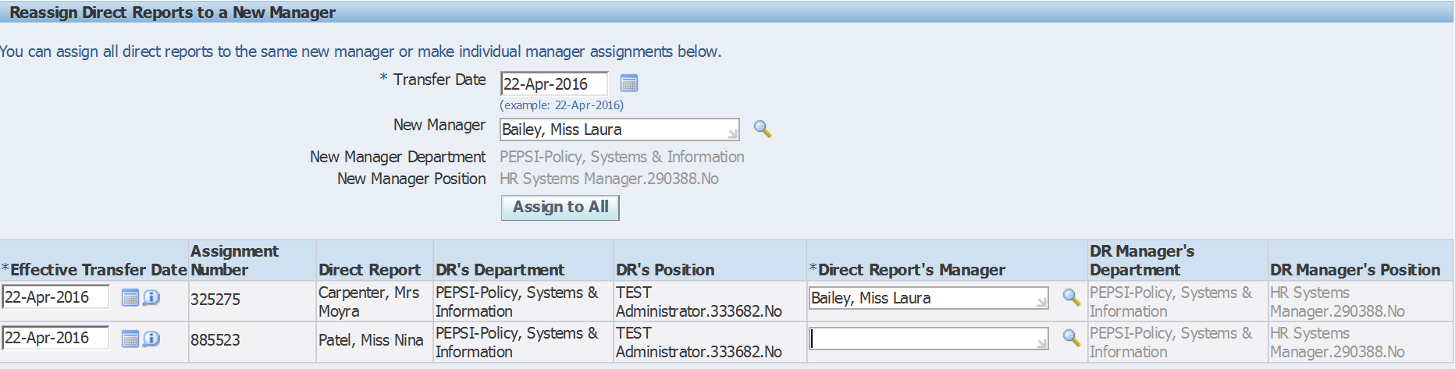

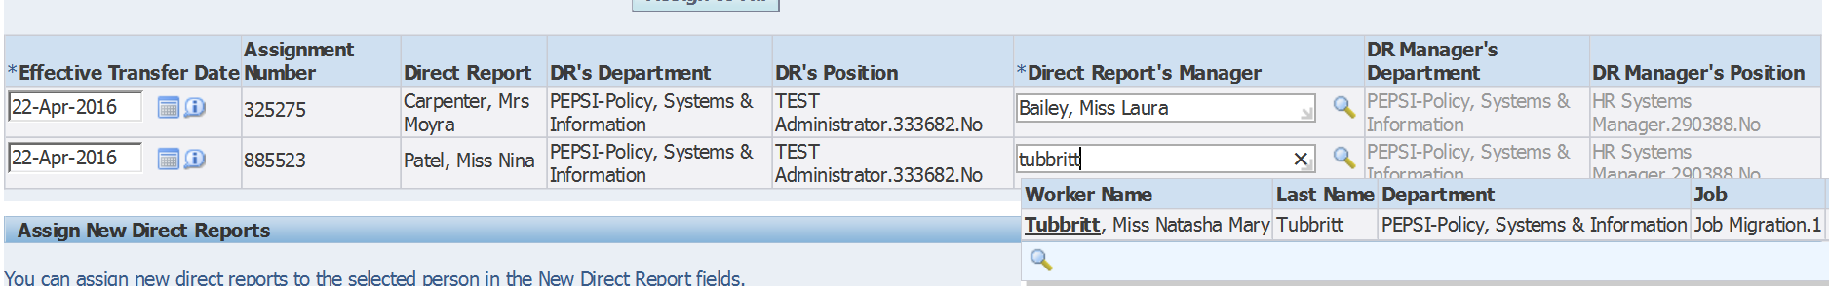

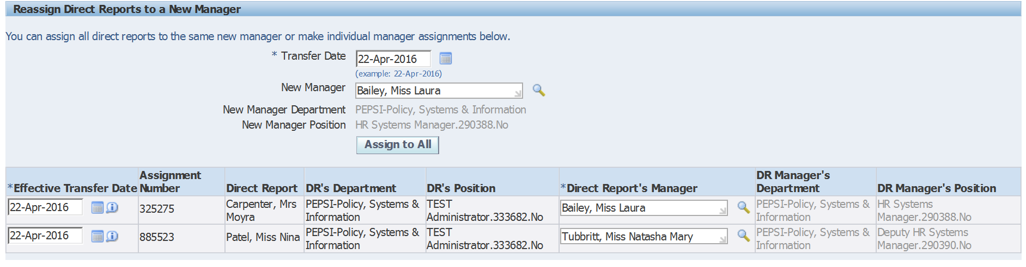

Once you’re happy that the direct reports have all been assigned to the correct new manager, select Next.

An overview of the change you’ve requested will be displayed. The blue circle icon shows against the new information you have entered.

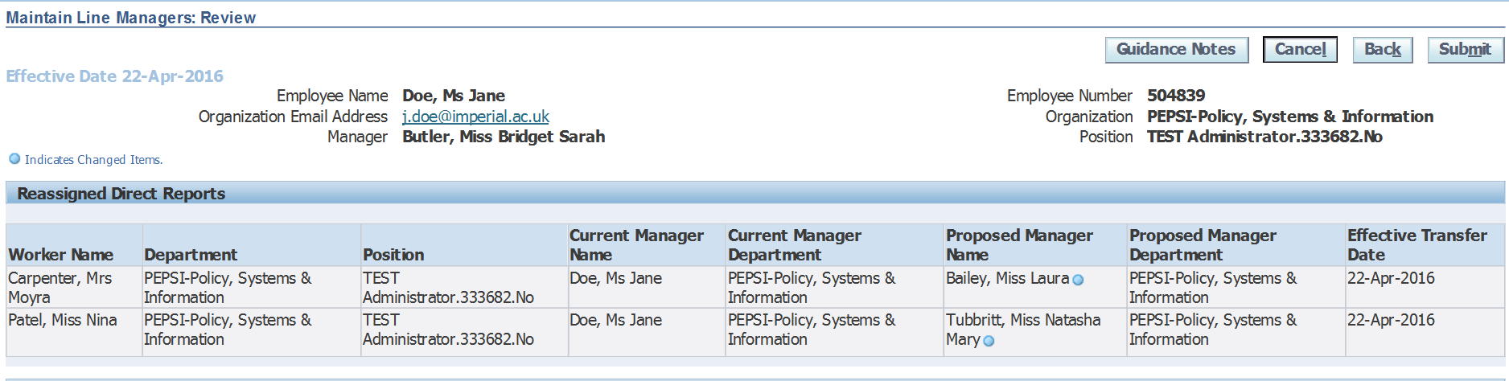

Any change in line management information is automatically routed to your own line manager before it is updated in the system.

This screen also gives you the option to add comments to your request which will be visible to your line manager when they are reviewing the changes. You could enter any information in this box which you think is relevant, and will help your line manager understand why you are requesting this change.

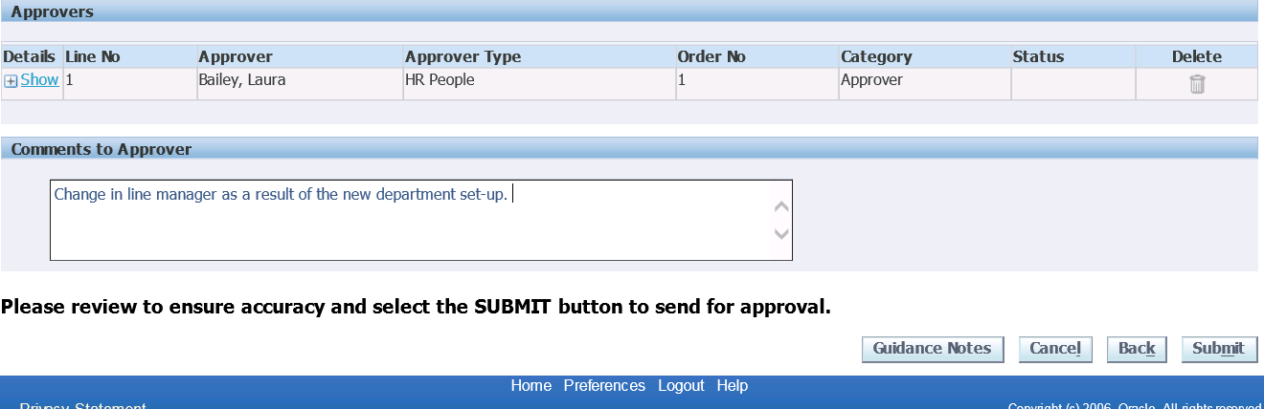

Once you are happy with your change, click on Submit. You will see confirmation that your change has been submitted for approval;

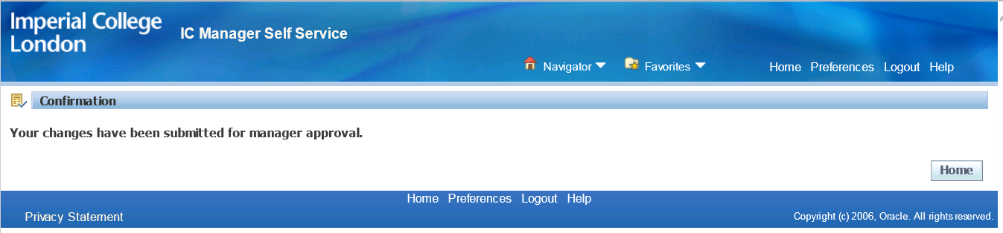

The action is now completed, pending approval from your line manager.