**TeamSeer (Home Page)**

The TeamSeer home page is where you can action or view team members’ planned and unplanned leave as a Line Manager or Line Manager’s Admin Assistant.

**TASKS box**: Find planned and unplanned Leave request along with the

email notification.

**TEAM OVERIVEW** **box:** Find a 12 month summary of direct reports

Leave or Sickness.

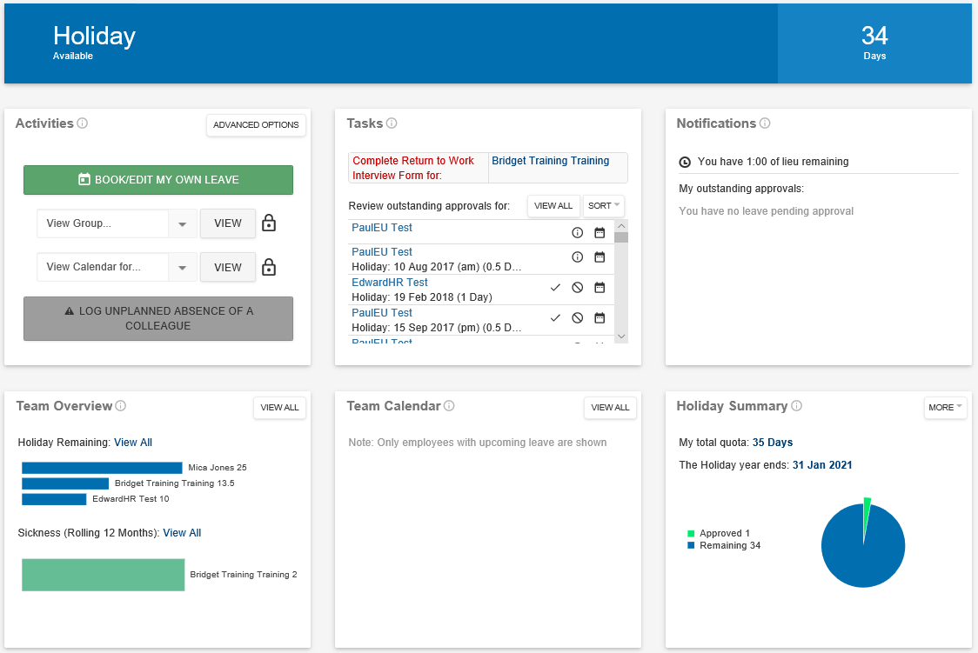

**RETURN TO WORK INTERVIEW FORM**

Can be accessed via the email notification or within the Task box here.



**ABSENCE REQUEST WITHOUT QUICK APPROVAL TICK ICON**

Click on the circle  icon and a grey box will appear with more information.

These types of leave will need to be approved using the button

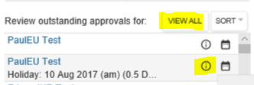

Types of messages that can appear:

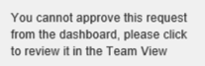 

**QUICK VIEW**

To view, hover over the leave request wording of a staff member and a grey box will appear with the details of the dates and leave requested. In addition a team calendar view will appear with a red hightlighted box of the date/s and leave.

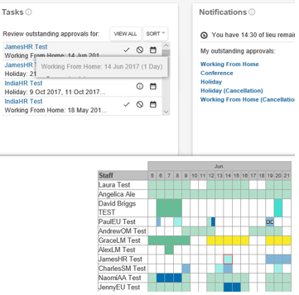

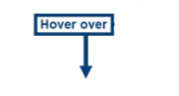

**TEAM OVERVIEW:**

Only direct reports will appear here.

**Holiday Remaining:**  Will show each team members remaining leave allowance.

**Sickness**

For full overview of all leave and unplanned leave press  button.

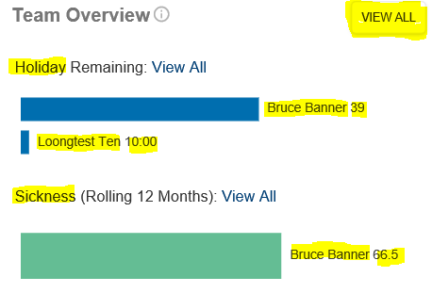

**QUICK APPROVAL**

For quick approval of leave press icon

