SHARED SPACE ACCESS AND OPENING HOURS

PURPOSE
This document describes the College policy and standard protocols for access to our shared spaces.

GOALS
The specific goals of this policy are to:
- Enable easy physical access to all College shared spaces by members of College and their guests during defined opening hours
- Preserve and protect the physical security of designated sensitive areas within Departments and Divisions
- Reduce the administrative effort in managing access to shared spaces across College for periodic, one off and / or adhoc visits

SCOPE
This policy applies to all buildings that contain College shared spaces, and all access ways and routes to those shared spaces:
- All staff and all registered students
- All College Shared Spaces, and associated corridors and access ways
- Physical controls on access to shared spaces (card readers, key locks, Digi-pads, etc.)
- Designated circulation and access routes
- NHS and medical campuses – all shared spaces where College (and not the NHS) is responsible for operation
Agreed exclusions to this policy are:
- College Library locations having locally designated opening hours
- College closure days including Bank Holidays, Easter and Christmas / New Year
- College spaces that are dedicated including research laboratories, staff offices, and staff working areas not accessible to all members of College
- Authorisation of role based permissions (e.g., Security, Cleaning) to access College space
- Physical security arrangements for campuses, buildings, and rooms
- Safety provision and arrangements for shared spaces
- During a security incident where access control doors are secured
- Disability provisions and reasonable adjustments
- Signage, way finding and campus maps
- When any said area is under construction or planned maintenance is being carried out

DEFINITIONS
Access arrangements for shared spaces are defined around College Opening Hours as visualised at appendix 1, and defined as:
Early Opening Hours Monday to Friday, 07.00 to 08:00
Day Opening Hours Monday to Friday, 08:00 to 19.00
Evening Opening Hours Monday to Friday, 19.00 to midnight
Weekends Saturday and Sunday, 08:00 to midnight
Out of Hours Monday to Sunday, midnight to 07:00
Building Opening Hours Monday to Sunday, 07:00 to midnight

The degree of access to shared spaces is defined in terms of the College swipe card system:
Open Mode of the electronic swipe card system allows access through door and / or barrier without requiring an Imperial College swipe card
Facility Mode of the electronic swipe card system allows access through door and / or barrier by any member of College with an active Imperial College swipe card
Card Only Mode of the electronic swipe card system allows access through door and / or barrier only to staff or students with specific access rights applied to their Imperial College swipe card
Locked Mode of the electronic swipe card system does not allow access to any Imperial College swipe card holder, other than those with authorised role based permissions such as security and cleaning staff

POLICY
- The approach, methods, tools and management of Access and Security will be specified and overseen by the Director of Estates Operations, on behalf of the Provost; and who is accountable for the integrity and effectiveness of arrangements described in this policy.

- Access during Day Opening Hours will be under the following provision: Any access control readers on the designated route into a venue and/or the venue, will be programmed onto Open Mode. This enables all staff/student/Alumni/visitors with an active Imperial College swipe card to access the space in question, whilst maintaining both an acceptable level of Security and the ability to provide activity reports.

- Access at Weekends and Evening Opening Hours and Early Opening Hours will be under the following provision: Any access control readers on the designated route into a venue and/or the venue, will be programmed onto Facility Mode. This enables all staff/student/Alumni/visitors with an active Imperial College swipe card to access the space in question, whilst maintaining both an acceptable level of Security and the ability to provide activity reports.

- There will be no access to buildings and the shared spaces they house, during Out of Hours times, unless specific approval is given by the relevant Head of Department / Head of Division, in accordance with relevant HR and Safety policies including

- Disabled Access Provision information and advice regarding access issues can be sought through the following Imperial College Hyperlinks.

Equality, Diversity & Inclusion Centre

guidelines on accessibility

accessibility information for all our campuses

Any persons using a space who may have accessibility requirements should in the first instance refer to ICLIS to ascertain the current accessibility features and arrangements for any given space.

- Access for guests: it is the responsibility of the event organiser/host to ensure external guests, who do not hold an active Imperial College swipe card, can access/egress a venue.

- Local Building Information: It is the responsibility of the person booking the room to ensure local information such as fire escape routes and assembly points are communicated to attendees using the space. Any attendees who unable to self-evacuate, would need to consider arranging a Personal Emergency Egress Plan (PEEP) but visiting the following link

http://www.imperial.ac.uk/estates-facilities/health-and-safety/fire-safety/peeps/

- Arrangements for events:

  - State Visits In the event of a state visit the college reserve the right to change the status of any access control from facility to another status including Card Only (only staff or students with specific access rights can gain entry) or Locked (No access to any card holder). Swipe readers can only be controlled via the Security control room under guidance from either the duty Security Manager (or duty Supervision)
  - College Events Local arrangements between the Director of Estates Operations, Security management and committee members will be made during the planning rounds of College events such as Open days and Imperial Festival. This may affect access to areas that may have booked.
  - Alternative Circulation Routes In the event that a designated route to a shared space is compromised or is considered unsuitable to reasons such as building works or a security concern, every effort will be made to provide a suitable alternative route to the space in question in line with this policy. Any access control readers on the secondary route will be programmed to Facility Mode to provide access to an active college swipe.

- Responsibilities in respect of access to College shared spaces are:

  - Students and Staff: To ensure any necessary measures are taken to comply with this policy and to report any issues they may experience with regards to access to the appropriate operations manager. This is to ensure the issue is addressed to prevent issues for future bookings.
  - Department Operations Managers: To ensure all College Shared Spaces available for booking are visible in College systems accordingly.
  - Security staff: To assist whenever practical to provide the necessary access requirements without contravening this policy and to report any maintenance issues regarding any security hardware at the earliest opportunity to prevent ongoing access issues.
  - Departments and Divisions: will not prevent or impede access to designated College Shared Spaces by, for example, installing locally controlled locks.
  - Estates and Projects: as refurbishments of buildings are undertaken legacy access restrictions like locks and keypads will be removed, and replaced with swipe card access to College standards.

- In the event that situations arise that cannot be resolved by application of the principles and policy articulated here, the escalation path for resolution will be the same as that in the College Space Sharing policy.

APPENDIX 1 – SHARED SPACE OPENING HOURS

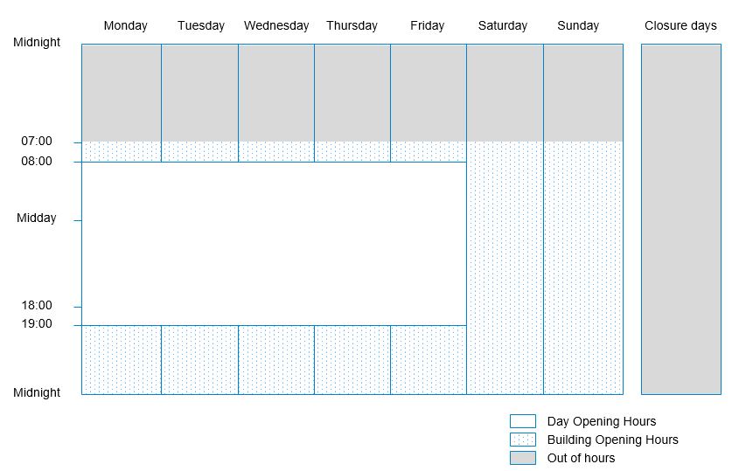

All individuals who have not been barred and who hold a properly issued and active College ID card
https://www.imperial.ac.uk/admin-services/library/use-the-library/our-libraries/
http://www.imperial.ac.uk/human-resources/procedures/leave/annual-leave/college-closures/
All spaces that are not designated as Shared Spaces per the college Space Sharing policy
Reasonable adjustments, in line with legislation, will be tailored to each individual’s needs
Being the period during which most teaching and work occurs
During which time the swipe card system will be programmed to Locked Mode
Imperial College Location Inventory System
Refer also to College Space Sharing policy about the responsibilities of members of College when using spaces
Including counterparts in the central functions and divisions
as designated in College Space Sharing policy

