December 2014 RISK ANALYSIS

Contents:
- December 2014 Risk Analysis – Information
  - Figure 1:
Frequency Count of Risks with significant scores
- Threat Risk: Common Theme Trend Analysis
- Appendix:
- Departmental threat risk charts by Faculty / Area
- Faculty Threat Risks

- December 2014 Risk Analysis - Information
Empirical contains approximately 950 Risks and about 49% (464) of these are Threat risks which have a significant score (Impact and/or Likelihood score of 7 or above or a total score of 25 or above) and have been used in this analysis. This total number of Threat Risks with significant scores is further reduced for analysis by only counting each Risk Category for any Risk Area (SID / Faculty / College) once even though the Risk Area may have multiple risks for each Risk Category.
Reducing the number of risks counted in this fashion results in a data set of 296 Threat risks of which 30 are College or Faculty level Risks. The number of Departments used is 58 which includes College level risks (1), Faculties (4 including the Business School) and 53 SID’s.

The frequency data indicates that key risk areas remain similar over time with clustering around Staff and Disaster Recovery. Some reordering in the lower frequency count categories has occurred but the profile is very similar to previous analyses (see Figure 1). Apparently significant increases in the number of risks in 3 areas were identified and considered:
- Inadequate Processes/Organisation: The increase is departments recognising that they may have inadequate processes within the department to undertake or monitor their activities. There is no evidence of a systemic issue.
- The increase in departments concerned about Insufficient space is predominantly Academic Services/Other academic departments concerned over their inability to secure sufficient space for their academic activities (teaching/lectures/seminars)
- The increase in concern about Regulation / Legal / Legislative Compliance is an increase in recording reflecting increased awareness of the risk but does not evidence any systemic issues.
Figure 1
Frequency Count of Risks with significant scores:
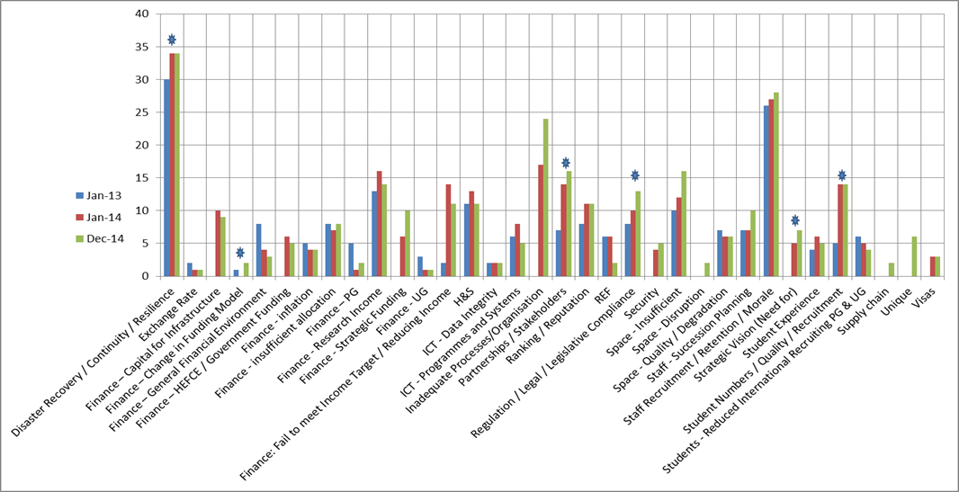

The charts in the Appendix show Departmental threat risks by Faculty / Area and include a chart for Faculty Threat Risks. The current College Risk areas are indicated on the charts with the symbol to indicate where Department and Faculty risks have alignment with College level risks.

The Risk Analysis is facilitated by Staff recording and updating Empirical forming a journal of risk information of benefit at all levels of the College. We would like to thank the Staff for their continued support and development of the information recorded in Empirical.

- Threat Risk: Common Theme Trend Analysis: December 2014
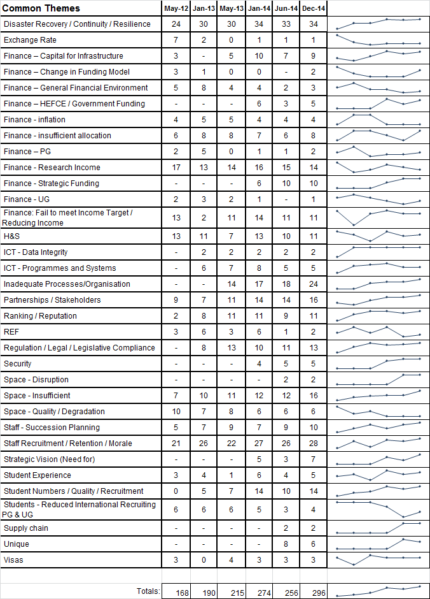

- APPENDIX

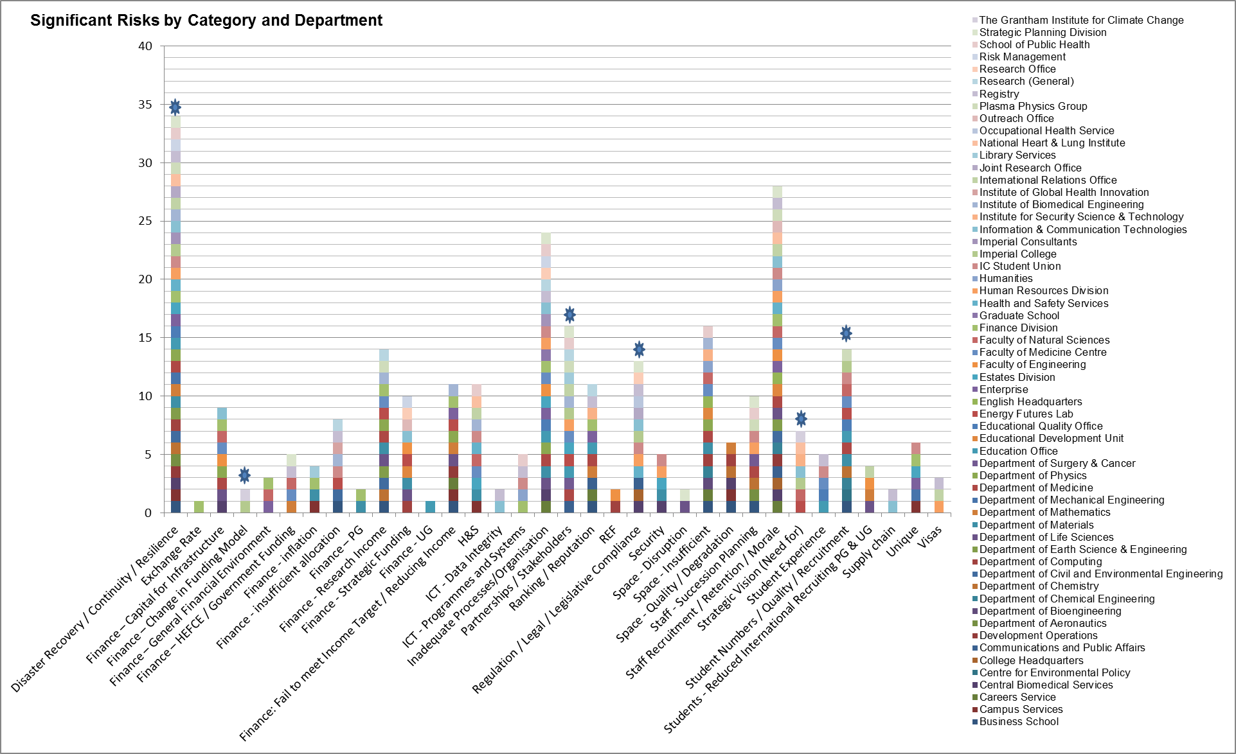
(Includes IC & Faculties)
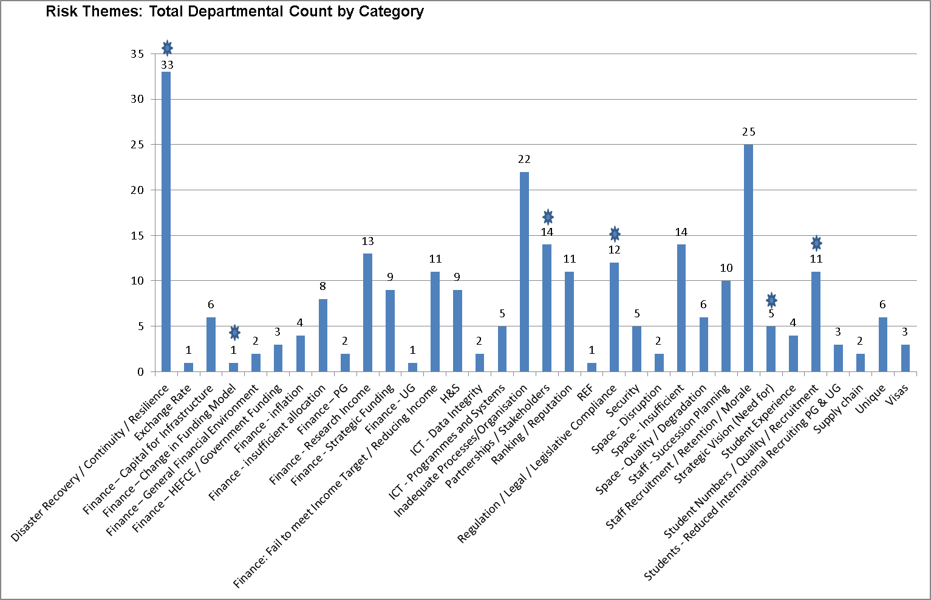
(Excludes IC & Faculties)

Academic Services / Other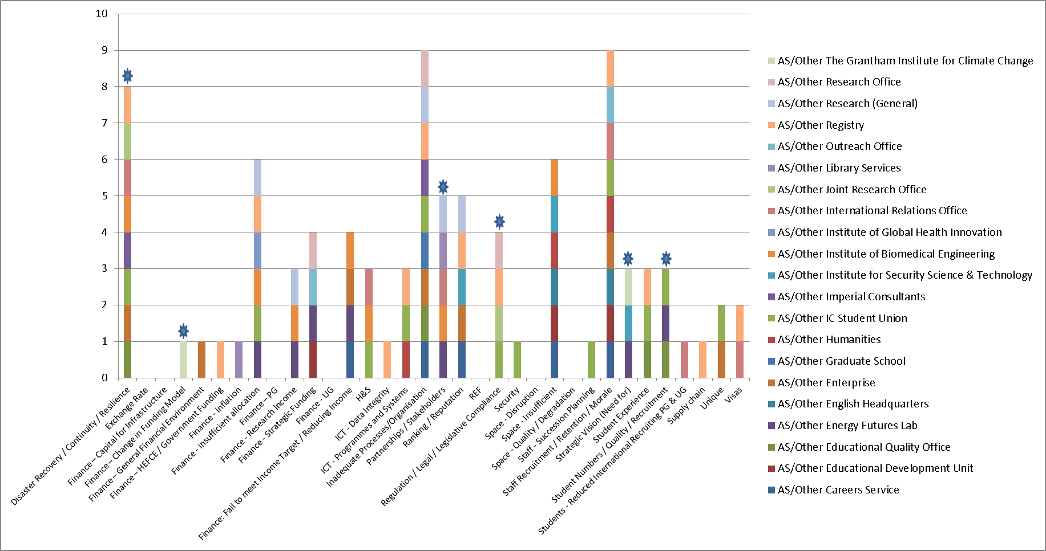
(Excludes IC & Faculties)

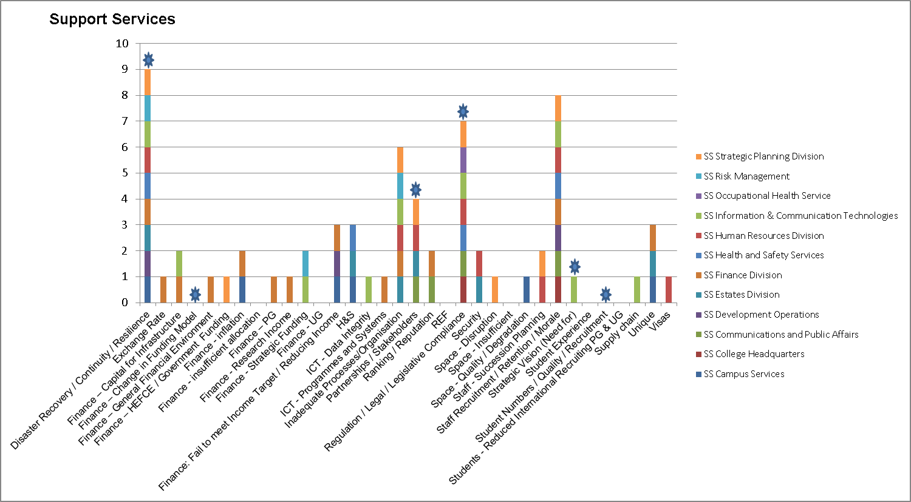
(Excludes IC & Faculties)

