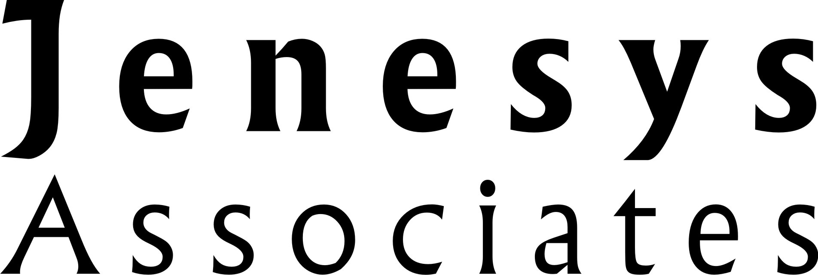

**Imperial Festival 2014**

**Draft Evaluation Report v1.3**

**Author:**

**Sarah Jenkins**

**September 2014**

**www.jenesysassociates.co.uk**

**Contents**

1 Summary of findings 3

2 Introduction 5

2.1 Imperial Festival 5

2.2 Evaluation aims 5

2.3 Evaluation methodology 5

3 Who participated in Imperial Festival 2014? 7

3.1 Visitor demographics 7

3.2 Background of public visitors 11

3.3 Profile of delivery participants 13

3.4 Participants’ experiences at Imperial Festival 15

4 How did participants rate Imperial Festival 2014? 17

4.1 Overall ratings 17

4.2 Visitor opinions: communication 19

4.3 Delivery participants opinions: communication 22

5 What were the impacts of Imperial Festival 2014? 24

5.1 Visitor impacts 24

5.2 Delivery participant impacts 27

6 What were the success factors of Imperial Festival 2014? 30

7 What was the learning from Imperial Festival 2014? 32

8 Conclusions 34

8.1 Conclusions 34

8.2 Future considerations 34

# Summary of findings

Imperial Festival 2014 was the third of an annual celebration and showcase of the accomplishments and activities of staff and students at Imperial College London. An external evaluation of the Festival aimed to assess its impacts on visitors, including alumni, staff and students who participated in delivering the Festival.

**Participation**

Of those who took part in the evaluation, 41% of visitors were members of the public. 33% were alumni, 25% were current Imperial staff or students and 2% were members of Imperial Court. 57% of visitors were age under 35. 53% were male and 46% were female. 43% of visitors were visiting the Festival with family and 87% visited the Research Zone marquee.

60% of public visitors had London postcodes. 65% of them had not visited Imperial before and 85% indicated that they already liked or loved science.

73% of those involved in the delivery of the Festival were members of Imperial staff and 19% were Imperial students. 45% delivered activities in the Research Zone marquee and 16% were general Festival volunteers. 88% had experience of outreach or public engagement before Imperial Festival 2014. A majority thought the Festival was showcasing Imperial research to the public and promoting STEM subjects or opportunities to young people.

**Opinions**

The Festival was highly rated with 91% of visitors and 96% of delivery participants rating it as ‘Excellent’ or ‘Good’. 80% of visitors rated that it was ‘Very easy’ or ‘Easy’ to navigate. 86% of visitors reported that Imperial staff and students provided ‘Very clear’ or ‘Clear’ explanations about their work and 93% rated staff and students’ listening and response to questions as ‘Excellent’ or ‘Good’.

78% of delivery participants ‘strongly’ agreed’ or ‘agreed’ that they were well-briefed about the Festival.

**Impacts**

82% of visitors reported that the Festival increased their understanding of the work carried out at Imperial ‘a lot’ or ‘somewhat’. 89% learnt something new at the Festival and 53% were now ‘more interested’ in science. 85% said they would come to a similar event in the future and 92% would recommend the Festival.

50% of delivery participants ‘strongly agreed’ or ‘agreed’ the Festival had made them think differently about explaining their work to non-specialists. 94% ‘strongly agreed’ or ‘agreed’ that they would recommend the Festival to a colleague or peer and 92% ‘strongly agreed’ or ‘agreed’ that they would participate in the future. Other reported impacts on delivery partners were enhanced opinions of Imperial, increased interest in public engagement and improved networking with other staff and students.

**Success factors**

*Variety of subjects and range of activities -* In particular the range of topics covered and the inclusion of interactive activities aimed at both children and adults.

*Enthusiasm and commitment of delivery participants -* An engaging approach and ability to adapt activities and presentations to particular audiences were highlighted.

*Number and type of visitors –* The large numbers and family nature of most visitors created an enjoyable atmosphere and generated high levels of interest.

Public visitors also highlighted particularly memorable or high quality talks or activities where the presenters seemed especially aware of the background knowledge of audience members and activities that successfully balanced information with engagement. Alumni visitors reported meeting other alumni as a success factor and welcomed the opportunity to preview the Research Zone when it was less busy. Delivery participants mentioned the quality of organisational aspects and the motivational impact of participation.

**Lessons**

*Number of visitors –* The busy and crowded nature of the Festival on Saturday meant that visitors were not always able to see or engage with activities and delivery participants were not able to engage with all the visitors they wanted to.

*Arrangements for tours*– the booking and joining arrangements were reported to be confusing and unsatisfactory. More tours are needed to meet visitor demand.  
  
Public visitors recommended that the Festival should incorporate activities for schools, especially specific activities for secondary school students. Alumni visitors felt that alumni activities could be more closely targeted to ensure their own year groups and departments were well represented. Delivery participants recommended clearer, more visible signage and information about locations and more detailed, specific briefings.  
  
*Catering options -* A hot drinks option and more consistent food quality would be welcomed. The variety of the food offering could also be improved.

**Conclusions**

**Imperial Festival 2014 was a well organised, highly successful event, which was considerably larger in scale and of a more professional standard than previous years. It met its stated aims and is having positive impacts on all categories of visitors and participants.**

**The Festival attracted large numbers of visitors. This created a positive, stimulating atmosphere and a sense of pride among staff, students and alumni, but consideration should be given as to how growing visitor numbers can be best managed to maintain a high quality experience for both visitors and those involved in delivery.**

# Introduction

## Imperial Festival

Imperial Festival is an annual celebration and showcase of the accomplishments and activities of staff and students at Imperial College London. It has four key objectives:

* To showcase the work of Imperial and celebrate its achievements
* To empower key stakeholders – Imperial staff, students and researchers
* To further public engagement across all Imperial departments and levels
* To generate a sense of pride from Imperial staff, students and the local community

The third Imperial Festival took place on 9 and 10 May 2014 and was bigger than in previous years, with new venues and increased numbers of activities, performances and workshops. The Festival opened to the public on Friday evening and Saturday afternoon and attracted an estimated 12,000 visitors. The annual Alumni Reunion ran alongside the Festival on the Saturday.

The Festival was evaluated by Jenesys Associates Ltd and their findings are documented in this report.

## Evaluation aims

To assess the impacts of the Imperial Festival on:

* Public visitors with no affiliation with Imperial College London
* Imperial staff and students who visit the Festival
* Imperial staff, students and others involved in delivery of the Festival
* Alumni who visit the Festival

N.B. ‘staff’ includes research staff and ‘students’ includes research students

To recommend enhancements to the Festival and, where they arise, improvements to other Imperial College London public engagement and outreach activities.

## Evaluation methodology

**Visitor survey**

A self-completion feedback e-survey for Festival visitors was made available via the Festival app and website. 318 valid responses were received between 9 and 23 May from visitors in all the target audience categories described above. Questions were branched according to demographic and background information so that only appropriate questions were asked to each category of visitor. There was a simplified set of questions for respondents aged under-12 (who were surveyed for the first time in 2014).

Additional questions for alumni about the Reunion were added for this category of visitors. These questions were devised by the relevant organisers and uploaded into the survey software by Jenesys Associates. The analyses of responses about the Alumni Reunion in included in appendix A.

**Deliverers’ survey**

Post-Festival, a self-completion feedback e-survey was created in Qualtrics and emailed to staff, students and others who had delivered activities or volunteered at the Festival. It was completed by 203 valid respondents between 16 and 30 May.

**Visitor interviews**

Short face-to-face interviews were conducted with 70 individual visitors at the Festival throughout Friday evening and Saturday. These complemented the visitor survey by capturing more detailed information about visitors’ reasons for their opinions and reactions to the Festival. Interviews were recorded and transcribed for analysis.

**Deliverers’ interviews**

Telephone interviews were conducted between 28 May and 19 June with 17 individuals who had delivered Festival activities. They were recorded and transcribed for analysis and sought to build on the deliverers’ survey by capturing information about reasons behind reactions and opinions.

**Data collection and analysis**

Survey data were collected using Qualtrics survey distribution software. The data from the interviews and the answers to open survey questions were coded and analysed using ‘MaxQDA’ software and reviewed to identify interesting quotes. Visitors’ quotes are shown in *blue* and delivery participants’ quotes are in *red*.

**Reporting**

All data in this report have been anonymised. Survey respondents were not forced to answer all questions and whether or not they answered some questions was dependent on responses to earlier questions. Therefore sample sizes differ and this report shows the number of respondents (n=) for every question. Percentages have been rounded and when totalled may be greater or less than 100.

Section 3 outlines the backgrounds and motivations of Festival visitors and individuals involved in the delivery of Festival activities. Section 4 examines their experiences and opinions of the Festival. Section 5 details the main impacts on visitors and delivery participants. Sections 6 and 7 highlight success factors and learning points. Section 8 documents the evaluation conclusions, including considerations for future Imperial Festivals.

# Who participated in Imperial Festival 2014?

This section records the demographics of visitors to the Festival; examines the backgrounds of public visitors in some more detail; summarises the profiles of those who took part in the delivery of activities; and records the Festival experience for visitors and delivery participants.

## Visitor demographics

***Visitor categories***

337 respondents completed the Festival visitor feedback survey. 41% (136) were members of the public, with 10% (34) being age under 18 and 8% (26) being secondary school students. 33% (110) were alumni, 25% (84) were current Imperial staff or students and 2% (7) were members of Imperial Court.

**Visitor categories (n=337)**

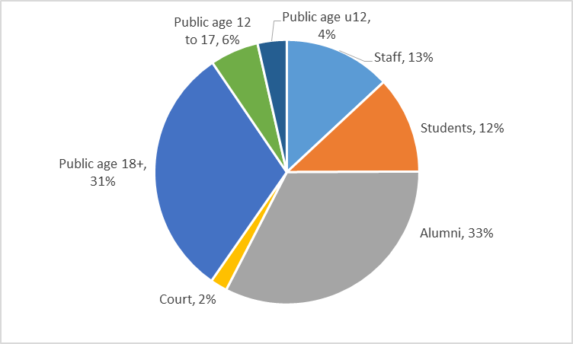

Interviews were conducted with individuals in all the above categories, except ‘public age under 12’. The distribution of these interviews and evaluators’ observations suggest that members of the public were the dominant visitor group on Saturday, with Imperial staff and students being prevalent on Friday evening. Primary school students who had taken part in schools activities on the Friday afternoon were also observed on Friday evening. Interviews suggest that, as a result of their experience at the schools activities, some of these students had brought their families back to the Festival.

*She [my daughter] came with the school this afternoon and had such a great time that she persuaded us to come along this evening. We are all having fun, I would say. (Adult visitor with no Imperial affiliation).*

***Age of visitors***

273 visitor respondents reported their age. 42% (115) were age between 25 and 44, with 34% (93) being younger and 24% (65) older than this age range. Alumni were older than average, with 53% reporting that they were 45 or older.

**Visitor ages (n=273)**

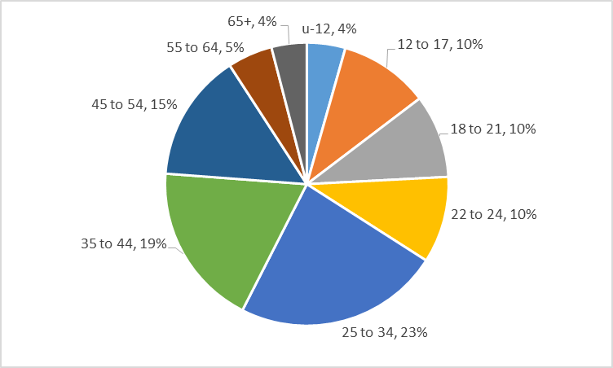

***Gender of visitors***

Overall, the gender of visitors was fairly evenly split, with 53% (171) of those who answered being male and 46% (147) being female. Most alumni (63%) who reported their gender were male, with 32% of alumni indicating that they were female.

**Visitor gender (n=321)**

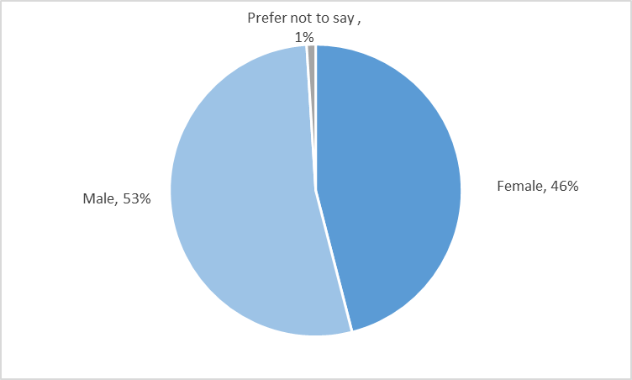

***Visitor motivations***

In interview, visitors were asked why they had come to Festival. Other than being interested in science, the most common reason among all visitor categories was the Festival’s interesting and appealing nature.

*I think the Imperial Festival is very new and a special activity for me and I find it quite interesting that they do it, so I decided to wander around and see what’s happening here. (Imperial undergraduate student)*

*I picked up a flyer in a cafe. It sounded really interesting so we came along and we’re pleased we did. (Adult visitor with no Imperial affiliation)*

*Well it looked like there's a lot of interesting things going on and from the outside it seems quite intriguing and we wanted to find out what's happening inside. (Adult visitor with no Imperial affiliation)*

***Festival publicity***

294 visitors selected all the ways they heard about Imperial Festival, with some selecting more than one method. Generally, the most common answer was ‘Word of mouth’ which was selected by 40% (126) of respondents. 60% of those who selected Email were alumni. No alumni selected ‘Facebook’, ‘Twitter’ or ‘Poster’. The most common description of ‘Other’ was an event listing such as TimeOut or Londonist. With the exception of two secondary schools students, all respondents who selected ‘Poster’ were Imperial staff or students.

**How visitors heard about Imperial Festival (n=294)**

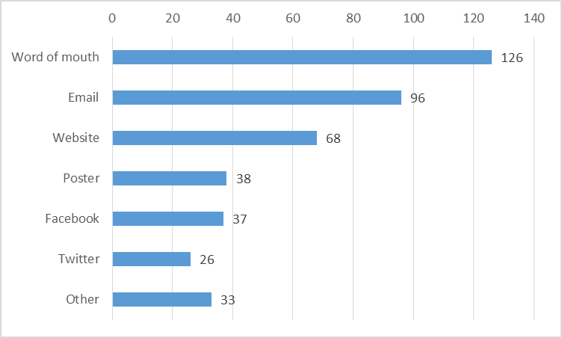

***Visitor Groups***

303 visitors identified their visitor groups, with some selecting more than one category. The most common answer was ‘Family’ which was reported by 43% (130) of respondents. Descriptions of ‘Other’ included Imperial alumni, organised groups and being on a date. A majority of those who selected ‘No one’ had an affiliation with Imperial i.e. were alumni, staff, students or members of Court.

**Visitor Groups (n=303)**

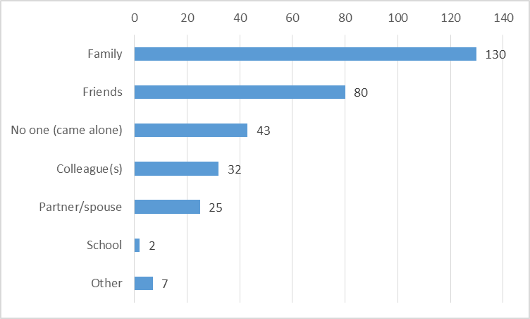

## Background of public visitors

***Location of public visitors***

120 members of the public reported their home postcodes. 60% (72) were located within London postcode boundaries. The ‘Other England’ includes postcodes in the East and West Midlands and South West.

**Home postcodes of public visitors (n=120)**

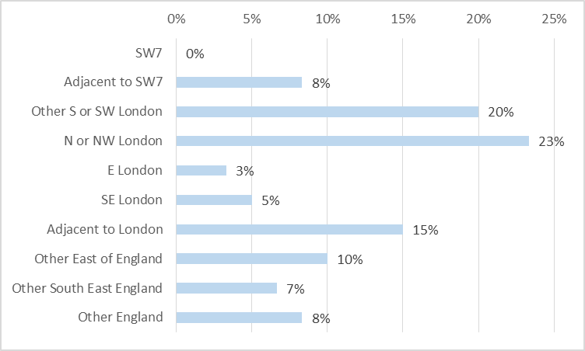

***Previous experience of Imperial***

65% (64) of public visitor respondents had not previously visited Imperial. The 35% (34) who had visited before indicated the nature of their prior visit or visits. Most of those who selected ‘Other’ reason had been to meet friends or family who work or study at Imperial.

**Reason for previous visit to Imperial (n =34)**

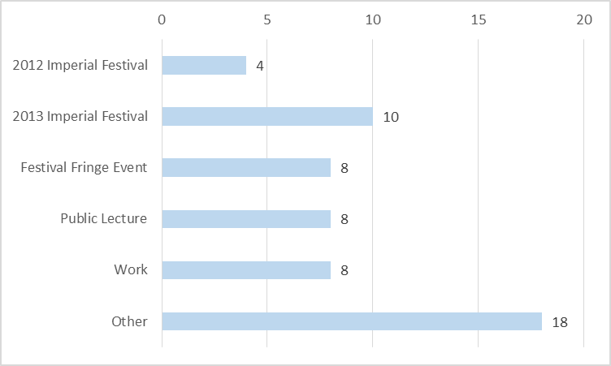

***Attitudes towards science***

134 public respondents of all ages answered when asked about their existing interest in science. 85% (114) indicated that they liked or loved it. All those who reported that they were neutral or disliked science were age 12 or over. This is consistent with the interview findings, where every interview subject reported that they or at least one other member of their visitor group was interested science.

**Existing interest in science? (n=134)**

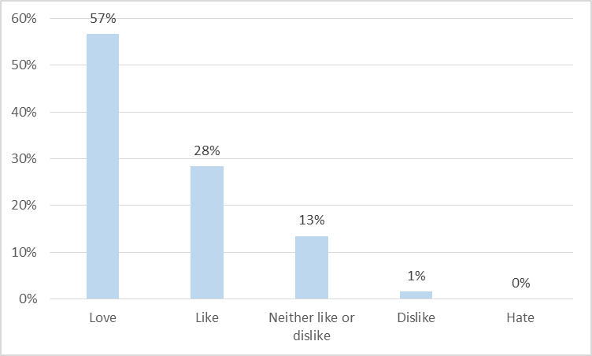

In interview, a majority of public visitors reported that they had not been to another science festival. However, all had visited museums or science centres. Most family visitor group members indicated that they had carried out these visits as a family group. Some older children said they had made these visits with their school.

*I’d say as a family we like sciencey things. We go to the Science Museum and Natural History Museum. (Adult visitor with no Imperial affiliation)*

*I’ve been to the Science Museum with my school, which was really good, and we’ve gone to a science talk with school, but I can’t remember where that was. (Under 16 visitor with no Imperial affiliation)*

## Profile of delivery participants

***Categories***

73% (148) of delivery participants who took the survey were members of Imperial staff and 19% (39) were Imperial students, meaning that 92% (187) were directly affiliated with Imperial. Respondents who selected ‘Other’ described themselves as members of Imperial-associated companies, performers, contractors or food vendors.

**Delivery participant categories (n=203)**

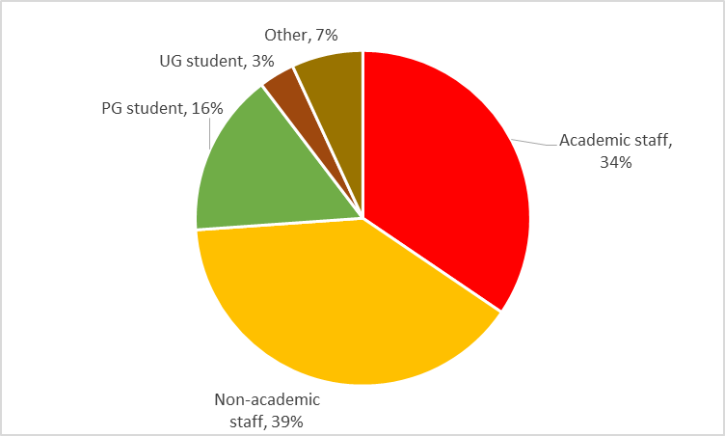

***Delivery participant motivations***

Imperial staff and students were asked why they had taken part in the Festival. The most common reasons were wanting to demonstrate their work internally and externally; wanting to help promote Imperial; and enjoying public engagement.

*I was keen to use the festival to show off a number of student projects to generate interest around the work we do. (Non-academic staff member)*

*To raise the profile of our work among those in the local area, among other members of the public and Imperial staff and students. (Academic staff member)*

*I wanted to help communicate research at Imperial to the public. (Postgraduate student)*

*Because I enjoy telling people about our research and it is fun to think of interactive ways of demonstrating what we do for the general public. (Academic staff member)*

Other reasons were being asked to participate as part of a job and to gain experience in outreach or engagement.

***Understanding of Festival aims***

Delivery participants’ descriptions of the aims of Imperial Festival can be categorised in order of significance as: showcasing and promoting Imperial and its research to the public; enthusing and informing young people about STEM subjects and opportunities; and generally engaging the public with science and engineering.

*To engage with the public, particularly getting children interested in science and engineering. (Academic staff member)*

*In my opinion the main aims are: encouraging children to study science, showing some of the research projects and achievements within the Imperial Faculties, engaging the public in research. (Postgraduate student)*

*To showcase Imperial's latest research and get people of all ages, especially young people, interested in all aspects of science. (Non-academic staff member)*

A minority of Imperial staff and students described the Festival as aiming to target specific adult audiences in the form of alumni and existing or potential funders and sponsors.

***Prior public engagement experience***

137 delivery participants reported their experience in public engagement prior to the 2014 Imperial Festival. 38% (52) had taken part in previous Imperial Festivals, which was the most common form of experience, followed by ‘activities at school(s)’ and ‘media activities’, both reported by 27% (37) of respondents. 12% (16) had no previous public engagement experience, including 7 postgraduate students and 6 members of academic staff. The most common ‘other science festival’ was Cheltenham, mentioned by 8 respondents. The most common descriptions of ‘Other’ activities were social media and blogging and one-off outreach events.

**Public engagement experience n=137**

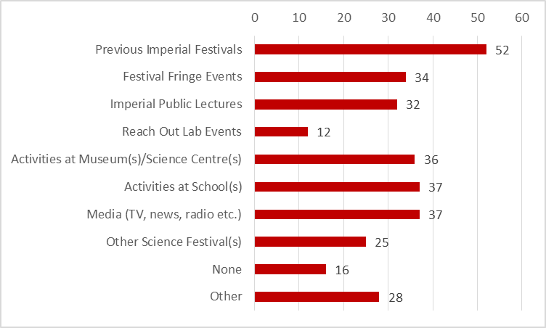

Three-quarters of all those who had taken part in previous Imperial Festivals had also undertaken other forms of out-reach or public engagement, most commonly Imperial Fringe events. Half of those who had taken part in previous Imperial Festivals were non-academic staff.

## Participants’ experiences at Imperial Festival

***Activities visited***

318 visitor respondents selected activities that they had done or seen at the Festival. The most common answer given by 87% (275) was ‘Visited the Research Zone marquee’. The 33 respondents who answered ‘Other’ included alumni who described activities that were part of the Alumni Reunion, such as decade lunches and visiting the alumni visitor centre. Non-alumni described a variety of ‘Other’ activities including visits to food stalls, the Light Zone, Talkaoke and non-robotics activities in the same location as the Robot Zone.

**Visitor experience of Festival activities (n=318)**

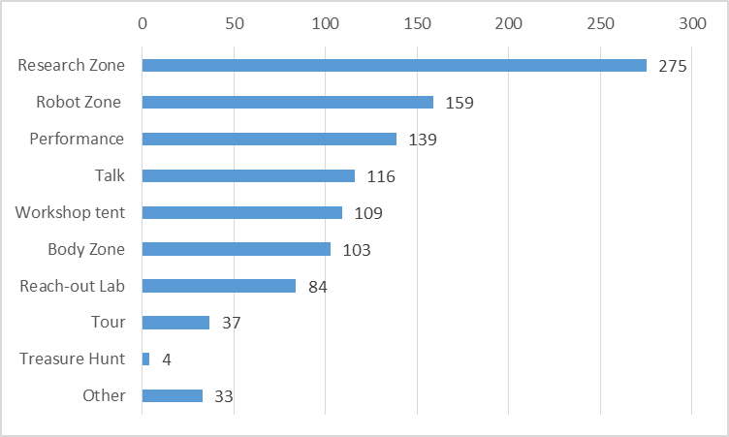

***Activities delivered***

Delivery participants were asked to select their primary activity at the festival. As shown overleaf, 45% (92) had taken part in activities in the Research Zone marquee. Of these, 55% (51) were academic staff members, 24% (22) were non-academic staff and 19% (18) were post-graduate students.

Most of the participants who selected ‘Other’ were involved in activities that were outside the Zones specified in the survey e.g. in the SAF building, Light Zone, or Activity Tent or busking.

73% of those who selected ‘Festival Volunteer’ were non-academic staff members.

**Involvement in delivery of Festival activities (n=203)**

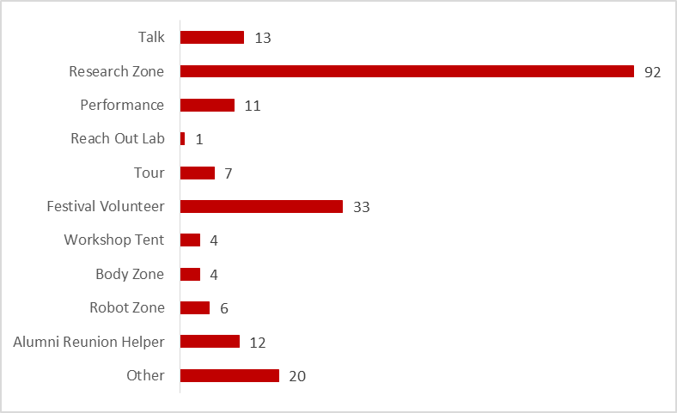

# How did participants rate Imperial Festival 2014?

This section reports visitors’ and delivery participants’ overall ratings of the Festival. It then examines the opinions of visitors and delivery participants about communication in relation to the Festival.

## Overall ratings

321 visitors rated their overall opinion of Imperial Festival. They rated it highly, with 91% (170) selecting ‘Excellent’ or ‘Good’. 4 respondents who rated it ‘Poor’ were two members of the public and two current members of Imperial staff. None of these respondents explained their ratings. Alumni ratings were similar to the whole cohort, with 52%, 39% and 9% rating it as ‘Excellent’, ‘Good’ and ‘Average’ respectively.

Those involved in delivery also rated the Festival highly, with 96% (195) reporting their experience as ‘Excellent’ or ‘Good’. Five of the respondents who selected ‘Average’ expected their specific activity or the Friday night to have been busier.

**Overall ratings of Imperial festival 2014 (n=203 and 321)**

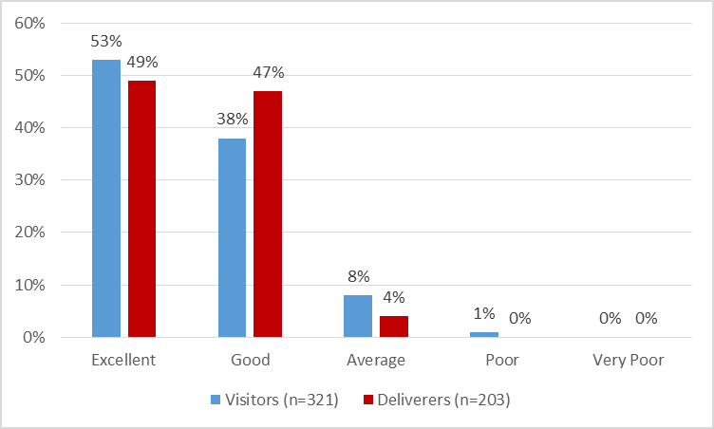

Visitors attributed their positive opinions to the wide variety and accessible nature of the activities.

*It's really good, it's really nice to see such a variety of science. I was really pleased that there's lots of people and that people are actually interested in science. And I like it how there's stuff for the kids as well. It seems pitched a fairly accessible level. (Adult visitor with no Imperial affiliation)*

*It's very impressive. It’s very interesting, I expected it to be a lot smaller because I've never been before, but it's very, very good. It's really easy to get around. I love all the food stalls, I didn't expect all that, that's good. Some of it's very complicated stuff and they've managed to explain it very well really. (Secondary school student)*

*I think it was excellent, very interesting. All sorts of things to do and see and think about. The variety is really good actually. (Imperial alumnus)*

Visitors and those involved in delivery of the Festival mentioned the atmosphere and scale of the Festival as contributing factors, in terms of both visitor numbers and the number of activities.

*Great fun atmosphere, lots of people. I like the layout, I like you've got some food going on and other bits and pieces. It really feels like a Festival. (Adult visitor with no Imperial affiliation)*

*I am surprised how big it is and that there’s food and music and other stuff. It feels more like a Festival than I suppose I expected. (Imperial undergraduate student visitor)*

*Busy! A good atmosphere with lots of people interested in learning more about what happens at the college. (Postgraduate student)*

*Brilliant atmosphere. Lots of footfall. (Academic staff member)*

*I loved the atmosphere especially the arts and quirky side of the Festival. The staff and huge numbers of public seemed to enjoy being there. (Non-academic staff member)*

Deliverers also attributed their positive opinions to the high levels of interest shown by a wide range of visitors.

*There were many people interested in our work. Our stand had been busy all the time when the PhD students were there. They enjoyed talking to the people from young to elderly. (Non-academic staff member)*

*I really enjoyed talking to such a range of different people (both young and old, people who work in science and others who do not), and working out how best to 'pitch' our research. (Postgraduate student)*

*I had a good time, but more importantly the visitors responded very well to our demonstrations, and asked lots of questions. (Academic staff member)*

These positive opinions were echoed in visitors’ comments on the Festival graffiti wall and general comments made in visitor interviews and survey comments.

*It was truly a great event – well done EVERYONE involved’. (Adult visitor with no Imperial affiliation)*

*The Festival made me very proud to have attended Imperial College and sorry not to have returned in the last 30 years. (Imperial Alumnus)*

## Visitor opinions: communication

Visitors were asked to rate the Festival information and navigation and their interactions with Imperial staff and students.

***Information and navigation***

Respondents age 12 or over rated the Festival’s printed programme highly. 87% (260) reported that they thought it was ‘Excellent’ or ‘Good’. 7 current Imperial students, 4 alumni, 2 secondary school students and 1 member of Court rated the programme as ‘Average’. The respondents who selected ‘Did not use’ were 8 alumni, 6 adult members of the public, 6 current students, 4 staff and 2 secondary school students.

**Printed Programme (n=299)**

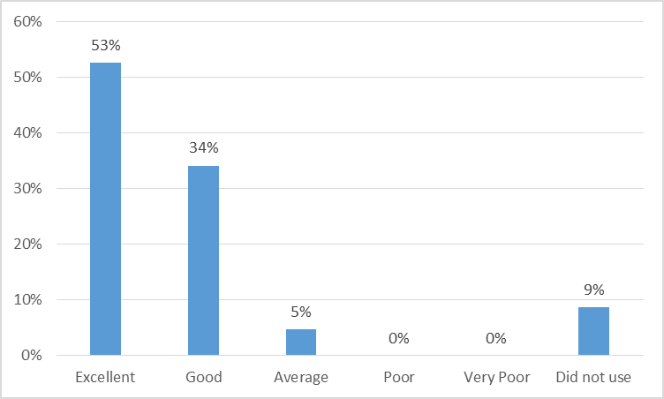

In interview, visitors highlighted the importance of having volunteers in addition to the programme in order to answer specific questions about event timings and locations.

*The programme is good in an “at a glance” way, but you still need to have people to ask. (Adult visitor with no Imperial affiliation)*

*The programme gives a good overview, but to be honest we’ve just asked people in t-shirts if we needed to find something. (Imperial alumnus)*

Visitors who had booked or tried to book tours reported that information about the booking process and number restrictions needs to be made clearer in the programme.

*We tried to book a tour but were too late. We had to find where to sign up and it was obvious that some people had signed-up before the [published] time. The programme needs to be clearer about this. (Adult visitor with no Imperial affiliation)*

*One thing the programme didn’t help us with was the tour. We did get on one, but not the one we wanted because we all wanted to go on the flight simulator and only found out this wouldn’t be possible when we went to sign up. (Adult visitor with no Imperial affiliation)*

A few interview subjects had downloaded the Imperial Festival app, but all of these reported that they were also using the printed programme to find out timings and locations.

Most respondents age over 12 indicated that it was easy to navigate the Festival. 80% (240) selected ‘Very easy’ or ‘Easy’. Over half of those who selected ‘Average’ were alumni or current students or staff. The respondents who selected ‘Difficult’ were 8 alumni and 4 current students.

**Ease of finding way around the Festival (n=300)**

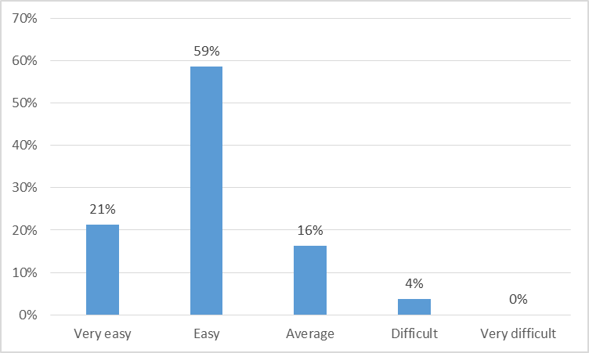

Interview feedback confirmed these findings, although there were some suggestions to have a central information hub and clearer location signage.

*There needs to be a central information point and more people walking about saying, "Over here we've got this, over here we've got that. This is very interesting, this'll be starting in half an hour's time" or whatever. A little bit more guidance. (Secondary school student)*

*For this number of people, you could do with an information desk at the centre of the Festival and some screens saying what is about to happen and where. (Adult visitor with no Imperial affiliation)*

*More obvious signs would be helpful when looking for particular venues that are not part of the main marquee. (Imperial alumnus)*

***Interactions***

Visitors reported that Imperial staff and students provided clear explanations about their work with 86% (253) selecting ‘Very clear’ or ‘Clear’. Two respondents who selected ‘Unclear’ were members of the public who rated the Festival as ‘Average’ and gave no further explanations for their ratings.

**Clarity of Imperial staff’ and students’ explanations about their work (n=294)**

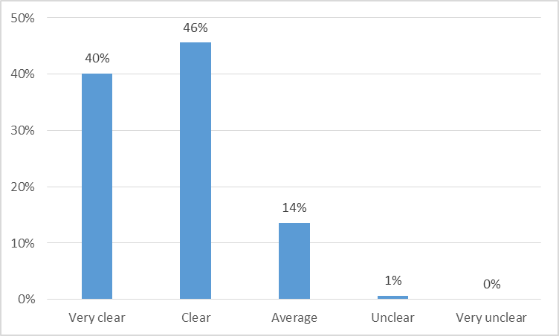

A majority of visitors also rated highly the way in which Imperial staff and students listened and responded to them. 93% (269) rated this aspect of the Festival as ‘Excellent’ or ‘Good’. The two respondents who rated this aspect as ‘Poor’ were current Imperial students.

**Listening and response of Imperial staff and students (n=289)**

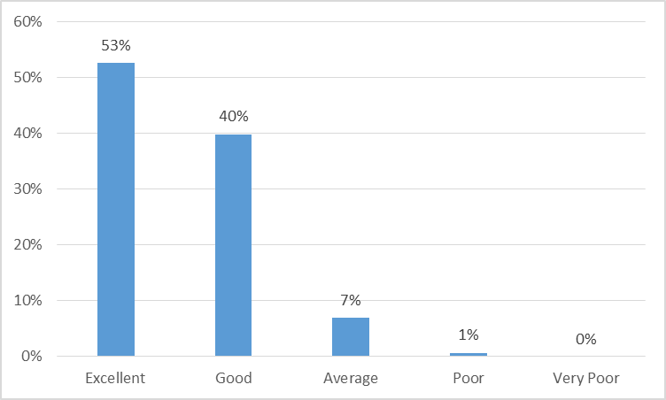

Visitor interviews and survey comments reflected these positive opinions about interaction and highlighted the quality of the engagement and the way in which staff and students adapted their approach for different audiences and age groups.

*I really liked talking to the scientists and doing stuff with them. They were awesome. (Visitor age under 12)*

*They seem so enthusiastic about it and make everything quite simple to understand. (Adult visitor with no Imperial affiliation)*

*The ones we've chatted to have been great, really enthusiastic about their subjects and willing to answer even stupid questions I can come up with. They were excellent and very interesting. (Imperial alumnus))*

*It is really enjoyable actually. Everyone is just really excited to talk about what they do. Everyone was really approachable to talk to and has some really interesting displays and ground breaking technology and I could feel part of the progress that was being made. (Secondary school student)*

## Delivery participants opinions: communication

78% (124) of delivery participants reported that they ‘strongly agreed’ or ‘agreed’ that they were well briefed before the Festival. Two respondents who ‘strongly disagreed’ that they were well briefed were involved in the Alumni Reunion. Twelve respondents who ‘disagreed’ included two individuals who were involved in presenting talks, six who took part in stands in the Research Zone and four Festival Volunteers.

**Briefing about the Festival (n=159)**

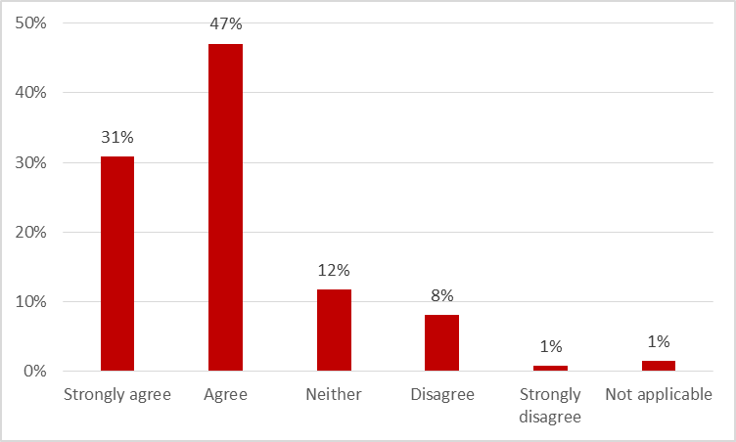

Delivery participant interviews suggested that exhibitors’ concerns about briefings were mainly due to uncertainty about specific timings and facilities such as furniture and power supplies. Volunteers stressed the need for face-to-face briefings and more details about the tours and talks in particular.

*In the run up to the Festival we were quite confused about what days we needed to be there. We’d heard it was Thursday, Friday and Saturday, and then it turns out it was only Friday and Saturday, even then it wasn’t all Friday afternoon and evening. There was a lot of confusion about that in our team, and I think perhaps the all that is needed is for the information from the Festival organisers to be a bit more standardised so you’d know exactly what you’re there for and the hours required. (Non-academic staff member)*

*I suppose the build-up was a little bit chaotic. It was only probably the week before that we knew from the organisers we were definitely doing it, which was less than ideal. It didn’t make that much difference in terms of the hardware, but it meant that our internal publicity suffered as a result. Also there wasn’t enough power in the marquee. In part it was because everyone’s demo was a little bit bigger than they thought it was. (Academic staff member)*

*On the day we turned up at the tent and nothing was laid out, we didn’t know which section of the tent we would be in, or all those kinds of things, which tables were for us etc. So that was a bit challenging - organising and finding people to talk to. (Academic staff member)*

*I think it did say please book [tours] beforehand on the brochure, but I don't think people were aware how far in advance they needed to book. Some people would come with two kids so there were four people and there were not enough spaces for them all and when we told them there was only 15 spaces on that tour they were really shocked. (Non-academic staff member)*

*There were a few people who'd come late and they were saying "Oh I've just missed the beginning, I'm really sorry, could I catch up with the tour?" And because we didn't know whereabouts they'd gone with the tours we couldn't advise them and that was quite frustrating. (Non-academic staff member)*

Exhibitors’ interviews also highlighted the need for specific briefing information about dealing with large numbers of visitors and diverse audiences.

*Very specifically, it would have been useful to have some guidance or a suggestion to create a flyer or a hand out to give people and help cope with large numbers. We had a limited number of promotional materials, I think if we’d thought about it more in advance would have had flyers to give out to people which would also have been a nice way to finish your conversation. (Academic staff member)*

*On Saturday I don’t think we expected for it to be that busy, it was absolutely crazy and we did not have enough people on our stand at all to cope with the numbers of people coming through. It is a good thing that we had that many visitors, but it’s just a shame that there weren’t more people that could speak to all the visitors to help push the message through of what we’ve done through our research. (Non-academic staff member)*

# What were the impacts of Imperial Festival 2014?

This sections examines the impacts on visitors, followed by the impacts on delivery participants.

## Visitor impacts

***Understanding about Imperial***

The Festival had a positive impact on most visitors’ understanding of the work carried out at Imperial, with 82% (238) reporting that it increased their understanding ‘a lot’ or ‘somewhat’. The respondents who reported that the Festival had ‘Not increased my understanding at all’ were 6 adult members of the public, 2 secondary school students and 1 alumnus. The secondary school students and 3 adult members of the public explained that they wanted more information about studying at Imperial or STEM careers and opportunities generally. 3 members of the public said they wanted to see more content targeted at scientists or older children.

**Understanding of work carried out at Imperial? (n=290)**

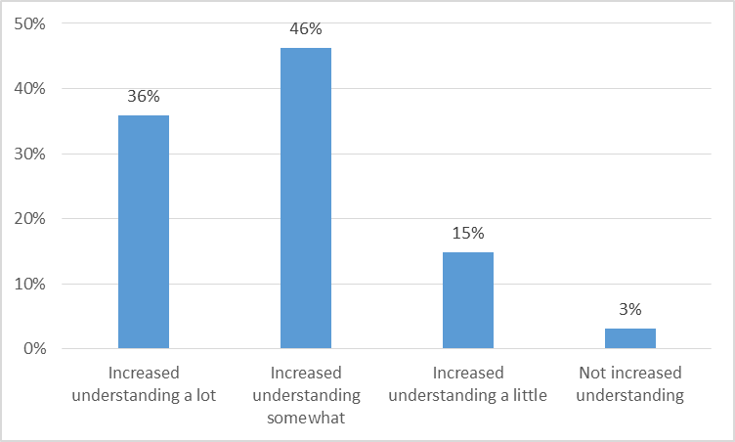

***Learning***

89% (256) of visitor respondents age 12 or over indicated that they learnt something new at the Festival. The respondents who reported that they had not learnt anything covered all visitor categories. Most of these gave the Festival an overall rating of ‘Average’.

**Visitors’ learning at Imperial Festival? (n=291)**

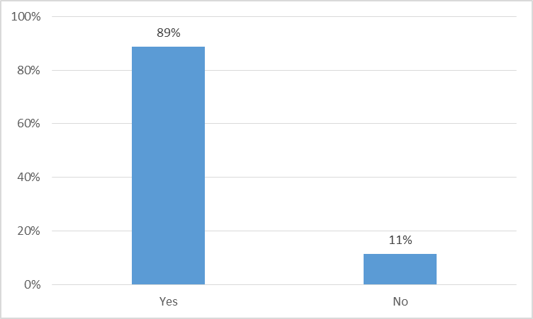

All visitors age under 12 and over half of visitor survey respondents age 12 or over described examples of something they had learnt at the festival, with a number citing a number of different topics or subjects.

*I learned how to make mucus and atoms from marshmallows and how the bicycle thing works. (Visitor age under 12)*

*So much! Lots about my body and how it works. Plus some quantum physics! (Academic staff member)*

*So much that was completely outside my field of interest, but in particular the use of bubbles for separating materials really stood out (RSM in the main marquee). I also very much enjoyed the talk on "Spanish Flu to Swine Flu" and the debate on "playing with perceptions of science" - both were very thought-provoking. (Imperial alumnus)*

*Loads of things! Two examples: learned about how students were making a helmet to help blind ski athletes, and how traces in a person's urine can be early stage indicators for other diseases such as diabetes! (Imperial student)*

*My children (9 & 7) learned how Hydrogen could be used to power a fan and then later how it was used to power a band's electrical equipment. They were also fascinated by the ability of a person to control a wheelchair with eye movement. They saw how robotics could be used in surgery. And lots more! (Adult visitor with no Imperial affiliation)*

***Interest in science***

53% of visitors in all categories reported that the Festival had increased their interest in science. Most members of the public who reported ‘No change’ had previously indicated that they already ‘love’ or ‘like’ science.

**Visitors’ interest in science (n=307)**

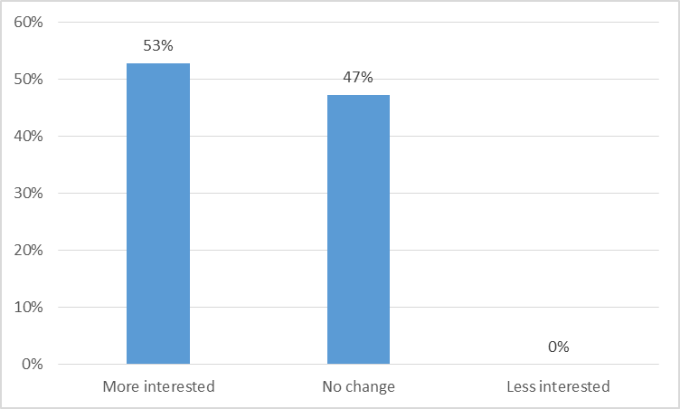

**Intentions**

A majority of visitors reported positive intentions, with 85% (248) saying they would come to an event like the Festival in the future and 92% (271) indicating that they would recommend the Festival to someone else, reinforcing the fact that it was a positive experience and had a positive impact on most visitors.

**Intend to come again or recommend (n=292-295)**

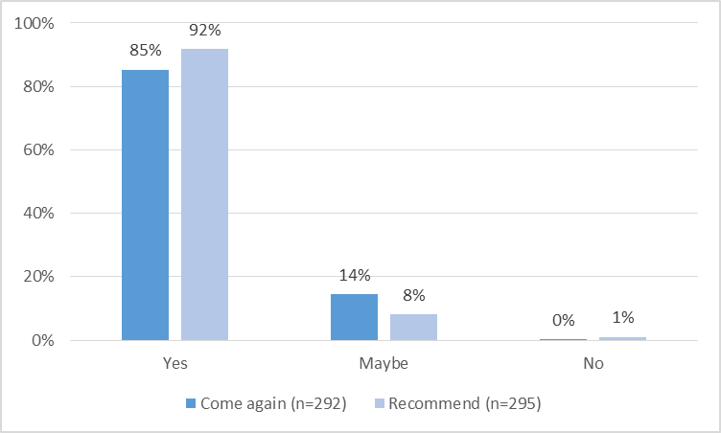

All visitor interview subjects said they would recommend the Festival to families in general and to adults who enjoy or are interested in science.

## Delivery participant impacts

Delivery participants were asked about the Festival’s impacts in relation to their work, if relevant. 50% (71) ‘strongly agreed’ or ‘agreed’ that participating in the Festival had made them think differently about explaining their work to non-specialists and 35% (51) ‘strongly agreed’ or ‘agreed’ that participation had made them think differently about their work.

**Impact on deliverers’ work and explanations (n=141-147)**

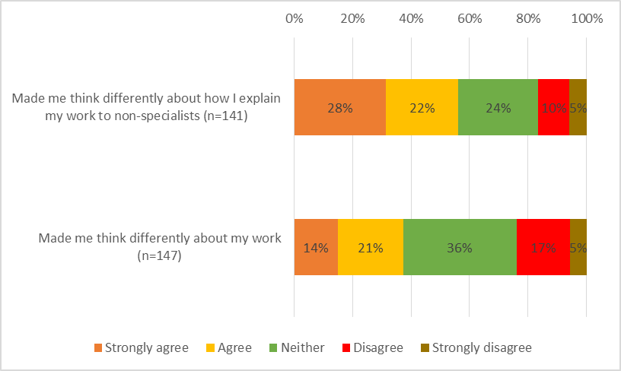

94% (149) of delivery participants ‘strongly agreed’ or ‘agreed’ that they would recommend taking part in the Festival to a colleague or peer. The 5 respondents who ‘disagreed’ or ‘strongly disagreed’ included 3 Alumni Reunion helpers, 2 of these respondents rated the Festival as ‘Excellent’ and ‘Good’.

92% (149) ‘strongly agreed’ or ‘agreed’ that they would recommend taking part in the Festival to a colleague or peer. The 3 respondents who ‘disagreed’ or ‘strongly disagreed’ were Alumni Reunion helpers.

**Deliverers’ future intentions (n=157-159)**

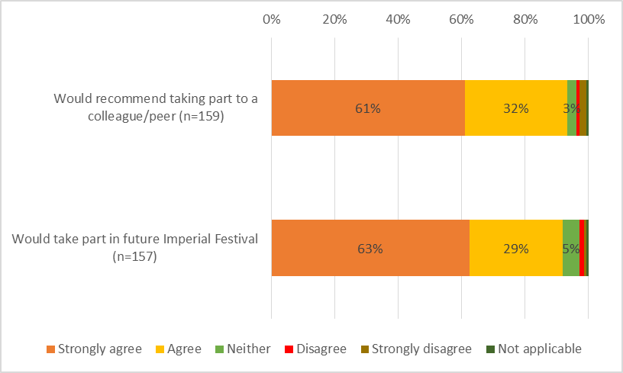

***Opinions of Imperial***

All delivery participants indicated that the Festival had enhanced their opinions of Imperial in some way. The most significant of this type of impact was recognition of a less formal side to Imperial.

*It's made it seem less 'stuffy and academic' to something more 'trendy and cool'. (Postgraduate student)*

*It definitely makes me view Imperial as a place with very well rounded interests (in the arts as well as sciences) and reinforces my view of Imperial as a world-leading research institute in a whole host of different fields. (Non-academic staff member)*

*It showed me that Imperial is quite relaxed, even though its research and student satisfaction is to a very high standard. (Academic staff member)*

Other impacts in this category were a reminder of the range and variety of research carried out by staff and students and increased or renewed awareness of the importance of public engagement.

*Normally we are all working away in our little realm but being reminded of the vast variety of topics and expertise you are part of is always reminding you of why you are here. (Academic staff member)*

*The activities on the day demonstrated just how enormous and varied the work the college undertakes is. (Non-academic staff member)*

*Reminded me that trying to engage the general public and school children with current research is a great idea and invaluable to the next generation. (Postgraduate student)*

***Attitudes to public engagement***

Most delivery participants based at Imperial reported that participating in the Festival had positive impacts in relation to their thinking about public engagement.

*I have a better understanding of the balance between interactivity and education ... also the need for demonstrators to help support that. (Non-academic staff member)*

*We need to do more and get the students (UGs, Masters, PGs) all involved as public engagement is very important to what and why we do science and engineering. (Academic staff member)*

*I was impressed by the extent of the Festival and wasn't really aware previously. Few universities make this effort to interact with public. (Academic staff member)*

*Outreach is not always viewed in a strictly positive light in some quarters and so it is helpful to have a large scale event to demonstrate its value. (Postgraduate student)*

***Miscellaneous impacts***

In interview and survey comments, delivery participants described a variety of other impacts that the Festival had on them. The most common of these was networking among Imperial staff and students

*It was so nice to mix with other staff. It provided us potential opportunities for cross departmental collaboration. (Academic staff member)*

*The Festival gives an insight into the research and activities that take place across the College. It is nice to see this as well as hear about it. (Non-academic staff member)*

*I exchanged contact information with people for potential collaborations. It gave me exposure within the Imperial wider community. (Postgraduate student)*

Other commonly described impacts were increased confidence or learning about how to communicate or explain research; and increased or renewed interest in public engagement.

*I've realised I enjoy outreach work more than I thought I would and I also realised that teaching children complicated science requires a lot of brain power to pitch at the right level. (Postgraduate student)*

*I feel more confident in public engagement, and more certain that it is something which I would like to pursue further. (Academic staff member)*

*I feel more confident in explaining science to non-scientists. I felt I understand my work better. (Non-academic staff member)*

*Has helped me practice easy to use wording to help explain research to the public and made our working team stronger as we all worked together for the festival. (Academic staff member)*

*It made me think about how to be more creative when explaining research. It has given me the opportunity to exercise my public engagement and communication skills. (Postgraduate student)*

Some deliverers reported that taking part in the Festival had encouraged them to develop new materials and resources that could be used in other outreach activities.

A few delivery participants described negative impacts in the form of the amount of time and resources needed to plan and deliver activities over 3 days (including the VIP session on Thursday night).

# What were the success factors of Imperial Festival 2014?

This section summarises feedback from visitors and delivery participants about factors that contributed to the success of Imperial Festival 2014. In order of significance the most important success factors identified by both groups were:

1. Variety of subjects and range of activities
2. Enthusiasm and commitment of delivery participants
3. Number and type of visitors

**Variety of subjects and range of activities**

The range of subjects covered and the inclusion of interactive activities aimed at both children and adults were highlighted here.

*The array of different activities to indulge in that can captivate people of all ages and fields. I found myself enjoying displays about types of science that I had not previously been interested in. (Secondary school student)*

*I think the wide range of activities and research was a huge plus. It was great to see so many things in an afternoon! I really enjoyed it! (Imperial student visitor)*

*The huge variety in the Research Zone and the range of levels. There truly is something for every age and background. (Adult visitor with no Imperial affiliation)*

*The breadth of exhibits on display was very impressive. The diversity of research demonstrated is key to success. (Postgraduate student)*

*The range of exhibition stands and that it was a very interactive event – all ages of people appreciated being able to take part and have a go at different things. (Non-academic staff member)*

*The variety. The effort put in by some of the research teams, incredible creativity and dedication to making it as enjoyable as possible for every member of the family. (Academic staff member)*

**Enthusiasm and commitment of delivery participants**

The engaging approach adopted by staff, students and other presenters plus their ability to adapt activities and presentations to particular audiences were highlighted here.

*All the staff were really nice and accessible to everyone and available to explain everything. There was always a smiling face available. (Adult visitor with no Imperial affiliation)*

*The enthusiasm of staff and the amazing work going on. I brought along a youngster who is doing her GCSEs and she was fired up by the work and presentations. (Imperial alumnus)*

*To see how young scientists are excited to talk about their research. It was interesting for me and the children and their explanations were really enlightening as well as engaging for all of us. Switching from knowledgeable adult to young child is no mean feat. (Adult visitor with no Imperial affiliation)*

*The enthusiasm of everyone involved in organising and activities. This makes it much more fun and rewarding. (Academic staff member)*

*The engagement with visitors was exceptional, this was particularly influenced by the overall enthusiasm of the volunteers at every stall. (Non-academic staff member)*

*Adjusting from small child to alumnus was stimulating and really made you think about your work and how you present it. (Postgraduate student)*

**Number and type of visitors**

Visitors indicated that the high number of visitors, particular on Saturday, and family nature of most visitors created an enjoyable atmosphere. For delivery participants, the atmosphere and interest in their work generated by a large number of visitors were important.

*We just stumbled across it. We are really pleased to see that it is busy and so obviously successful and that there are lots of families here. Excellent all round! (Adult visitor with no Imperial affiliation)*

*The buzz. Much bigger and slicker than last year well done. It is brilliant to see so many kids enjoying themselves and taking part in activities. (Imperial staff visitor)*

*The atmosphere with lots of people felt like a proper Festival. I was surprised as I didn’t expect that. It doesn’t feel like you are learning, but you are really. (Secondary school student)*

*There were a lot more general public visitors than I thought there might be. It is the most important audience at this type of event. (Non-academic staff member)*

*There were a lot of visitors! We had many people come to talk to us and see what we were demonstrating and discuss the research of the department. …it was a great source of leads for further outreach work. (Academic staff member)*

*The publicity must be working – it was so busy. The number of people and how interested they are in your work is very rewarding. (Postgraduate student)*

***Additional success factors***

*Public visitors* highlighted particularly memorable or high quality talks or activities. The most common of these were talks where the presenters had seemed particularly aware of the background knowledge of audience members, e.g. meteorites and cannabis, and activities that balanced being informative with engaging, interactive, innovative tasks for visitors e.g. knitting a blood vessel and snot doctors.

*Alumni visitors* reported meeting other alumni as a success factor. They also welcomed the opportunity to preview the Research Zone when it was less busy.

*Delivery participants* described the quality of the Festival organisation and the motivational impact of participation on Imperial staff and students.

# What was the learning from Imperial Festival 2014?

This section summarises feedback from visitors and delivery participants about lessons and suggestions from Imperial Festival 2014, which could be of use in future years. In order of significance the most important learning points identified by both groups were:

1. Number and distribution of visitors
2. Arrangements for tours
3. Catering options

**Number and distribution of visitors**

The busy nature of some areas, not only when it rained, meant that visitors on Saturday were not always able to see or engage with activities and delivery participants were not able to engage with all the visitors they wanted to. Conversely, visitors and delivery participants indicated that Friday evening was quieter than expected.

*Because of the crowds and layout in the big marquee it was hard to get close enough to see and hear. Maybe opening on Sunday as well as Saturday would help spread the crowds. (Adult visitor with no Imperial affiliation)*

*Even when it wasn’t raining it was difficult to see the most popular stalls. Could you spread things out more into some of the surrounding buildings or area behind the graffiti wall? Maybe opening for longer would help too. (Adult visitor with no Imperial affiliation)*

*It became frustrating when it became too crowded to see or do much. (Imperial alumnus)*

*It was getting to the point where there were too many people at once. Maybe extended opening hours on Saturday would help manage the flow. (Academic staff member)*

*The small marquees were too crowded and not nearly as welcoming as the large marquee. Also Friday was very quiet: why not open earlier on Saturday and end earlier on Friday? (Postgraduate student)*

*From what I saw later on Friday night the outside areas were sparse even though there seemed to be plenty in the Research Zone. Maybe you could close on Friday at 7.00pm and open longer on Saturday. (Non-academic staff member)*

**Arrangements for tours**

Visitors and Festival volunteers found the arrangements for booking and joining tours to be confusing and unsatisfactory. They also suggested that more tours were required to meet visitor demand.

*The tours were quite chaotic and we thought we turned up to book at the right time, but some names were already on the list. Also the people who were signing you up did not seem that well informed about them. (Adult visitor with no Imperial affiliation)*

*The Tours were very popular and we failed to get on any. Trying to sign up I got the impression that the organisation and communication about them could be improved. (Adult visitor with no Imperial affiliation)*

*We did not manage to get to the tour booking desk quickly enough. Could some of the tours be repeated more frequently to accommodate the numbers who are interested? (Imperial alumnus)*

*I think the least successful aspect was not having enough information as a volunteer on the tours. The guide we had did not say where the tours were being held and did not highlight there were limited spaces. (Non-academic staff member)*

*There needs to be more visits and activities inside research buildings. The demand is obviously there. It also would help manage the visitor numbers by distributing them more widely around the campus. (Academic staff member)*

*People were complaining that there were not enough spaces for tours. Perhaps there could be more options to take part in these on Friday for example? (Non-academic staff member)*

**Catering options**

Visitors indicated that they would welcome a hot drinks option and more consistent quality of food. Delivery participants, including those with food vouchers, and visitors were critical of the poor quality and limited nature of some of the catering. The quality of food at the farmers’ market concessions was praised, although several of these vendors ran out or were subject to long queues.

***Additional learning points***

*Public visitors* recommended that the Festival should incorporate activities for schools especially specific activities for secondary school students in order to attract and engage them.

*Alumni visitors* felt that alumni activities could be more specifically targeted to ensure their individual year groups and departments were as well represented as possible.

*Delivery participants* recommended clearer, more visible signage and information about locations and more-detailed, more-specific briefings in advance of the Festival.

# Conclusions

## Conclusions

This evaluation provides evidence that Imperial Festival 2014 was a well organised, highly successful event, which was considerably larger in scale and of a more professional standard than previous years. It also met its stated aims by providing staff and students with a unique opportunity to present their research to public visitors, alumni and other staff and students and undertake outreach and public engagement within a professional environment.

The Festival attracted large numbers of visitors. Visitors and delivery participants indicated that whilst this created a positive, stimulating atmosphere and a sense of pride in staff, students and alumni, consideration should be given as to how the growing visitor numbers can be best managed. Imperial staff and students involved in the delivery of activities expressed concern about extending the duration of the Festival as this would require additional human resources and/or increased time commitments.

The Festival is having positive impacts on all visitors and participants. Members of the public, Court, alumni, staff and students reported high levels of enjoyment; new learning about specific STEM subjects or themes; and increased understanding about Imperial and its work. Members of the public, particularly families, also indicated that the Festival had impacted positively on their general understanding and enjoyment in relation to science.

## Future considerations

Imperial Festival has reached a significant point in its development. Visitor numbers and the number of activities have grown in each of the three years that the Festival has run. Visitors and delivery participants enjoy taking part, and it will be important to maintain those levels of enjoyment in the future. Careful planning and management are required to ensure that visitor and delivery experiences are not compromised by growth.

Consideration can be given about to how to ensure visitors make the most of areas away from the Research Zone marquee, e.g. by having more activities in these areas and larger marquees for workshops and the Light Zone.

The growth in visitor numbers makes it increasingly important to ensure delivery participants are afforded sufficient space for all activities; receive detailed briefing information about the Festival and the nature and size of its audiences; and have access to good quality catering. Time and resource demands on participating Imperial staff and students are not insignificant and it may be possible to involve greater numbers of Imperial support staff and students to ensure these demands do not become too onerous.

Visitor numbers are higher on Saturday than Friday and there is visitor demand for longer opening hours at the weekend. This needs to be balanced against the time demands on staff and students and the time required for alumni previews. It may be possible to consider opening for less time on Friday and longer on Saturday, or otherwise maximising the opportunity provided by Friday night, e.g. by using part of the evening for VIP visitors.

There is demand to expand activities for school students of all ages. Working with teachers and Imperial outreach teams should ensure that these activities are relevant and well-targeted, as well as fully-integrated in the Festival programme. Consideration needs to be given as to the likelihood of attracting large numbers of secondary school students at a time when many are busy with exams.

As the Festival grows, it will be important to maintain quality of activities and to ensure participants are well briefed about engaging the large numbers and different types of visitors.

The arrangements for tours would be enhanced if more tours and/or spaces were available; volunteers involved in sign-up have more detailed briefings, including tour routes; sign-up times are enforced; and descriptions in the programme include number limits and fuller descriptions about the nature of the tours and all constraints.

In future, the evaluation of the Festival could place a greater emphasis on impacts, as many of the operational challenges identified in 2013 have been addressed. This should include internal impacts such as impacts on research and teaching and, now there have been three Festivals could include a longitudinal study of these impacts. It will also be necessary to develop an evaluation plan and tools for use with schools, if these are to become a more significant audience for the Festival.