**MUSE-SGI Non-Technical Overview**

**Power Sector Module**

# Context

The power sector has a significant role to play in the future decarbonisation. In fact, electricity consumption accounts for about 30% to 50% of final energy consumption in most countries [1].

In order to meet the binding environmental targets on a global scale, the power system has to face a challenging technological transition [2]. The role of fossil fuels in the power sector needs to be integrated with emerging and novel technologies capable of delivering a low-carbon energy system. The increasing share of variable renewable energy, market liberalization, and the advances on power storage, all together make the power system planning and operation more complex. Alongside the technology uptake, changes in policy frameworks related to the power sector largely affect the entire energy system.

# Problem Statement

Within the MUSE modelling environment, the power sector module, PSM, is designed to simulate real decision-making in power generation investments and operations in response to the change in fuel and carbon prices as well as electricity demand on a global scale. Given the electricity demand profile, fuel and carbon prices, the PSM must generate electricity prices, total system costs, fuel demands as well as greenhouse gas emissions associated to power generation on a global scale, disaggregated into regions and temporally resolved into timeslices. Furthermore, the module must produce indicators such as capacity margin and loss of load with the same temporal and geographical resolution. The PSM module needs to be bottom-up and technology-rich to assess effects of changes in technology performance and policies.

# Module Approach

The PSM is based on a two-step simulation approach to model electricity system planning and operating decisions as close as possible to real investors' behaviour in the market.

A merit-order approach based on Short Run Marginal Cost (SRMC) is used for the modelled regions composed of developed countries. Power plants dispatch follows the rule ‘low SRMC comes first’; as such, electricity demand is served first from generators operating at lower costs and then from the more expensive ones until demand is fulfilled. The market strike price is determined at the balance point between demand and supply and is used to calculate the generator profitability in terms of annual cash flow. The decision on investment in new plants is only made on profitable generators, which have a positive annual cash flow.

For the modelled regions where an actual electricity market is not present, the PSM replicates the same approach using a different metric, which is the plant levelized electricity cost (LCOE). The generators dispatch order is built from low to high LCOE until the electricity demand is met.

# Relationship with MUSE Modules

The PSM module dynamically exchanges a set of variables with the Market Clearing Algorithm (MCA) in MUSE to determine the electricity price in every modelled region per time period and timeslice. A snapshot of the data workflow for a generic iteration in a generic time period, timeslice and region is shown in Figure 1.

The module uploads exogenous parameters for the techno-economic and environmental characterisation of each generator type per region. The full data exchange protocol between the PSM and the next modules in MUSE is detailed in Table 1.

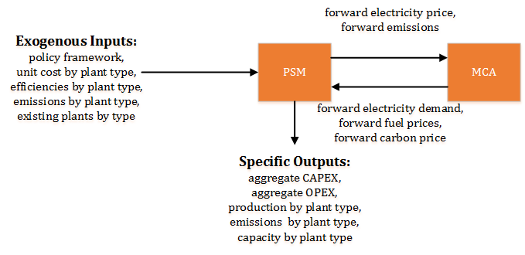

Figure 1: Major interactions between PSM and the rest of MUSE

Table 1: Description of the data exchange protocol for the PSM.

|  |  |
| --- | --- |
| PSM Key Inputs | PSM Key Outputs |
| MUSE core dynamic variables   * Forward electricity demand for each time period with timeslice disaggregation (PJ/year) * Forward fuel price for each time period with timeslice disaggregation (MUSD2010/PJ) * Forward carbon price (MUSD2010/GtCO2)   PSM-specific input parameters   * Techno-economic characterisation (conversion efficiency, unit investment and operating costs) of each generation plant by technology type in each time period and region * Existing generation plants for the model base year by technology type, including their retirement profile * Policy framework and fiscal regimes | **MUSE core dynamic variables**   * Forward electricity price for each time period, region and timeslice (MUSD2010/PJ) * Forward emissions for each time period, region and timeslice (GtCO2/year) * Forward electricity generation for each time period, region and timeslice (PJ/year)   **PSM-specific outputs**   * Power generation investment and retirement in capacity terms by time period, technology type and region * Aggregate CAPEX and OPEX by time period, timeslice and region * Power generation operation details (e.g. activity, energy consumption and emissions) by time slice, technology type and region |

# References

1. IEA World Energy Statistics and Balances. International Energy Agency, 2016.
2. Electricity Information. International Energy Agency, 2015.