MUSE-SGI Non-Technical Overview
Biorefinery and Refinery Sector Module

Context
As it provides fuels and petrochemicals for every sector of the economy, the refinery sector presents extremely complex interlinks across the whole energy system. Refineries are one of the world’s most energy-intensive industries, accounting for about 8 % of delivered industrial energy consumption in OECD countries and about 6 % of delivered industrial energy consumption in non-OECD [1]. Worldwide, petroleum and other liquid fuels are the dominant source of transportation energy with a share of 96 % in 2012 where a further growth of the world transportation sector liquid fuels consumption is expected [2].

The increasing need for fuels and petrochemicals as well as stricter GHG emissions cuts, urge this sector to a dramatic technological change and innovation. On the one side, the refining industry needs to keep pace with the increasing demand through new investments. On the other side, it needs to adjust not only to economic factors but also to the changes in the regulation framework. In fact, stricter limits to GHG emissions as well as energy security concerns are calling for technological innovation in the production of fuels and chemicals from renewable sources through advanced biorefineries [1].

Problem Statement
Within the MUSE modelling environment, the biorefinery and refinery sector module, BRSM, is designed to model the production and marketing of fuels, including petroleum and non-petroleum products as well as commodities obtained from renewable sources. The purpose of the BRSM is to project fuel prices, production levels based on primary energy prices, process technologies, energy policies and regulations according to the market demands, disaggregated into regions and temporally resolved into timeslices. In addition, the BRMS estimates the capacity expansion required to meet the demand, considering the decommissioning profile of the existing stock and simulated real-time decision-making of the asset operation as well as the consumption of primary energy. In doing so, the BRSM is designed to simulate real decision-making and uses a bottom-up approach to assess the characteristics of different refining and biorefining processes, and capturing effects of changes in technology performance and policies.

Module Approach
The BRSM is based on a two-step simulation approach to model investment decisions and operating strategies and represent real investors' behaviour in the market. A merit-order approach based on net present value (NPV) is used.
The production of fuels is carried out based on the rule highest NPV comes first’; as such, the demand is first covered by the processes with the highest profit and then from the less profitable ones until demand is fulfilled. Based on the mix of technologies used, the required amount of primary energy is determined.
The market strike price is determined at the balance point between demand and supply. Prices projections of fuels are determined from the technology mix and primary energy sources used to meet demand. The decision on investment in new refineries is only made on technologies that are expected to garner sufficient revenue to support their capital and operating requirements.

Relationship with MUSE Modules
The BRSM module dynamically exchanges a set of variables with the Market Clearing Algorithm (MCA) in MUSE to determine the price in every modelled region per time period and timeslice. A snapshot of the data workflow for a generic iteration in a generic time period, timeslice and region is shown in Figure 1. The module uploads exogenous parameters for the techno-economic and environmental characterisation of each process type per region in the base year as well as projected improvements in the next simulation periods. The full data exchange protocol between the BRSM and the next modules in MUSE is detailed in Table 1.

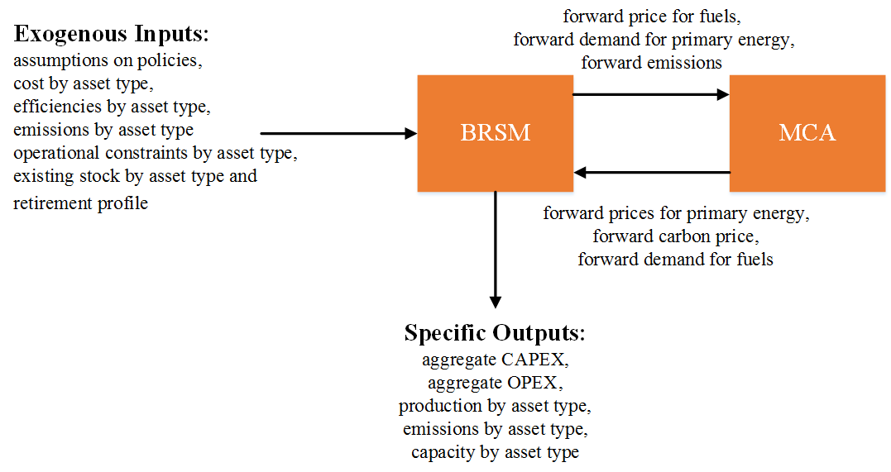
Figure 1: Major interactions between BRSM and the rest of MUSE

Table 1: Description of the data exchange protocol for the BRSM.
BRSM Key Inputs | BRSM Key Outputs
MUSE core dynamic variables  - Forward fuel demand for each time period with timeslice disaggregation (PJ/year)  - Forward primary energy price for each time period with timeslice disaggregation (MUSD₂₀₁₀/PJ)  - Forward carbon price (MUSD₂₀₁₀/GtCO₂)  BRSM-specific input parameters  - Techno-economic and environmental characterisation (conversion efficiency, unit investment and operating costs, GHG emissions and F-gases) of each refinery process by asset type in each time period and region  - Existing refineries for the model base year by asset type, including their retirement profile  - Policy framework and fiscal regimes | MUSE core dynamic variables  - Forward supply curve for fuels for each time period, region and timeslice (MUSD₂₀₁₀/PJ)  - Forward emissions for each time period, region and timeslice (GtCO₂/year)  - Forward primary energy demand for each time period, region and timeslice (PJ/year)  BRSM-specific outputs  - Investment and retirement in capacity terms by time period, technology type and region  - Aggregate CAPEX and OPEX by time period, timeslice and region  - Refinery operation details (e.g. activity, energy consumption and emissions) by time slice, asset type and region

References
- IEA World Energy Statistics and Balances. International Energy Agency, 2016.
- IEA International Energy outlook 2016. International Energy Agency, 2016.

