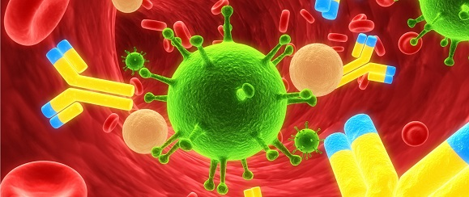
Department of Medicine
Centre for Immunology and Vaccinology

Sort Application Form

The Sort Application form must be completed and submitted to Parisa Amjadi prior to booking. This from provides essential information to ensure correct setup and allocation of appropriate amount of time.
---------------------------------------------------------------------------------------------------------------------------

Name:
Email:
Phone:

Institution/Department:

Supervisor’s name:

Brief description of the project:

Please list all fluorochromes or dyes used for your experiment:

Sort’s detail:

In order to allocate enough time for your sort, please provide the following information:

Please be aware that you should allow extra time if you have more than one sample to sort or if you need to collect your cells into more than one collection tube. After stopping a sort the sort collection chamber must remain closed for 10 minutes to ensure that aerosols have safely settled.

Frequency (%) of target cells needs to be sorted
(Please attach a FACS plot showing the actual % of cells from FSC/SSC gate)

Number of sorted cells required:

Total number of cells per sample:

Number of samples to sort:

Cell type:
(To have the right nozzle and pressure setting ready before your arrival for sorting)

State if you require: (check all that apply)

Sterile sort
Room temperature
Cold sort at 4 C

Sort Collection Device: check all that apply

15ml tubes
5 ml FACS tubes:
Two-way sort Four-way sort

1.5 ml Eppendorfs:
Two-way sort Four-way sort

Multi-well Plates:
384 wells 96 wells 24 wells 12 wells 6 wells

Do the collection media or samples contain any potentially hazardous reagents (e.g. toxins or carcinogens)?
Yes No
If yes, please provide details: (a copy of COSHH risk assessment form is required for hazardous reagents)

Additional information:

