
MDU
Molecular Diagnostics Unit
Imperial College London
Jefferiss Trust Laboratory, St Mary's Campus, Norfolk Place
London W2 1PG
Tel. +44 (0) 207 5943 917

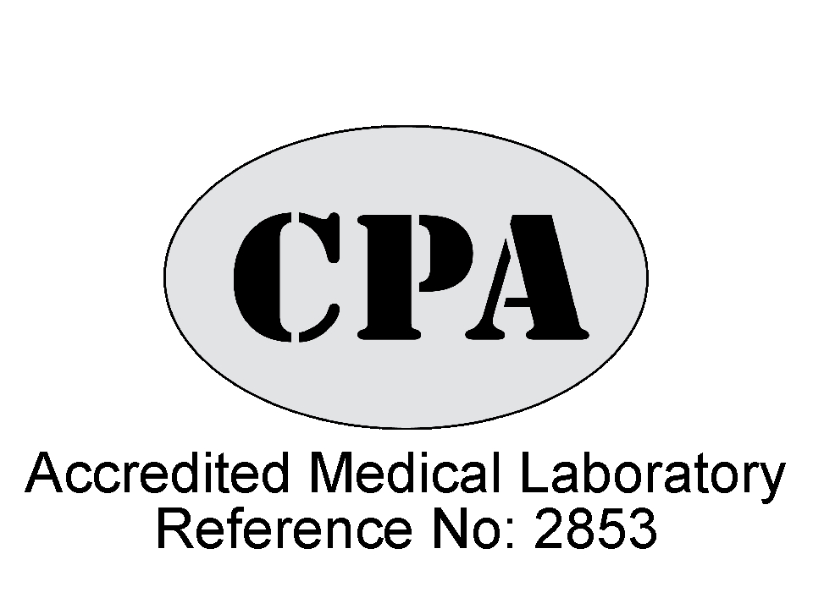

HLA-B*5701 SCREENING REQUEST FORM
Please send 1 x 4.5ml EDTA Vacutainer to: Steve Kaye, Molecular Diagnostics Unit, 4th floor Medical School Building, St. Mary’s Hospital, Norfolk Place, London W2 1PG.
The laboratory closes at 5pm, if delivery cannot be guaranteed by this time samples can be kept in the refrigerator for up to 3 days. Please ensure samples are packaged in accordance with the safety requirements of the courier or Royal Mail. The DX address is: DX6630607 PADDINGTON 91W

Request from/report to: Doctor_____________________________________

Centre/Clinic________________________________

Address____________________________________

____________________________________

Tel___________________email_________________
Patient details (sticker)

Clinic number_________________________ Probable country of infection___________

Date of birth_________________________ Sample date________________________

