
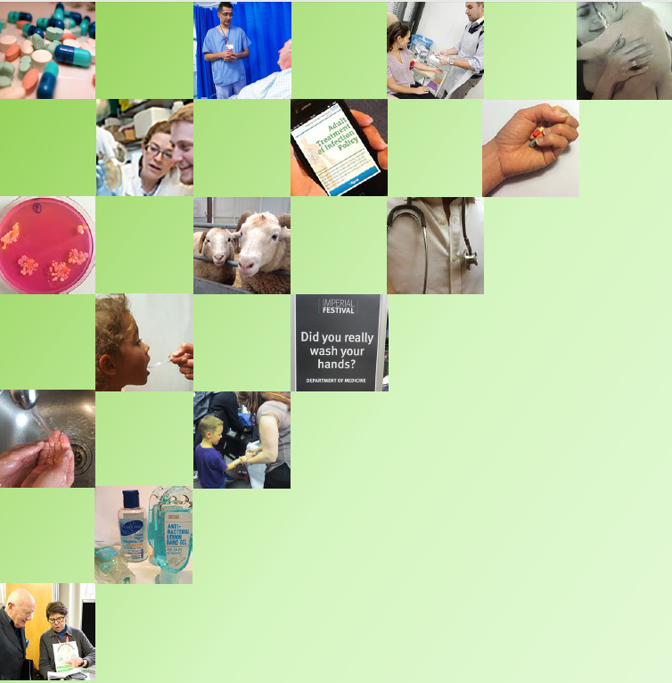
Health Protection Research Unit in Healthcare Associated Infections & Antimicrobial Resistance

Patient and Public Engagement Activity Pack
Antimicrobial Resistance: Play Your Cards Right

Antimicrobial Resistance: Play Your Cards Right
This pack is designed as a free guide, with printable resources, to allow you to run your own engagement activity about antimicrobial resistance.
The activity aims to educate participants about antibiotic resistance and the consequences that might arise due to an increase in resistant bacteria, in a fun “game show” style format.
Antibiotic resistance has serious implications at individual as well as global levels that the participants might not be aware of. This activity will highlight these.

Crediting the HPRU in HCAI and AMR at Imperial College.
We would be delighted to hear from you if you choose to use our resources. Please do contact us at head.ops@imperial.ac.uk and tweet pictures of the activity and tag us: @HPRUamr

Artwork by welovesolo.com under Creative Commons (Attribution 3.0)

Activity Objectives
The objective of the activity is to teach participants the dangers of antibiotic resistance in a fun, “game show” style format. The activity is ideally suited for a Science Fayre or Festival, or other public engagement event.
By the end of the activity:
- All participants should understand that antibacterial resistance is a huge global threat
- All participants should understand that antibiotics should only be taken if necessary

Background Information
Antibiotics are used to treat infections caused by bacteria. They also underpin much of modern medicine from routine surgery to cancer treatment.
If used too often or incorrectly then bacteria can develop (evolve) ways to avoid being killed by antibiotics. This is called resistance. Drug Resistant bacteria are harder to kill than non-resistant bacteria. If bacteria become resistant to several different types of antibiotics, this is called multi-drug resistance and can eventually become impossible to treat.

Activity Preparation
You will need:
- A background on which to display your cards – e.g. poster-boards, a wall, shelves, table
- Blutac/drawing pins/Velcro dots to fix the cards to the background if it is a vertical surface
- Play your cards right laminated cards (See printable resources at the end of this document)
Optional
- “Voting” double sided fluorescent cards for participants if played as a group game
- Accessories such as fairground lights /Bruce Forsythe masks

Activity Description
This activity is based on the game show “play your cards right”.
It can be played either with a single participant or as a group activity.
There are 4 categories with several questions in each category.
The question is set out on a “card”.
Four cards, containing possible answers are laid out, face down, in ascending order.
Participants pick a card, which is then turned over to reveal an answer.
Participants are asked whether they would like to stick with their answer or choose a higher card or a lower card.
In a group activity the decision to go higher or lower can be done by “voting” with a show of hands or voting cards (or shouting “higher” and “lower”).
Once the individual or group has decided they are happy with an answer, the question card is turned over to reveal the correct answer.
The process can then be repeated with a different question/category.
Activity set-up.
There are a lot of cards in this game!
You do not need to use all the cards, or even all the categories. This can be tailored to the issues you wish to highlight, or to the space available. However, for the game to work, the cards must be set up correctly.
The resources below are designed to be printed double sided and laminated.
The picture on the back of the cards indicates the category, each of which attempts to tackle a different aspect of the nature or impact of antimicrobial resistance. The categories are:
- “A Global Problem”
- “A Natural Phenomenon”
- “The Causes of AMR”
- “What can I do about AMR”
To make set-up easier the printable cards are marked with a coloured square in the bottom right-hand corner. This indicates which sets of answers go with which question.
The square also contains a number 1-4 to indicate the order in which cards are to be placed left to right, so that the answers are also ascending.

To set up the game correctly
- Choose the categories and questions you wish to use
- Display/layout the question card followed by the possible answer cards for that question (as indicated by the coloured square in the corner).
- Ensure the possible answers are laid out face down and in ascending order ( as indicated by the number in the square.

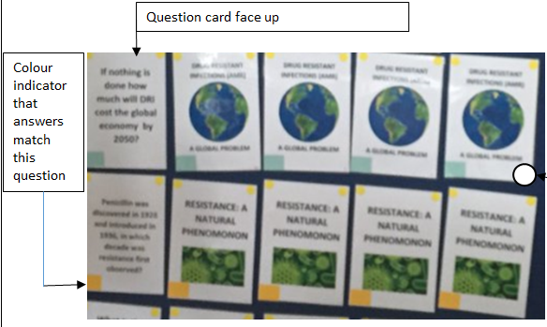

Answer cards, initially displayed face-down. Numbers in the coloured squares should be in ascending order left to right i.e. 1,2,3,4

How many people is it currently estimated die annually of Drug Resistant Infections?

700,000 globally.
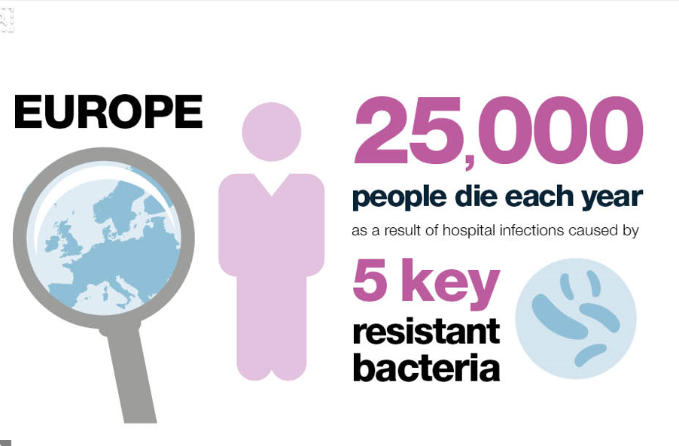
Particularly the young or old
Adds £1 Billion to hospital and treatment costs

23,000 deaths p.a in the USA

100,000

DRUG RESISTANT INFECTIONS (AMR)

A GLOBAL PROBLEM
1

500,000

DRUG RESISTANT INFECTIONS (AMR)
A GLOBAL PROBLEM
2

700,000

DRUG RESISTANT INFECTIONS (AMR)
A GLOBAL PROBLEM
3

1,000,000

DRUG RESISTANT INFECTIONS (AMR)
A GLOBAL PROBLEM
4
How many additional DRI deaths are estimated by 2050 if nothing is done about AMR?

10 Million
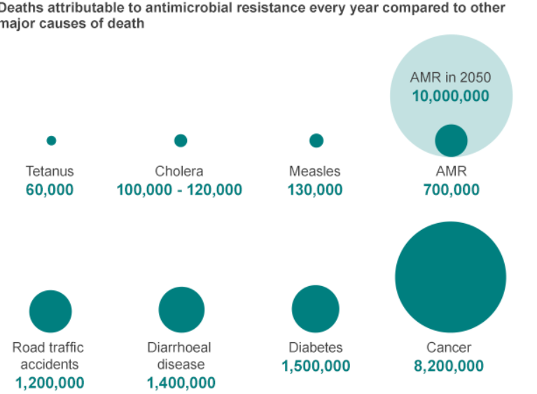
Results from Jim O’Neil review estimate that by 2050 AMR/DRI will kill more people than Cancer….

DRUG RESISTANT INFECTIONS (AMR)
A GLOBAL PROBLEM
1

1 Million

DRUG RESISTANT INFECTIONS (AMR)
A GLOBAL PROBLEM
2

2 Million

DRUG RESISTANT INFECTIONS (AMR)
A GLOBAL PROBLEM
3

5 Million

DRUG RESISTANT INFECTIONS (AMR)
A GLOBAL PROBLEM
4

10 Million

If nothing is done how much will DRI cost the global economy by 2050?

£77 Trillion in GBP which is….$100 Trillion
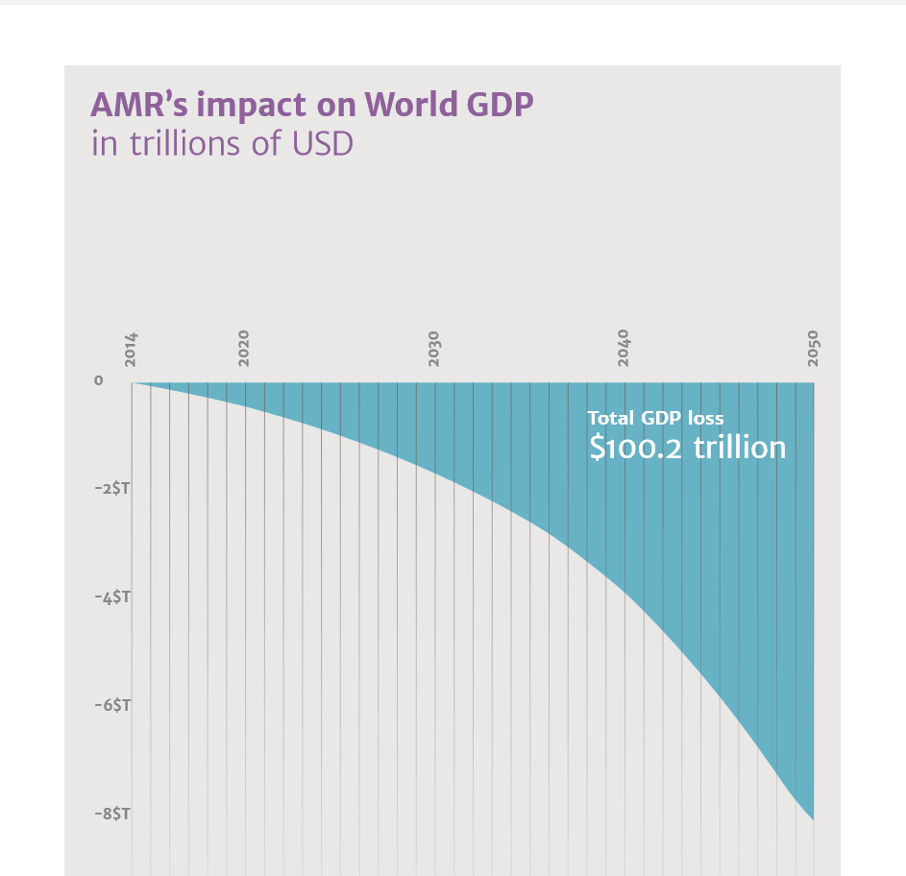
United States' GDP was estimated to be $18.56 trillion in 2016

£33 trillion

DRUG RESISTANT INFECTIONS (AMR)
A GLOBAL PROBLEM
1

£44 trillion

DRUG RESISTANT INFECTIONS (AMR)
A GLOBAL PROBLEM
2

£55 trillion

DRUG RESISTANT INFECTIONS (AMR)
A GLOBAL PROBLEM
3

£66 trillion

DRUG RESISTANT INFECTIONS (AMR)
A GLOBAL PROBLEM
4

Penicillin was discovered in 1928 and introduced in 1936, in which decade was resistance first observed?

1940s.
In his Nobel Lecture Fleming warned of the risk of resistance:
“The time may come when penicillin can be bought by anyone in the shops. Then there is the danger that the ignorant man may easily underdose himself and by exposing his microbes to non-lethal quantities of the drug make them resistant”

Resistance is a naturally occuring phenomon, using antibiotics drives greater resistance through selection pressure. 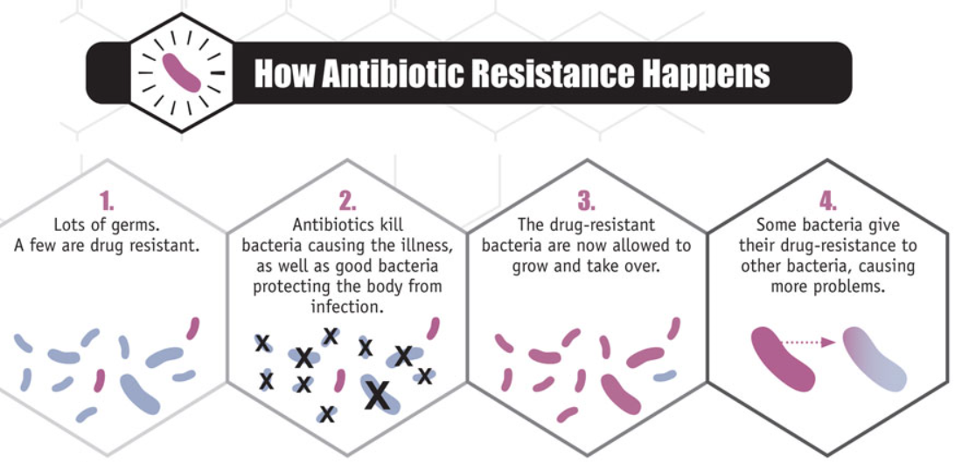

RESISTANCE: A

NATURAL PHENOMENON
1

1940s

RESISTANCE: A
NATURAL PHENOMENON
2

1960s

RESISTANCE: A
NATURAL PHENOMENON
3

1980s

RESISTANCE: A
NATURAL PHENOMENON
4

2000s

What is the average time between the introduction of new antibiotics and observed resistance?

6.8 YEARS
Because resistance is a natural phenomenon and can be driven by antibiotic use, the introduction of each new class of antibiotic results in resistance. Many organisms are now multi-drug resistant….
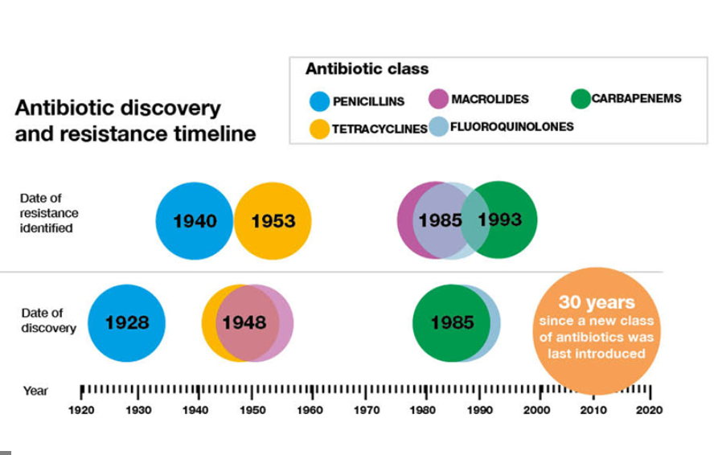Inventing a new antibiotic will not solve the problem of resistance.

RESISTANCE: A
NATURAL PHENOMENON
1

7 years

RESISTANCE: A
NATURAL PHENOMENON
2

10 years

RESISTANCE: A
NATURAL PHENOMENON
3

20 years

RESISTANCE: A
NATURAL PHENOMENON
4
30 years

What levels of multi-drug resistance are currently being witnessed in the European Region?

DRUG RESISTANT INFECTIONS (AMR)
A GLOBAL PROBLEM

<5%

DRUG RESISTANT INFECTIONS (AMR)
A GLOBAL PROBLEM
1

<20%

DRUG RESISTANT INFECTIONS (AMR)
A GLOBAL PROBLEM
2

<50%

DRUG RESISTANT INFECTIONS (AMR)
A GLOBAL PROBLEM
3
>50%

>50%
Levels of multi-drug resistance varry by organism, however across EARS-Net and CAESAR countries levels of >50% multidrug resistance have been reported for Acinetobacter spp and Klebsiella pneumoniae
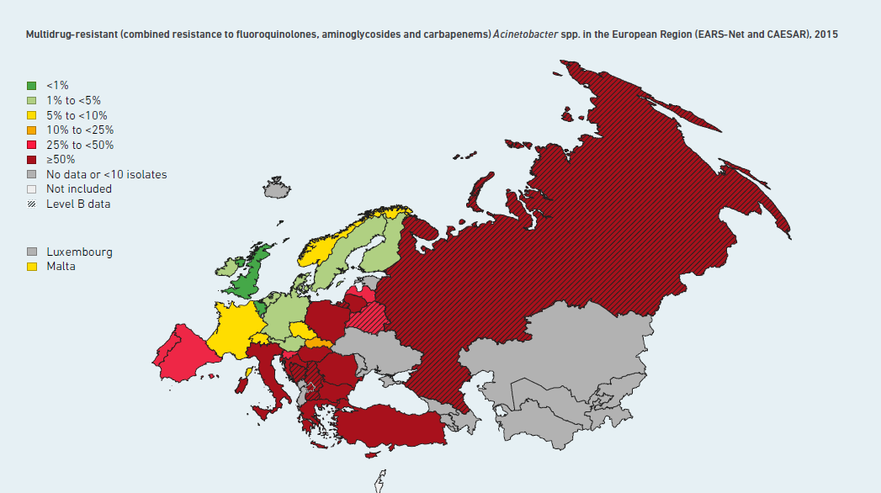
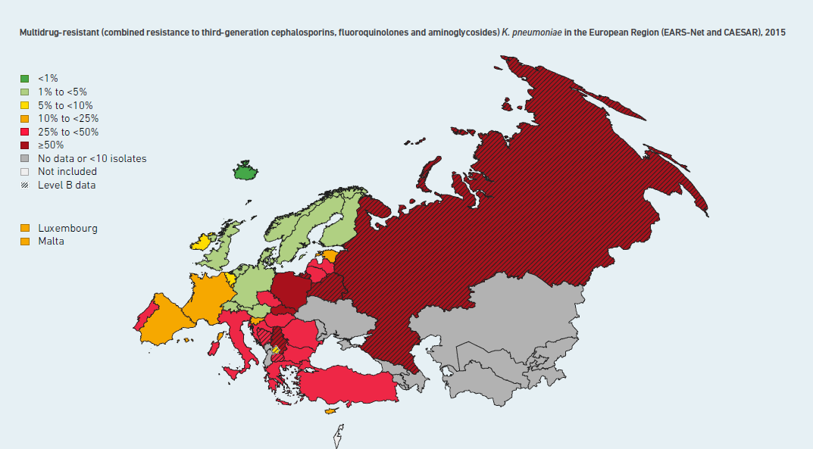
Bacteria are able to share their genetic material in the form of plasmid DNA which may include the genetic code for reistance. This can be shared vertically andhorizontally and between members of different bacterial species.
4

How many prescriptions for antibotics were given in the UK in 2015?

36.5 Million

T
Prescribing Costs in Hospitals and the Community in England in 2015/16 was £16.8 billion

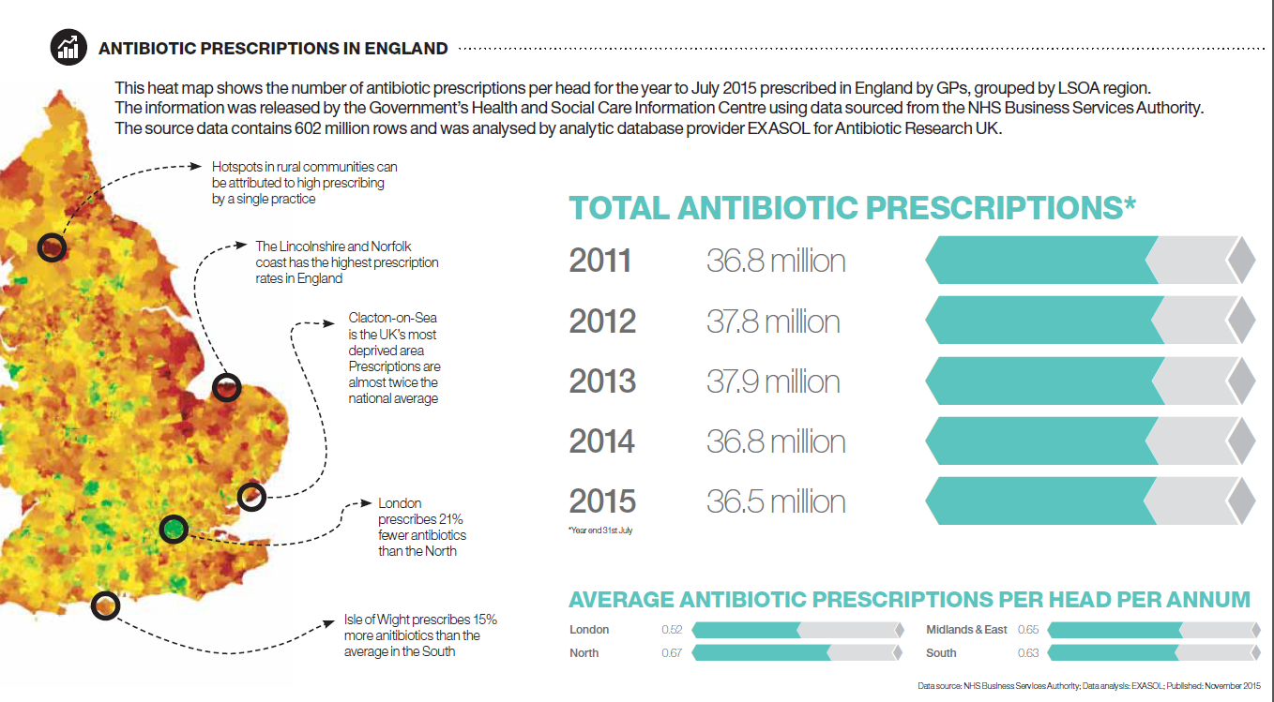

15.5 Million
= one prescription for just under a quarter (24%) of the total UK population

THE CAUSES OF ANTIMICROBIAL RESISTANCE
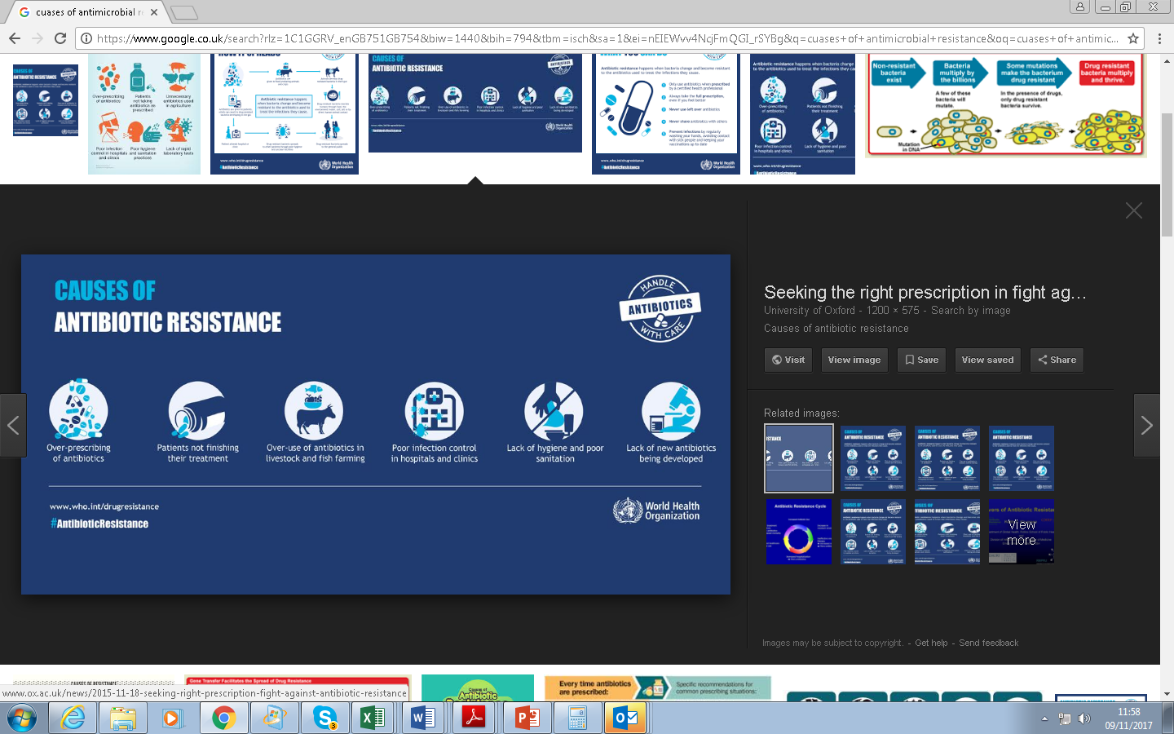

1

25.5 Million
Equivelant to one prescription in the year for 40% of the total UK population

THE CAUSES OF ANTIMICROBIAL RESISTANCE

2

36.5 Million
Equivelant to one prescription in the year for over half (56%) the total UK population

THE CAUSES OF ANTIMICROBIAL RESISTANCE

3

45.5 Million
Equivelant to one prescription in the year for 70% of the total UK population

THE CAUSES OF ANTIMICROBIAL RESISTANCE

4
How many of the 40M people who recieve antibiotics for respiratory issues annually in the US do so unneccesarily?

68%
Some over-prescribing results from the lack of adequate diagnostic tools, but patient behaviour plays a roll too…..a survey of 610 physicians chosen randomly by the American Academy of Paediatrics found that 40% of the paediatricians reported that they had received requests from parents 10 or more times in the past month when they did not feel it was indicated.
Forty-eight percent reported that parents always, most of the time, or often pressured them to prescribe antibiotics when their children are ill but use of antibiotics was not indicated.
In follow-up questions, approximately one-third of physicians reported they occasionally or more frequently comply with these requests.
The UK isn’t much better: a survey compiled by the Longitude Prize from responses from 1,004 GPs across the UK and found 28% have prescribed antibiotics several times a week even when they were not sure if it is medically necessary, and 45% had done so knowing it would not help.
93% said that they had faced pressure to prescribe the drugs, with 44% admitting to having prescribed antibiotics simply to get the patient to leave the surgery on at least one occasion.
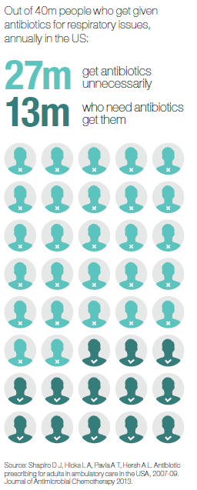

5 Million
(12%)

THE CAUSES OF ANTIMICROBIAL RESISTANCE

1

10 Million
(25%)

THE CAUSES OF ANTIMICROBIAL RESISTANCE

2

20 Million
(50%)

THE CAUSES OF ANTIMICROBIAL RESISTANCE

3

27 Million
(68%)

THE CAUSES OF ANTIMICROBIAL RESISTANCE

4
How many tons of antibiotics are used globally in animal agriculture per year?

65,000 tons
(out of the 100,000 tons produced annually)
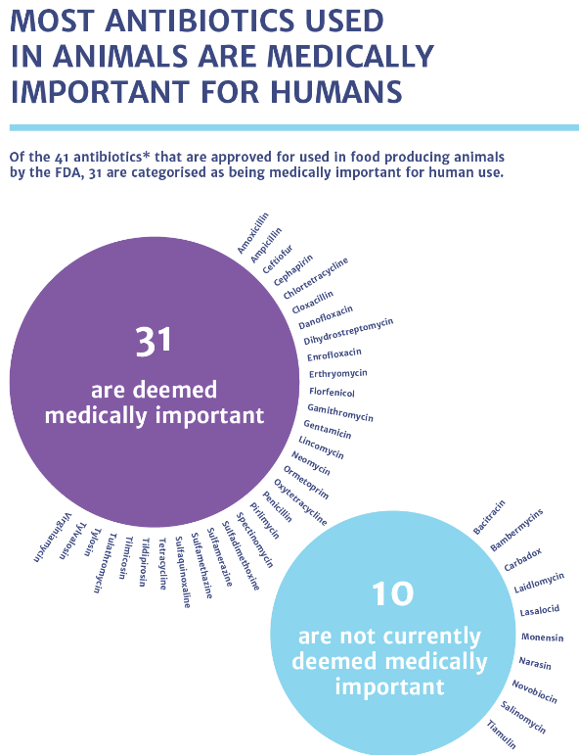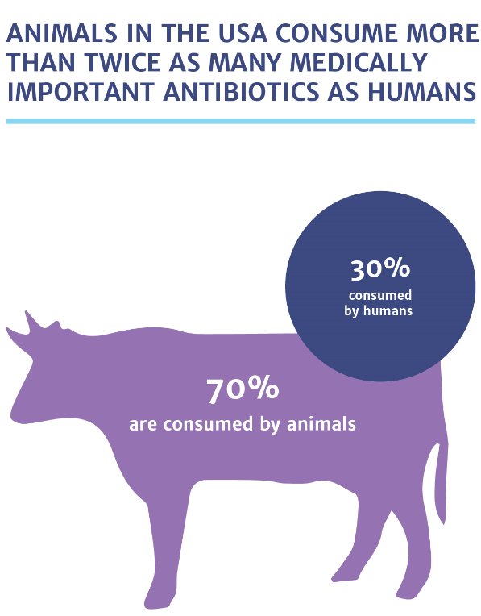
Antibiotic use in animals is sometimes required, but much of their global use is not for treating sick animals, but instead either to prevent infections (sometimes to compensate for poor farming practices) or simply to promote growth.

Wide scale use of antibiotics in humans and animals alike encourages the development of resistance. While the actual importance of the animal reservoir of antimicrobial resistance for human health is an area of controversy most experts agree that it is a concern and that the development of resistance in this reservoir should be also limited as much as possible.

20,000 tons

THE CAUSES OF ANTIMICROBIAL RESISTANCE

1

35,000 tons

THE CAUSES OF ANTIMICROBIAL RESISTANCE

2

55,000 tons

THE CAUSES OF ANTIMICROBIAL RESISTANCE

3

65,000 tons

THE CAUSES OF ANTIMICROBIAL RESISTANCE

4
What percentage of sore throats got better within just 7 days without antibiotics?

90%

A Cochrane systematic review of Antibiotics for sore throat conducted a meta-analysis of 27 Randomized Clinical Trials and 2,835 cases of sore throat:

- It found that without antibiotics 40% of sore throats resolve in 3 days

- 90% resolved in 7 days.

Between 95 and 85% of sore throats in adults are caused by viruses which antibiotics cannot treat anyway.

Of the remaining bacterial infections, while they feel awful, will generally go away within a few days without specific treatment

25%

WHAT CAN I DO ABOUT
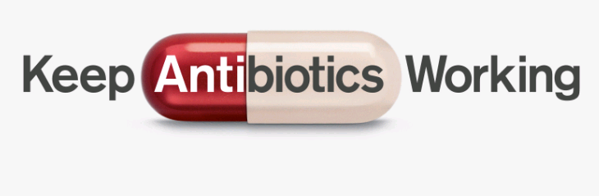
ANTIBIOTIC RESISTANCE?
1

50%

WHAT CAN I DO ABOUT
ANTIBIOTIC RESISTANCE?
2

70%

WHAT CAN I DO ABOUT
ANTIBIOTIC RESISTANCE?
3

90%

WHAT CAN I DO ABOUT
ANTIBIOTIC RESISTANCE?

4

Antimicrobial resistance is a side effect of antibiotic use. Are you more likely to have resistant bacteria in your body if you have previously used antibiotics compared with if you hadn’t?

Yes – it’s nearly twice as likely
Chung et al. enrolled 119 children who had an outpatient visit for otitis media or respiratory infection; 71 had been prescribed an antibiotic, and 48 had not been prescribed any antibiotic (133).
At the initial visit and then 2 and 12 weeks later, participants had throat cultures taken to detect a markers for resistance.
At the 2-week follow-up, 67% of children who had been given antibiotics had the resistance marker, compared to 36% of children who had not been given antibiotics
Our own research has also shown that Individuals prescribed an antibiotic in primary care for a respiratory or urinary infection develop bacterial resistance to that antibiotic.
The effect is greatest in the month immediately after treatment but may persist for up to 12 months. This effect not only increases the population carriage of organisms resistant to first line antibiotics, but also creates the conditions for increased use of second line antibiotics in the community.
Taking antibiotics has an impact on you personally but also on your community

No- you’re less likely to have resistant bacteria

WHAT CAN I DO ABOUT
ANTIBIOTIC RESISTANCE?
1

No difference: you’re just as likely to have resistant bacteria

WHAT CAN I DO ABOUT
ANTIBIOTIC RESISTANCE?
2

Yes, you’re twice as likely to have resistant bacteria

WHAT CAN I DO ABOUT
ANTIBIOTIC RESISTANCE?
3

Yes you’re three times as likely to have resistant bacteria

WHAT CAN I DO ABOUT
ANTIBIOTIC RESISTANCE?
4

How long should you wash your hands for to get them properly clean?

20 seconds
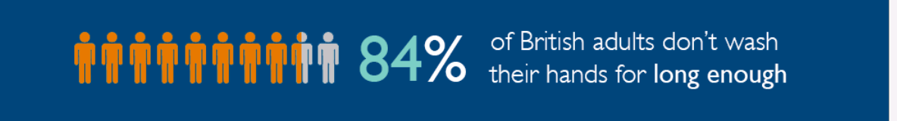
A good way to protect yourself and others from DRI is to limit transmission through good hand hygiene

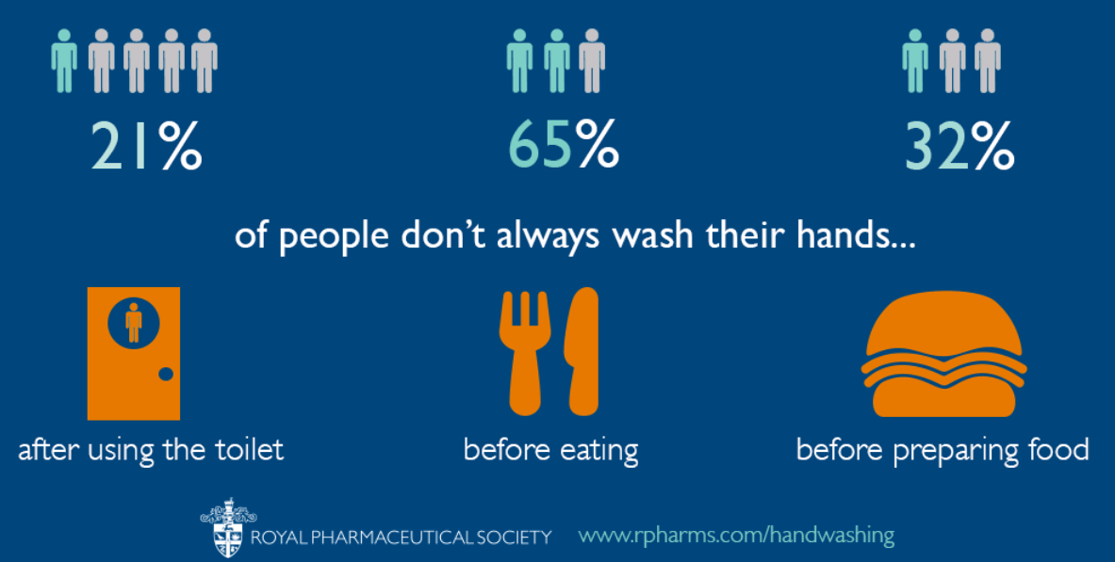

5 seconds

WHAT CAN I DO ABOUT
ANTIBIOTIC RESISTANCE?
1

10 seconds (long enough to sing happy birthday)

WHAT CAN I DO ABOUT
ANTIBIOTIC RESISTANCE?
2

20 seconds (long enough to sing happy birthday twice)

WHAT CAN I DO ABOUT
ANTIBIOTIC RESISTANCE?
3

30 seconds
(long enough to sing happy birthday three times)

WHAT CAN I DO ABOUT
ANTIBIOTIC RESISTANCE?
4

How long should you wait before going to the doctor for a cough or bronchitis?

21 days
A lot of unnecessary prescribing is for self-limiting illnesses.

New NHS guidelines give the following guide times
Common Illnesses | Most people are better by
Earache (middle ear infection) | 8 days
Sinusitis (adults) | 7-8 days
Sore throat | 7-8 days
Cold | 14 days
Cough or bronchitis | 21 days

7 days

WHAT CAN I DO ABOUT
ANTIBIOTIC RESISTANCE?
1

10 days

WHAT CAN I DO ABOUT
ANTIBIOTIC RESISTANCE?
2

14 days

WHAT CAN I DO ABOUT
ANTIBIOTIC RESISTANCE?
3

21 days

WHAT CAN I DO ABOUT
ANTIBIOTIC RESISTANCE?
4

