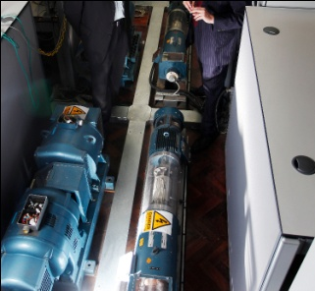
CI9.S.1.1 Systems Analysis of Advanced M & E Issues
Course leader: | Professor David Fisk
Other contributors: | Professor Washington Ochieng, Dr Nick Leon, Dr Angeloudis Panagiotis, Dr Ned Ekins-Daukes & Dr James Keirstead
Pre or co-requisites:
Term: | Autumn
Contact hours: | 25

1.0 Aims

This module aims to provoke an ‘out-of-the-box’ approach to analysing emerging technologies in M & E engineering contexts, through stimulating new applications likely to be used in industry in the next few years.

2.0 Syllabus

- Whole system design with exergy analysis
- Survey Data acquisition into data systems with GPS
- Optimal systems approach to logistics planning
- Visualisation techniques in system design and project planning
- Managing systems clash

3.0 Intended learning outcomes

On successfully completing this module, students will be able to:

- Show confidence in analysing unfamiliar technologies proactively
- Show proficiency in exergy analysis as a services systems analysis tool
- Apply hands-on familiarity with logistics systems optimisation tools
- Identify experience of Site Surveying with GPS systems
- Practice experimentation with 3D visualisation and prototyping technology

4.0 Assessment

- Assessment of this module is in the form of progress tests usually given as in class group work and individual follow-up assignments.

