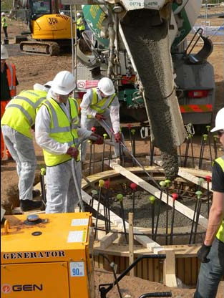
CI9.S.2.3 Low Carbon Technologies: Renewables and nuclear
Course leader: | Dr Ben Britton & Dr Michael Rushton
Other contributors: | Dr Mark Wenman
Term: | Autumn
Contact hours: | 25

1.0 Aims

This module aims to introduce the students to the new types of systems components involved in low-carbon technologies for heat and energy supply. Nuclear energy is viewed as a services system component. This component is taken with students on MSc Nuclear engineering. Similar treatments are made for photovoltaic and fuel cell applications. Whole systems design concepts will be reinforced

2.0 Syllabus

- Nuclear engineering introduction (jointly with Materials Department MSc)
- Fuel cells integrated into building services
- Deployment and development of photovoltaic systems

3.0 Intended learning outcomes

On successfully completing this module, students will be able to:

- An understanding of the basics of nuclear energy engineering
- Knowledge of how to integrating Fuel cells in the power and heat networks
- Knowledge of PV systems implications and prospects

4.0 Assessment

- Assessment of this module is in the form of progress tests usually given as in class group work and individual essay.
- Assessment of this module examination (coursework) worth 5%

5.0 Recommended textbooks
Category as defined by Central Library:
C = Core, S = Supplementary
S | Lamarsh, J. R., & Baratta, A.J., (2001) Introduction to Nuclear engineering, 3 ed., U.S.A., Prentice Hall

