Prepared draft on 3rd May | David Mountford (Dept. Chemical Safety Advisor) and Stefan Hoyle (Head of Health and Safety in the Faculty of Natural Sciences)
Reviewed draft 18th May | Alan Spivey (academic), Jochen Brandt (PDRA rep) and Stephen Chawner (PG rep)
Reviewed draft 3rd June | David Mountford and Stefan Hoyle
Revised draft 11th July | David Mountford
Revised draft 9th August | Revised after investigation into a fire involving pyrophoric liquid (IN004465) and including comments from College Safety Dept and academic members of staff in the Synthesis and Catalysis ‘theme’.
9th August | Version 1 approved by Head of Dept.
2nd October 2019 | Version 2 - Separated into standalone Code of Practice number 2.33

Code of Practice for working with pyrophoric chemicals

Contents
Section | Page
- Introduction | 2
1.1 Definitions | 2
1.2 Approvals | 2
- Basic safety practices required when working with pyrophoric compounds | 3
- Standard operating procedure for handling pyrophoric liquids (SOP1) | 4
- Storage, transport and disposal of pyrophoric liquids | 4
3.2 Preparing and drying glassware | 5
3.3 Set up apparatus | 5
3.4 Assemble reaction apparatus, purge it with N₂ and make final preparations for the transfer | 6
3.5 Preparing to add the pyrophoric liquid | 7
3.6 Transfer of pyrophoric liquids - accessing the reagent bottle | 7
3.7 Transfer of pyrophoric liquids using a syringe | 9
3.8 Cannula transfer - for volumes of pyrophoric liquids greater than 20 mL | 10
3.9 Using Balloons to apply back pressure instead of bubblers | 11
3.10 Clean up | 12
- Disposal of pyrophoric liquids | 12
4.1 Disposal of stock bottle of pyrophoric liquids | 12
4.2 Disposal of pyrophoric liquids from transfer needles and cannulas | 13
4.3 Disposal of reaction mixtures | 13

Introduction
The best practice procedures below are to be adhered to by those working with pyrophoric chemicals in the Chemistry Dept. at Imperial College. The procedures described are aimed at ensuring the majority of work with pyrophoric chemicals is standardised within the Dept. Where a group’s procedures differ from those listed below they must have their own SOPs and assessments in place and these have to be reviewed and approved by the PI and then the Safety Committee.
The first section is applicable to all pyrophoric chemicals. The document then describes the specific procedures for handling pyrophoric liquids, solids and gases.
Departmental SOP 1.6.5 covers work with pyrophoric solids as well as pyrophoric liquids and can be found following the link:
https://imperiallondon.sharepoint.com/sites/fons/faculty/safety/chemistry/Pages/Departmentally-approved-SOPs-Chemistry.aspx

1.1 Definitions
Pyrophoric chemicals are liquids, solids and gases that have the potential to spontaneously ignite in air. The United Nations Globally Harmonized System of Classification and Labelling of Chemicals for Substances Health and Environmental Hazards defines pyrophoric gases, solids and liquids as follows:
Pyrophoric gas: A pyrophoric gas is a flammable gas that is able to ignite spontaneously in air at a temperature of 54ºC or below.
Pyrophoric liquids and solids: A pyrophoric liquid or solid are liquids or solids that even in small quantities, are liable to ignite within 5 minutes after coming into contact with air.
They often also have corrosive, water reactive, and peroxide forming properties. Improper use of these materials has resulted in research labs being shut-down to deal with the after effects of fires, damage to lab equipment, injury and even death.
Pyrophoric gases, pyrophoric liquids and pyrophoric solids all share the property of spontaneous ignition.
These type of chemicals have the hazard statement: H250: Catches fire spontaneously if exposed to air and the symbol:

1.2 Approvals
The procedures described below have been written after discussion with the Chemistry Health and Safety Committee and have been approved by the Head of Department. The procedures are to be followed when performing reactions with pyrophoric chemicals. Any procedures deviating from the procedures described below must be reviewed by the PI and then the Safety Committee.

Basic safety practices required when working with pyrophoric compounds:
- Use of these chemicals falls under the Dangerous Substances and Explosive Atmospheres Regulations (DSEAR) 2002 and the Control of Substances Hazardous to Health Regulations (COSHH) 2002:
DSEAR require users to apply the following control hierarchy:
  - Reduction of the quantity of dangerous substances to a minimum.
  - Avoidance or minimising of the release of a dangerous substance.
  - Control of the release of a dangerous substance at source.
  - Prevention of the formation of an explosive atmosphere, including the application of appropriate ventilation.
  - Ensuring that any release of a dangerous substance which may give rise to risk is suitably collected, safely contained, removed to a safe place, or otherwise rendered safe, as appropriate.
COSHH requires users need to identify whether they can:
  - Eliminate the need for using the pyrophoric material.
Where elimination is not possible:
  - Substitute the pyrophoric material with a less hazardous or reactive version (for example, hexyllithium in place of t-butyllithium).
Where substitution is not possible:
  - Ensure experiments are planned so that the quantity of pyrophoric chemical needed for the reaction is minimised.
  - Ensure all engineering controls are in place and working.

- Only perform experiments after you have received appropriate hands-on training from a competent member of your research group. Record training using the online records system. Record training in the procedure under the ‘Procedural and Equipment Training’ tab: https://imperiallondon.sharepoint.com/sites/serv/SafetyDpt/Training/SitePages/Home.aspx
- You must never work alone when handling pyrophoric chemicals and must always work within Imperial College hours when core emergency support is available (Monday – Friday / 09.00 – 17.00).
- Before each reaction you must:
- Review procedures and your reaction assessment with a competent member of the research group.
- Ensure all necessary equipment is available.
- Ensure the fume cupboard or other enclosure is clear of chemicals and items not involved with the reaction, in particular, flammable solvents and other sources of ignition such as blue roll.
- Ensure all emergency equipment (e.g. sand) is near and easily accessible.
- Ensure all personal protective equipment (PPE) is available and in good working order.
- Ensure another worker is with you and ready to assist if needed – never work alone.

Standard operating procedure for handling pyrophoric liquids (SOP1)
Pyrophoric liquids include, but are not limited to, organolithiums, organozincs, organoaluminiums and organoboranes.
Work with pyrophoric liquids must take place in a fume hood (or similar enclosure e.g. glove box) with access to an inert gas (e.g. N₂ or Ar) and a vacuum system. If a vacuum system is not available other purging methods should be used.
The hood contains all the equipment and serves as a barrier between the experiment and the operators and others in the lab. Always work behind the sash.
Before initiating any work with pyrophoric liquids, a Reaction Risk Assessment must be completed, this includes the titration of organolithium reagents. This Reaction Risk Assessment must be signed off before commencing work, with appropriate direct supervision being provided to inexperienced researchers.
Pyrophoric liquids (hazard phrase H250) must be stored in cold storage in tightly sealed containers. The stock bottle must be stored within a secondary container to prevent damage to the stock bottle.
Any storage area for storing these chemicals must be ‘spark proof’ (e.g. fridge) and suitable for storage of pyrophoric and flammable chemicals. Ideally, it is located as close to the worker area as possible to minimise transport between hood and storage.
Before use, allow the stock bottle to warm to room temperature in the fume hood to minimise condensation on both the outside of the bottle and within the bottle.
Two methods of applying back pressure when handling pyrophoric liquids are used in the Dept:
- Preferably a bubbler with suitable mineral oil,
- Balloons of inert gas can also be used.
Both methods have specific SOPs which must be followed.
Always check the location of the nearest emergency full body shower and eye wash station and ensure that they are easily accessible. A dry powder extinguisher or bucket of sand, and a bottle of sand must be immediately accessible (not CO₂ extinguishers which can react with some organolithium compounds and alkali metals and hydrides). If relying on use of a powder extinguisher you must request to have specific training in its use from the Fire Safety Office: http://www.imperial.ac.uk/estates-facilities/health-and-safety/fire-safety/
When handling pyrophoric liquids lab coats, safety glasses and nitrile gloves must be worn. In some cases (for example if using >100 mL of a pyrophoric liquid) additional personal protective equipment may be required, for example flame resistant lab coat, flame resistant gloves, safety goggles and a face shield. If you are unsure, you should discuss the PPE requirements of your reaction with either your PI, Departmental Chemical Safety advisor or other experiences staff member (i.e. level 1 trainer) before you begin your work, this is an essential part of the Reaction Risk Assessment process.

3.1 Storage, transport and disposal of pyrophoric liquids
Stock reagent bottles are stored in designated spark free (ATEX rated) cold storage within closed secondary containers. No more than two 100 mL bottles of any individual pyrophoric chemical can be stored in the designated location. If a particular experiment requires additional bottles to be stored for a short period of time, this has to be approved by the PI. Should research necessitate a long-term increase in the volumes of pyrophoric liquids being stored, the Faculty Safety team should be informed.
Note: On first use, i.e. when the reagent bottle is first removed from cold storage and the metal container, it must be dated and initialed by the user on the bottle to indicate when it was first opened.
The experiment must be planned so that the volume of pyrophoric chemical required is minimised, whilst still allowing the experiment to take place. No single stock bottle of pyrophoric chemical should exceed 100 mL. If a stock bottle larger than 100 mL needs to be ordered it must be reviewed by the Department Chemical Safety Advisor.
Always transport the stock bottle in a sealed secondary container.

Preparing and drying glassware
Ensure all glassware that will come into contact with liquid pyrophoric chemicals are clean and absolutely dry. There are many methods for drying glassware, and it will vary from group to group and may also depend on the reaction to be carried out. All research groups must have a SOP approved by their PI in place for drying glassware. If a group has more than one method, each of these must be approved by the PI.

3.3 Set up apparatus
Set up N₂/Ar and vacuum manifolds. The N₂/Ar used to create the inert atmosphere must be dry and high purity (i.e. oxygen free). After passing through the manifold it is released into the hood through a mineral oil bubbler. This provides positive pressure to the system and prevents air from entering the system.
A vacuum pump supplies the vacuum to the manifold. A liquid N₂ trap is placed in line to trap contaminants.

Using mineral oil bubblers:
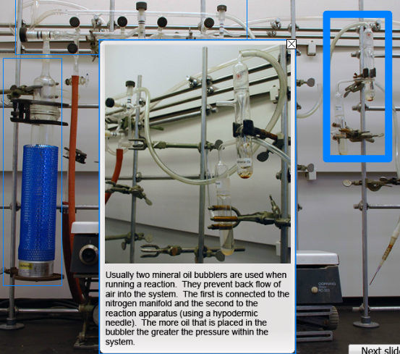

Cold trap set up:
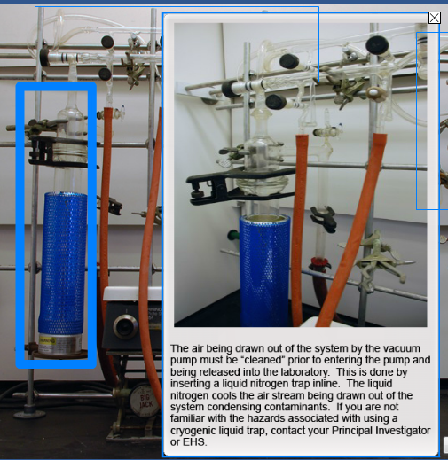

Dual manifold set up:
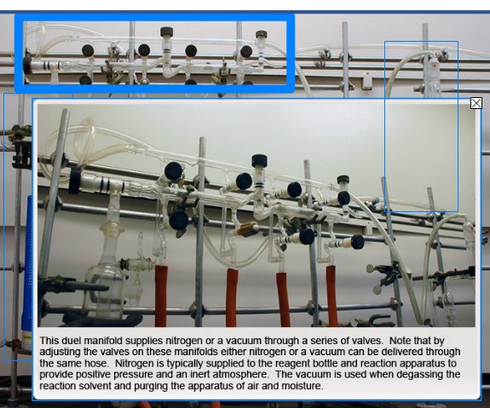

3.4 Assemble reaction apparatus, purge it with N₂ and make final preparations for the transfer.
- Remove glassware from desiccator and immediately assemble in the fume hood.
- Ensure joints provide a tight seal.
- Add rubber septa to the reaction flask - it will be punctured with a needle or cannula to transfer the pyrophoric liquids.
- Pull vacuum on the empty, dry flask, then fill with N₂, repeat this process a further 2 times to leave the reaction flask under N₂. When switching ensure the taps are opened slowly to prevent air being drawn back in through the bubbler.
- Add the dry, degassed (oxygen free) solvent to the reaction flask.
- Once N₂ is blanketing the solvent, and where a coolant is needed, the reaction vessel is placed in a coolant bath. Depending on the reaction, inert hydrocarbon solvents can be used such as heptane with dry ice. Acetone or 2-propanol cooling baths should be used with caution as these can react with organolithium solutions if they were to be spilled. The coolant is required as reactions are exothermic and cooling and controlling of the rate of addition will keep the reaction at an acceptable temperature.
- All flammable items must be removed from the fume hood (paper, boxes, plastic etc.) in addition to any other apparatus not directly associated with the reaction. The sill of the fume hood should also be clear of blue paper towel, notes or any other potentially combustible materials. Good housekeeping in the fume hood is essential.
- When using a solvent that absorbs moisture quickly, you may want to use a cannula to transfer the anhydrous solvent so it will not be exposed to moisture in the air.

3.5 Preparing to add the pyrophoric liquid
Once the apparatus is set up, and you have followed the six key rules listed in Section 2, 4a – f you can prepare to remove the pyrophoric liquid from the store.
Ensure you are wearing a lab coat, safety glasses and nitrile gloves. Ensure the reagent bottle is placed in the fume hood in a secondary container (steel bowl or similar) and secured with a clamp - DO NOT place the bottle on a heater or stirrer which could heat up the bottle inadvertently.
When transferring via a syringe, ensure a small volume of solvent (under N₂ with a septum) is available (50:50 toluene: isopropanol) for flushing needles and syringes of excess reagent after transfer. The isopropanol will inactivate any residual pyrophoric liquid and the toluene will act as a heat sink for the quench.
Before starting the transfer and reaction, ensure you have a co-worker nearby; this work must not be done alone.

3.6 Transfer of pyrophoric liquids - accessing the reagent bottle
(The pictures demonstrate using a Sigma Aldrich Self Seal system. Other suppliers may have different self-seal systems, but the same general guidelines apply to all suppliers’ bottles).
After removing the plastic cap there is a Teflon seal. The pyrophoric liquid within the reagent bottle is covered in a blanket of N₂ or Ar and separated from the atmosphere by the Teflon seal.
These SOPs describe the use of N₂ as an inert atmosphere, there may be times where Ar is a more appropriate choice but the exact same experimental method would be employed.
The pyrophoric liquid must be accessed by puncturing the seal with an appropriate needle, i.e. 3-5 inches long and no larger than 16 gauge. The seal is self-sealing once the needle is removed as long as the needle gauge is not too large and the seal has not been punctured too many times. If the self-sealing system fails, moisture may enter the bottle and a fire may start. For this reason, the self-sealing system (it will vary depending on the supplier) must be visually checked before each use to ensure the seal is still effective. If there is any doubt about the seal or the age of the bottle (which should be dated at first opening), it must be recapped before being removed as hazardous waste.
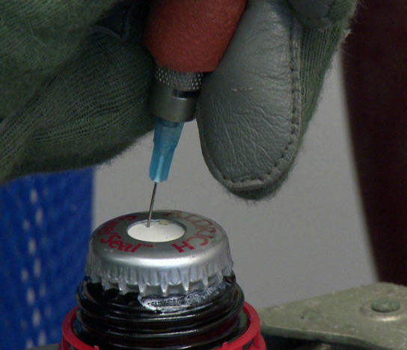
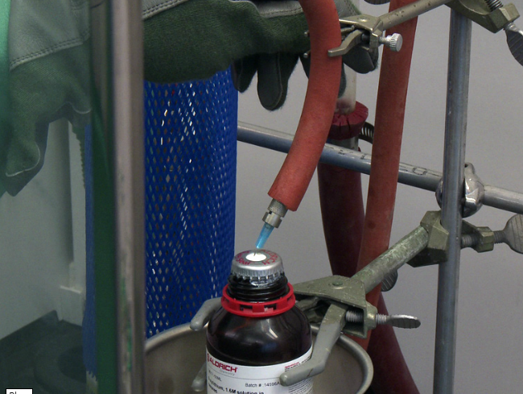

When puncturing the seal, do not use the centre; instead, select an unused location near the edge of the seal to increase the life and integrity of the seal. Ensure the needle enters and is supported in a vertical position. You will also need to support the N₂ line which will reduce the strain on the seal.
Care should be taken that the level of the needle does not go beneath the level of the liquid as this can lead to the pyrophoric liquid spurting out when a second puncture is made.
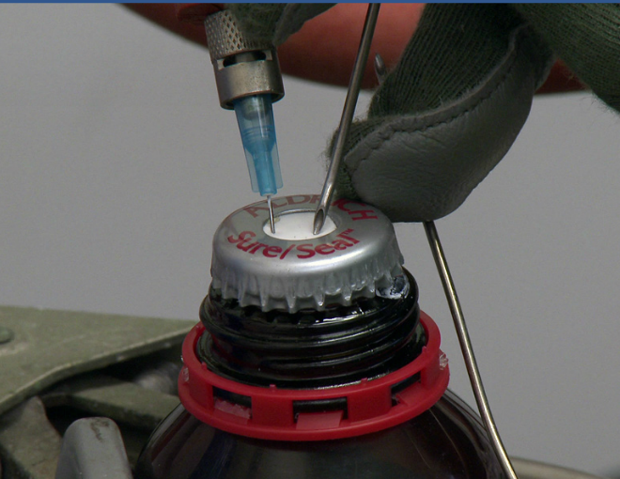
Typically a seal will be punctured twice during each transfer; the first supplies N₂ to the bottle and the second removes the pyrophoric liquid from the bottle.
Always select locations on opposite sides of the seal as shown.

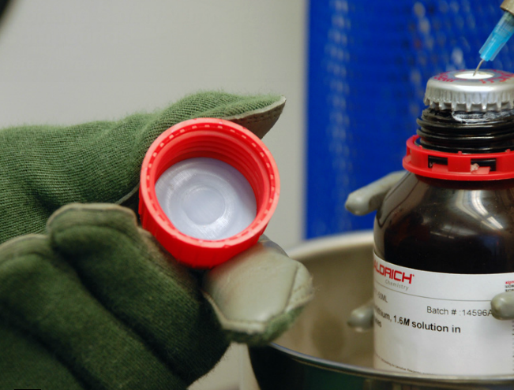

When the transfer is complete, the plastic cap (which contains an additional seal) must be reattached, as well as between uses.

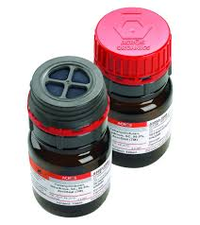
The images above show the chemicals using the Sigma Aldrich self-sealing system. Other suppliers are available, for example Acros provide their air sensitive chemicals in a different sealing system (AcroSeal). For more information on AcroSeal go to: https://www.fishersci.com/us/en/brands/I9C8LQ45/resources.html

3.7 Transfer of pyrophoric liquids using a syringe
- Syringe transfers can only be completed with a maximum syringe size of 20 mL.
- Syringes must only be filled 2/3 full of pyrophoric liquid.
- Always use a Luer lock (locking system) needle and syringe for syringes greater than 1 mL. This ensures the needle stays on the syringe barrel when removed from the reagent bottle seal.
- For syringes of 1 mL or less the costs of the Luer lock system may be prohibitive compared to the risk, therefore use of Teflon tape to securely hold the needle onto the syringe is permitted.
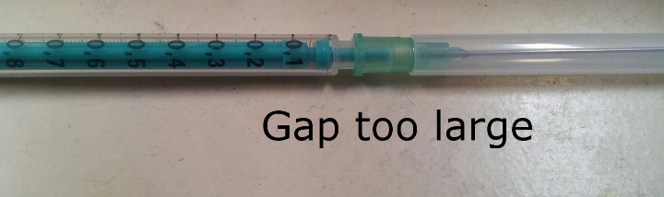
Picture to demonstrate 1 mL non-Luer lock syringe that has too large a gap between needle and syringe.

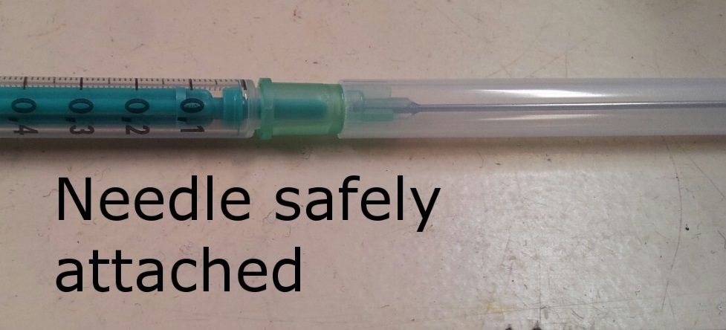
Picture to demonstrate 1 mL non-Luer lock syringe that has needle attached to syringe body correctly.

Picture illustrating use of PTFE tape to correctly secure non-Luer lock needle to the syringe body and prevent the needle coming away from syringe when using pyrophoric liquids.
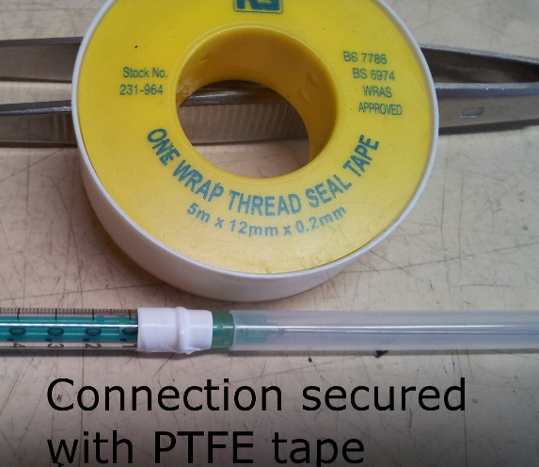

- The needle selected must be 7.62cm (3 inches) or longer to ensure that it can reach the bottom of the reagent bottle, and a maximum of 16 gauge. Larger gauge needles make it more difficult for the Teflon to self-seal after removal of the needle.
- Needles can be as long as 30cm (1ft) but remember, this results in more pyrophoric liquid having to be disposed of after use as the dead volume is correspondingly higher.
- Place an extra needle and syringe in the fume hood in case you have a problem with the first.
- Glass syringes with Teflon-tipped plungers (gastight) syringes are best. Simple ground glass syringes are more prone to causing air bubbles and should not be used when handling pyrophoric reagents. Disposable plastic syringes have a good seal on the plunger and work well. Any syringe you use MUST have a needle-lock mechanism (Luer lock) to prevent separation of needle and syringe.
- Before transfer, ensure the reagent bottle is placed in a secondary container, is clamped and under a blanket of N₂.
- The needle should be inserted slightly off-centre.
- The N₂ adds 3 – 5 psi to the bottle and makes it easier to draw the plunger of the syringe back, as N₂ replaces the volume of the liquid withdrawn.
- Using a separate vessel filled with N₂, purge the needle and syringe with N₂ at least 3 times.
- If you are not ready to do the transfer, leave the needle and syringe under the N₂ atmosphere.
- After being purged, the syringe is inserted through the Teflon seal opposite the N₂ line and into the headspace of the reagent bottle. Any N₂ in the syringe is released into the headspace and then the needle placed into the pyrophoric liquid.
- The pyrophoric liquid is then drawn slowly into the syringe by slowly withdrawing the plunger.
- Once the required volume is obtained, the needle is withdrawn into the reagent bottle headspace and N₂ from the head space drawn into the syringe to provide an inert N₂ buffer. You should not take more reagent into the syringe than you will need for your reaction.
- The needle is withdrawn from the septum by gently pulling on the needle, not the syringe.
- The needle is carefully inserted into the reaction flask and the reagent released slowly into the reaction solvent, ensuring it is dropped down the side of the reaction flask. This action pre-cools the pyrophoric liquid and allows the heat generated by the reaction to be absorbed by the coolant. Pay close attention to the reaction and adjust the rate of addition to get the correct rate of reaction. If the addition will take more than a few minutes use a glass gas tight syringe.
- When the transfer is complete, N₂ is drawn into the syringe and the needle removed from the reaction flask. Flush the needle three or four times with a 50:50 mixture of toluene and isopropanol (located and pre-prepared in the hood) to remove residual reagent. Ensure that the needle is placed in the solvent mixture before expelling the N₂ and that the needle remains below the solvent level as it is being flushed. Large volumes of solvent pose a fire hazard so you should only use a small volume for flushing, for example up to 1.5 times the volume of the syringe.
- Place a shield in front of the reaction to augment the hood sash until the reaction is complete.
- Disassemble the barrel from syringe to allow contact with air. The syringe and barrel are discarded after being left to dry in the hood for 30 minutes.
- Disposable syringes must not be reused as residual chemicals in the barrel may cause the plunger to stick, increasing the risk of pulling the plunger out of the syringe due to excess force when withdrawing. Glass syringes must not be reused until they have been washed, dried and prepared again.

3.8 Cannula transfer - for volumes of pyrophoric liquids greater than 20 mL
Where a large volume of a pyrophoric reagent needs to be transferred, it is safer and easier to have a cannula transfer to a graduated addition funnel than to use multiple individual syringe additions. When using large volumes of pyrophoric reagents there is the additional danger of developing an overpressure, particularly in reactions (e.g. organolithium reactions) where a gas is evolved. In many cases the gas evolved will also be flammable and poses an additional risk.
- The reaction apparatus is set up using a 2-neck reaction flask with a graduated addition funnel attached. The apparatus is purged with N₂ and the reaction solvent degassed as described above in section 3.7.
- Take a clean dry 12 gauge cannula from a desiccator and purge it with N₂. Make sure that both ends are sharp and that the cannula is not blocked. Flush the cannula with N₂ from a separate container; this also identifies if there are any blockages in the cannula. Once flushed, insert the cannula into the reagent bottle seal (on the opposite side to the N₂ needle).
- Once purged, the cannula is inserted through the septum attached to the graduated addition funnel.
- A needle with Tygon tubing attached to the bubbler is then attached to the graduated addition funnel.
- To initiate the flow of pyrophoric liquid to the addition funnel, the flow of N₂ to the reaction vessel is shut off.
- The cannula is lowered into the reagent and the pressure differential forces the reagent to flow through the cannula.
- When the correct volume has been transferred, the cannula is lifted into the headspace of the reagent bottle. This causes N₂ to flow through the cannula, purging it of any residual pyrophoric liquid.
- The N₂ supply valve to the reaction apparatus is reopened and, once purged with N_{2,} the cannula is removed from the reagent bottle and the graduated addition funnel. When removing the cannula make sure the two ends point away from you in case it is not fully flushed. The bubbler can also be removed from the graduated addition funnel.
- Before initiating the reaction with the pyrophoric liquid, remove the N₂ supply line from the reagent bottle, replace the cap and return it to storage.
- Place a shield in front of the reaction to augment the hood sash.
- When all is set, the reagent can be added at an appropriate rate and with appropriate cooling if necessary.

3.9 Using Balloons to apply back pressure instead of bubblers
Where the gas manifold pressure is insufficient for a cannula transfer, you may want to use a balloon filled with either N₂ or Ar to provide the necessary back pressure for the transfer.
- Take a clean dry 12 gauge cannula from a desiccator and purge it with N₂. Make sure that both ends are sharp and that the cannula is not blocked.
- Prepare a dry two-neck flask with one neck connected to the vacuum/N₂ line while the other is capped with a rubber septum.
- Prepare a fresh inert-gas balloon (old balloons are more likely to break): remove the plunger from a 2 mL syringe and cut the end off. Attach two high-quality balloons to the syringe with parafilm. Add a reusable gas valve (ordered from Cole-Parmer with cat #WZ-30600-00). Fill the balloon with N₂ and close the valve.
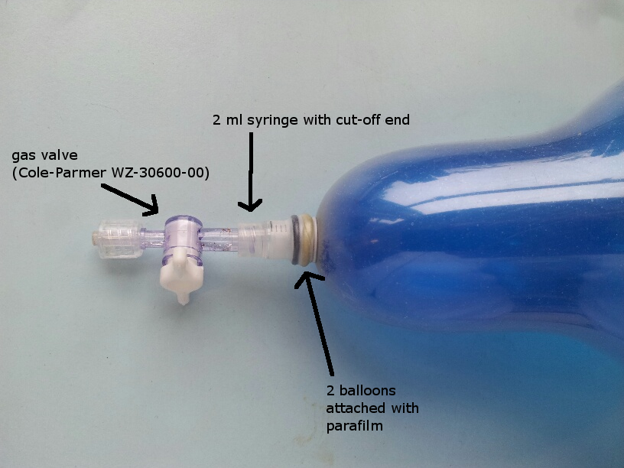

- Attach a needle to the gas valve of the balloon. Open the valve for a couple of seconds to flush the needle, then carefully push the needle through the seal of the reagent bottle.
- Take the previously prepared cannula and pierce it through the seal of the pyrophoric liquid bottle ensuring that the end of the cannula is above the level of the liquid.
- Allow the N₂ to flush the cannula for a couple of seconds, then push the second end through the septum of the receiving flask.
- Keep the reaction flask connected to the N₂ line BUT close the gas supply. The N₂ should now flow from the balloon through the cannula into the reaction flask, through the N₂ line and out of the bubbler.
- Lower the cannula below the level of the pyrophoric liquid. The liquid will transfer to the reaction flask. The flow rate can be adjusted by adjusting the balloon’s gas valve.
- When the transfer is complete, lift the cannula above the level of the pyrophoric liquid. Leave the cannula connected to both containers.
- Wait until the remaining drops have been pushed from the cannula by the N₂ flow from the balloon. Then turn the N₂ gas supply to the gas line back on.
- Carefully remove the cannula from the reaction flask, then from the reagent bottle. Leave the cannula at the back of your fume cupboard to slowly quench with ambient air.

3.10 Clean up
- When finished, clean and tidy up the fume cupboard ready for your next experiment.
- Remove the needle supplying N₂ and replace the plastic cap onto the reagent bottle.
- Use a secondary container to transport the reagent bottle to the spark free cold store.

Disposal of pyrophoric liquids

Disposal of stock bottle of pyrophoric liquids
As long as the bottle container and seal are intact, the stock bottle should be disposed of via the hazardous waste stream. Disposal of a 100 mL bottle of tert-Butyllithium solution was £1.10 via the hazardous waste stream (as of May 2016). This is a set price. Contact the Chemistry Research Technicians to arrange disposal.
If there are any doubts about the integrity of the bottle or the seal do not use the chemical. Contact the Faculty of Natural Sciences Safety Team and the Dept. Chemical Control, Disposal & Technical Systems Specialist.

4.2 Disposal of pyrophoric liquids from transfer needles and cannulas
When the transfer is complete, N₂ is drawn into the syringe and the syringe flushed three or four times with a 50:50 mixture of toluene and isopropanol (located and pre-prepared in the hood) to remove residual reagent. The volumes of solvent used for washing should be kept to a minimum.
Take care during this process: fire incidents have been reported in the past as solvents have been ignited by the pyrophoric liquid coming into contact with air while in the needle or cannula (due to no N₂ buffer). The liquid starts combusting and when the operator tries to quench it in a flammable liquid, a fire ensues. All standard controls to prevent fires must be implemented to reduce risks of serious damage to individuals, equipment, and buildings.

4.3 Reaction mixtures
Most of the pyrophoric reagent should have been consumed during the reaction. Do not assume that the risk from the reagent is low. Following cautious quenching (with a cooling bath in place for large scale reactions), depending on the hazards of the other components of the reaction mixture, this can be disposed of as hazardous waste in the lab using the available chemical waste disposal routes.

