

CNRS-Imperial International Research Centre (IRC) Connect Fund
Aims of fund
This fund aims to grow the research, innovation and entrepreneurship collaborations between Imperial and CNRS as part of the CNRS-Imperial International Research Centre for Transformational Science and Technology, with a key focus on a convergence science approach to addressing UN Sustainable Development Goals. The fund aims to seed activities that develop new Imperial-CNRS networks and collaborations that can scale-up convergence science consortia to target various funding opportunities which contribute to the mission of the IRC (see Appendix 1). Applications must be made by a permanent member of Imperial staff and include a CNRS co-lead. Each proposal can receive up to £10,000 of funding, and there are two application deadlines: 2 July and 22 October 2024.
Background
The CNRS-Imperial International Research Centre (IRC) for Transformational Science and Technology (IRC) was launched in April 2022 and is one of a few global IRCs organised by CNRS with key partners, and it is the only IRC in the UK and Europe. The IRC brings together the complementary strengths of both institutions to address larger societal grand challenges.
While launched only two years ago, the IRC has already provided a framework and impetus for the development of new collaborations, most notably the expected launch of the Ayrton Bleriot Engineering International Research Lab (ABEL) set to launch in January 2025, the International Research Project in Integrative Metabolism and Precision Medicine launched in January 2023, and the International Research Network in Physics (AdvancinG TechnOlogy, AppLications anD FundaMentals In Coherent NanosourcEs – GOLDMINE) launched in April 2024, and a renewal of the Abraham de Moivre International Research Lab signed in April 2024 which expands collaborations in Mathematics.
Aims
The funding can be used to develop or expand Imperial-CNRS networks, or to create new or scale up existing collaborations in research, innovation and entrepreneurship. The proposed collaborations must do one of the following: a) develop Horizon Europe or other external funding opportunities (establishing a network with general work programmes in mind is acceptable, or PIs may have a specific call in mind and use the funding to help write the proposal for that), b) engage industry or other external partners in research, innovation or entrepreneurship activity that benefits the IRC, c) develop CNRS collaboration mechanisms such as an International Research Lab, or d) grow the IRC’s research, innovation or entrepreneurship activities in another way not identified above but which address one of the IRC aims outlined in Appendix 1.
Thematic areas
Proposals should note how the activity will develop or support one of the three IRC interdisciplinary pillars/thematic areas: health, sustainability, and connectivity (see chart below) and/or support the strategic development of existing IRLs, IRNs or IRPs.
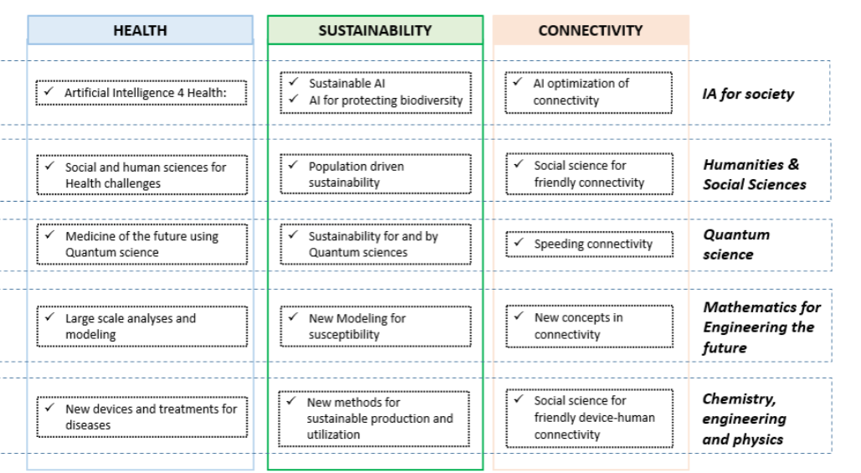

Funding and Project Duration
The maximum award amount per project is £10,000, and activities and funding must conclude by 31 July 2025. Funding will be transferred to the Imperial applicant but can be used to cover approved expenses of CNRS and Imperial staff eg workshop expenses at CNRS site in France.
Funds can be used for the following:
- Student support costs (e.g., student bursaries)
- Limited Research Consumables
- Travel/Accommodation/Subsistence
- Small project-related equipment
- Funding for proposal development including contributions towards support services such as proposal writing;
- Funding to support capability-mapping to target external funding opportunities (e.g buyouts of a PhD student or Postdoc time);
- Networking events such as workshops, training academies and seminars to bring together ECR researcher communities to foster new links, or strengthen existing collaborations.
The following costs are not eligible:
- Salary
- Bench fees
- Indirect and estate costs
Eligibility
- The Fund is open to permanent Imperial College staff members only, and one proposal per principal applicant per call is permitted.
- The application must be submitted by an Imperial staff member, and must include a CNRS co-applicant.
- Proposals can include additional partners (beyond CNRS and Imperial) as relevant.

Timeline
Call opens 13 September 2024
Call closes 22 October 2024
Awards start: 1 November 2024
Activity and spending must conclude by 31 July 2025

If funds remain we may organise a second call in November, with awards to start in December or January, but the spending deadline will be 31 July 2025.

Evaluation criteria
- Does the proposed activity support one of the IRC aims and one of the IRC interdisciplinary pillars?
- Does the proposal identify the importance, creativity, and potential impact of the research/workshop/staff exchange and/or new partnership, emphasising the synergy between research groups at Imperial and CNRS (and any additional partners)?
- Is the funding requested, and are the activities proposed, reasonable and feasible?
- Are there wider Imperial and CNRS institutional benefits (to other departments, faculties, centres or students and staff etc) the partnership/consortia will bring?

Appendix 1: Aims of the IRC
- Promote international collaboration and exchange to conduct research and training of the highest academic quality, especially where science and technology come together to address societal global challenges and United Nations Sustainable Development Goals (SDGs). The IRC seeks to broaden and extend existing official CNRS-Imperial collaborations in place and also to scope and support new areas of collaboration.
- Support early career researcher training for PhD students and post-doctoral researchers. This includes providing international experience for graduate students from Imperial and French academic CNRS partners that will enhance their scholarly training and prepare them for their academic career.
- Facilitate the creation of international networks for CNRS and Imperial researchers, as well as for faculty and graduate students of Imperial and CNRS’ research and academic partners;
- Foster the bringing together of teams with a view to setting up projects within the framework of the Horizon Europe programme
- Provide frameworks for co-creation of research and education partnerships that impact on development challenges in Lower Middle Income Countries (LMICs) and Least Developed Countries (LDCs) e.g engagement through the Horizon Europe Africa Initiative
- Provide access to complementary facilities (infrastructures, labs) and data and both institutions
- Increase innovation connections with UK and French industry partners to enhance research impact on society.

CNRS-Imperial IRC Connect Fund
Application Form
Please complete the following form and return to international.relations@imperial.ac.uk
Project Details
Imperial Project Lead (include name, position, and contact details)
CNRS Project Lead (include name, position, and contact details)
Other Project Partners (include name, position and institution, and contact details)

Project overview (200 words)
Lay summary of the application and how it will contribute to the development of the IRC.

Importance, creativity, and potential impact of the research/workshop/staff exchange scaled up or new collaboration?
Briefly describe the project/activity and its benefits, emphasising the synergy between research groups at Imperial and CNRS (and any other partners as relevant).
(300 words)

Identify how the proposed activity supports one (or more) of the IRC aims and one (or more) of the IRC interdisciplinary pillars. (300 words )

Institutional benefits
Outline wider institutional benefits to Imperial and CNRS (and other partners as relevant) the proposed partnership/consortia will bring. (300 words)

Funding requested
Total Amount in £GBP

Item | Details and Justification | Cost | Total (GBP)
Workshops and related costs
Travel, Accommodation and subsistence
Professional services fees e,g grant writer
Research strategy development support costs (e.g student bursaries/ buy-out of PhD or post-doc time)

Other costs (please specify)
Total Funding Requested (GBP)

