
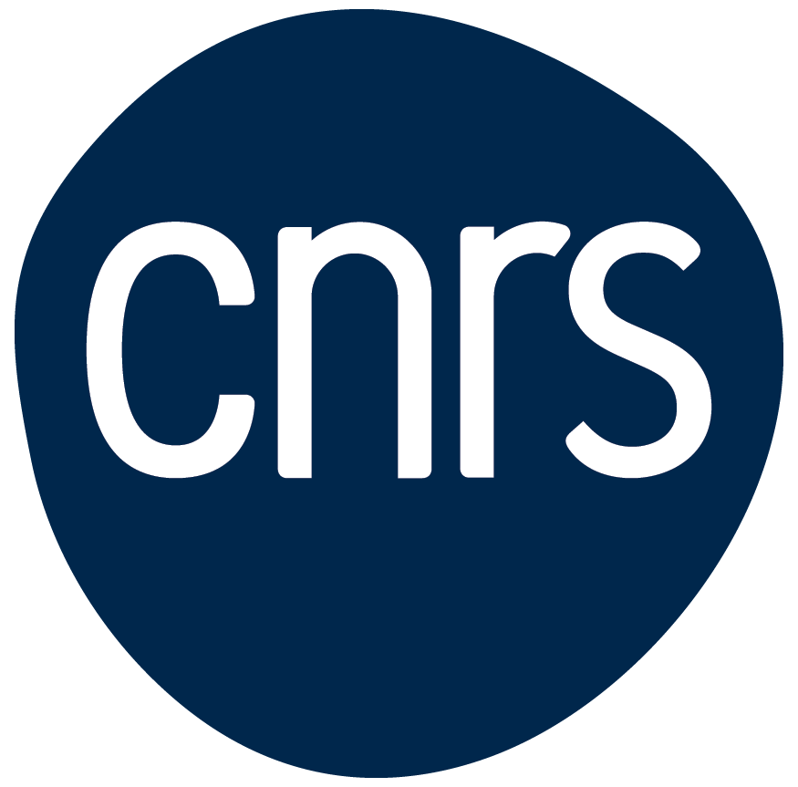


2026 Call for Global Researcher-Short Visits in AI in Science Capacity Building
Co-funded by the Schmidt AI in Science Global Faculty Fellowships and the CNRS–Imperial “Abraham de Moivre” International Research Laboratory (IRL)

Overview
The Eric and Wendy Schmidt AI in Science Global Faculty Fellowships, in partnership with the CNRS–Imperial “Abraham de Moivre” International Research (IRL), are pleased to announce a Call for Short Visits to Imperial on the topic of AI in Science Capacity Building
This initiative aims to strengthen global capacity in the application of Artificial Intelligence to scientific research, fostering collaboration, knowledge exchange, and long-term partnerships between Imperial College London, CNRS, and universities and research institutes in Least Developed Countries and Low and Middle Income Countries (as identified by the OECD), as well as research institutes in Brazil, Chile, and South Africa. Applicants must also be affiliated with, or keen to establish collaborations with, one of the CNRS-Imperial collaborations under the CNRS-Imperial International Research Centre (IRC) for Transformational Science and Technology umbrella (You can read more about the IRC collaborations below and see the academic leads for each on the IRC website):
- International Research Lab 'Abraham de Moivre' (Mathematics)
- International Research Lab Ayrton Bleriot Engineering Lab
- Imperial–CNRS International Research Lab in Multiscale Metabolism 'Antoine Lavoisier'
- International Research Network Quantum Fields and Strings
- International Research Network GOLDMINE (AdvancinG TechnOlogy, AppLications anD FundaMentals In Coherent NanosourcEs)
- International Research Network LhARA (Laser-hybrid Accelerator for Radiobiological Applications)

Programme Objectives
The short-term fellowships (one-month visits) are designed to:
- Build sustainable capacity and leadership in AI-driven scientific research across CNRS and Imperial partner institutions in the Global South.
- Promote the exchange of ideas, methodologies, and tools in the use of AI for fundamental and applied sciences.
- Strengthen research networks between Imperial -- and in particular Imperial’s I-X Centre for AI in Science --, CNRS laboratories, and partners in Least Developed Countries and Low and Middle Income Countries (as identified by the OECD), as well as in Brazil, Chile, and South Africa
- Encourage equitable global collaboration in scientific innovation, research training, and AI education.

Available Fellowships
Over a three-year period, up to four one-month visits per year will be supported at Imperial’s I-X Centre for AI in Science, in collaboration with the CNRS–Imperial “Abraham de Moivre” International Research Laboratory (IRL). The CNRS-Imperial IRC supports this initiative. The CNRS-Imperial IRC is one of seven global IRCs created with CNRS, with each IRC working in different but complementary areas, to do science that benefits people and our planet.
This short visit programme provides an opportunity for researchers to also explore how their work might also engage this wider network of IRCs.
These visits will complement the Schmidt AI in Science Global Faculty Fellowship network.

Eligibility
- Applicants must be researchers from universities or research centres in LDCs, or LMICs, or Brazil, Chile, or South Africa.
- Applicants must have links, or be keen to develop links, to one of the CNRS-Imperial collaborations that are part of the larger CNRS-Imperial International Research Centre.
- Applicants should have an active research interest in the application of AI to the sciences, preferably focused on the mathematical sciences but also including, physics, chemistry, metabolism and health, life sciences, or engineering.
- The call is open to faculty members who are not current Schmidt AI in Science Fellows.
- Each applicant must secure a host supervisor based at Imperial and affiliated with one of the CNRS-Imperial IRC collaborations.

Funding and support provided for a four-week visit to Imperial:
- Subsistence grant: £950 per week to cover food, accommodation and other necessary expenses. (adjusted if the visit Is less than one month)
- Up to £1500 towards return economy flights
- Payment for standard visitor visa (£127)
- Contribution towards costs for travel/medical insurance
- Administrative support for visa application and ATAS clearance, where required.

Please note: Only individual research members are eligible for the funding, and dependents will not be supported. Visitors are expected to arrange their own accommodation in London for the duration of their stay. Placements must take place in 2026. Separate calls will be launched to recruit applicants for 2027 and 2028 visits. If your application for a visit in 2026 is approved, but you experience delays of visa, ATAS or similar reasons, please contact us to discuss options. We can't guarantee that we can postpone your visit but will endeavour to find a solution.

You should prepare to have at least £200 (or equivalent) available to you if successful as there may be some instances where you will need to pay in cash/local currency. We will reimburse you when you arrive in the UK.
- Fellows will receive support from the hosts and departments as outlined above, and have opportunities for networking and mentorship with Imperial's I-X and Schmidt programmes, the CNRS-Imperial IRC, and other related networks.

Visit Options

Visiting researchers must identify the purpose of their visit, as this determines visa requirements and documentation required.

Visit Options

Option 1: Meetings
For attending meetings, workshops, and events

Requires:
- UK Standard Visitor visa

Option 2: Research
For undertaking research in addition to meetings.

Requires:
- UK Standard Visitor Visa + ATAS clearance (unless visiting Medicine or Imperial Business School)
Applicants must briefly outline planned activities so ATAS requirements can be assessed.
ATAS note: Apply for ATAS at the same time as your visit application. Approval can take up to three months and is required before applying for a visa.

Application Process
Applicants must submit the following to the Selection Committee via umi-staff@imperial.ac.uk for evaluation:
- A two-page proposal outlining:
  - The selected visit option
  - The planned research visit and its relevance to AI in Science.
  - Expected outcomes and potential for sustained collaboration.
  - How the visit supports capacity-building and network development.
- A short CV (maximum two pages).
- A letter of support from the host supervisor (based at Imperial and connected to one of the CNRS-Imperial IRC collaborations.
- A letter from your home Institution confirming support for your visit.
Applications will be evaluated, according to the following criteria:
- Scientific quality and originality.
- Relevance to AI in Science.
- Potential for long-term collaboration and impact.
- Contribution to capacity-building in the countries targeted in this call.

Key Dates
- Call launch: 11 March 2026
- Application deadline: 24 April 2026
- Notification of results: Within 6–8 weeks of submission.

If additional funding remains after the first application cycle, we may open a second call for applications for visits in 2026.

Contact
For further information or queries, please contact: umi-staff@imperial.ac.uk, Heather Kerst h.kerst@imperial.ac.uk or Lucile Genin l.genin@imperial.ac.uk
Please refer to our Global Fellowships Page for additional information and answers to frequently asked questions.

