

Career Goals
Big Goals | What are your Career Goals? i.e. Lecturer/Fellowship? Data Scientist?
Stepping Stones | How will you achieve your Big Goals?
Break down your goals into small, achievable tasks so that you get frequent opportunities to accomplish them and feel motivated to take on other goals.
i.e., Big Goal = Secure a fellowship | Stepping stones = To secure a fellowship I will have to - search for funding, find a host, draft an application, establish collaborators, budget plan, update CV….
i.e., Big Goal = Transition to industry | Stepping stones = To transition to industry I will have to - research job opportunities, network with potential employers, update CV, update LinkedIn profile….

Top tips for setting goals and creating your stepping stone:

SMART Goals
- Specific – precise and detailed – what exactly do you want to achieve?
- Measurable – with criteria for determining progress and success – how will you know when you’ve achieved it?
- Achievable – attainable and action-oriented – is it something you have control over?
- Realistic – relevant and aligned – why is this applicable to your career / life?
- Time-bound – grounded within a time-frame – when do you want to achieve your goal?

Locke's goal-setting theory (1968, Edwin A. Locke and Gary P. Latham,)
- Clarity – effective goals are clear, measurable, specific
- Challenge – difficult enough to be interesting, not so difficult that you can't reach them
- Commitment – attainable and relevant – i.e. contribute to an overarching goal
- Regularity of Feedback – monitor your progress to maintain momentum and enthusiasm
- Allow enough time especially if you have to learn how to do the task "on the job“

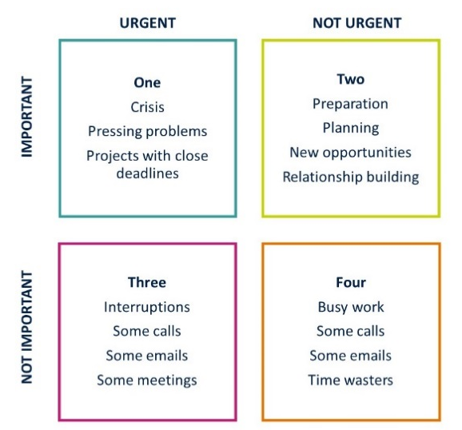
Priorities
- Set priorities so that you know which of your goals to focus your attention toward
- Clarity – Effective goals are clear, measurable, specific
- Challenge –difficult enough to be interesting, not so difficult that you can't reach them.
- Commitment –attainable and relevant – i.e.. contribute to overarching goal
- Regularity of Feedback – Monitor your progress to maintain momentum and enthusiasm
- Allow enough time especially if you have to learn how to do the task "on the job“
- Setting priorities will help you avoid feeling overwhelmed by having too many goals
- Consider your goals using the Urgent vs. Important Matrix; classify your daily, weekly and future tasks / goals across the four quadrants. Important = tasks which will have a significant impact. Urgent = tasks which will have an immediate impact and you must do now
- Most tasks you plan based on your goals will be Important or Urgent & Important
- Consider your time and how to focus on the important things in your career and life

Contact us:
ecri@imperial.ac.uk

