

Idox GRANTfinder 4 Education

Online research funding and news service

Imperial has subscribed to Idox GRANTfinder 4 Education, an online provider for research funding information offering a searchable database of funding opportunities with the option to subscribe to alerts.
GRANTfinder 4 Education allows academic institutions in the UK to service all their funding search requirements in one place:
- RESEARCHconnect – funding opportunities for research staff of all levels and interests
- GRANTfinder – of interest to staff in business engagement, knowledge transfer, marketing
- POLICYfinder – for coverage of white papers, consultations and policy landscape information

This resource offers the ability to search for up-to-date funding opportunities, and share information across defined groups and the wider communities at Imperial - please see the RESEARCHconnect quick start guide from Natural Sciences for more information.

GRANTfinder 4 Education - the UK's first grants and policy information service tailored specifically for further and higher education institutions, featuring over 13,000 continuously updated opportunities. As a professional funding service powered by Europe’s leading provider of funding and policy information, GRANTfinder 4 Education provides you with the following key benefits:

- A one-stop-shop of funding information – removing the legwork when searching for funding opportunities.
- A holistic view of the funding landscape – thousands of funding opportunities reported to support both R&D and wider business development.
- Updated in real-time – as soon as it knows about a new funding opportunity, so do you.
- All information is presented in Plain English – ensuring that jargon and text-heavy guidelines are easily accessible to users.
- Email alerts – automatic updates on saved searches, alerting you to new or updated funds relevant to your research.
- News alerts – approaching deadlines and new funding calls delivered directly to your inbox.
- Encouraging knowledge transfer – allows you to disseminate information through bespoke reports and intuitive reporting features.
- A regular funding bulletin - categorised by discipline, keeping you updated with research areas of interest to you.
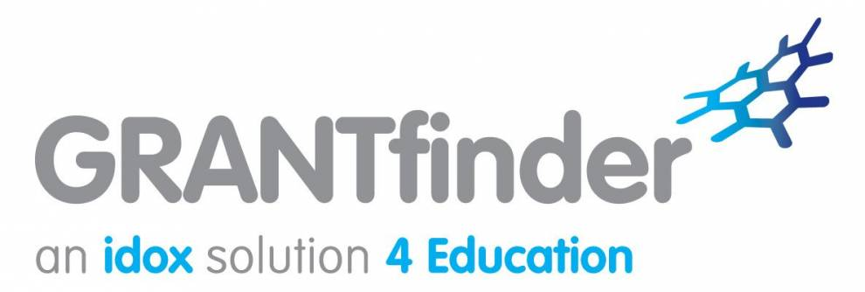

GRANTfinder 4 Education Sign Up
- Features of the system
Please see a quick start guide to learn how to:‌
Start a search - Filter results - Retrieve a search - Set up email alerts

See Explore RESEARCHconnect video for step by step instructions
- How to sign up
Register - to set up an account you need to register on Idox Grantfinder
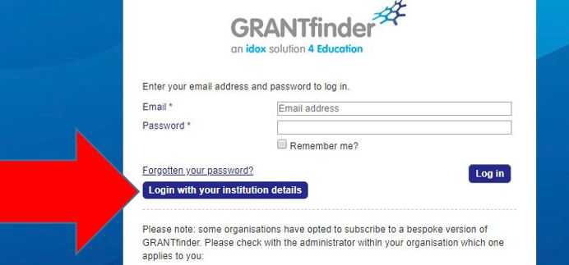
To login go to https://search.grantfinder.co.uk/education/ Click on the Blue “Login with your Institution Details Button”

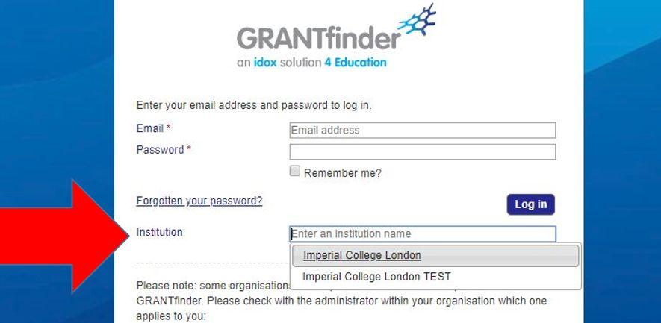
Type Imperial College London in the “Institution Field” and click enter. Once redirected to Imperial’s own login page, enter your Imperial login details to access the site.

GRANTfinder 4 Education has three separate but complimentary modules which can be explored by selecting the relevant blue button once you are logged in. The modules are as follows:
- RESEARCHconnect – funding opportunities for research staff of all levels and interests
- GRANTfinder – of interest to staff in business engagement, knowledge transfer, marketing
- POLICYfinder – for coverage of white papers, consultations, and policy landscape information

Contact us:
ecri@imperial.ac.uk

