
Negotiation Skills

1. What is negotiation?
Negotiation can be defined as a strategic discussion that results in a desirable outcome for both involved parties. This tip sheet will provide you with suggestions to help you with the process.
Negotiations require give and take, meaning that one or both parties will need to make some concessions.
There are many scenarios where you will need to negotiate. These may include discussions about:
- Authorship and authorship order
- Salary or a fee for some consultancy work
- Your role and responsibilities within an institution or research group
Learning to negotiate is a skill which takes time and practice.
2. The negotiating process
The diagram below shows the different steps involved in negotiation, although they may not necessarily follow the order shown.

3. Prepare
Go into a negotiation scenario fully prepared. Try to view the process as a strategic game where both parties are aiming to get most of what they want.
Identify what you want. Write down a list of your ‘must haves’ as well as a list of negotiables. Consider all the elements that could form part of a negotiation e.g., if you are discussing a working package, there is more to be considered than the salary. Think about other benefits that may be on offer such as childcare schemes, help with relocating, part-time working etc.
If you are discussing your responsibilities at work, write down all the responsibilities that you have. What do you want to keep, and which duties are you looking to stop doing?
Consider what you might lose if you do not get what you want e.g., not negotiating a salary can result in a significant financial loss over a lifetime, or continuing with a growing list of responsibilities may lead to workplace burn-out.
Second guess what your negotiating partner might want. Think about the person you are negotiating with. What will be important to them? Try to second guess what they might be unwilling to compromise on.
Let’s say you want to use 3 of your 10 development days to take a course on science communication which runs 4 times a year. Your group leader is reluctant to let you go because they cannot see the benefits to your research, and you are also co-writing writing a paper with an imminent deadline. It is likely that your group leader will want you to meet the deadline so keep this in mind when you speak to them about the course. Let them know about the 4 courses available and reassure them that you will sign up for the later course to ensure you meet the deadline for the paper. It is also worth pointing out how the course will improve your writing skills for future publications. This is likely to benefit both you and your group leader!
Human relationships often work on the principles of reciprocity; people are more willing to give if they also get some of what they want.
Developing one’s emotional intelligence is key in effective negotiation. This Harvard Business Review article looks at this in more detail. Start by trying to understand other people’s emotional triggers. For example, David Rock’s SCARF model describes 5 ‘domains’ that can influence people’s behaviour in social situations. These are status, certainty, autonomy, relatedness, and fairness. Understanding how these domains play a role in people’s emotional triggers will help improve your negotiation skills.
Here is an example. You are working with a principal investigator that likes to know what is happening and when. You notice that anything that makes them feel uncertain about the future, such as your work plans, tends to trigger an unfavourable response. This could be an example of someone that likes to have ‘certainty’ in their life and/or work. When you are negotiating with someone like this, try to keep them informed and up to date to ensure a more favourable response to requests. Minimising this ‘certainly’ trigger for your line manager will help them feel secure and more open to negotiation.
Understanding your own triggers and threats will also help you. Take the time to identify your own emotional triggers. You can then choose to interact calmly, using executive functioning rather than the heightened emotions associated with a fight or flight response.
It is also helpful to understand how different people handle conflict, as described in the Thomas-Kilmann conflict model. A person’s behaviour in conflict situations falls broadly into five modes known as competing, collaborating, compromising, avoiding, and accommodating. Knowing your behaviour mode and your negotiating partner’s mode will help you to adapt your behaviour to complement theirs. Two competing styles, for example, make it very difficult to reach an agreement!
4. Discuss
Your preparation should serve you well when you begin to discuss what you want. Listen very carefully to what is being said as well as observing body language closely. Are you able to identify key elements that might be important to your negotiating partner? Are these elements in your list of negotiables or not?
Although obvious, it is important that both parties understand completely what is being said. Clarify the discussion at every stage, paraphrasing or restating what you have said and what your negotiating partner has said. This will ensure effective communication and clarity throughout the process.
5. Proposition
As the conversation progresses, it should become clear what both parties want. If this is not clear, take the opportunity to seek clarity. Use phrases such as ‘So what I understand is…..’ or ‘Just so I am clear, what we have agreed is….’
Remember your preparation here and hold strong on your non-negotiables. Don’t be tempted to self-sabotage and let negative thoughts affect your proposition, leading you to agree to something too soon. You can slow down the process, ask for more time, or request another discussion, if you feel that things are moving too quickly.
6. Bargaining
Ideally, you will be able to reach an agreement where some of your needs are met and some of your negotiating partner’s needs are met as shown in the grey box below.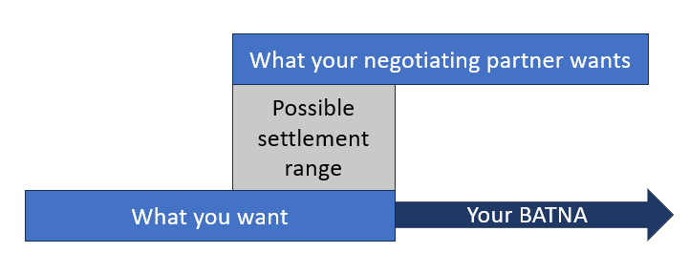
However, it can be useful to have a plan B, or what Ury and Fisher in 1981 call, a BATNA (Best Alternative to a Negotiated Agreement) if possible.
Having a plan B will allow you to walk away if you need to, allowing you to feel safe and confident regardless of the outcome.
An example of a BATNA might be that you have been asked to do some consultancy work for a company, but they are offering you a fee that is lower that your request. Your BATNA is that you have another piece of work lined up that pays what you want. Whether you share your BATNA with your negotiating partner depends on the context, and whether it will give you an advantage i.e., in this case an increase in the fee the company is willing to pay you.
7. Agreement
The final stage of the process is where you both clearly state, and write down the agreement, with follow-up actions.
When negotiating, try to keep emotions at bay and aim for a win-win scenario for both parties. Negotiation takes practice, which comes with experience in different scenarios.
8. Useful Links
- Science Careers: Think you can’t negotiate your job offer or postdoc position? Think again.
- HBR: Emotion and the art of negotiation.
Contact us: ecri@imperial.ac.uk

