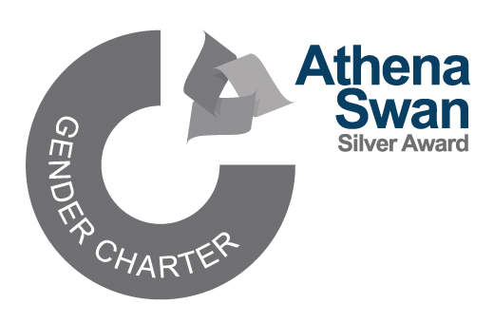


The Julia Higgins Medal and Awards

Nomination particulars
The Julia Higgins Medal and Awards are awarded annually to recognise significant contributions to the support of women in academia at Imperial. The Medal and Awards are named in honour of Professor Dame Julia Higgins, who has been a leading light in improving the standing of female academics at Imperial.
Awards can be made to individuals, departments, or groups of individuals (of any gender). The awards recognise significant contributions to the creation of a ‘level playing field’ for women in academia, in accordance with Imperial’s Values and Behaviours of Respect, Collaboration, Integrity, Innovation, and Excellence.
Nominations should focus on specific activities within the last two years. Nominees with sustained contributions or recent high impact achievements may be selected for a Julia Higgins Medal. If you would like your nomination to be considered for a Medal, please make this explicit in your nomination statement.
We welcome nominations from across Imperial and particularly encourage nominations for those who have not already received some form of recognition. Details of previous winners are available.
The deadline for nominations is Friday 13 March 2026.
The completed nomination form should be returned by email to the Associate Provost (Equality, Diversity & Inclusion), Professor Bernadette Byrne and Dr Wayne Mitchell.

Other staff recognition awards
Imperial is committed to building a supportive, inclusive, and highly motivated staff community across all disciplines, functions, and activities.
Imperial has a number of different staff awards to recognise and celebrate the achievements and hard work of staff. Nomination periods are open at the same time, so please consider nominating colleagues for these awards too. We would like to particularly highlight the President’s Award for Excellence in Equality, Diversity and Inclusion.

Julia Higgins Medal and Awards nomination form
Name of the member of staff / department / group of individuals whom you are nominating:

Proposer’s details
Name:
Department:
Email address:
Phone number:
Signature:
Date:
Seconder’s details
Name:
Department:
Email address:
Phone number:
Signature:
Date:

Nomination statement (no more than 500 words)
Please explain what your nominee has done to merit a Julia Higgins Award. Provide evidence of specific actions or activities undertaken within the last two years.
The focus should be on the impact and/or beneficial effects your nominee has made to support women in academia at Imperial, rather than the nominee’s academic or professional success.

