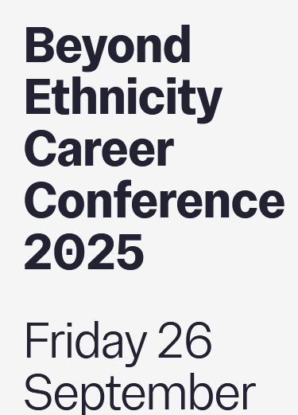

Workshops
You will have the opportunity to go to one of the workshops at 1.20pm and one of the workshops at 2.20pm

1.20pm workshops

Connecting for Impact in a Mosaic World- Susan Popoola
This is a workshop grounded in Susan’s work of creating a Mosaic World that recognises and values the uniqueness and value each person brings.

Susan will be facilitating a session that empowers participants to better recognise and appreciate the value that they and others contribute to the workplace. The workshop will support participants in more confidently developing understanding and creating connections that enable them to have a stronger, more positive impact both at work and in the wider world.

Science’s Colonial Legacy: Reflecting on our Own Practices- Dr Nuzhat Tabassum
Dr. Nuzhat Tabassum will give a deep dive into how European scientific endeavours were shaped by Imperialism with a focus on Earth, ecological and environmental sciences (but not excluive to). Tabassum will share her own journey including exclusionary academic experiences, challenges working in natural history, and (un)learning practices. You will explore how scientific institutions continue to benefit from the legacy of European Empires and understand how they harm people and the environment. At the end of this session, we will work together on brainstorming actions to address colonial attitudes in our research and feel empowered to embed more inclusive practices in our work.

2.20pm workshops

Workplace Adjustment: Calibre- A Case Study of Inclusive Practice- Gabriella Kerr-Gordon
Gabrilla Kerr-Gordon has run Calibre, Imperial College’s career development and leadership programme designed specifically for people who identify as neurodiverse, disabled, or who have a long-term physical or mental health condition. Join Gabreilla to find out about her experience of working with colleagues who have faced institutional and interpersonal barriers in their careers and how they have attained their goals by understanding the legal framework around equality, honing their leadership skills and broadening their networks.

Building Confidence and Resilience to Overcome Imposter Syndrome- Faith Ruto
Have you ever experienced imposter syndrome?
That feeling of not belonging or doubting your own success even when you’ve earned it? You’re not alone. Research shows that up to 70% of professionals encounter imposter feelings at some point in their careers and for ethnic minority professionals, this experience is often intensified by systemic barriers, bias, and the pressure to constantly prove oneself.
This workshop, Breaking Barriers: Building Confidence & Resilience to Overcome Imposter Syndrome, has been designed specifically for you. Over the next 60 minutes, we will explore how imposter syndrome shows up in your professional journey and how you can transform those doubts into strengths.
This empowering 60-minute masterclass will help you:
- Challenge self-doubt and silence the inner critic.
- Strengthen resilience in the face of workplace barriers.
- Boost confidence and step into their authentic power
This dynamic and interactive session offers a safe and empowering space to reflect, share, and take bold action.
Key Takeaways: Walk away with clarity, practical strategies, and a renewed belief in your ability to successfully navigate and thrive in your career in the age of AI Workshop Takeaway

