Minutes

Safety Health Environment Leadership Team (SHELT) #3
12.00 – 14.00 on Thursday 21 January 2021
Via Microsoft Teams

In attendance:

Name | Company
Denis Murphy (Chair) | Head of Health and Safety, EO (Imperial College)
Sangita Kerai | Health & Safety Advisor, EO (Imperial College)
Adam Srodzinski | Head of Projects, EO (Imperial College)
Sean Fanning | Head of Fire Safety, EO (Imperial College)
Rakesh Patel | Head of Maintenance, EO (Imperial College)
Jan Carberry | Communications Officer, EO (Imperial College)
Guy Fairhurst | Building Manager, EO (Imperial College)
Derek Rees | Programme Director, CLOCS
Kathleen Hegarty | Oakland Building Services
Aron Manoharan | Erith
James Winsor | Quest
Max Sjoblom
Andy Cook | Kinetic Contractor
Mark Baker | 8Build
James Stedman | Cuffe Plc
David Anderson
Mark Henman | ARC Group
John Fawcett
Dee Barber | KDC
Richard Gayle | Russell Cawberry
Sarah Bidmead | ISG
Jack Pitt | ISG
Shaun French | Llorett Fire and Security

1. | Welcome and opening statement by Chair – Denis Murphy (DM) | Action
1.1 | DM wished everyone a happy new year and thanked them for attending this meeting.
1.2 | DM informed everyone that Olu Oduntan is in hospital with COVID, and therefore will be taking this meeting today. Our thoughts and prayer are with Olu and wished him a speedy recovery.
1.3 | DM wishes everyone in attendance are keeping well and looking after their colleagues, friends and family throughout these difficult and uncertain times.
2. | Construction Logistics and Community Safety (CLOCS) - Derek Rees (DR)
2.1 | DR delivered a presentation (Pdf attached under Action) on the impact of the construction HGVs have on pedestrians, cyclist, motorcyclists and other road users, due to many factors, including lack of visibility.
2.2 | Statistics indicate that there have been 28,325 fatalities or personal injuries due to collision with a construction vehicle in the last 5 years.
2.3 | DM & AS agreed to look at what more Imperial and our contractor partners could do, to improve the management of construction related delivery risks and to consider registering as a CLOCs Champion. | DM/AS
2.4 | Jack Pitt stated that they are part of the programme and will reinstate it with ISG
2.5 | Imperial are registered on the Fleet Operator Recognition Scheme (FORS).
2.6 | SF asked if the data of incidents have improved with increased cycle lanes put in place during the pandemic  DR – there is a delay by a year on the official data. The current data is for 2019. However, it has been noticeable that limited vehicle movement has reduced congestion on the road and as a consequence has encouraged vehicle to go faster!
3. | Site Operating Procedures -Version 7: The challenges involved in compliance – Denis Murphy
3.1 | DM asked the contractors of their processes applied during the pandemic especially with regards travelling from home to work.
3.2 | Jack Pitt (ISG) Building E, White City – have been on site ever since the March 2020 and have adapting their logistic plans to fit within the restrictions. Imperial have been given them the flexibility, providing additional space on site to allow for social distancing.  With over 100 people on site at any one time, they have completed a risk assessment for travel; welfare facilities; sanitisation; temperature checks; staggered start and finish times; set up one-way systems; staggered break; created hard segregation by building walls for separation. They have asked their contractors to review their RAMS and SoPs. They have a Daily Activity Brief with the team. The Project Manager has been very accommodating.
3.3 | Dee Barber (KDC) Reaction Centre, Silwood Park – workers stay locally for two weeks at a time and have been provided with apartments (as opposed to hotel stay) with own cooking and welfare facilities. They have all been issued with company vehicle, and those who cannot drive have been paired with someone who can (encouraged to wipe surfaces in the vehicle; keep face covered and windows open for ventilation) they remain together in a bubble at work too.
3.4 | Richard Gayle (Russell Cawberry) COVID test lab in Flowers Building – are working on staggering people coming on site; temperature checks are taken before entry to site; where social distance is not practical they have issued suitable PPE and facing away from one another if working together; work is prioritised in order to ensure there are not many people in an area that cannot accommodate social distancing; staggering breaks; cleaning team assigned to sanitise after space has been occupied; bins are removed regularly; details of visitors are taken for track and trace; hand sanitisers are available in all areas; one way system in operation together with barriers and floor marking and when using the contractors canteen workers are told to scan the NHS track and trace QR codes.
3.5 | Mark Henman (ARC Group) – Maintain trust with the workers and ensuring that they are getting regular lateral flow tests.
4. | Revised Construction Fire Safety CoP - Sean Fanning
4.1 | The Construction Fire Safety CoP and policies are currently under review, although all documents are available on the College webpages.
4.2 | The Fire Team are working remotely and periodically visit the various sites. They continue to have regular tests when on site.
4.3 | Hot Work Permit to Work (PTW) is also being updated. There is a five days requirement for submission of PTW which should be accompanied with a RAMS. Approval for PTW would also need to be given by the Building and Maintenance Managers.
4.3 | Fire Alarm activation forms would need to be submitted for any alteration to fire alarms to validate the system.
4.4 | Acetylene – not permitted on campus  Hot Work – not permitted. Sufficient approval process should be completed. Certified evidence on training and competence will need to be provided for the use of hot works.
5. | Accidents and incident report 2020 – Denis Murphy
5.1 | Both DM and AS congratulated all the contractors for the amazing work that they have done over the last year under the difficult circumstances of restricted access, hours, space and delivery.
5.2 | Virtual site inspections carried out by Olu, 90-95% have scored GREEN, which is really good.
5.3 | Contractors Accidents/Incidents Report (Jan- Dec 2020)  Total Hours Worked (All Sites) 796,308  Fatality 0  Over 7 days Injuries (RIDDOR) 1  Minor Accidents 10  Near Misses 18
5.4 | 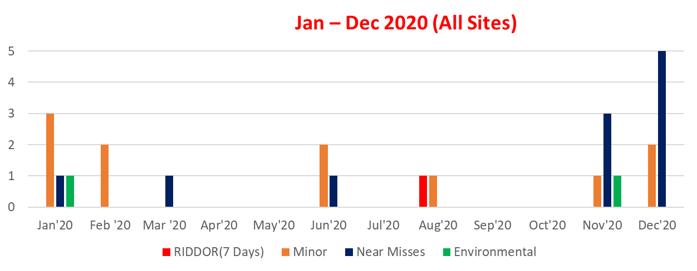  Accident Frequency Rate (7 Days)  ICL – (Jan – Dec 2020) 0.13  UK Construction RIDDOR (HSE) 2019/20 1.7
5.5 | RIDDOR Incident:  A loaded pallet truck accidentally fell from a loading bay from level 3 to ground floor which pushed loading bay gate to strike x1 operative standing behind the gate in the nose  Root Causes:  Operative not following safe system of work, absence of toe board to stop falling items  Measures to prevent reoccurrence:  Stop blocks and toe boards installed on the loading bays at all floor levels, operatives retrained, frequent inspections introduced
6. | AOB
6.1 | SF stated that virtual inspections are working well and may be something worth considering going forward, saving time on travel between sites.
7. | Date of Next Meeting
7.1 | April 2021 – invite and agenda will be sent nearer the time.

