Minutes

Safety Health Environment Leadership Team (SHELT) #4
13.00 – 14.30 on Thursday 29 April 2021
Via Microsoft Teams

In attendance:

Name | Company
Denis Murphy | Head of Health and Safety, EO (Imperial College)
Oluseyi Oduntan (Chair) | Health & Safety Advisor Construction, EO (Imperial College)
Sangita Kerai | Health & Safety Advisor, Facilities, EO (Imperial College)
Adam Srodzinski | Head of Projects, EO (Imperial College)
Rakesh Patel | Head of Maintenance, EO (Imperial College)
Jan Carberry | Communications Officer, EO (Imperial College)
Kathleen Hegarty | Oakland Building Services
Steve Ryan | Quest
John Mauthlley | Cuffe Plc
Mark Henman | ARC Group
Richard Gayle | Russell Cawberry
Sarah Bidmead | ISG
Jack Pitt | ISG
John Sinnott | Oakland Building
Maggie Taylor | Assistant Building Manager, (Imperial College)
Marcus Griffiths | TESN
Bernie Mead | Elecro
Ivor Brown | Graham
Samantha Booth | Logan Construction
Sarah Weare | TESN

1. | Welcome and opening statement by Chair – Oluseyi Oduntan (OO) | Action
1.1 | OO thanked everybody for attending this meeting and introduced some of the ICL members present | Info
1.2 | OO reminded the contractors that SHELT meeting is for everybody and encouraged them to participate in the discussion. Contractors are reminded to feel free to suggest topics for the SHELT agenda. | Info
1.3 | DM also thanked all attendees for coming
2. | Hot Works Process Flowchart (Projects) - OO
2.1 | OO informed contractors that the revised Fire Safety CoP has now been approved and can be downloaded from the College website.  OO presented the new Hot Work process in a flowchart format and explained each stage of the process in details. The Hot Work procedure is now live, and contractors should follow the new process when they undertake hot work tasks, but only as a last resort, other less risky alternatives should be the first option.  Rak Patel sought clarification whether the new process will also apply to in house maintenance team. New process is for construction projects only and maintenance team should continue with their existing established practice.  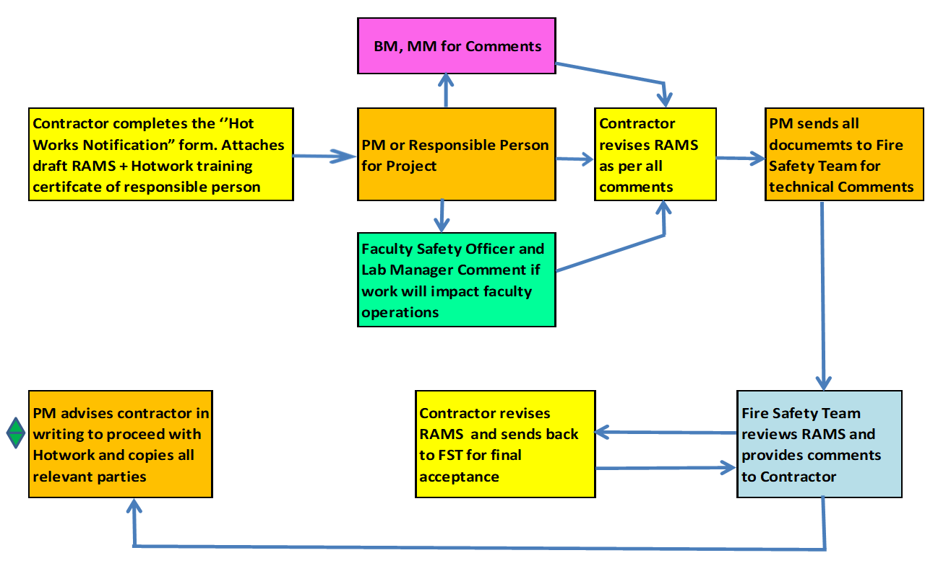 | Info
2.2 | Summary of New Hotwork Process:  Contractors must attach draft RAMS and a copy of the “Hot Works Passport” training certificate to Project Manager (PM), Building Manager and Maintenance Manager for comments.  If works are to be undertaken in an area controlled by a Faculty e.g. a laboratory, or if a Faculty facility may be negatively impacted e.g. affects an extract fan or ductwork from a fume cupboard, then a copy of the RAMS should also be forwarded by the PM to the Faculty Safety Officer and Laboratory Manager for comments.  When all comments have been received and the RAMS updated as necessary by the contractor, the PM will forward the documents to the Fire Safety Team for their comments.  Any comments received from the Fire Safety Team should be incorporated and the revised RAMS resent to the Fire Safety Team for final acceptance.  Upon receipt of final acceptance by the Fire Safety Team and with the Building Manager’s approval, the PM can advise the contractor in writing, that they may proceed with the hot works, in accordance with the agreed RAMS | Info
2.3 | DM informed contractors that the new changes to the Hot Work process is mainly targeted at the PMs, as the contractors are already following the process even in the old regime. | Info
2.4 | Most contractors confirmed they have no problem implementing the new Hot  work procedures. Contractors are advised to download and read the revised Fire Safety CoP including the Hot Work flowchart and update their site managers accordingly.
3. | Lateral Flow Testing (LFT) – OO
3.1 | OO started by quoting a recent statement by the UK Health Secretary-  ’’Regular workplace testing is a vital part of our route back to normal life…lateral flow tests have already been hugely successful in finding positive cases quickly and every positive case found is helping to stop the spread- so I encourage employers and workers to take this offer up. We must do all we can to stop the spread of Covid, right now’’  Facts and myths about Lateral flow test were discussed. It was explained that:  - LFT is only for workers showing no symptoms  - LFT can be conducted on site or at home  - LFT must be done once a week after weekend  - You should continue to use LFT even if already vaccinated  - A confirmatory PCR test is required after a positive LFT  - The test results must be reported on NHS website  The College strongly advise contractors to use LFT to monitor the Covid-19 status of their operatives as this aligns with the best practice that most construction companies have now adopted. | info
3.2 | DM advised that although at this stage the use of LFT remains optional, he appealed to contractors to consider the option particularly when the College feels strong about it as a sensible way to demonstrate that contractors are not increasing the chances of spreading the virus as we start to see increased numbers of students coming back to campus. | Info
3.3 | Mark Henman (ARC Group) confirms that ARC sites are already using LFT to monitor their staff and explained that the process is quite simple. He stated that their operatives take advantage of a Test centre near their site to take their tests.  Their workers are mandated to go for one LFT per week. He reiterated that his site is committed and will continue to use the LFT to monitor his workers as it provides confidence to everybody including the workers. | Info
3.4 | Richard Gayle (Russell Cawberry) agreed that LFT should be adopted by his company and would henceforth request that operatives show their results to site managers on a weekly basis before being allowed on site. | Info
3.5 | Mark Henman (ARC Group) – Will continue to maintain trust with the workers and ensure that they are getting regular tests. | Info
4. | Accidents/Incidents Report (Jan- Mar. 2021)
4.1 | OO presented the accident report for the first quarter 2021 and thanked everybody for their continued support in achieving these figures despite the challenges and restrictions posed by Covid.  Our Accident Frequency Rate (AFR) for the year remains 0.  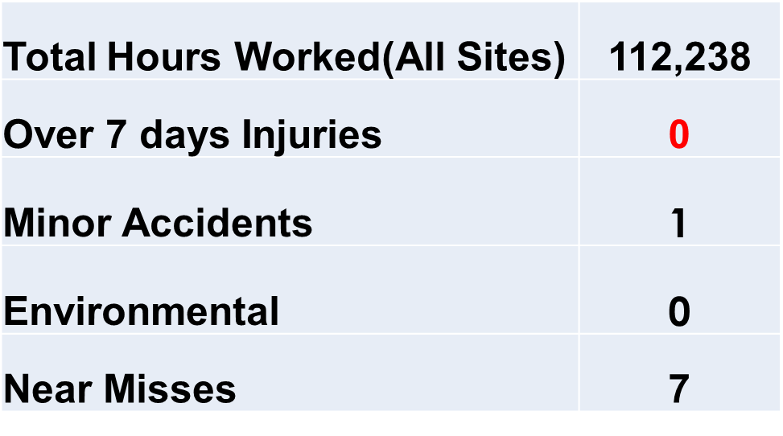 | Info
4.2 | RIDDOR Incident:  There has been zero RIDDOR incidents reported this year and where minor incident was recorded, it had been fully investigated and measures to prevent reoccurrence had been implemented by the contractors. | Info
5 | AOB
5.1 | OO informed that the physical site inspections will resume next month as we have now employed a temporary Construction H&S Advisor who will be supporting OO to undertake these tasks.  Sean Peet will start w/c 3rd May and OO will take him on the majority of the projects to introduce him to the Site Managers. | Info
5.2 | Adam Srodzinski equally thanked contractors for their continued cooperation and collaboration. He informed that consultation on CLOCS as presented at the last meeting is still ongoing and contractors will be advised of College’s position in due course. He appealed for understanding and continued cooperation. | Info
5.3 | Richard Gayle (Russell Cawberry) asked if the SHELT meetings could be moved to the mornings to reduce the interruption to a whole day. This was put to a voice vote and a majority agreed.  Henceforth SHELT meeting will be held on the 3rd week in Jan, April, July, and Oct between 10:00 – 12:00 noon.  OO to send out invitations for the remaining SHELT meetings for this year | OO
76 | Date of Next Meeting
6.1 | July 22nd 2021, 10am- 12:00 – Agenda will be sent nearer the time.

