The EYEC curriculum
Document Ref: EYEC 19
Imperial College London
Property Division: Early Years Education Centre
Version: 3
Date: September 2026

The Early Years foundation Stage Framework (EYFS) states: All children deserve the care and support they need to have the best start in life. Children learn and develop at a faster rate from birth to five years old than at any other time in their lives, so their experiences in early years have a major impact on their future life chances. A secure, safe, and happy childhood is important in its own right. Good parenting and high-quality early learning provide the foundation children need to fulfil their potential. The EYFS sets the standards that all early years providers must meet to ensure that children learn and develop well and are kept healthy and safe. It promotes teaching and learning to ensure children’s ‘school readiness’ and gives children the right foundation for good future progress through school and life. The EYFS is about what children learn, as well as how they learn. Effective practice is a mix of different approaches. Children learn through play, by adults modelling, by observing each other and through adult-guided learning.
As part of our commitment to the children attending Imperial College Early Years, we ensure that we are following a curriculum that caters for each child’s individual needs. We follow the Early Years Foundation Stage (EYFS) framework, where we observe, plan, and set targets around these guidelines. We also have our own curriculum which is based around the Froebelian approach and his Principles.

The Early Years Foundation Stage (EYFS) Statutory Guidance
When considering the needs of the child and to promote good and effective practice, the EYFS principles are taken into consideration, these are:

- A Unique Child
- Positive Relationships
- Enabling Environments
- Learning and Development

Our aim is to provide experiences that will holistically support children’s development in the seven areas of learning, depending on the children’s individual needs, through children’s interests, child-initiated and adult-led activities.

The seven areas of learning are divided into:

Prime areas of learning which are the fundamental areas that support development in all other areas they are the main focus of development up to the age of 3 years
- Personal social and emotional development
- Communication and Language
- Physical development

Specific areas of learning that include essential skills and knowledge for children to participate successfully in society
- Literacy
- Mathematics
- Understanding the world
- Expressive arts and design
The Characteristics of effective learning are woven throughout all areas of learning
- Playing and Exploring-Engagement
- Active Learning-Motivation
- Creating and Thinking Critically- thinking

More information on the guidance can be found at EYFS statutory framework for group and school-based providers

Froebelian approach
Friedrich Froebel believed that children learn 'best through self-activity, play, talk and reflection'. He also valued the importance of forming warm, secure and close attachments with others, in particular within a child's family and wider community. Frobel understood that children learn best by using their senses via their own first-hand experiences in the world around them and that it is through an adult’s sensitive interaction and observations that enable children to thrive. Believing that play encourages children to discover how things work, through experiences which are active, hands on and of interest to each individual child. All being incorporated through the Froebelian principles:

- Unity and connectedness
- Autonomous learners
- The value of childhood in its own right
- Relationships matter
- Creativity and the power of symbols
- The central importance of play
- Engaging with nature
- Knowledgeable, nurturing educators
Within our curriculum we have core areas which take into consideration the EYFS and the Froebelian approach, which we place great importance on and therefore are set out daily for all the children to play and explore, these include;

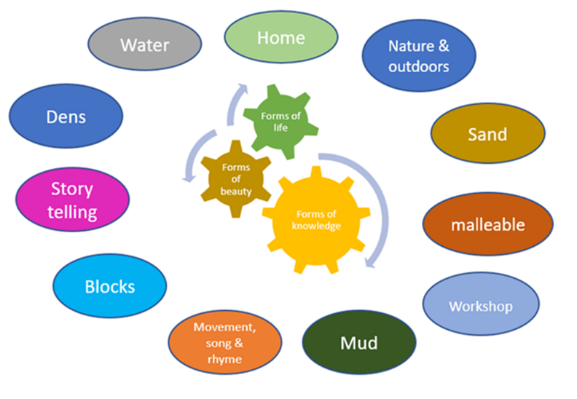

Document revision dates

Version Number | Effective Date | Description of key changes
1 | October 2024
2 | October 2025 | Link to EYFS updated
3 | September 2026 | Link to EYFS updated

