Bulk Update of Rolled Over Leave to an Allowance

If you need to update a large number of records to reflect the approved rolled over leave allowance or holiday bought, use the below bulk upload steps.
To access the system click here 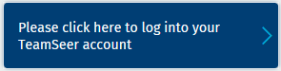 and enter your single sign on details.

On the top ribbon of tabs select HR Admin
The HR Admin page will be displayed
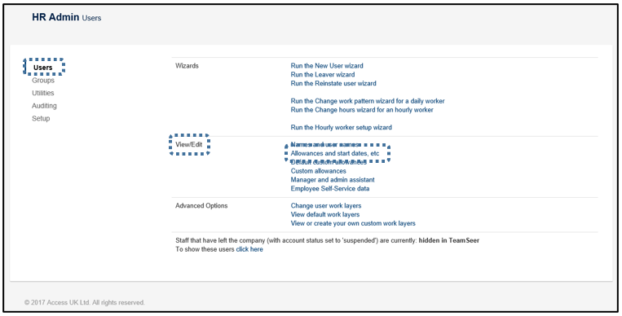
On the left hand side, the Users submenu should be selected by default, but if it’s not click on the Users section.
In the View/Edit section in the middle of the page select Allowances and Start dates, etc.
To set the filter, in the top right corner click into the box labelled Choose a filter.
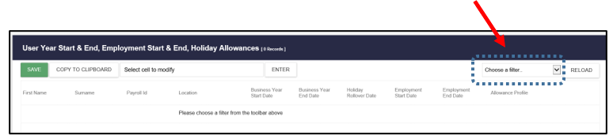
A number of different filters are available with:
All users
Group
Location
Surname starts with…
To view a team calendar group, select GROUP and hit the Reload button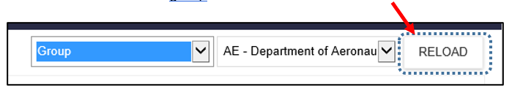
Example shows Group and the AE – Department of Aeronautics filters selected and this will open up the employee data in that specific TeamSeer Calendar Group.

Results will appear.
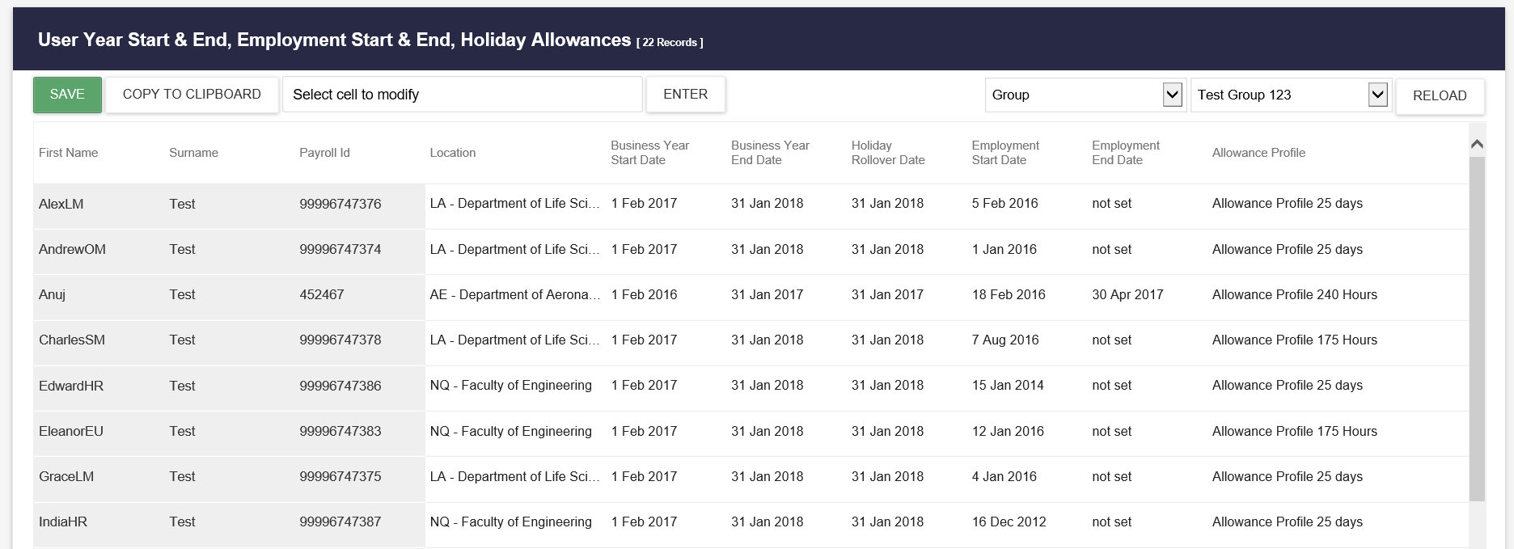
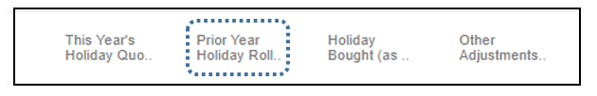
- Prior Year Holiday Rollover will rollover a maximum of 5 days annual leave into the new leave year of 1 February.
TIPS:
- You can use the arrows and navigation bar to scroll through to see allowance columns.
- If you hover the curser over any of the column titles, the further title details will be shown about the data or information contained in that column.
- Click on the column titles to arrange (words by alphabetic or numbers by) order

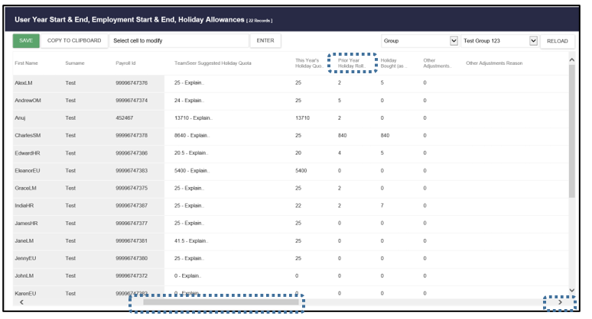
The additional leave approved by a department will be manually added into the Prior Year Holiday Rollover:
- The Prior Year Holiday Rollover field
  - Will hold the allowance rolled over of up to 5 days
  - Hourly allowance rolled over will show in minutes (example: 35 hours will show as 2,100 minutes)
  - This data will be held in the rollover spreadsheet provided to you by the HR Systems team

Steps to bulk update rolled over allowance
- To enter the number of days of additional leave click into the cell for the relevant staff member. E.g. AmdrewOM Test. The cell will be highlighted dark blue;
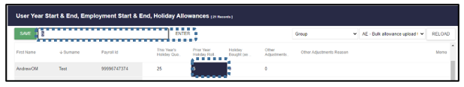
- This activated the edit box in the top left of the page and the cursor has automatically populated the data from the column selected (Prior Year Holiday Rollover or the Holiday Allowance).

- Enter the correct amount
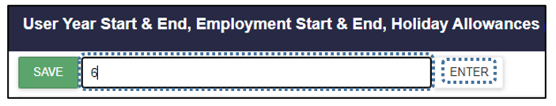
- Press the Enter button and the column will be updated with the corrected amounted.

Repeat steps A to D and work through the rest of the additional approved leave in that team calendar group.
*Note Hourly allowance will need to be added in minutes. Alternatively go to the My Admin | Allowance page to add the hourly allowance.
When you’ve finished entering the approve rollover allowance or bought leave for all employees you must hit the green Save button in the top left hand corner.
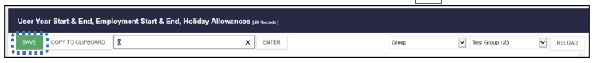
NOTE: If you exit before pressing the save button all your work will be lost.

