Approvals

There are two ways to approve change manager requests, either via email notifications or from within ICIS HRMS.

Approval via email notification
As an approver the change manager request will be routed to you via email.
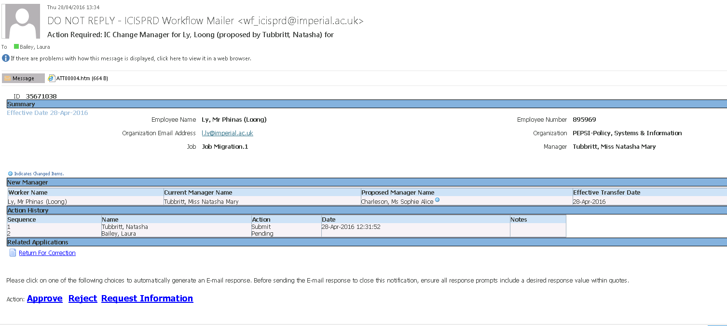

Please review the request and select the appropriate action, Approve, Reject or Request Information
This will automatically generate an email which you must SEND to complete your response
If required you can enter a comment between the quotes in the email. Please do not amend the email further.
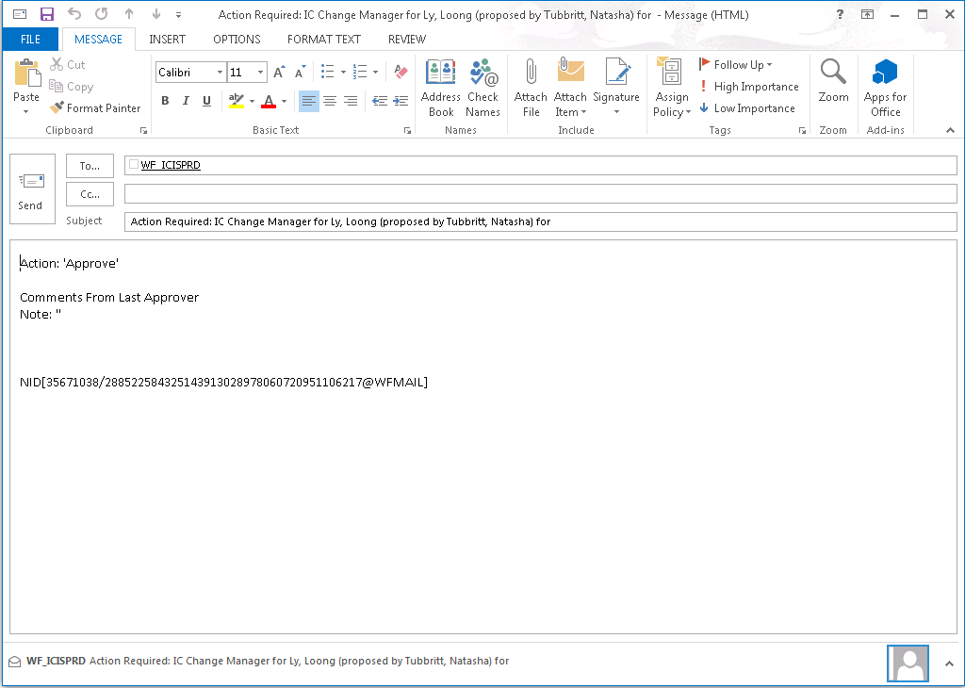

Click the send button on the email.
Your response has been sent.

Approval via ICIS workflow

Log into ICIS HRMS.
All requests for approval will appear in the Worklist area on the right hand side
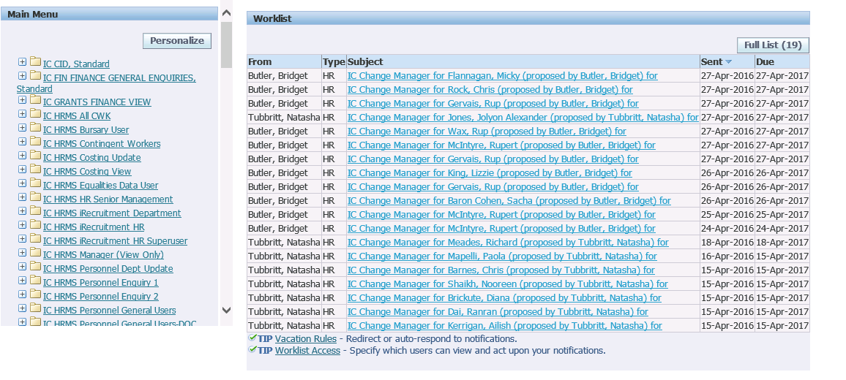
Select the relevant notification.
Please review the request.
If required you can enter a comment in the response field.

Select the appropriate action, Approve, Reject or Request Information

Your response is completed and the item is removed from your worklist.

