Delegated Authority – Maintain Line Manager
Log into IC Manager Self Service in one of the following ways:

If you do not use ICIS already: | Existing ICIS users:
1. You should use the link (https://icisremote.ad.ic.ac.uk/dana-na/auth/url_1/welcome.cgi). Use your College network username and password to login. | 1. You should use the standard ICIS link (http://icis.imperial.ac.uk/) and your College network username and password to login. IC Manager Self Service has been added to your ICIS account so you will be able to find it in your ICIS navigator as an extra responsibility when you log in.

Expand your delegated authority responsibility. N.B. this will take the format IC HR RE – Delegated MSS. The highlighted digits determine which area of records you have been given access to. For example, RE would give you access to update records for those that sit within the RE Primary HR Organisation.

To update line manager data expand your Delegated MSS responsibility, and select Maintain Line Managers.

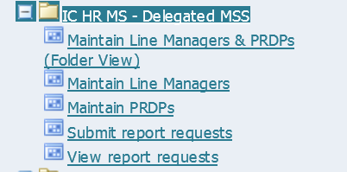

You will be prompted to decide whether you want to change the current effective date. If you’re correcting information, select Yes and enter the date that the change should have been applied to. If you’re inputting new data in anticipation of a change happening in the future select Yes and input the future date. If the change can be applied from today’s date, select No.
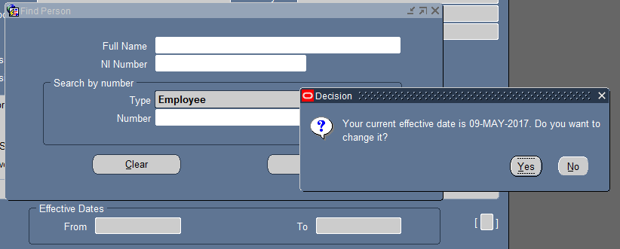

To find the record you need to update you can search by the name or CID number of the individual. If searching by their name use the format SURNAME% or if by their full name SURNAME%FIRSTNAME, e.g. PATEL%PRIYA

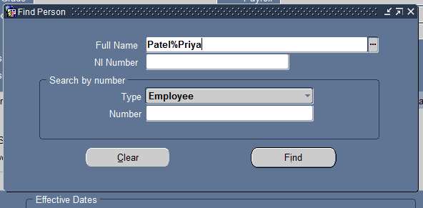

Enter your search terms and then hit enter or the Find button.

The current line manager details held for that individual will be displayed in the yellow fields at the bottom of the box.
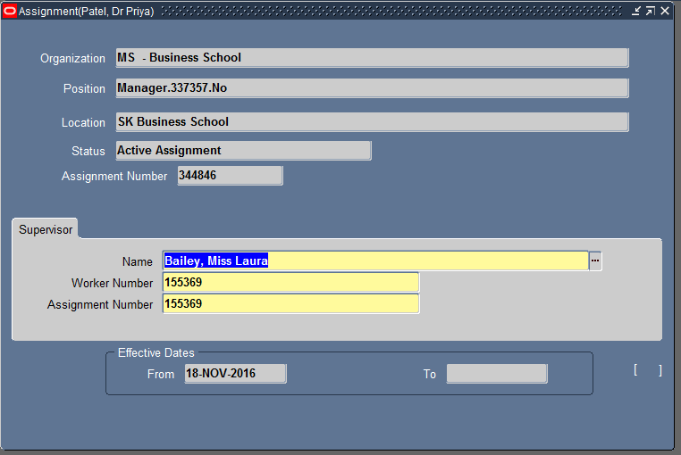

In the Supervisor section, delete out the current line manager’s name. Search for the new line manager by clicking on the 3 dots symbol at the end of the Name field;

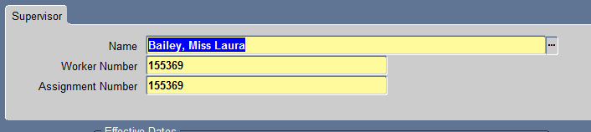

A search box will appear and you can enter the details of the new line manager you wish to assign. You must search by Name to find the new line manager in the format SURNAME%FIRSTNAME.
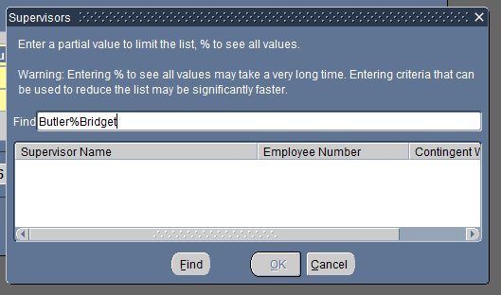

Click the find button to bring up a list of matching results and select the correct entry;
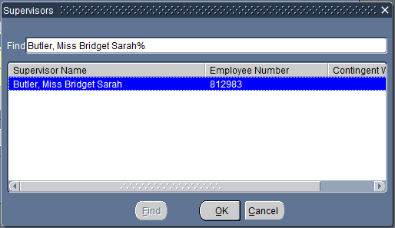

You will be prompted whether you want to save the change as an Update or Correction. Always select Update as we want to keep a record of all previous data.

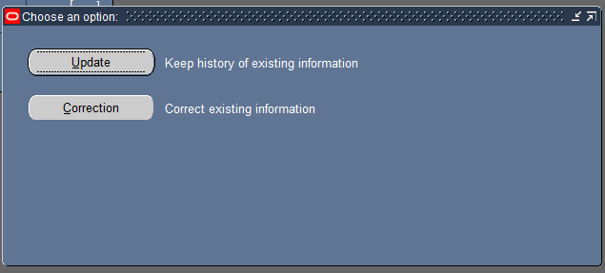
The worker number field will automatically populate with the new line manager’s CID number. However you will need to manually enter the CID number again in to the currently empty Assignment Number field;
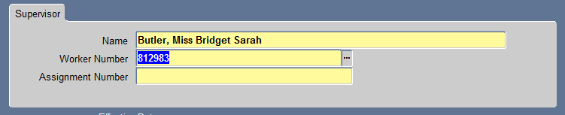
You can either copy and paste the number in and hit save, or use the 3 dots icon at the end of the field to bring up the search box again.
You can then search by the CID number to bring up the correct entry;
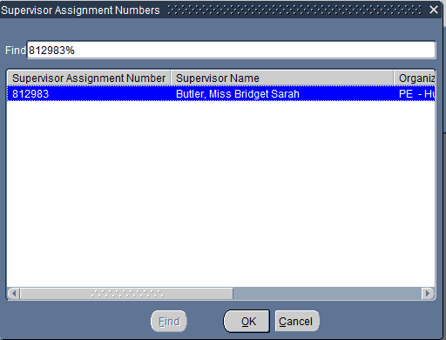

To save and submit your changes, click on the yellow disk icon on the grey tool bar at the top of the ICIS window;
