**Maintaining Line Managers: Effective Date Options**

For any change in line manager information, you will always be asked to complete the date you wish this change to become effective from.

The Maintain Line Managers : Effective Date Options page will always default to today’s date and you can leave this date in, if appropriate. Alternatively you can enter an historical date or a future date.

In some instances, it may be necessary to change the effective date.

**Future Dated changes already exist for a particular individual**

If a future dated change exists for an individual, you will receive an information message at the top of the Effective Date Options page;

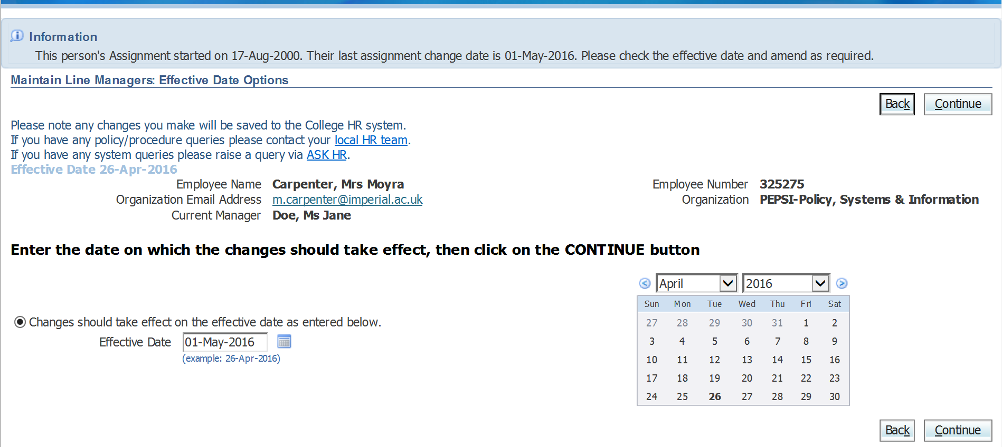

The effective date field will also update to reflect the date that the future change is recorded as happening.

**N.B. You are still able to overwrite this date if you wish to.**