IMPERIAL COLLEGE

ADDING NEW EXTERNAL INTERESTS

FOR APPROVAL

Table of Contents:
Adding a new External Interests for approval.…………….………………………………3
Adding External Interest using email links………………………………………………...9

A Declaration of Interest
The three required declarations have been centralised under the Annual Declarations folder within Imperial College Information System (ICIS):
- My External Interests
- Information Governance and Security
- Policy on the Use of Animals Return

‘If you require further clarification on the process please click here to review the Imperial College’s ‘Register of External Interests and Annual Declaration Policy.’

Adding new External Interests for approval:

- Log into ICIS Self Service by entering your college username and password.

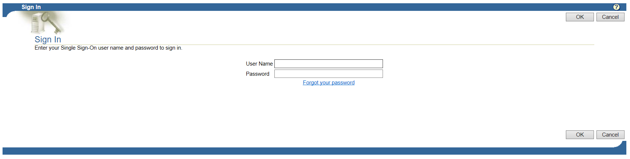

- From the Main Menu by pressing on the to open up My Details folder and click on Annual Declarations

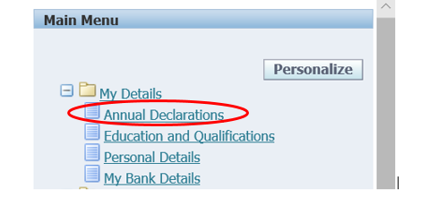

- To add a new interest, click on the Add new button highlighted below:
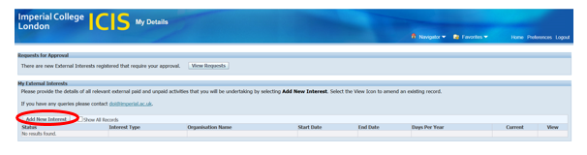
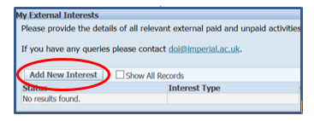
- The system will auto populate the Name, Department and Approver.

However, staff with a secondary role/s will be required to select the relevant Department the Interests is related to.

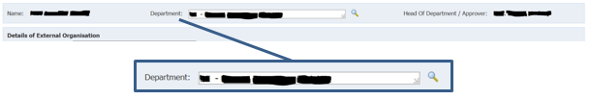

To amend click into the department field and delete. Press the magnifying glass iconto open a search page.

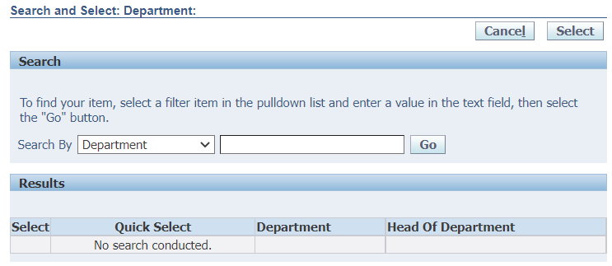

Press the Go button for results to appear and click on action icon in the column labelled Quick Selection to pull through the specific department.

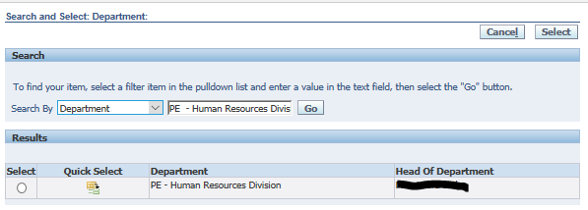

- Select the appropriate Interest Type from the picklist e.g. Directorship.

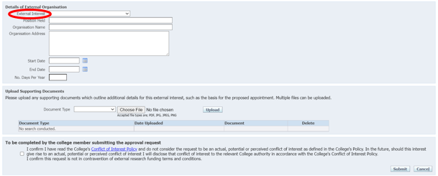

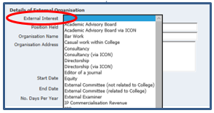

- Complete the remaining fields as shown below:

Note: Organisation Address field can only hold a maximum of 150 characters (including spaces).
- Upload Supporting Documents
- Select from the drop down menu the type of document being uploaded
- Select browse to find and attach the corresponding document
- Press upload

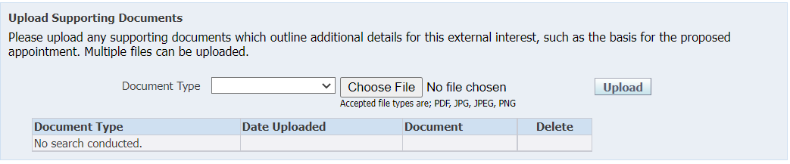

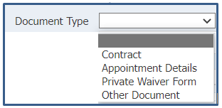

Note: Any number of relevant documents can be uploaded against each document type.

For the External Interests that require a Private Waiver to be signed and uploaded within the supporting documents. This be confirmed in the upload support document and a link is provide to the Private Waiver form.

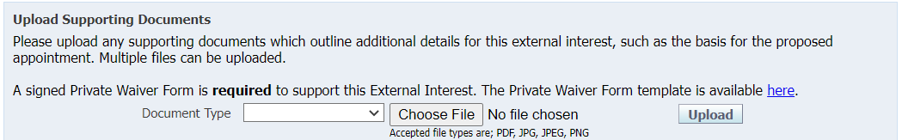

All External Interests requiring this waiver will have the above sentence highlighted in yellow along with a direct link to the Private Waiver template.

Private Waivers are not required for all positions. To view a full list of positions, policies and guidance online click here.

- Complete the final field

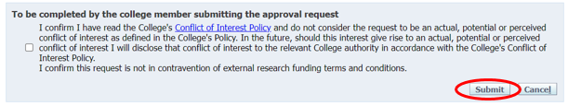
- Click in box for the tick symbol to populate
- Press Submit
Will be sent off for approval

By ticking the box you agree to have read the College's Conflict of Interest Policy and do not consider the request to be an actual, potential or perceived conflict of interest as defined in the College's Policy.

- If you have further interests to declare, click on Add another and repeat steps 3 to 7.

Note: Clicking on Cancel will return you to the homepage and will not save any data entered into the Details of External Organisation page displayed.

To submit the newly added declaration or existing declarations of Interest
Follow steps 10 to 12 below

- Within the Annual Declaration of Interests press the Submit Declaration button

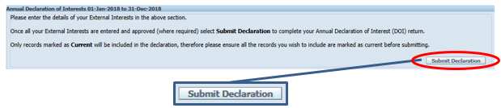

Note: The ‘current’ declaration return year will a year behind for example in 2022 the 2021 declaration between 1st Jan 2021 to 31st Dec 2021 will be submitted. In order to submit an external interest, the relevant box in the Current Interests column must show as ticked.

Declaration of Interests for that are not showing can be added retrospectively for approval.

- A confirmation page will open and once submitted no further information can be amended in the declaration/s.
- To submit current Declarations of Interest press YES

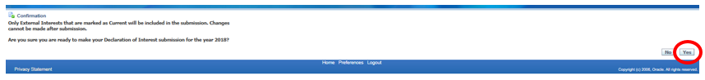

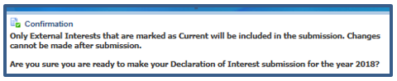

Note: Clicking on NO will return you to the homepage and without submitting the Declarations.

- Once submitted the page will automatically return back to the home screen with confirmation of your submitted current Declaration of Interests

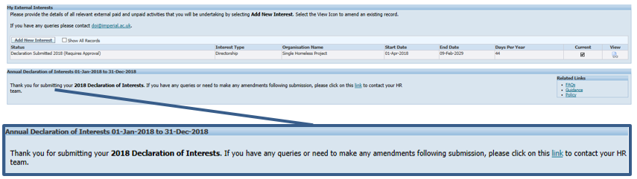

- Under Status there will be a list of all entered Declaration of Interests and once submitted for approval will say (Requires Approval)
- A confirmation message will appear, thanking you for your submission
- The Head of Department / Approver will receive a notification
- Once approved or decline by the Head of Department you will receive a confirmation email

Note: After submitting your return, you will be sent a confirmation email. If you have any queries or need to make any amendments following submission, please click on this link to contact the DOI team.

- Once submitted this will trigger off an approval request email to your Department Manager/Approver.

- If you wish to logout of ICIS after submitting your return, click on the Logout button in the top right hand corner.

Note: If you have any queries or need to make any amendments following submission, please click on this link to contact the DOI team.

Submitting External Interest using email of Interest:
Email communication will go out across the college to those required to complete the Declaration of External Interests.
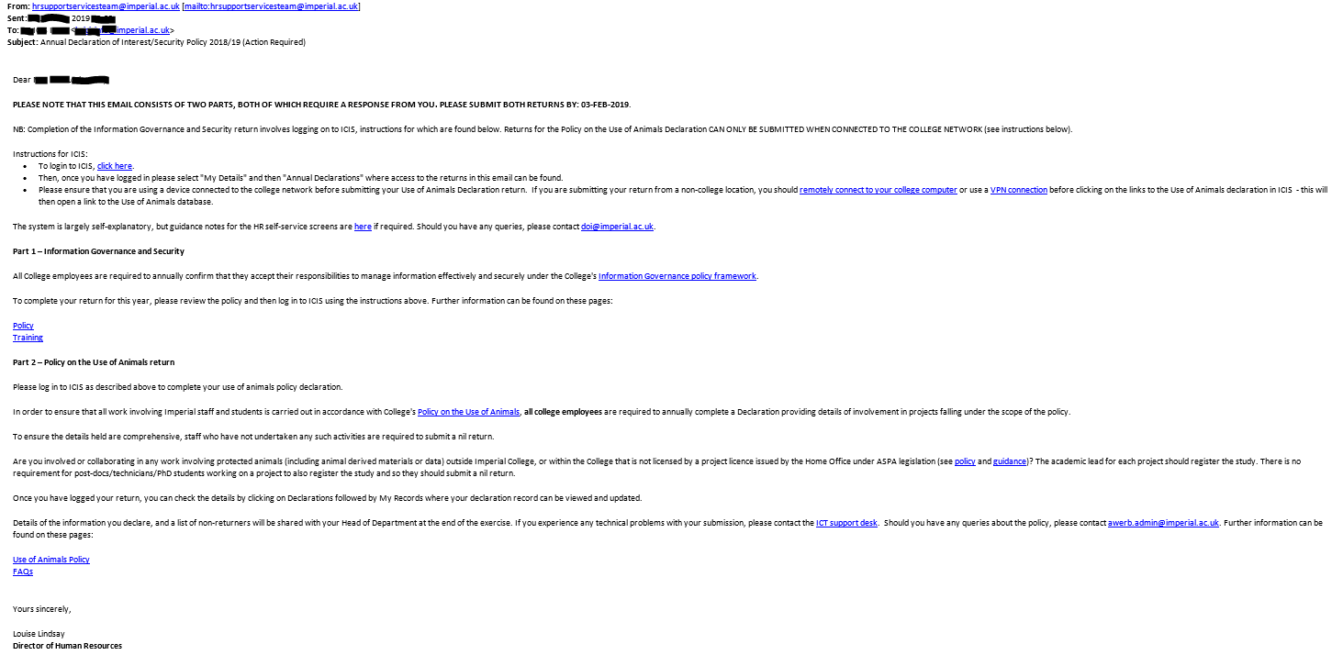

The log in link will direct you to the ICIS page and please follow steps 1 to 14.

Once submitted the page will automatically return back to the home screen with confirmation of your submitted current Declaration of Interests.

- The Status will be a list of all entered of Interests and once submitted for approval will say (Requires Approval)
- A confirmation message will appear, thanking you for your submission
- The Head of Department / Approver will receive a notification
- On success / rejection you will receive a confirmation email

After submitting your return, you will be sent a confirmation email. If you have any queries or need to make any amendments following submission, please email the DOI inbox on doi@imperial.ac.uk.

