TeamSeer FAQs

Staff
How do I log into my account?
Log into TeamSeer directly using your College username and password.
For offsite or remote working, how can I still access TeamSeer?
The TeamSeer site is accessible through the Imperial College’s intranet pages such as the LOG ON Button to TeamSeer on the Annual Leave page or the within the A-Z HR page under letter L where you will find the Log in to TeamSeer link. Additional the development of a mobile webpage is underway to meet Imperial’s accessibility requirements.
How do I book my holiday or log an unplanned absence?
Once you log into TeamSeer click on your name for the drop down menu and select. This opens the Help & Documentation page for you to click on the Video Tutorials and select the Ideal to users new to TeamSeer to watch the online video guidance.
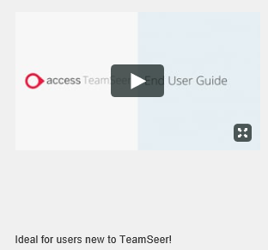
Who is able to enter sick leave?
Any member of staff within the College can log their own sick leave on TeamSeer. A line manager or line manager admin assistant can also log sick leave on behalf of a colleague. Once a sickness is logged, the member of staff who is unwell will receive an email notification for them to confirm the details.
Please note, no other leave type can be raised on behalf of another member of staff unless you have permissions to do so. Nominated departmental administrators and HR Staff Hub are able to log other types of leaves.
Will my sick leave be visible to my team?
No. Sick leave will be hidden and your team will be unable to see details. The only leave that will be visible on your calendar will be annual leave, work from home days and training. Nominated departmental administrators and HR Staff Hub will have visibility to leave types so they are able to carry out their normal working duties.
What happens if I am unwell during my holiday leave?
You must submit a cancellation request for any 'other' leave (e.g. holidays) you had booked during this period. Once the cancellation has been approved by your manager, you are able to complete the return to work form.
Will the system take into account College closure dates?
Yes. College Closure dates will be entered into TeamSeer each year.
I don’t work full time, how will the system process my work pattern?
Work patterns will be taken from the HR database, and changes will be captured daily. If you have a varying work pattern (e.g. a shift pattern), your line manager is able to update this via Manager Self Service (MSS) or a departmental administrator will liaise with HR Staff Hub to update your pattern within your HR record on ICIS. TeamSeer will calculate your leave entitlement accordingly.
I am a part- time member of staff and think my leave in TeamSeer has been calculated incorrectly. How can I check this?
Please visit our annual leave webpage, which provides guidance on how to calculate your entitlement (holiday and mandatory leave).
If I leave and re-join Imperial, will I have the same account?
Yes, if you re-join Imperial the system will identify you based on your CID number and your account will be reactivated.
Will the system link with my outlook calendar?
Yes, you can link your TeamSeer record to your outlook calendar and the system will create calendar entries in your Outlook calendar. Full instructions: Adding Teamseer Permission in Outlook Guidance
How is my TeamSeer calendar group allocated?
The calendar group you are set up within TeamSeer is taken from your own HR record within ICIS. The Organisation within ICIS Assignment page is the TeamSeer Calendar you will be placed in and for reference, please see below:
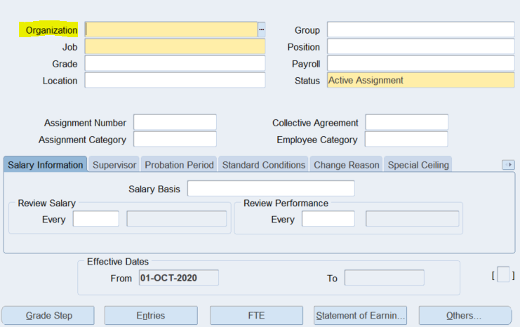
Managers
I am a manager and have had some line manager changes in my team. How can I update TeamSeer?
Please update any line manager changes via Manager Self Service (MSS) at this link http://www.imperial.ac.uk/human-resources/ask-staff-hub/self-service/manager-self-service/. Changes will be captured daily and updated in TeamSeer automatically. Please allow 1 working day for changes to be updated.
I am a manager, am I able to nominate a second approver to approve my direct report leave requests?
Yes, you can select a second approver in the system. Please contact your leave and absence system administrator who can set this up for you.
Support
I am having an issue with my TeamSeer calendar view, it is out of alignment with the calendar days?
This can be fixed by using your zoom in/out function. By zooming in or out will re-align your calendar view.
If I have any further questions, who can I ask?
If you experience any problems with the system, please contact your departments Leave and absence system administrator or the HR Staff Hub.
If I have technical issue, who can I ask?
If you experience any problems with the system, please email Availability Management Support inbox on availabilitymanagementsupport@imperial.ac.uk.

