Academic Staff Promotions 2027

Appendix 4
Criteria for Promotion for
Senior Research Staff (Non-Clinical)
(to Senior Research Fellow, Principal Research Fellow)
Overview


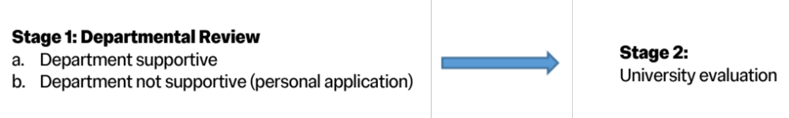
- Introduction
(Advanced) Research Fellows, in the Research Job Family, may be promoted to Senior Research Fellow or Principal Research Fellow. Candidates are assessed through the Academic Promotions procedures.
Staff on the Research track work almost exclusively on original or applied research, keeping up-to-date with the literature and publishing reports and papers. They do not have major teaching delivery commitments but do supervise students. They are usually funded from external sources.
- Grading and Appointment/Promotion Criteria
Promotion to Senior Research Fellow
The research profile of a candidate for appointment/promotion to Senior Research Fellow must be, as a minimum, commensurate with those achieving appointment/promotion to Associate Professor Grade 2 (formerly Reader).
  - Senior Research Fellows require extensive research experience. The quality of research is evidenced by refereed publications, invitations to speak at conferences, and general public dissemination of knowledge. Senior Researchers will hold an established national and international research reputation. They will have the ability to attract significant external research funding (directly or indirectly, according to the rules of the funding body).
  - While the primary focus of a Senior Research Fellow's activity will be research of high quality, this will usually involve leading a team of other research staff, technicians, administrative staff, and research students. Such teams may be drawn from several disciplines.
  - For appointment/promotion to this level, candidates must demonstrate:
    - an established research reputation which is proven by substantial output of publications and reports in refereed and prestigious publications;
    - the ability to devise and direct research projects;
    - the ability to lead research teams and to supervise the work of researchers and other staff;
    - evidence of successful supervision of research students;
    - success in directing research programmes as evidenced by a growing ability to attract significant external funding (directly or indirectly, according to the rules of the funding body).
  - For appointment/promotion to Senior Research Fellow, reports will be sought from external referees in line with the promotion process to Associate Professor (Grade 2).

Promotion to Principal Research Fellow
The research profile of a candidate for appointment or promotion to Principal Research Fellow must, as a minimum, be commensurate with those achieving appointment as a Chair or promotion to Professor.
- Principal Research Fellows will have made an outstanding contribution to research and scholarship, evidenced by an established international reputation in research. They provide academic leadership in a number of ways, including managing large-scale units and/or projects. They also have the ability to attract funding from major research programmes (directly or indirectly, according to the rules of the funding body). Supervision of other staff and students is the norm at this level.
As Principal Research Fellows undertake a complementary but different role to that of a Professor, they must, unquestionably, be international research leaders in their field.
- For appointment/promotion to Principal Research Fellow, researchers must demonstrate:
- a significant research record which has international academic distinction and is recognised internationally;
- the ability to devise and direct large research projects;
- proven ability to inspire colleagues to develop their own research potential;
- the ability to attract significant funding from major research programmes (directly or indirectly, according to the rules of the funding body);
- evidence of successful supervision of research students.
Project management may include leading large multi-disciplinary teams and/or collaborating with groups in other higher education institutions and/or the public and private sector.
- For promotion/appointment to Principal Research Fellow, reports will be sought from external referees in line with the promotion process to Professor.

