Academic Staff Promotions 2027

Appendix 6

Promotion Criteria for
Senior Honorary Associates from Research Councils or Consultants / Community Physicians in the NHS
(to Honorary Senior Lecturer/Honorary Clinical Senior Lecturer, Honorary Professor of Practice/Honorary Clinical Professor of Practice)
Overview
Non-Clinical Honorary (time limited)
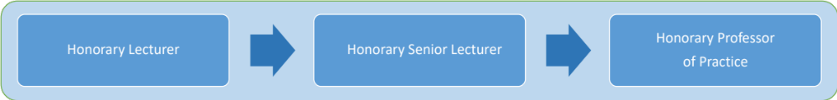
Clinical Honorary (time limited)

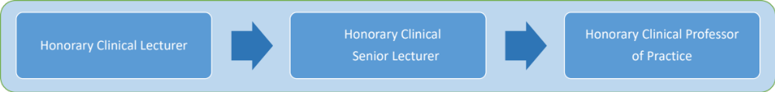
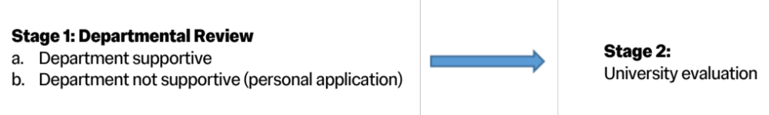
- Following the adoption of globally recognized titles for academic staff, a review of titles for honorary/visiting staff is currently progressing but no change will occur in the year 2026-27. In this context, “honorary” means “temporary for more than a year” while “visiting” means “temporary for less than a year.”
- Applications for promotion to senior Honorary positions of Senior / Clinical Senior Lecturer, Professor of Practice / Clinical Professor of Practice. Each role requires a different and increasing level of contribution. Contributions are expected (to varying degrees) in all four areas of education, research, leadership and management, administration and profession and practice.
- The Honorary Non-Clinical or Clinical Professor of Practice role bridges the interface between a strictly academic role, and a senior professional or clinical role. The conferment of this title recognises outstanding contributions to Imperial in one or more of three areas (education, leadership and management, profession and practice). Please see detailed criteria below.
- Imperial has a flexible approach to its routes for promotion and will judge each individual case on its merits.
- As an individual’s career develops, promotion may be from the lowest level to the highest, or to any intermediate level, provided the relevant criteria for promotion are met.

General Criteria for Promotion
Imperial takes into account contributions to:
Education,
Research,
Leadership and management, Profession and practice.

These four regions of activity – education, research, leadership and management, profession and practice – are interrelated and candidates will be expected to demonstrate achievements in all these activities but to different extents. Each individual case will be judged on its merits: the relative weightings between the various achievements, and the level of attainment in each, will determine the most appropriate promotion.
The Application Form provides a framework that enables applicants to showcase their contributions and how they meet the criteria.
Indicators of Achievement
- Education
Imperial requires all candidates coming forward for promotion to demonstrate excellence and impact in educational activities. Candidates should include full details of their educational activities and achievements and contributions to education in the broadest sense.
Activities include creative and clear teaching assessment and feedback that shows a well-developed understanding of how students learn effectively, particularly in clinical contexts; innovative and flexible methods of delivery that enhance student learning; and align to Imperial’s Learning and Teaching Strategy; evidence-based educational practice; contribution to the development of technology enhanced learning (TEL); the development and design of modules, programmes and assessment; organisation and coordination of complex undergraduate and postgraduate programmes; delivering inclusive teaching and assessment that supports a diverse student cohort; successful engagement of students as partners in their learning; evaluation of programmes and modules which is used to enhance learning and teaching; innovating to meet the changing needs of students, the subject discipline and the relevant professions; personal tutoring; student support, outreach work; fostering students’ self-confidence and self-esteem to promote participation; teaching on transferable skills programmes, and successful completion of teacher training.
Measures of recognition include sustained excellence in teaching, evidenced by student success and progression, qualitative student feedback, peer observation and commendations by external examiners; the effective and/or innovative management of educational programmes; design of new modules and/or or redesign of existing modules and/or programmes; the receipt of teaching awards; the achievement of a University or national learning and teaching qualification; membership of national and/or international educational committees; membership of educational and accreditation committees of professions; acting as an external examiner; contributions to student support; appointment as Departmental Director of Studies or Senior Tutor; successful research student supervision; the development of evidence-based practice; publications on teaching practice and/or on educational research.

Progression up the career ladder to Professor of Practice / Clinical Professor of Practice will involve a broadening of the contribution to education, from excellence in teaching delivery, through to the organisation and management of Departmental education and student support activity, leadership on educational matters at Faculty and/or University level and in educational transformation (e.g. curricula development, innovative use of technology enhanced learning and, where appropriate, education research).
The following activities provide an indication of the activities that might be expected where “Education” is playing a dominant role in an application:

Honorary Lecturer / Honorary Clinical Lecturer to Honorary Senior Lecturer / Honorary Clinical Senior Lecturer
  - Track record of effective and flexible approach to delivery of programmes and modules.
  - Contribution to the design of modules and programmes and evidence of thorough evaluation of modules and programmes. Application of this evaluation to the development of personal practice.
  - A commitment to their own development as a teacher and educator through the learning and implementation of best practice.
  - Significant evidence of contributions to education within the Department that have led to improvements and/or innovation in programme/module design and delivery.
  - Significant contribution to tutoring and/or student support and/or support for lecturers.
  - Thorough evaluation of programmes and modules taking into account student learning outcomes and the aims of the curriculum. Application of this evaluation to the development of personal practice.

Honorary Senior Lecturer / Honorary Clinical Senior Lecturer to Honorary Professor of Practice/ Honorary Clinical Professor of Practice
  - Evidence of excellence in teaching delivery and/or innovative practice which has greatly enhanced and/or changed the nature of learning and teaching in the applicant’s field.
  - Significant impact on the design and management of the curriculum and programmes within the Department.
  - Strong evidence of national and international research into the effectiveness and validity of education programmes and curricula.
  - Significant contribution to leadership in education within the University.
  - An impact on Imperial’s reputation for excellence in education within the wider community.

Research
Activities include undertaking independent and collaborative research; developing research proposals and funding bids and winning financial support; planning, leading and directing research activity and managing a research team; presenting findings at conferences; publishing results of research which leads to an established reputation; planning and leading research activities of outstanding quality and national/international repute, which advance the reputation of the Department and Imperial; providing expert advice, internally and externally; contributing to the development and implementation of Departmental/Faculty research strategies.
Measures of recognition include the quality and quantity of research output; a sustained track record in attracting research funding and identifying funding resources; a national and/or international reputation for research, reflected in level of output, level of innovation and the impact on the discipline or profession; widely recognised excellence and reputation among peers; the award of prizes; giving prestigious lectures; membership of national and international committees e.g. Research Council and professional or government committees; work on editorial boards of scholarly journals; visiting appointments at other institutions.
Progression in research will involve a growing national and international reputation combined with individuals making an increasing impact on their discipline or profession. At the Honorary Senior Lecturer / Clinical Senior Lecturer level originality is important; seminal research and influence become of increasing importance in moving to Honorary Professor/Clinical Professor of Practice.
Note: Imperial is a signatory to DORA (Declaration on Research Assessment), which mandates that in hiring and promotion decisions, the scientific content of a paper, not the JIF (Journal Impact factor), is what matters. More information on DORA is available at https://sfdora.org

Leadership and Management
Activities include, in addition to managing the individual’s own work, contributing to the management of the Department/Faculty/University, e.g. contribute to the process of admissions, examinations and quality assessment; formulate research and teaching strategy; monitor and ensure effective management of assets and budgets; recruiting and selecting staff; managing and motivating staff to achieve their objectives; promoting equality and implementing equal opportunities; undertaking effective performance and development reviews; acting as an Academic Adviser or mentor; membership of internal and external committees; acting as an Athena SWAN coordinator; involvement in advancement activities; involvement in public engagement activities; collaborative working.
Measures of recognition include proven capability to lead and design research/teaching programmes; effective and innovative formulation of research and teaching strategy; staff management skills that lead to enhanced team performance; an active interest in personal development and developing others; regular involvement in staff development activities to develop academic, management and personal effectiveness skills; evidence of managing change successfully, making effective decisions and solving managerial problems.
Academic leadership becomes of increasing importance in moving to Honorary Professor of Practice or Honorary Clinical Professor of Practice.

Profession and Practice
Activities include involvement in consultancies; contributing to continuing professional development; membership and/or leadership of respected institutions/organisations /peer review bodies; acting as an expert witness; contributing to improvements in clinical management and processes; contributing to improvements in healthcare.
Measures of recognition include medals and awards; a major role in changing and improving professional practices; creative contributions to projects; industrial/medical application of research findings; innovations in healthcare that are recognised by a significant audience; patents; industrial initiatives arising out of research such as spinout companies etc.

In progressing up the career ladder to Honorary Professor of Practice / Honorary Clinical Professor of Practice, it is highly likely that the national and international standing of a candidate will have had an impact on the relevant profession.

Use of the title Professor of Practice
Upon a successful award of the title of Honorary [Clinical] Professor of Practice (Field) it is a University requirement that the title is used in full as shown below,
“Dr Xxxx, Honorary [Clinical] Professor of Practice (Neurosurgery)”
with no abbreviation on letterheads, web pages or elsewhere. The title may not be abbreviated to “Professor” as this would indicate that the person holds the full academic title of Professor (which requires additional criteria not required of the Professor of Practice title). The specialty should be included in brackets, as the example above shows.

