Adding Bought Holiday to an Allowance

To access the system visit: https://saml.imperial.ac.uk/simplesaml/module.php/core/loginuserpass.php?AuthState=_f6e91c680d5293f995f00fbf1eb93f3136644cc08f%3Ahttps%3A%2F%2Fsaml.imperial.ac.uk%2Fsimplesaml%2Fsaml2%2Fidp%2FSSOService.php%3Fspentityid%3Dteamseer%26cookieTime%3D1516880222

and enter your single sign on details.
When logged into the system, click on the tab for “My Admin” along the top ribbon.

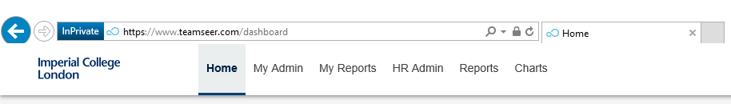

This page will always display your own details as a default view.

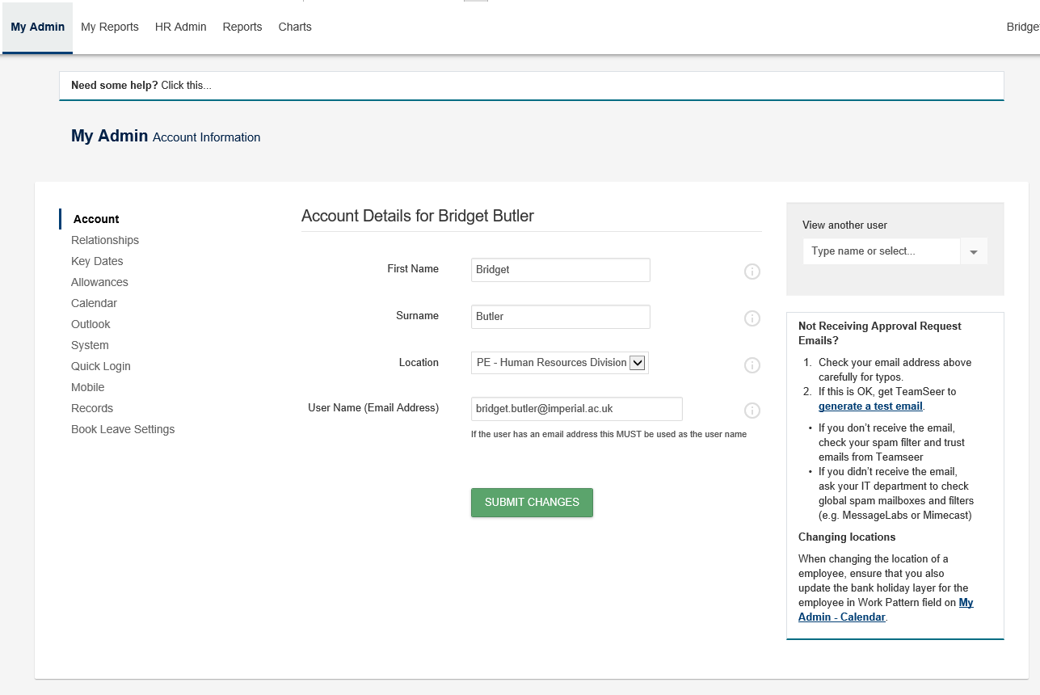

You will need to bring up the record for the individual who you wish to enter bought holiday allowance for. To do this, on the right hand side of the page you should see a box for “View another user”. Enter the surname or CID of the individual whose record you need to make changes to.
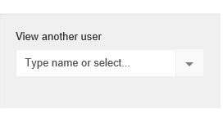
The page will then automatically update to show the details of that individual;

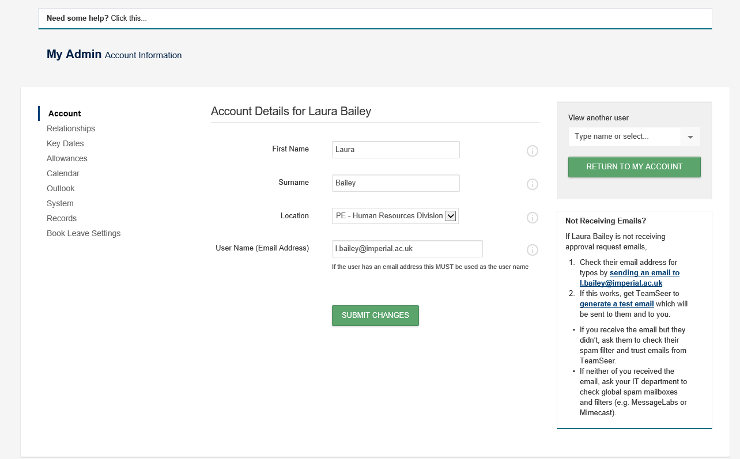
On the left hand side of this page the following menu will be displayed, and will currently be on the Account section. To add in additional bought leave to an individual’s allowance, click on the Allowances section;

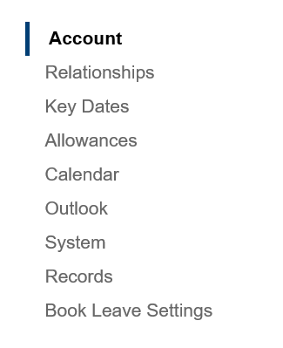

The current allowance details for that individual will be displayed.
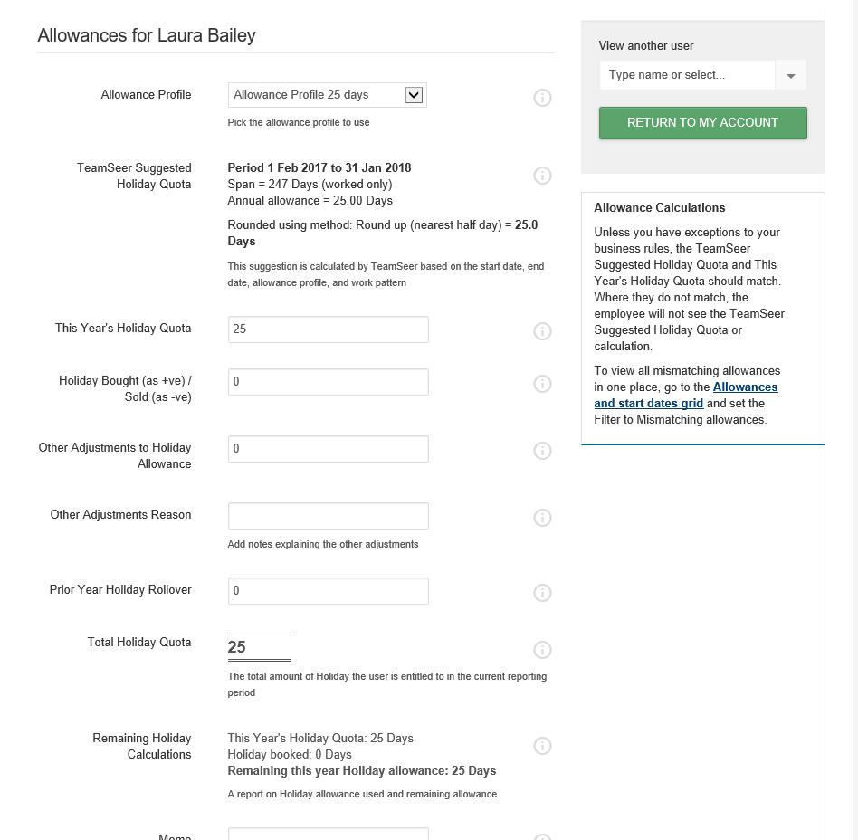
To enter any additional holiday bought, scroll to the field labelled “Holiday Bought (as +ve)” and enter the number of days that have been agreed and confirmed.

Scroll to the bottom of the page and hit the green Submit Changes button to re-calculate the new allowance.
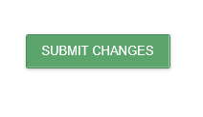
The allowance page will be refreshed and the new allowance in the Total Holiday Quota will reflect the new total;
