This document has three sections: calculations, totals and parameters.
Calculations
Calculations can be added as column to reports and used in conditions too. Discoverer runs on an Oracle database and can utilise database functions in calculations.

Invoke the following panel by navigating the menu option: Tools > Calculation.
Create a new Calculation
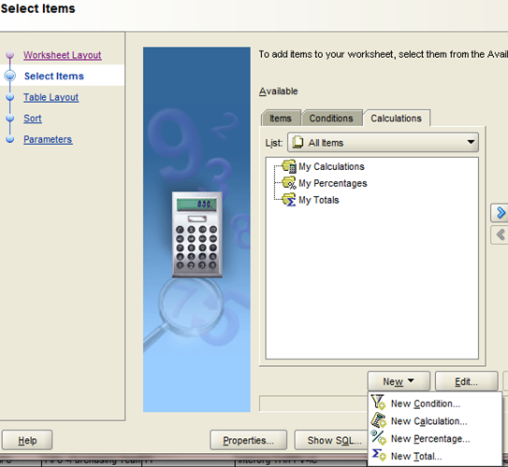

A list of database functions is available within Selected Items > Functions. Documentation for Oracle functions can be found online (eg at http://beginner-sql-tutorial.com/oracle-functions.htm).
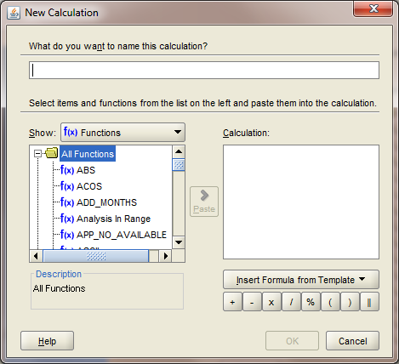

Database functions include Numeric, String, Date and Conversion functions. Common functions are
substr | extracts a substring from a string  substr('what',3,2) gives 'at'  which starts at position 3, with a length of 2
lower, upper | changes case  lower('Coat') gives 'coat'  upper('Coat') gives 'COAT'
length | length of string  length('add') gives 3
instr | finds position of characters within a string  instr('lulu','lu',2) finds 'lu' at position 3  (starting from position 2).  instr('lulu','lu',1) returns 1
case | case substitutes a value with another value – a kind of lookup. ‘Else’ provides a default value.  case when some_column = 'IMPERIAL'  then 'Imperial College'  else case when some_column = 'UCL'  then 'University of College London'  else 'Unknown'  end end  Note: ‘End’ closes the CASE statement.
decode | decode is very similar to Case – but is less easy to read  decode(data_type, 'IMPERIAL', 'Imperial College',  'UCL' , 'University of College London', 'Unknown')
greatest | greatest (3,2) will select 3
least | least (3,2) will select 2
to_date | to_date converts a string to date  to_date('01-Jan-01')  Date functions can be applied to the converted date.  last_day(to_date('01-Jan-01')) gives '31-Jan-01'
to_char | to_char converts dates and numbers to text.
nvl | nvl substitutes NULL values with a default. The default can be text, date or numeric.  nvl(some_column,0) gives 0 when NULL  NULLs are special values that are not 0 or blank, but are the result of unpopulated cells.
replace | replaces a character or a set of characters  replace('add','d','p') gives 'app'  replace('add','dd','ge') gives 'age'
lpad, rpad | pads values to the specified length with a designated character to either the left or right.  lpad(1,5,0) gives 00001 –  '1' is padded with '0’ to a length of five characters.

For all of the above functions, values are supplied by the selected column. For example you may want the first two characters of the segment2 analysis code because it provides additional meaning:
CASE when substr(segment2,1,2)= 'AA' THEN 'Balance sheet' ELSE 'Profit loss' END

- Creating calculations: Use ‘Paste’ button to provide an outline of the function

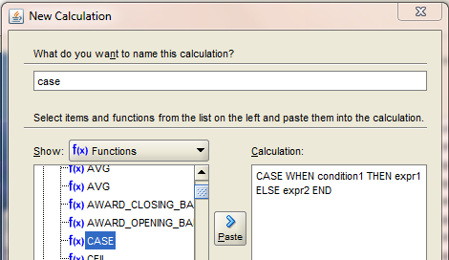

- When selecting columns, use the ‘Paste’ button to avoid typos.
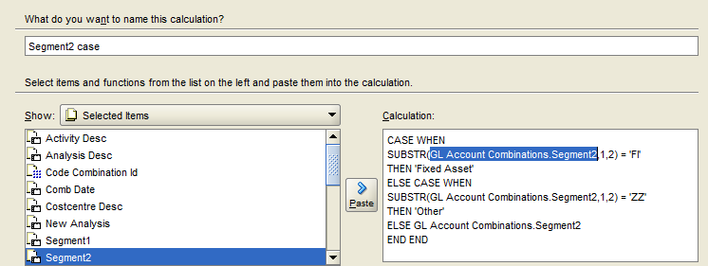

- Calculations can be used in conditions
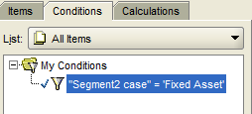

Totals
There are three steps to creating totals – demonstrated below.
- Notice the checkerboard icon beside ‘Code Combination Id’. This icon indicates a numeric data type that permits numeric operations. SUM the ‘Code Combination Id’ with a ‘right hand click’ to ‘Add to Worksheet’. The selected operation will be ‘ticked’
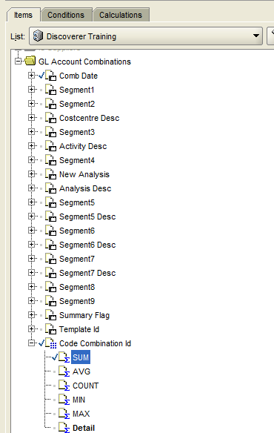

If the ‘Available Items’ panel is not available then use menu: View > ‘Available Items Pane’

- Next, create a new Total
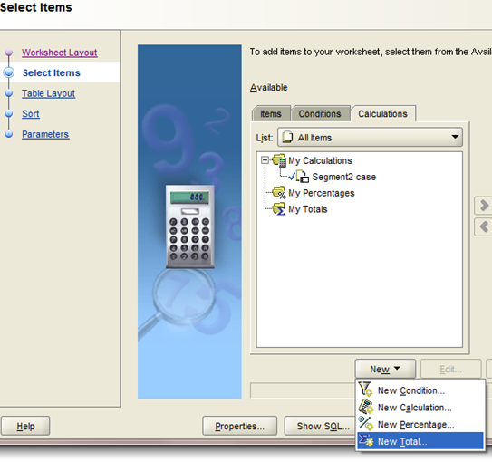
Configure the New Total to Sum on ‘Code Combination Id’ and Subtotal on each change of ‘Comb date’
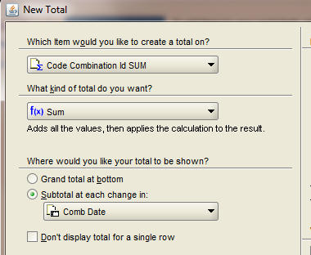
- Ensure Sort is set to ‘Group Sort’
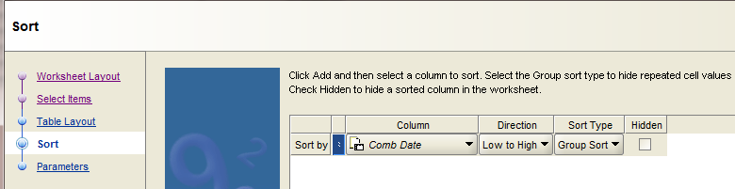

Report with totals
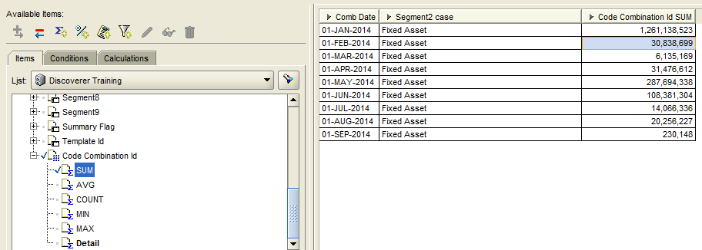

To change the column’s heading, right-hand click the ‘Code Combination Id SUM’ and ‘Edit Heading’.

Parameters
Parameters are used to change the criteria of a report’s conditions. Parameters will prompt the user to enter a value each time a report is run. For example, a parameter for month allows the same report to run for each available month, by prompting the user to select month.

- First a simple parameter to get started. Create a parameter by first creating a condition.
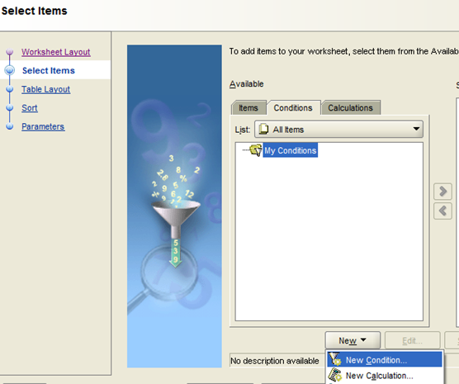
While creating the condition, select ‘New Parameter’
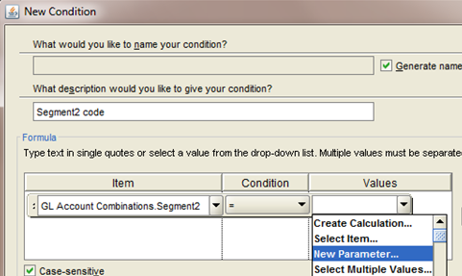

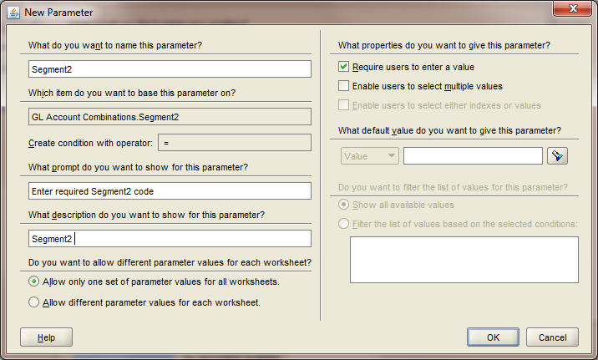

Select OK, Finish. Run the report to prompt the parameter input.
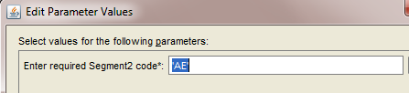

- Next, a parameter that utilises drop-down lists.
Use the menu navigation: View > ‘Selected Items Pane’. Notice three items have '+' beside them (‘Comb Date’, Segment2 and ‘Summary Flag’). The ability to expand items is determined when the Discoverer Administrator creates a folder within a business area – in this case the ‘GL Account Combinations’ folder in the business area ‘Discoverer Training’
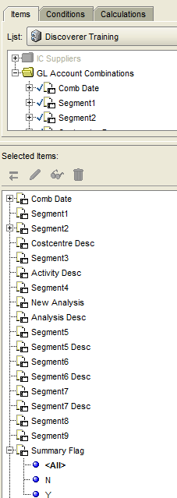
Expanding ‘Summary Flag’ gives N, Y. Expanding Segment2 gives a drop-down list of Segment2 values.

Create a condition for ‘Segment2’ and provide a default value using the ‘torch’ 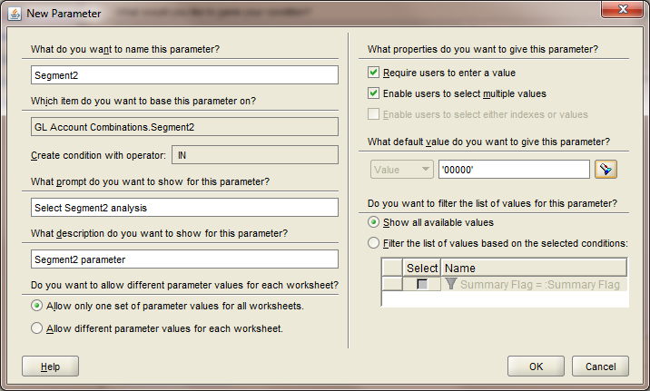
OK and Finish

Run the report. Use the Torch icon to select multiple Segment2 values
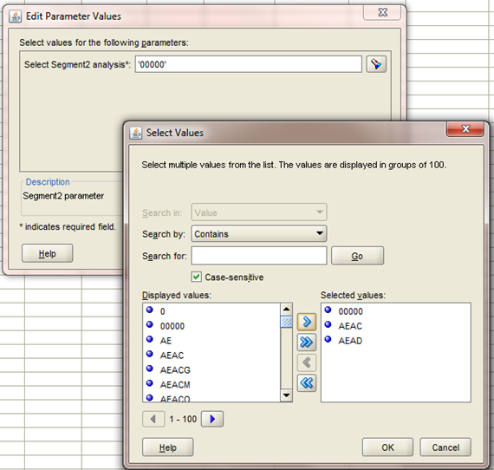

Menu navigation to edit parameters: Tools > Parameters

