- Connecting to Discoverer Plus
Connect to Discoverer using the URL: http://www.icis.ic.ac.uk/disco/dplus.htm. This URL runs a script to pre-populate connection values

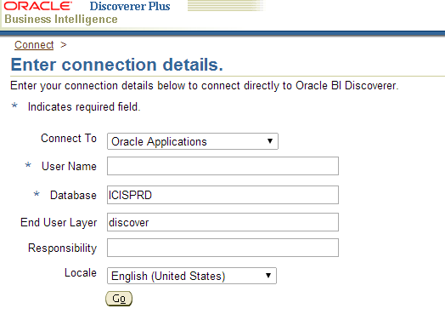
- Enter your User Name and Click Go
- Select an appropriate responsibility. For example if you are writing a HR report, you’ll select an HR responsibility. Responsibilities are inherited from your ICIS profile and are intended to restrict access to sensitive data. Additional ICIS responsibilities can be requested using http://www.imperial.ac.uk/ict/servicedesk/icis/

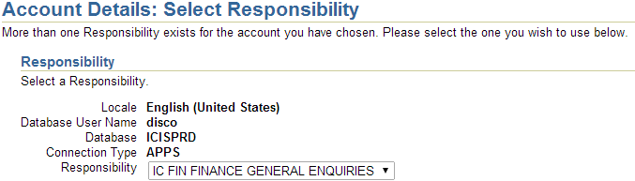
- Accept notifications.
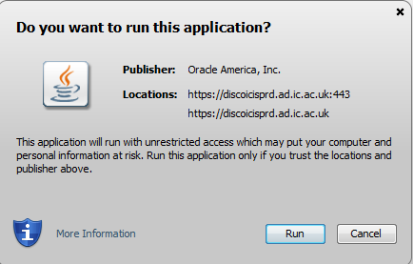 | 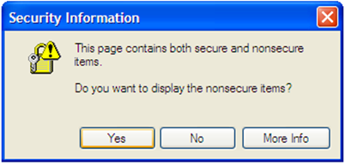

- Configuration Options. Navigate Tools > Options
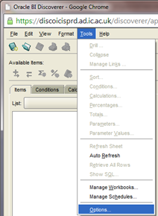
Ensure your profile utilises the following options
Check ‘Ask for confirmation’ otherwise reports will run Automatically (which generally slows writing a report)  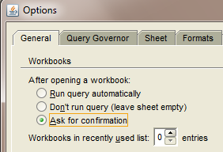 | Note options to limit data retrieval and timeouts  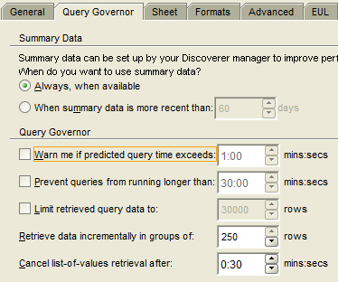
Crosstab style: ‘Inline’; show null values as '–'  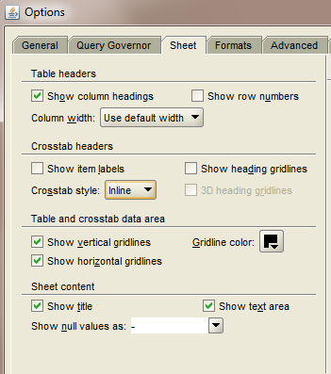 | Disable detections for both fan-trap and multiple join path  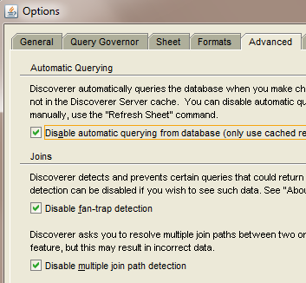

- Developing a report.
First a description of useful icons

Important icons are: Create new report; Open existing report; Save current report; Run report
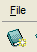

Create a new report by clicking top left icon

- Deselect options for ‘graph and text area’
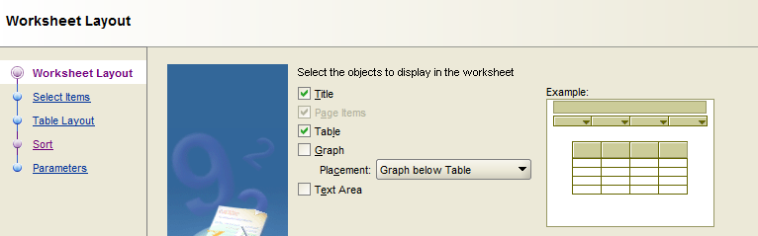

- Discover is organised to categories of ‘Business Areas’ and within each Business Area are Folders that provide logical groups of information. Security access to Business Areas is determined via ICIS roles. You require appropriate ICIS roles to access protected Discoverer Business Areas. Additional ICIS responsibilities can be requested using http://www.imperial.ac.uk/ict/servicedesk/icis/

Select ‘Discoverer training’ from the List of Business Areas and the ‘IC Suppliers’ Folder
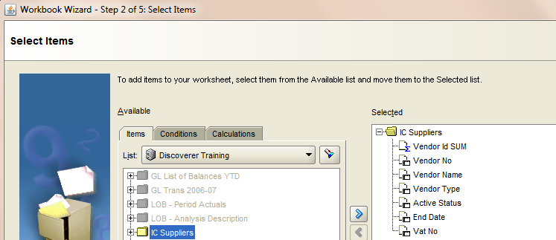

- Individual fields can be selected using ‘>’ to add, ‘<’ to remove. Selected fields.
In this example, ‘Vat No’ has not been selected and that field will not appear in the final report.
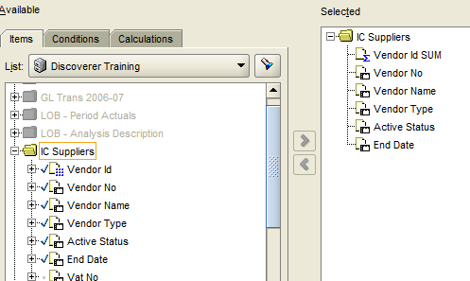
- Create Conditions by selecting Conditions tab and ‘New’
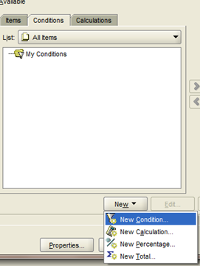

- Add condition
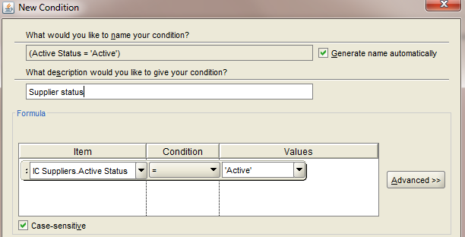
- Conditions refine data selection (for example limiting vendors to those called ‘Smith’. Below, the condition for ‘Vendor Type’ has been created, but not Selected – it will not be used by the report. Selecting the condition will reactivate use.
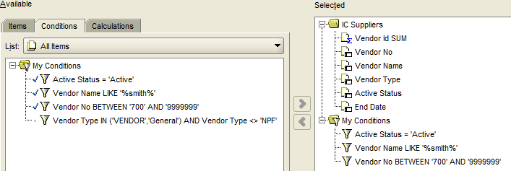
- a few points on Condition operators:
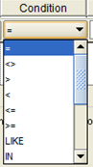 | 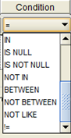
  - IN requires comma separated values. Discoverer will add the brackets.
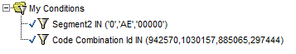
  - BETWEEN requires the first value to be the smallest value.
The first BETWEEN condition will work, the second will not
  - use the wildcard character ‘%’ with LIKE. A condition
will retrieve Segment2 values for ASADA, ASAEM, ASAER, ASAEX, ASAGM, ASAGR, ASAGX.
Try to avoid leading conditions with ‘%’ because the database will not use any indexes to retrieve data (ie avoid Segment2 LIKE '%ASA%').
  - Case sensitive. Be aware that conditions must be aware of case. A condition "Segment2 = ' asada' "will not retrieve values for ASADA unless the tickbox is deselected.
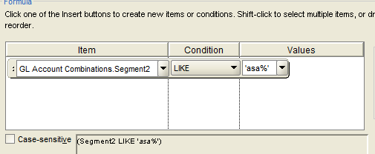

- Select ‘Next’ to add ‘Page Items’.
Drag ‘Vendor Type’ into ‘Page Items’. A report can have more than one ‘Page Item’ –although, reports are generally run without ‘page items’
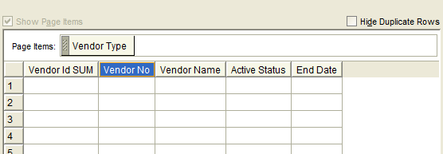
- Select ‘Next’ to Sort fields (for example sort Vendor Name)
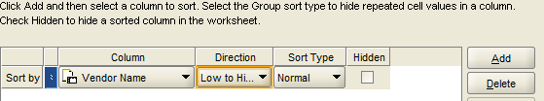
- Select ‘Finish’ to complete report and run report using icon 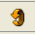.
- Select page items to select Vendor type
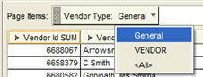
- Double click on the report title or sheet name to rename
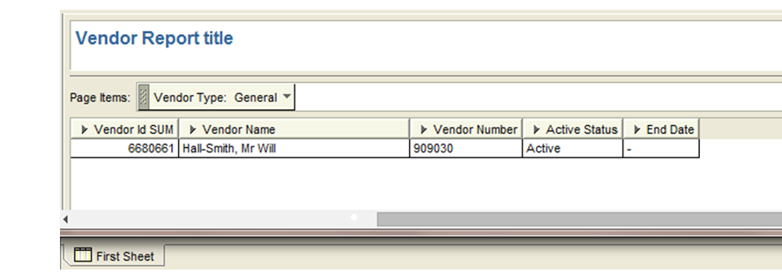

- Right-hand click on column heading to format data or change column name
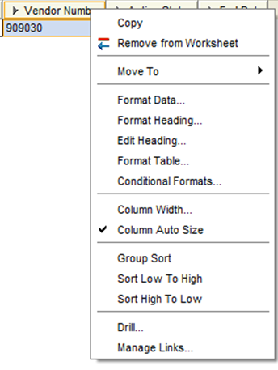
- Column ordering can be altered by dragging column headings across the report. Simply click on a column heading and drag it left or right.
- Report titles can include dynamic values for ‘report date’ and ‘report name’: double click the Report Title > Insert
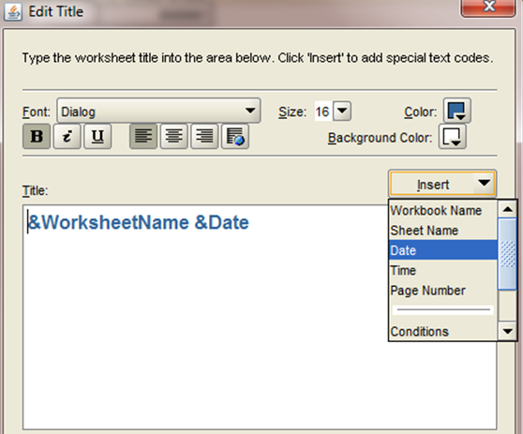

Additional points
- Security Access issue. If you receive a message like ‘Item xxx ... is missing’ then you’ll need to raise a call with ICT Discoverer Support to grant access. To speed resolution, include the report name and screen-prints in the call. Calls can be raised at https://imperial.service-now.com/ict/make_a_request.do
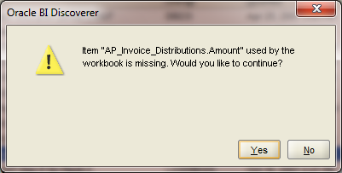
- to Save the report: File > Save. Change name from ‘Workbook 4’
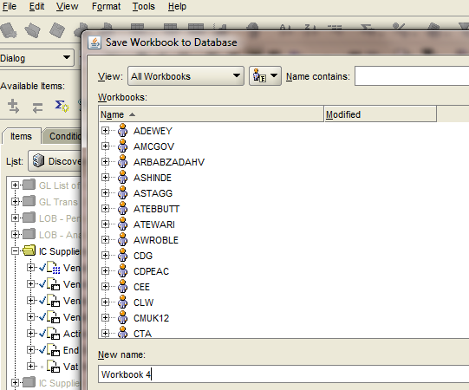
- Navigation pointer
Navigating Tools > Conditions will bring up the report definition wizard.
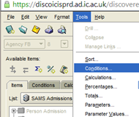
Report Wizard. Can change sort, create conditions, etc
