Update January 2014
Following the upgrade to Empirical Version 5 in November 2013 Pending Controls no longer have actions – previous actions have been converted to Pending Controls and the text “Converted from Pending Control Action” has been added at the beginning of each Pending Control Description where a conversion has occurred.
Process Diagram 1 shows the amended sequence:
Process Diagram 1 | 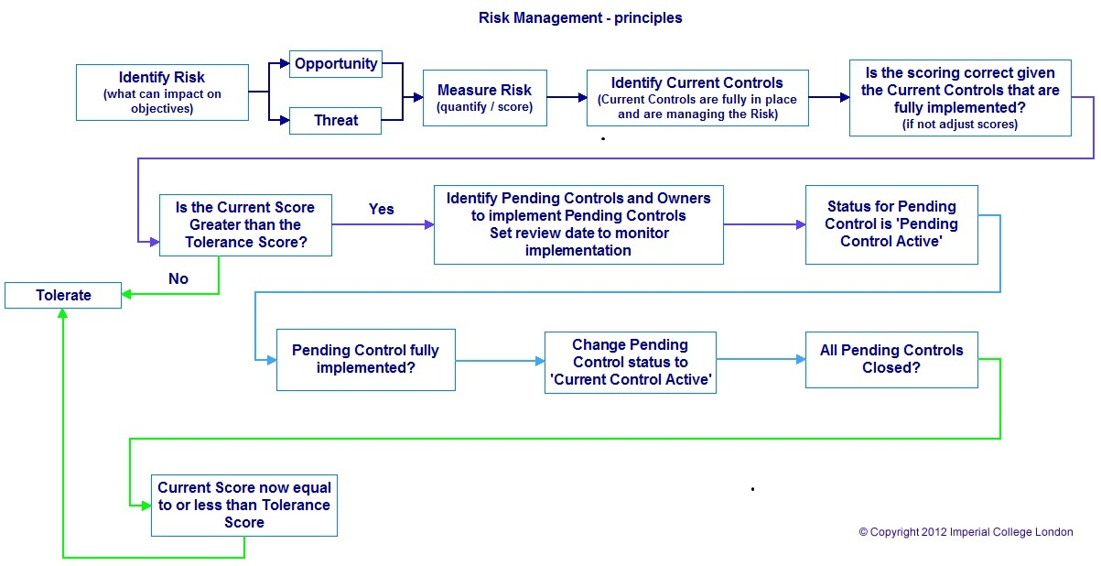

Empirical User Guide: Look Ups
This guide is divided into 3 parts:
- A look up section containing Quick User Prompts which is designed as a list of brief information reminders for users
- A look up section containing a Learning List for the complete application. This section is designed for newer or less frequent users who may need more information than is contained within the Quick User Prompts in Section 1 and includes screen images to assist.
- Appendices
Sections 1 and 2 are designed to be used with Empirical running at the same time. This guide supplements the pop-up help that is available within Empirical (when the mouse pointer changes to a question mark over a heading in Empirical then clicking the heading will bring up the context-specific on-line help for that component)

Information: Uses of Empirical

The function of Empirical is:
- to provide information that is useful locally,
- to escalate and cascade information that is useful for Departments, Faculties and the College,
- to provide assurance to Senior Management so they in turn can assure the Risk Committee, College Council and HEFCE that the College is actively managing its risks.
Empirical is currently regularly used at College, Faculty and Department levels and is also beginning to be used in broader ways. Capturing the information that is available and processing it through Empirical helps with modelling and comparing in and across the College and against external factors that may impact on or be impacted by the College. Reports based on multiple variables can be run on the information in Empirical to facilitate queries that can assist decision making.

One of the benefits of this is that in 2012 Risk Registers will not need submitting with the Planning Round papers as the information will be drawn directly from Empirical. All risks will therefore need to be updated by 31/5/12. If you would like assistance please contact the Risk Manager (email n.kay@imperial.ac.uk; tel. x48495).

If it is found that when reviewing a risk no changes are required then a note should be made in Empirical that the risk has been reviewed but no changes were required at this point in time (other than changing the review to a future date). This information should be entered by creating a note in the ‘Risk Notes’ area on the Risk Details page of each risk to which this applies. As part of the assurance process Internal Audit conduct analysis to identify that risks are being actively reviewed so it is important to note that the review has been conducted within Empirical rather than just changing the review date.

Information: New Functions in Empirical
Developing and rolling out enhancements to Empirical is an on-going process. One of the latest enhancements is a Knowledge Library of example risks to assist when identifying or reviewing risks.
A related function is the ability to copy and then amend the information contained within a Library (or other) risk to create a new risk that is tailored to your area but may have information in common with other risks in Empirical (see item 9.a and 9.b for information).

Section 1
Look Up: Quick User Prompts

How to:
1.a | Log into Empirical: | Open http://www.imperial.ac.uk/empirical with Internet Explorer or Chrome and use your College User Name and Password to sign in (Single Sign On)  Click this text for full details on how to log in
2.a | Create a risk | From Empirical Home Page select ‘Create’, fill in mandatory and appropriate optional fields and click create. When you have created the risk you will need to add Current and Pending Controls and Actions appropriately.  Click this text for full details on how to create a risk.
3.a | Create a Current Control | Open the risk you want to add a Current Control to. In the Current Controls area click ‘Create’. Enter the information about the Control in the ‘Description’ field. Click ‘Create’.  Click this text for full details on how to create a Current Control
4.a | Create a Pending Control | Open the risk you want to add a Pending Control to. In the Pending Control Area click ‘Create’. Enter the information about the Control in the ‘Description’ field. Click ‘Create’  Click this text for full details on how to create a Pending Control
5.a | Create a Pending Control Action | Either: Create a Pending Control which will automatically take you to the ‘Create a Pending Control Action’ function  Or: Open the risk, open an existing Pending Control, in the ‘Actions’ area click ‘Create’.  Enter the information about the Action in the ‘Description’ field. Click ‘Create’.  Click this text for full details on how to create a Pending Control Action
6.a | Assign an Owner to a Pending Control Action | Either: Create a Pending Control Action which will automatically take you to the assign an ‘Action Owner’ function  Or: Open the Risk, open an existing Pending Control, open a Pending Control Action, then in the ‘Action Owners’ area click ’Create’. Use the Search function to select the Owner and click ‘Create’  Click this text for full details on how to assign a Pending Control Action Owner.
7.a | Create a note | Notes can be added to Risks, Controls and Actions and the procedure is the same for each note: In the ‘… Notes’ area click ‘Create’, add the note to the ‘Note Text’ field and click ‘Create’.  Click this text for full details on how to add a Note
8.a | Add a Review date | Risks, Pending Controls and Pending Control Actions can be allocated a review date. If ‘Email Notification’ is switched on then reminder emails will be sent as the Review Date approaches.  To add a Review Date to a risk: open the risk, select edit, click the calendar icon next to the Review Date field and select a date then click ‘Update’.  To add a Review Date to a Pending Control or a Pending Control Action click ‘Details’ click the calendar icon next to the Review Date field and select a date then click ‘Update’.  Click this text for full details on how to add a Review Date

New Function in Empirical
One of the functions rolled out recently in Release 4 was the ability to copy and then amend a risk and its components.
9.a | Copy a Risk | On the Empirical Home page in the final column on the right hand side click ‘Copy’, allocate a new Risk Identifier; select/enter information for Mandatory fields and click create. The new risk created by copying can then be opened and edited.  Click this text for full details on how to Copy a Risk

10.a | Filters | The availability of filters has been extended and will be displayed at the top of the page under the ‘Search Filters’ heading when these are available. One or more filters can be used and partial or complete information can be entered into the filter fields.  Click this text for full details of available filters
11.a | Edit, Copy, Paste | Copy and Paste functions can be used in Empirical in Risks, Current Controls, Pending Controls, Pending Control Actions and all notes (except current control notes). To use these functions to update risk details open the risk, select edit, make the changes and then click ‘Update’. For all other items click ‘Details’, make the changes and then click ‘Update’.  Click this text for full details of Edit, Copy and Paste functions
12.a | Bulk Updates | Bulk updates can be used to quickly change information across multiple components. Bulk updates can be used for Risk Ownership, Action Ownership, Review Dates and Organisations. Not all Bulk Update functions are available to all users. Contact the Risk Manager for assistance with the Bulk Update functions.  Click this text for full details of the Bulk Update functions
13.a | Reports | Click the ‘Reports’ tab then select the Report Type using the tabs. Reports can be filtered prior to generating and then exported to spreadsheet or Portable Document Format (PDF) (except the Scatter Diagrams). Available Reports are:  Risk Summary: Returns a reduced set of fields useful for gaining an overview of a set or sub-set of risks.  Risk Register: Returns a full set of fields providing full information about a set or sub-set of risks.  Review Date: Uses Review Date filters to return Risks that have review dates within that period.  Scatter Diagram: Provides 2 matrices (Threats and Opportunities) plotting Impact times Likelihood scores to give a visual representation of the spread of Risks.  Click this text for full details of the Reports functions
14.a | Email Reminders | Empirical has functionality that can generate emails. These are used to inform Risk and Control owners that they have been allocated a responsibility or they are used to inform of an approaching review date. Emails assigning ownership are automatically generated* but the Email Notification of review dates defaults to ‘off’ but can be changed to ‘on’ by ticking the ‘Email Notification’ check box in the ‘Risk Details’ area.  Click this text for full details of Email Remainders  *When creating a risk and assigning ownership to someone in your own Organisation there is an option not to generate an email informing them of Ownership – this does not apply when assigning ownership elsewhere.
15.a | Linked Risks | Risks can be linked to other risks where it is established that there is a relationship that is helpful to monitor. Risks can be linked by selecting the ‘Create’ button in the ‘Linked Risks’ area of the Risk Details when creating or editing a risk.  Risks can be linked by entering the appropriate Risk Id or by selecting from the ‘Organisation’ drop down or ‘Risk List’ drop down. Linking risks extends visibility of your risk to those who can view the risk you are linking to.  Click this text for full details of Linked Risks

Section 2
Look Up: Complete Application Learning List

How to:
1.b | Log into Empirical: | http://www.imperial.ac.uk/empirical
Can use Internet Explorer
Can use Chrome (but has not been validated)
Firefox may work but sometimes returns an error referring to data transfer or the security certificate not being validated. It is currently better not to use this browser for creating or editing in Empirical.

To log into Empirical:
Either:
click this link: http://www.imperial.ac.uk/empirical
Or:
Open your browser, copy and paste this link into the address line http://www.imperial.ac.uk/empirical and press enter
Or:
Open your Browser on an Imperial page; left click once on ‘Admin & Services’; left click once on ‘R’ in the alphabet shortcuts; left click once on ‘Risk Management’; left click once on Empirical (system link)

Then:
Enter your College User Name and Password and click ok to access Empirical (Single Sign On). If you have any queries please contact the Risk Manager
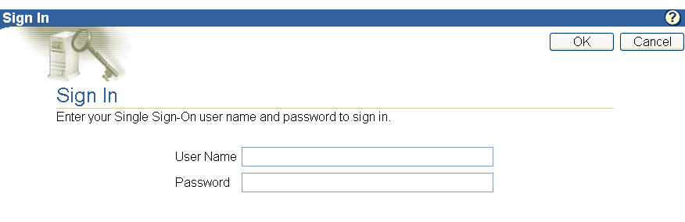

2.b | Create a risk |  | From Empirical Home Page select ‘Create’
Beneath the ‘Search Filters’, on the right hand side of the screen is a ‘Create’ button. Left click this once to begin creating a new risk. |  |  |  | 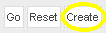
'Risk identifier'
The 'Risk identifier' is the reference for a risk that is used to identify and access the risk.
The information you enter here is a label that will assist when referring to the risk.
The format is not constrained but guidance is that using the form ‘Dept-risk number-year ‘ (i.e. Dept-001-11, Dept-001-12) is most helpful and allows risks to be shown as current by updating the ‘year’ component of the Risk identifier.
n.b. ('Risk Identifier' is also referred to as 'Risk Serial Id' or 'Risk Id' depending on the function being used)
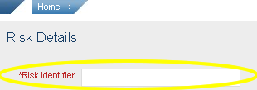
'Organisation'
Click the 'Organisation' field to list the ‘Organisational Entities*’ and left click once in the drop-down list to select the area the risk relates to
Or:
Click ‘Search’ (to the right of the ‘Organisation’ field), enter part or the entire name and click ‘Go’ then select from list.
'Organisation' refers to the area the risk is allocated to.
The information relevant to your area is based on the College’s ‘Organisational Entities’. These are drawn from the ‘Building Blocks’ listed by HR at http://www3.imperial.ac.uk/secretariat/collegeinfo/buildingblocks.

* The area you work in relates to ‘Organisational Entities’ which can be, for example, a Faculty, Division, Department, Institute, Office, Service, Bureau etc. These will be referred to throughout as ‘Organisational Entities’.
'Organisation Details'
When an ‘Organisational Entity has been selected then clicking 'Organisation Details' will display the Organisation Hierarchy and Details associated with that risk.
‘Title’
The (Risk) Title should capture the essence of the risk and briefly describe it. A conditional format is helpful e.g. If we do / don’t do x then y may / may not occur.
Titles or components of them can be used in the filter fields and in specifying report formats so a brief but descriptive title helps with these functions.
The ‘Title’ field has a 255 character limit (which includes spaces).
‘Description’
Describe the risk here. Include causes and consequences and sufficient information to explain the risk in a way which is understandable to someone who is not from your area or discipline.
If you use acronyms and abbreviations please include the full phrase in the description as this helps give clarity and also assists with searches and analysis
The ‘Description’ field has a 4000 character limit (which includes spaces).
‘Risk Owner’
The Risk Owner is the person who is responsible for the area the risk applies to. The Risk Owner is selected from a drop down list using the following procedure:
Click on the 'Search' next to the 'Risk Owner' field to open the list, search for the owner by scrolling though the list or using the search function*, then click on the person you want to select.
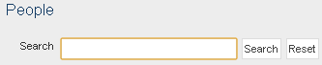
*search on surname. To search on surname and initial/forename use the format: surname, initial/forename (there are no spaces between the surname, comma and initial or forename).
‘Send email to the Owner’
When a risk is allocated to a ‘Risk Owner’ the default system action is that an email will be sent informing that person they have been ascribed to a risk as its owner. If this is not required then uncheck the box labelled ‘Send email to owner’.

‘Author Name’
The Risk Author is the person who creates the risk on the system. When you create a risk your name will already be in the ‘Author Name’ field.
To change the name in this field:
Click on the 'Search' next to the 'Author Name' field to open the list, search for the author by scrolling though the list or using the search function*, then click on the person you want to select.
*search on surname. To search on surname and initial/forename use the format: surname, initial/forename (there are no spaces between the surname, comma and initial or forename).
'Risk Type'
Risk Type refers to whether the risk is an Opportunity or Threat. Click the field to show the drop down and select Opportunity or Threat.

With a 'Threat' risk the objective is to reduce the impact and likelihood to as low as reasonably practicable. This will help minimise the probability of occurrence and minimise damage were the risk to be realised.
With an 'Opportunity' risk the objective is to raise the impact and likelihood to as high as is reasonably practicable to maximise the benefits of realising the opportunity.
'Treatment'
Click on the 'Treatment' field and select from the list.
Treatment is the approach we are taking to managing the risk.
These approaches are: Treat, Transfer, Tolerate or Terminate.
Treat |  | Controls and actions are implemented to reduce the risk score to the tolerance level.
Transfer |  | Responsibility for the controls and actions to implement them is transferred elsewhere - agreement must be obtained before a risk can be transferred. You can never transfer the reputational aspect of a risk.  If the risk is transferred then add a Risk Note to state where it is transferred to.
Tolerate |  | When there are no new controls, or improvements to controls that can be actioned then the risk must be tolerated.
Terminate |  | Rarely used and then usually temporarily - e.g. field trips suspended to country X due to current political climate.
'Impact'
Click the 'Impact' field and select the score from the list.
The 'Impact' is the score used to quantify the consequences of a risk, were that risk realised. A scale of 1 to 10 is used where 1 is low and 10 is high. The impact score is entered when creating a risk and may be adjusted when reviewing a risk.
See Appendix A for guidance on selecting ‘Impact’ scores
'Likelihood'
Click the 'Likelihood' field and select the score from the list.
The 'Likelihood' is the score used to quantify the probability of a risk occurring. A scale of 1 to 10 is used where 1 is low and 10 is high. The likelihood score is entered when creating a risk and may be adjusted when reviewing a risk.
See Appendix B for guidance on selecting ‘Likelihood’ scores
'Tolerance'
Click the 'Tolerance' field and enter the tolerance score for this risk.
For all risks the objective is to move to a position where the risk is fully managed and can therefore be tolerated. The Tolerance Score for a risk should be selected to demonstrate either that the risk is fully managed and can be tolerated as it is with the current controls that are in place or that pending controls and actions need introducing to improve the management of that risk.
The Tolerance score is a variable that is compared against the ‘Current Score’. For a ‘Threat’ risk the Tolerance is maximum acceptable score for this risk i.e. the level of risk we are prepared to accept, so if the current score is above the tolerance score then this means we should be doing something to reduce the current score to equal to or less than the tolerance score (for opportunity risks we should be trying to raise the current score to equal to or above the tolerance score i.e. as high as reasonably practicable).
For 'Threat' risks the College's Risk Tolerance Level is 25 or below and we should be aiming to reduce risk scores to at least this level; however the principle of 'as low as reasonably practicable' applies and it may not always be possible to reduce the current score to 25. It may be the case that everything being done is adequate to manage the risk but that the current score remains high and in these circumstances the tolerance score should be raised to meet the current score. The risk will still show in Empirical as ‘amber’ or ‘red’ (medium or high level risk) and this flags that there is a higher level of risk associated with this activity / objective and a higher level of caution is necessary.
'Current Score'
The 'Current Score' is generated by the system and is the product of multiplying the 'Impact' by the 'Likelihood'.
With a 'Threat' risk the objective is to reduce the current score to as low as reasonably practicable. With an 'Opportunity' risk the objective is to raise the score to as high as reasonably practicable.
'Next Review Date'
The 'Next Review Date' field is set to show when the risk should next be reviewed to monitor progress and changes. Risks should be reviewed at least once a term.
Click the Calendar icon, navigate to the date you want for the review and click to select it.

'Status'
The ‘Status’ field gives the current management condition of the risk. Some status changes are automatic but some are manual. The table below gives information about each status condition available for the risk:
Active: | Once a risk has an owner it is 'Active' until it is closed. | Automatically assigned
Rejected: | If an owner does not accept ownership then the status changes to 'rejected' | Automatically assigned: Email notifies Author of rejection
Pending: | When a Risk Author creates a risk with a Risk Owner that is not themself, or if the Risk Owner changes, then the status of the Risk is 'Pending' until the (new) Owner accepts that risk. | Automatically assigned
Closed: | Once a risk, or the situation it applies to, is no longer relevant then it can be closed. | Manually assigned by Risk Owner or Author
Archived: | Periodically, closed risks will be archived. | System Administrator only assigns this status

'Email Notification of review dates'
Left click the check box to switch this function on. Email reminders of review dates will be sent 2 weeks before the review date, one week before, on the review date, one week after, two weeks after.
If you want to receive email reminders based on approaching review date click the check box next to 'Email Notification'. Starting 2 weeks before approaching review dates you will be sent weekly email reminders. These will continue until the review has taken place and the 'Next Review Date' has been changed.
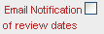
'Restricted View'
Left click the check box to switch this function on
• Restricted Tab restricts visibility to the following only:
o Those nominated as a member in the organisation list (i.e. those with editing rights)
o The Risk Owner
o Action owners associated with the risk in question.

n.b If your restricted risk is subsequently linked to another risk (using the ‘Linked Risks’ function) then visibility of your restricted risk is extended to the organisation / persons associated with the risk you are linking to.

When you have entered the information click the ‘Create’ button to complete the process of creating the risk information – you will be prompted if the information is not complete. Successful creation of the risk will take you to the screen that shows the risk information and the areas for creating current and pending controls.

3.b | Create a Current Control | Open a risk and in the Current Controls area and click ‘Create’
Enter the information about the Current Control in the ‘Description’ field. Include sufficient information to explain the control in a way which is understandable to someone who is not from your area or discipline. If you use acronyms and abbreviations please include the full phrase in the description as this helps give clarity and also assists with searches and analysis. The ‘Description’ field has a 4000 character limit (which includes spaces).
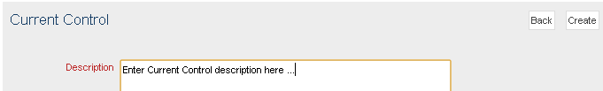
When you have completed the description click ‘Create’.

4.b | Create a Pending Control | Open the Risk to which you wish to add a Pending Control. In the ‘Pending Control’ area click ‘Create’  
Enter the information about the Pending Control in the ‘Description’ field. Include sufficient information to explain the control in a way which is understandable to someone who is not from your area or discipline. If you use acronyms and abbreviations please include the full phrase in the description as this helps give clarity and also assists with searches and analysis. The ‘Description’ field has a 4000 character limit (which includes spaces).
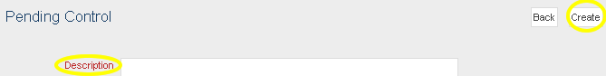
When you have completed the description click ‘Create’.

5.b | Create a Pending Control Action | Either: Create a Pending Control which will automatically take you to the ‘Create a Pending Control Action’ function  Or: Open the risk, open an existing Pending Control, in the ‘Actions’ area click ‘Create’.
Enter the information about the Pending Control Action in the ‘Description’ field. Include sufficient information to explain the action in a way which is understandable to someone who is not from your area or discipline. If you use acronyms and abbreviations please include the full phrase in the description as this helps give clarity and also assists with searches and analysis. The ‘Description’ field has a 4000 character limit (which includes spaces).

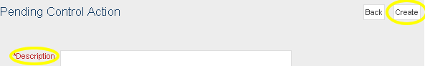
When you have completed the description click ‘Create’.

6.b | Assign an Owner to a Pending Control Action | Either: Create a Pending Control Action which will automatically take you to the assign an ‘Action Owner’ function  Or: Open the Risk, open an existing Pending Control, open a Pending Control Action, then in the ‘Action Owners’ area click ’Create’.
The Action Owner is the person who is responsible for implementing the action that applies to the Pending Control. The Action Owner is selected from a drop down list using the following procedure:
Click on the 'Search' next to the 'Action Owner' field to open the list
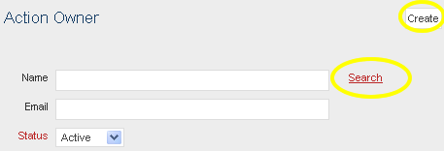
Search for the owner by scrolling though the list or using the search function*, then click on the person you want to select.
*Search function – enter surname and click search
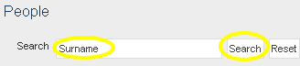
Once you have selected the Action Owner from the list click ‘Create’

7.b | Create a note | Notes can be added to Risks, Controls and Actions and the procedure is the same for each note
Open the risk and navigate to where you want to add a note: In the ‘… Notes’ area click ‘Create’

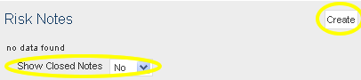

Type the note info into the ‘Note Text’ field and click ‘Create’.

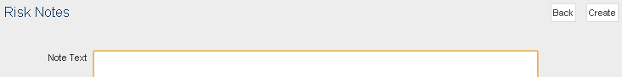

Notes are a 4000 character (including spaces) text field and are used to record information for yourself or others. Notes are especially important when reviewing a risk because if there are no changes needed at the point of review then this should be recorded in a Risk Note to say that the review has taken place.

8.b | Add a Review date | The procedure for allocating a review date is the same whether it is for a Risk, or a Pending Control or a Pending Control Action once you navigate to the correct point.
To navigate to the correct point:
- To add a review date to a risk: open the risk and click edit.
- To add a review date to a Pending Control: open the risk, click ‘details’ in the Pending Control area to open the Pending Control
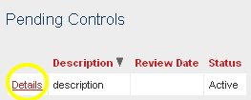

- To add a review date to a Pending Control Action open the risk, click ‘details’ in the Pending Control area to open the Pending Control, click ‘details’ in the ‘Actions’ area
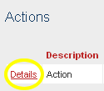
To Add a Review date:
Click on the Calendar icon next to the Review Date field
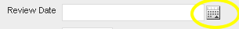
Select the Month and the year then click the day to select the date
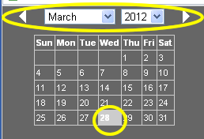
Date is now set – click to confirm
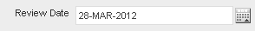

New Function in Empirical
As part of the enhanced functions rolled out in Release 4 was the ability to copy and then amend a risk and its components.
9.b | Copy a risk | To assist with creating new risks a ‘Copy’ function has been introduced. By ‘copying’ an existing risk the process of creating a risk is shortened as some information is pulled in from the existing risk and can be edited / modified once the copied risk has been created.  The process for copying a risk is the same whether you are copying from an existing risk or a Knowledge Library risk.
n.b. Not all fields are automatically populated when copying a risk – some require manual text entry or selection from a list.
Begin on the Empirical Home Page
Select any appropriate filters to narrow the list of displayed risks e.g. choose the type of Risk you want to copy from the list in the ‘Risk Type’ field (options are: All, Threat, Opportunity or Library).
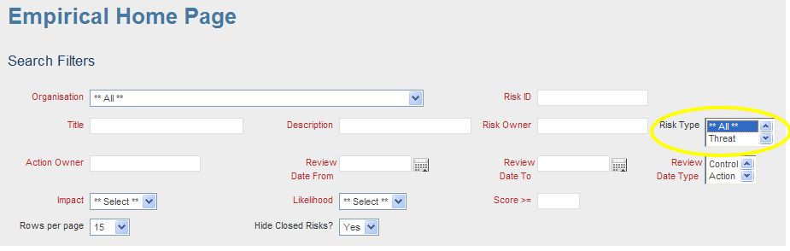
When you can see the risk that you want to copy (scroll through the risk list if needed) left click once on the ‘Copy’ text at the right hand side of the risk (See Copy Diagram 1).
Copy Diagram 1
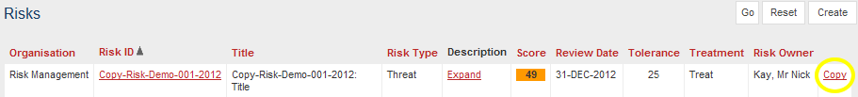
You will need to enter a new ‘Risk Identifier’ and select the ‘Organisation’ (see 2.b for more info). Some fields (examples are flagged with a star below) will be pre-populated with the text from the risk you are copying.
You will need to select the ‘Risk Owner’ and ‘Risk Type’ and enter a ‘Next Review Date’ if wanted (see 2.b for more info).
(See Copy Diagram 2)
You will need to expand the selections for ‘Pending Controls’, Current Controls’ and ‘Risk Notes’ by clicking the ‘+’ sign next to each (See Copy Diagram 2).
For ‘Pending Controls’:
- The Pending ‘Control Description’ will be populated and can be edited at this point.
- The Pending ‘Control Review’ Date field will be blank but a review date can be selected at this point.
- The ‘Copy Control’ check box will be ticked – untick this if you do not want to copy the Pending Control.
- The ‘Copy Control Notes’ check box will be unticked – tick this if you do want to copy the Pending Control Notes.
- The Pending Control ‘Action Description’ will be populated and can be edited at this point.
- The Pending Control ‘Action Review’ Date field will be blank but a review date can be selected at this point.
- The ‘Action Owner’ field will be populated but can be changed at this point by selecting from the ‘Action Owner’ drop down list (see 2.b for more info).
- The Pending Control ‘Copy Action’ check box will be ticked– untick this if you do not want to copy the Pending Control Action.
- The ‘Copy Action Notes’ check box will be unticked – tick this if you do want to copy the Pending Control Action Notes.
For ‘Current Controls’:
- The Current ‘Control Description’ will be populated and cannot be edited at this point. Once the new risk has been created by copying you can open and edit its components including the Current Controls (see 2.b for more info).
- The ‘Copy Control’ check box will be ticked – untick this if you do not want to copy the Current Control.
- The ‘Copy Control Notes’ check box will be unticked – tick this if you do want to copy the Current Control Notes.
For ‘Risk Notes’:
- The ‘Notes Text’ field will be populated and can be edited at this point. If you want to copy the note then tick the ‘Copy Note’ check box.
Copy Diagram 2
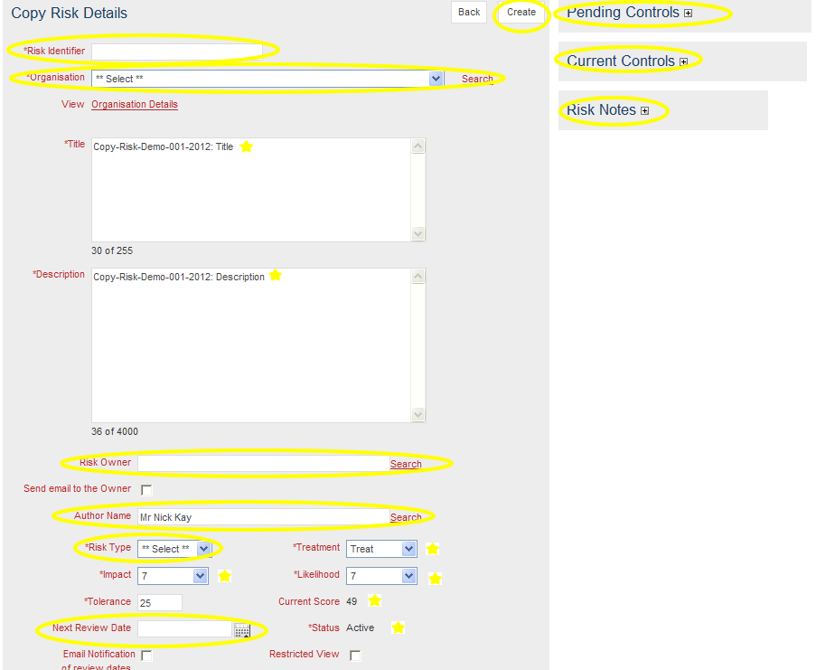
Copy Diagram 3
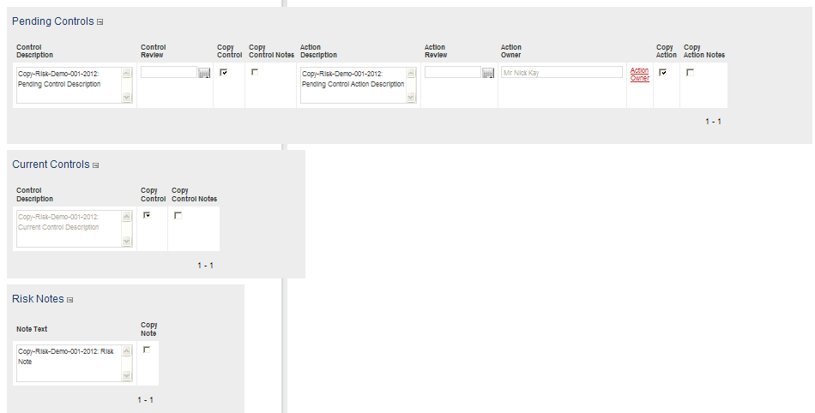
Once all steps in the ‘9.b Copy a risk’ function have been completed then click ‘Create’ (See Copy Diagram 2) to create the new risk.
Copy-Risk-Demo-001-2012 and Copy-Risk-Demo-002-2012 have been set as part of the Knowledge Library and can be viewed in Empirical while using this section – the Risk ID’s have been changed to ‘KL-Copy-Risk-Demo-001-2012’ and ‘KL-Copy-Risk-Demo-002-2012’.

10.b | Filters |  | The availability of filters has been extended and will be displayed at the top of the page under the ‘Search Filters’ heading when these are available. One or more filters can be used and partial or complete information can be entered into the filter fields.
Filters can be used individually or in conjunction. The Filter function operates as if there is a ‘wildcard’ either side of the text you enter in free text fields. For example: entering the text string ‘man’ in the ‘Title’ Filter will return risks where the title includes the words: Managerial, many, demand, performance, manual etc.
Remember to clear the filters once you have finished with them by clicking ‘Reset’.
List of Search Filters: |  | Filter Type / Notes:
Organisation |  | Drop Down. Select from within the Organisational Entities available in the drop down list and click ‘Go’.
Risk ID |  | Free Text. Use to display / report on a specific or set of risks.
Title |  | Free Text. Useful in analysis when looking for related risks.
Description |  | Free Text. Useful in analysis when looking for related risks.
Risk Owner |  | Free Text. Useful for identifying risks that a particular person owns.
Risk Type |  | Drop Down. By selecting and clicking ‘Go’ sets of risks can be displayed / reported on. Available categories are: ‘All’, ‘Threat’, ‘Opportunity’, ‘Library’
Action Owner |  | Free Text. Useful for identifying Actions that a particular person owns.
Review Date From |  | Useful when Displaying / Reporting on risks that are due for review within a particular period from a specific date. Can be used with ‘Review Date To’ to specify a closed period of time.
Review Date To |  | Useful when Displaying / Reporting on risks that are due for review within a particular period before a specific date. Can be used with ‘Review Date From’ to specify a closed period of time.
Review Date Type |  | Drop Down. By selecting and clicking ‘Go’ sets of risks can be displayed / reported on. Available category items are: ‘All’, ‘Risk’, ‘Control’, ‘Action’. Use this filter alone to view / report on all review dates in the selected category or use in conjunction with ‘Review Date From’ and / or ‘Review Date to’ to select items specific to a period in time.
Impact |  | Drop Down. Select from equal to or greater than an Impact score of 1 to 10.
Likelihood |  | Drop Down. Select from equal to or greater than a Likelihood score of 1 to 10.
Score |  | Free Text. Filters on equal to or greater than for the risk score you enter (2 to 100)
Rows per page |  | Drop Down. Allows for selection of the number of risks displayed at once. If there are more risks available than the number of rows selected then you have to click ‘Next’ at the foot of each page to view further risks. Row count categories available are: 15, 25, 100, 250, All.
Hide Closed Risks? |  | The default selection for this is ‘Yes’. If you want to see closed and open risks change this to ‘No’ and click ‘Go’.

11.b | Edit, Copy, Paste | Copy and Paste functions can be used in Empirical in Risks, Current Controls, Pending Controls, Pending Control Actions and all notes (except current control notes). To use these functions to update risk details open the risk, select edit, make the changes and then click ‘Update’. For all other items click ‘Details’, make the changes and then click ‘Update’.
The majority of the displayed text in Empirical, whether ‘system’ text or user-entered text can be highlighted, copied and pasted within editable fields in Empirical. Text from other applications (word processing, spreadsheets, web pages etc) can be copied and pasted into editable Empirical fields.
To use this functionality within the details of a risk it is necessary to open the risk and select edit. Once changes are complete than click ‘Update’ to confirm the changes.
For Controls, Actions and Notes click ‘Details’ make the changes and then click ‘Update’. Note that Current Control Notes cannot be edited – to add information to Current Control notes it is necessary to create a new note.

12.b | Bulk Updates | Bulk updates can be used to change quickly information across multiple components. Bulk updates can be used for Risk Ownership, Action Ownership, Review Dates and Organisations. Not all Bulk Update functions are available to all users. Contact the Risk Manager for assistance with the Bulk Update functions.
Risk Ownership Bulk Update:
To change the Risk Owner on one or more risks select the owner you wish to change FROM in the 'Risk Owner' field by selecting from the available owners by using the ‘Search’ function. Then select the person you want to change ownership to in the 'New Risk Owner' field by using the ‘Search’ function and click 'Go'. Check one, many or all Risks listed and click update.
Action Ownership Bulk Update:
To change the Action Owner on one or more Actions select the owner you wish to change 'From' in the 'Action Owner' field. Then select the person you want to change ownership to in the 'New Action Owner' field and click 'Go'. Results are listed by 'Risk ID' with the risk title and action description displayed. Multiple Actions for risks may be listed - check one, many or all of the check boxes and then click 'Update' to transfer ownership
Review Dates Bulk Update:
Review Dates can be updated using the Bulk Update function according to the Review Date Type – these types are: ‘Risk, Control and Action. Select the type from the ‘Review Type’ drop down; select the ‘Current Review Date’ using the Calendar function, select the ‘New Review Date’ using the Calendar function, and then click ‘Go’. Risks, Controls or Actions with the selected ‘Current Review Date’ are displayed by ‘Risk Id’, ‘Risk Title’ and ‘Review Type Description’ (Review Type Description is a generic term covering the description field). Check one, many or all Risks listed and click update.
Organisations Bulk Update
To Bulk Update the Organisation for a set of risks select the ‘Organisations’ tab in the Bulk Updates area. Then select the ‘Current Organisation’ from the drop down and the ‘New Organisation’ from the drop down and click ‘Go’. Check one, many or all Risks listed and click update.
Contact the Risk Manager for assistance with the Bulk Update functions.

13.b |  |  | Reports |  | Click the ‘Reports’ tab then select the Report Type using the tabs. Reports can be filtered prior to generating and then exported to spreadsheet or Portable Document Format (PDF) (except the Scatter Diagrams). Available Reports are:  Risk Summary: Returns a reduced set of fields useful for gaining an overview of a set or sub-set of risks.  Risk Register: Returns a full set of fields providing full information about a set or sub-set of risks.  Review Date: Uses Review Date filters to return Risks that have review dates within that period.  Scatter Diagram: Provides 2 matrices (Threats and Opportunities) plotting Impact times Likelihood scores to give a visual representation of the spread of Risks.
Reports can be exported to Spreadsheet format – this is an editable format and the data can be used as per normal functions to produce graphs etc – however the spreadsheet is unformatted and will require ‘tidying’. To generate the spreadsheet after running the report scroll to the bottom of the page and click ‘Export to spreadsheet’. The report is generated in .csv (comma separated value) format that can be saved using your spreadsheet programme in its appropriate format. Once saved it can be emailed, printed etc in the usual manner.
Reports can be exported to Portable Document Format (PDF) and are laid out more neatly – these can be attached to reports, printed for meetings etc but are not easily edited. It is necessary to save the PDF report prior to attaching to an email for sending it to a recipient – an error report will be generated if this is not done and the recipient will not be able to access the Report. To generate the PDF scroll to the bottom of the page and click ‘Print’ then save the PDF. Once saved it can be emailed, printed etc in the usual manner.
Neither Spreadsheets not PDF’s can currently be generated from Scatter Diagram Reports.
Risk Summary Report and Risk Register Report:
Use one or more Filters to select the parameters for running the report and then click ‘Go’.
Review Date Report:
This report defaults to Review Dates beginning from the current date and ending 1 month ahead. These dates can be changed to any period or to a Review Date From’ or a ‘Review Date To’ (delete the date in the appropriate field by clicking in the field and deleting the text).
14.b |  | Email Reminders |  |  |  | Empirical has functionality that can generate emails. These are used to inform Risk and Action owners that they have been allocated a responsibility or they are used to inform of an approaching review date. Emails assigning ownership are automatically generated* but the Email Notification of review dates defaults to ‘off’ but can be changed to ‘on’ by ticking the ‘Email Notification’ check box in the ‘Risk Details’ area.  *When creating a risk and assigning ownership to someone in your own Organisation there is an option not to generate an email informing them of Ownership – this does not apply when assigning ownership elsewhere.
When creating a risk there are 2 email options available.
- ‘Send email to the Owner’ – This is unchecked by default as normally a Risk Owner will be within your organisational Entity and will not need informing that the risk has been created. If you wish the Owner to receive an email informing that the risk has been created then tick this box.
- If you allocate a Risk to an Owner outside of your Organisational Entity or you allocate an Action Pending Control to anyone except yourself an email informing them of this will be sent. The email includes two ‘buttons’ – one for ‘Accept’ and one for ‘Reject’. If ownership is accepted (by clicking the button in the email) then no further action is required. If ownership is rejected then an email will be returned to you informing that the requested owner has rejected ownership.
- Review date emails: In the Risk Details area is a check box for ‘Email Notification’. If this box is ticked them email reminders of review dates will be sent 2 weeks before, 1 week before, on the review date, 1 week after and 2 weeks after. Then an email is sent to the Administrator informing that a review date has passed and not been reviewed.
15.b | Linked Risks |  |  | Risks can be linked to other risks where it is established that there is a relationship that is helpful to monitor. Risks can be linked by selecting the ‘Create’ button in the ‘Linked Risks’ area of the Risk Details when creating or editing a risk.  Risks can be linked by entering the appropriate Risk Id or by selecting from the ‘Organisation’ drop down or ‘Risk List’ drop down. Linking risks extends visibility of your risk to those who can view the risk you are linking to.
Selecting the ‘Create’ button allows you to link a risk to another. This can be useful especially when grouping and organising risks that have multiple aspects and have been separated for clarity. In can also be used to link risks across organisational entities to achieve common perspectives and share resources across mitigations.
If you have set a risk to ‘Restricted’ and then link it to a risk outside of your Organisation then you are extending the restricted view to include those who can view the risk you are linking to.

Section 3: Appendices

Appendix A: Objective Criteria for assessing Impact
Impact | Criteria
10  Critical  9 | Critical impact on the achievement of College/Faculty/Department/Division aims, objectives and overall performance. Service is seriously affected and major loss of income and/or reputation or high increase in costs. Very difficult and long term to rectify. Major injuries and/or deaths.
10  Critical  9 | Financial loss >40% College/Faculty/Department/Division annual budget
10  Critical  9 | Closure of an academic department/major research project.
8  Major  7 | Major impact on costs, income and certain key organisational objectives. Affects a significant part of the organisation. Serious impact on output, levels of service and external relationships. Medium to long term effect on reputation and expensive to recover. Death of an individual or several major injuries.
8  Major  7 | Financial loss 26-40% College/Faculty/Department/Division annual budget
8  Major  7 | Loss of a number of high profile staff
6  Serious  5 | Significant waste of resources and impact on operational efficiency, output, quality and goals in more than one work area. External contacts may be affected and reputation damaged. Medium term effect and may be expensive to recover. Major injury.
6  Serious  5 | Financial loss 16-25% College/Faculty/Department/Division annual budget
6  Serious  5 | Loss of a high profile member of staff/research group
4 Moderate 3 | Medium impact on output, time lost, finance or assets. Short to medium term effect. Minor injuries.
4 Moderate 3 | Financial loss 6-15% College/Faculty/Department/Division annual budget
4 Moderate 3 | Loss of Key Member of staff/research group
2  Minor  1 | Minimal financial or other loss, delay, interruption or inconvenience. Little or no damage to the College’s reputation. Can be easily and quickly put right. Little or no effect on the College’s reputation. No injuries
2  Minor  1 | Financial loss <5% College/Faculty/Department/Division annual budget

Appendix B: Objective Criteria for assessing Likelihood
10 | Certain: | 90 + %
9 | Almost certain | 80 - 89%
8 | Very probable | 70 - 79%
7 | Probable | 60 – 69%
6 | Highly likely | 50 – 59%
5 | Very likely | 40 – 49%
4 | Likely | 30 – 39%
3 | Possible | 20 – 29%
2 | Unlikely | 10 – 19%
1 | Rare | 0 – 9%

