JUNE 2014 RISK ANALYSIS

Contents:
- June 2014 Risk Analysis - Information
- Threat Risk: Common Theme Trend Analysis
- Appendix:
- Departmental threat risk charts by Faculty / Area
- Faculty Threat Risks

- June 2014 Risk Analysis - Information
Empirical contains currently nearly 1000 risks and of these nearly 50% have a significant score (Impact and/or Likelihood score of 7 or above or a total score of 25 or above) and have been used in this analysis.

The analysis extract was taken from Empirical at the beginning of June 2014, which was slightly later than normal to allow for updating requests to be accommodated, and the data set further reduced by counting common theme categories once per Department for threat risks giving a total count of 256 risks across 54 Departments (see appendix: ‘Faculty Risks’ diagram for Faculty level threat data. Opportunity risks and College level risks are not included in this analysis).

College changes, such as changes in establishment and areas of activity, impact on the Risk Profile and this analysis should be considered as a guide rather than a definitive analysis of College Risks as the scope it applies to is dynamic. The analysis is generated by the information currently recorded in Empirical and where some of the changes are quite small reliance should not be placed on the trend indicator without further corroboration. Also some risks (8 in total) are so specific to particular areas they have been categorised as ‘Unique’ rather than creating specific categories for such specialised areas of risk.

The frequency data (see Figure 1) would indicate that the key risk areas remain similar with clustering around Finance, Staff and Disaster Recovery.

Figure 1
Disaster Recovery, Finance, ICT and Students show an overall slight decrease, with the remaining areas staying generally level or with an increase count of 1 or 2 and, although requiring continued monitoring, there are no currently recorded major increases or new areas.

The charts in the Appendix show Departmental threat risks by Faculty / Area and include a chart for Faculty Threat Risks. The current College Risk areas are indicated on the charts with the symbol to indicate where Department and Faculty risks have alignment with College level risks.

The Risk Analysis is facilitated by Staff recording and updating Empirical forming a journal of risk information of benefit at all levels of the College and we would like to thank the Staff for their continued support.

- Threat Risk: Common Theme Trend Analysis

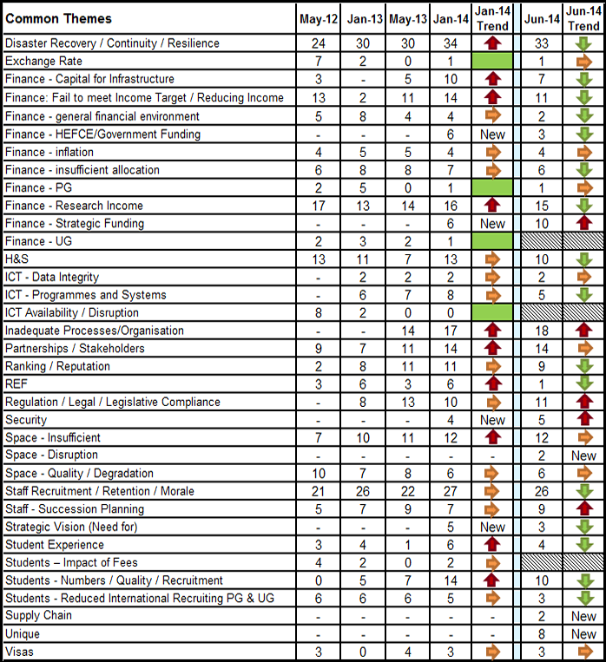

APPENDIX

