Template and instructions for extended abstracts
First A. Author*¹, Second B. Author2 and Third C. Author3
^{1, 2} Authors’ Department, Institute, Organisation, Country
(E-mail: firstauthorsname@aaaa.bbb, secondauthorsname@aaaa.bbb)
³ Author’s Department, Institute, Organisation, Country
(E-mail: thirdauthorsname@aaaa.bbb)

Abstract

This is the template and instructions for extended abstracts. Authors are advised to read carefully the extended abstract guidelines, and follow them.

Introduction
The extended abstract should be 2-pages in length, and fully written in English, including figures, tables and references.
The extended abstract should explain the aim and scope of your study, the materials and methods used, the results obtained and the main conclusions reached.

Methodology
The structure of the extended abstract should be:
- Abstract (65 – 100 words)
- Introduction (140 – 180 words)
- Methodology
- Results
- Future work (70 – 100 words)
- Acknowledgement (optional)
- References (5-14 references)

2.1 Table, figure and equations
Examples for tables and figures are, respectively, Table 1 and Figure 1.
Table 1: Table caption
Properties | Data
Property 1 | 1234
Property 2 | 1234

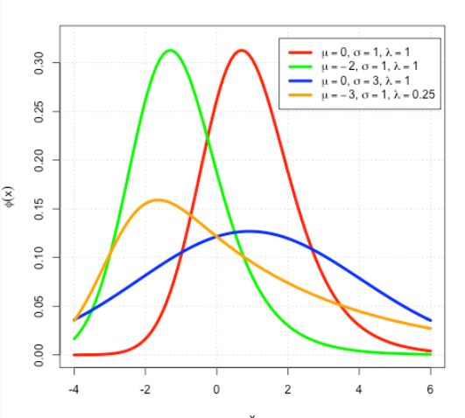
Figure 1: Figure title
Equations should be labeled as in Equation (1), with a number towards the right margin, if there is more than one equation.
(1)

Results
You can fill in this template and then convert it to Pdf format.
Your extended abstract must be submitted using the website submission page:

Future work

Acknowledgements

References
References should be listed as cited in the text, using reference numbers and presented in the following format:
[1] Berawi, M.A., (2004). Quality Revolution: Leading the Innovation and Competitive Advantages. International Journal of Quality & Reliability Management, Volume 21(4), pp. 425–438 (Journal articles)
[2] Harris, M. (2014). The GRO Green Roof Code. Final report of Green Roof Code of Best Practice for the UK 2014. Available online at: https://livingroofs.org/wp-content/uploads/2016/03/grocode2014.pdf, Accessed on 14 February 2017

