Students’ netiquette guidance
Chemical Engineering
With thanks to the Department of Aeronautics who originally developed this guide.

The purpose of this document is to outline a common set of etiquette guidelines and expectations for the new MS Teams lecture environment within the Department of Chemical Engineering, to be followed by lecturers and students with the goal of ensuring the best experience for all.

Following these guidelines should help minimise disruption and distraction, while promoting engagement, interactivity and participation.

Using MS Teams

- Before the start of term, you should take the time to ensure that MS Teams is installed on your computer and familiarise yourself with the software.
- The Imperial College London ICT pages have information and videos on using Teams, including scheduling and joining meetings, sending messages and using groups.

Preparing for lectures

- Prior to your lecture, make sure your equipment is fully functioning, including microphone, camera, internet connection and applicable software.
- You are encouraged to download the lecture notes (if available) from BlackBoard prior to the lecture start in case the quality of the stream is too low for you. This will allow you to listen to the lecturer’s explanation whilst being able to follow the notes.

Joining lectures

- Please ensure your microphone is muted when joining lectures. Instructions on how to do this can be found below.
- Check that your background (if visible on the camera) is appropriate. If not, consider using MS Teams’ built in background effects which can be accessed during a meeting - as detailed below.
- If the lecturer forgets, please remind them to start the recording of the lecture.

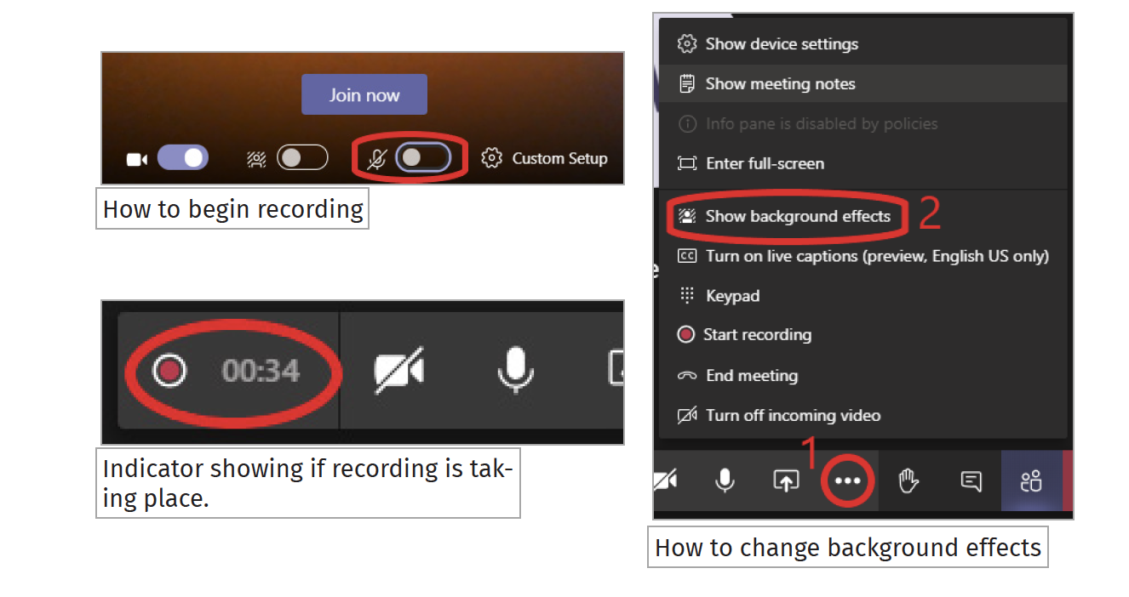
How to mute your microphone

During lectures

- Keep your microphone muted unless asking a question or indicating a problem with the lecture.
- Do not share your screen unless asked to by the lecturer. If you are unsure how to share your screen, see the guidance below. More guidance can be found at the Microsoft Teams training website.
- You are encouraged to interact as much as you would in person with the lecturers to stay engaged and concentrated. Guidance on asking questions can be found below. You may wish to have your camera on for the duration of the lecture to give the lecturers visual cues on your engagement and understanding of concepts. Guidance on how to share your video can be seen below.
- Check periodically to ensure that the lecture is still being recorded.

Questions

- To ask a question either type one in the chat, or ‘raise your hand’. When asking a question over voice, remember to un-mute your microphone and mute it once again after you have finished. Guidance on how to do these actions can be seen below.

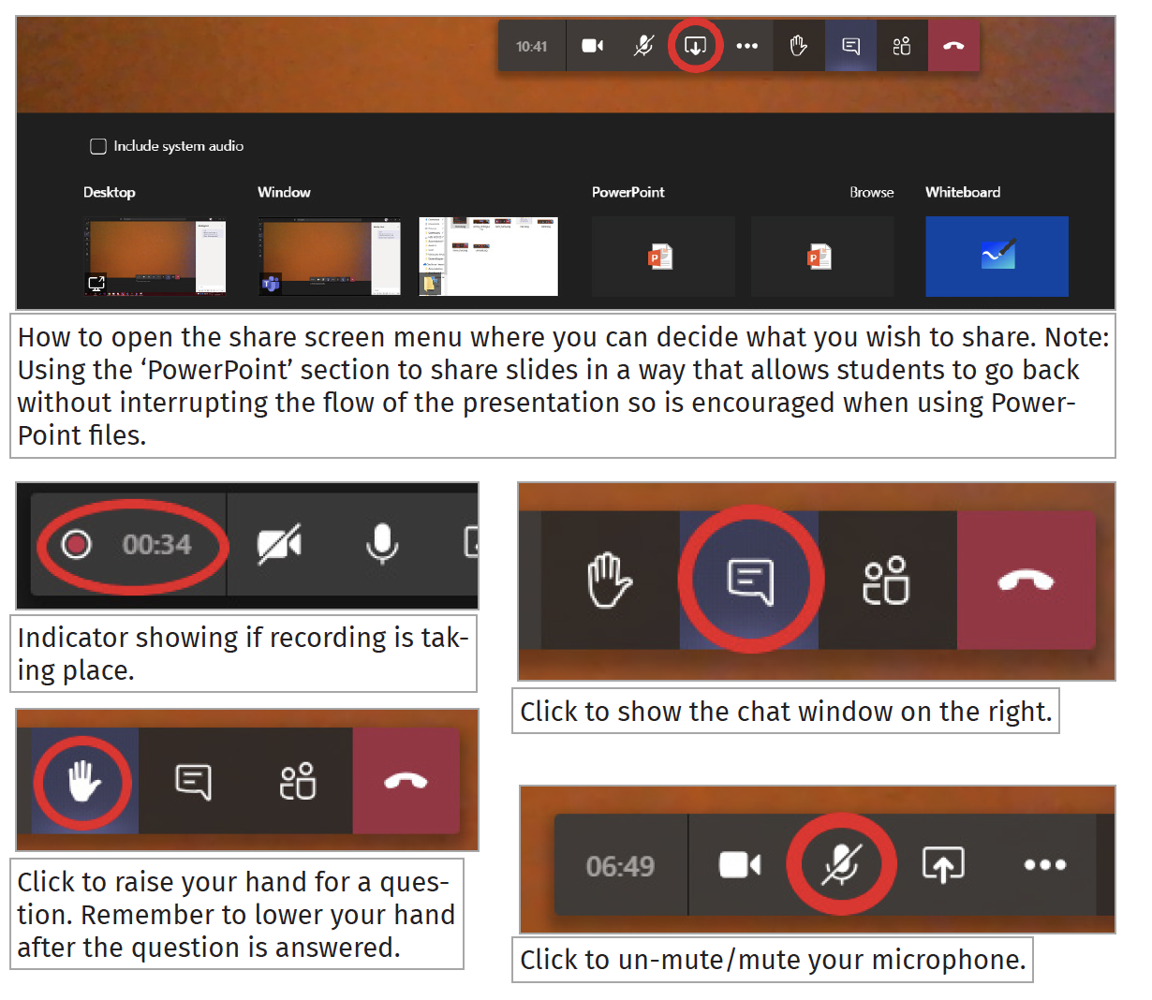

After the lecture

- Some time at the end of the hour block should be left for a break, as would normally be expected in person. This time should be used to go over any further questions you may have.
- You are not expected to stay in the meeting between lectures, but you may remain for academic-related discussion.

Small group sessions

- The Department strongly advises that both students and teaching staff keep their cameras on during small group sessions e.g. during personal and academic tutorials, laboratories, and other practical sessions like project-based module work. Keeping your camera on can be a good way to signal your engagement in a session and gives others some non-verbal cues. This will help to establish good rapport and make the most of your online interactions with staff and students.

Other general guidelines

- In common areas and shared spaces, it is good practice to wear earphones and headsets when communicating during your online sessions. This will help to minimise noise and avoid distracting others who may be sharing that space.

