Instructions for digitally signing on Adobe (Free version)
- Open the PDF in Adobe
- Open up the ‘preferences settings’ – can open this by CTRL + K
- Select Signatures > Identities & Trusted Certificates > More, then clicking Add ID to create a new self-signed certificate
- Once the digital certificate has been created, open the PDF and search for ‘digitally sign’ in the tools section of the document (see screenshot)
- Follow the instructions to add the digital signature, and select on the document where it will be inputted, provide your password to authorise
- Once signed you will be prompted to save a new copy of the signed document

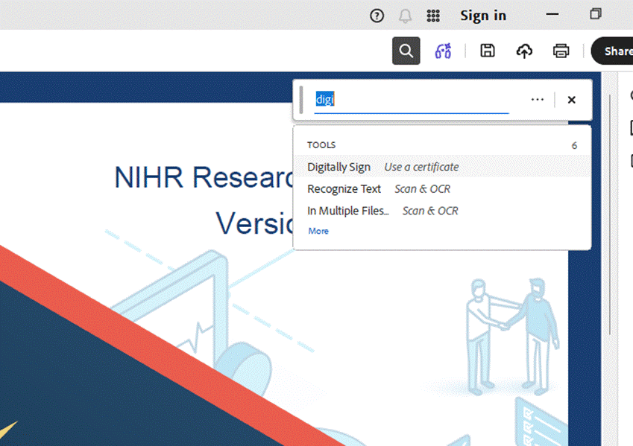

If you sign this way it also adds the date and time, which is why it is compliant with Imperial’s Trial Unit standards. Please do not confuse this with the adobe sign function on Adobe, which is not a sponsor compliant signature option.

