**Study protocol**

Vaccination timeliness in preterm infants.

|  |  |
| --- | --- |
| **Protocol version no:** | **V3**  **23/07/2019** |
| **IRAS project ID:** | **209347** |

**Title of study**

Vaccination timeliness in preterm infants.

**Abstract**

Despite global recommendations that preterm infants should be immunised on a par with their full-term peers, a recent review of the literature found that globally, preterm infants experience some significant delays; this project aims to investigate this issue further and to identify any factors associated with vaccination timeliness.

This multi-centred study uses a secondary data analysis design and includes data for approximately 6000 infants born in the North Yorkshire and Humber region due their first vaccination between January and June 2018. It is envisaged that the findings may influence policy makers and service providers in developing strategies which ensure that preterm infants are vaccinated with minimal unwarranted delays.

**Contact details**

Chief Investigator: **Helen Sisson, PhD student**

Lecturer in Public Health

Faculty of Health Sciences

University of Hull

Cottingham Rd, Hull, HU67RX

[h.sisson@hull.ac.uk](mailto:h.sisson@hull.ac.uk)

01482 464538

Supervisor 1: **Dr Eric Gardiner**

Statistician

Faculty of Health Sciences

University of Hull

Cottingham Rd, Hull, HU67RX

[e.d.gardiner@hull.ac.uk](mailto:e.d.gardiner@hull.ac.uk)

Supervisor 2: **Professor Roger Watson**

Professor of Nursing

Faculty of Health Sciences

University of Hull

Cottingham Rd, Hull, HU67RX

[r.watson@hull.ac.uk](mailto:r.watson@hull.ac.uk)

Sponsor: University of Hull, Cottingham Rd, Hull, HU67RX

Lead site: Hull University Teaching Hospitals NHS Trust, Research & Development Office, Office 13, Daisy Building, Castle Hill Hospital, Castle Road, Cottingham, HU165JQ

**List of contents**

|  |  |
| --- | --- |
| **General Information** | |
| Title page  Abstract  Contact details | |
| **Section** | |
| 1. Background | 1 |
| 1. Research aim and objectives | 2 |
| 1. Study design/methods    1. Defining the region    2. Data transfer    3. Data to be collected | 2  3  4  4 |
| 1. Ethics and approvals | 7 |
| 1. Finance and insurance | 8 |
| 1. Dissemination | 8 |
| 1. References | 9 |

1. **Background**

Vaccination is an important public health activity which has resulted in a significant decline in infectious diseases and even the eradication of some infections (World Health Organisation (WHO), 2016). Globally, the emphasis on vaccination programmes is placed on children under five years of age, as this is where the burden of infection is greatest (UNICEF, 2016).

The UK has a well-established routine childhood vaccination schedule which commences once the infant reaches eight weeks of age (Salisbury & Ramsay, 2013a); uptake rates of 94% for the primary course of immunisations for infants suggest that the schedule is acceptable to the considerable majority of parents and carers (Public Health England (PHE), 2017). Guidance cites a small number of contraindications to vaccination (Salisbury & Ramsay, 2013b), indicating that there are very few circumstances under which vaccinations should be deferred or not administered at all, perhaps reflected in the high uptake rates (PHE, 2016). Preterm infants are defined as those born before a gestational age of 37 weeks (WHO, 2017), and immunisation policy from around the world is unanimous in guidance around vaccinating preterm infants; prematurity is not a reason to withhold vaccination, and preterm infants should receive their vaccinations on a par with their full-term peers, that is, according to their chronological age without adjusting for prematurity (Salisbury & Ramsay, 2013c; American Academy of Pediatrics, 2015; Australian Government, 2015; Public Health Agency of Canada, 2015).

Preterm infants are particularly vulnerable to infection and vaccination policy supports the practice of timely vaccination in this population. In spite of this, some early enquiries found that vaccinations were frequently delayed in this population (Vohr & Oh, 1986; Wariyar et al., 1989). However, these studies were undertaken in circumstances when guidance supporting timely vaccination in preterm infants was just emerging, which suggests that practice at this time was inconsistent. Yet more recent practice experience has substantiated the existence of a delay, as in the primary care setting, both parents and health care providers have been witnessed advocating vaccination deferrals for reasons which are not supported by current guidance. This observed existence of a delay prompted further exploration, and the findings of a systematic literature review on the topic revealed an association between low birthweight, low gestational age and a delay in primary vaccinations (Sisson et al, 2017). The review also explored parental characteristics in association with vaccination timeliness; the literature was inconclusive when examining a delay in vaccination and mothers’ socioeconomic status or level of education. Only one US study examined parental ethnicity, which concluded that when compared with white infants, those from all other ethnicities were significantly more likely to have experienced vaccination delays. Hospitalisation was also a factor associated with vaccination timeliness, although the literature was divided on this, with some studies reporting that hospitalisation was a barrier to timely vaccination, and others finding the opposite.

1. **Research aims/objectives**

The review took a global perspective and strongly indicated that vaccinations in preterm infants are delayed. However, the studies reviewed were either small scale, not contemporaneous or not based on a UK population, therefore, this study is designed to investigate this further in a UK, regionally based study.

The aims are to investigate vaccination timeliness in preterm infants, and to explore factors associated with this. Specifically, its objectives are to investigate the following:

i. Are primary vaccinations delayed in preterm infants?

ii. Is there a difference in mean primary vaccination age between preterm and full-term infants?

iii. Is there a relationship between gestational age and age at vaccination?

iv. If a delay exists, what are the factors associated with this?

1. **Study design/methods**

The study takes a regionally based approach, using the North Yorkshire and Humber area, analysing primary vaccination data relating to preterm infants in the area over a six-month period between 1st January 2018 and 30th June 2018. The primary vaccinations are the first vaccines offered to all infants at 8, 12 and 16 weeks of age. These vaccinations have been chosen to study because preterm infants are particularly vulnerable to infection making the earliest months of their life a time when the immunological support which vaccination provides especially vital. It is estimated that the identified six-month time frame would produce data relating to 400-500 preterm infants who would be matched to full term controls also from the region, also due vaccination in the same time period (approximately 6,000 infants in total). The region hosts five units providing advanced care for preterm neonates: Hull Royal Infirmary, York Hospital, Scarborough Hospital, Scunthorpe General Hospital and Diana, Princess of Wales Hospital, Grimsby.

The study uses secondary data sources; the Maternity Services Data set (MSDS), Child Health Information Service or, CHIS (which holds comprehensive immunisation details for all infants), and the National Neonatal Research Database (NNRD). The databases would be linked via infants’ individual NHS numbers, with this being the only common identifier between the datasets; using such patient identifiable information requires CAG approval which is being sought (see Ethics and approvals, section 4). There are four CHIS departments in the region, and approval from the hosting organisations would also be obtained.

***3.1 Defining the region***

The region being studied is defined by the Local Maternity System (LMS). The recommendations from the publication Better Births (NHS England, 2016), work in tandem with sustainability and transformation plan (STP) processes (NHS, 2014) to provide maternity services. There are 44 STP areas in England, and for this study, the Humber, Coast and Vale LMS is relevant.

The Humber Coast and Vale (Figure 1) hosts a population of 1.4 million and six clinical commissioning groups (CCGs).

**Figure 1 – Humber Coast and Vale STP area**

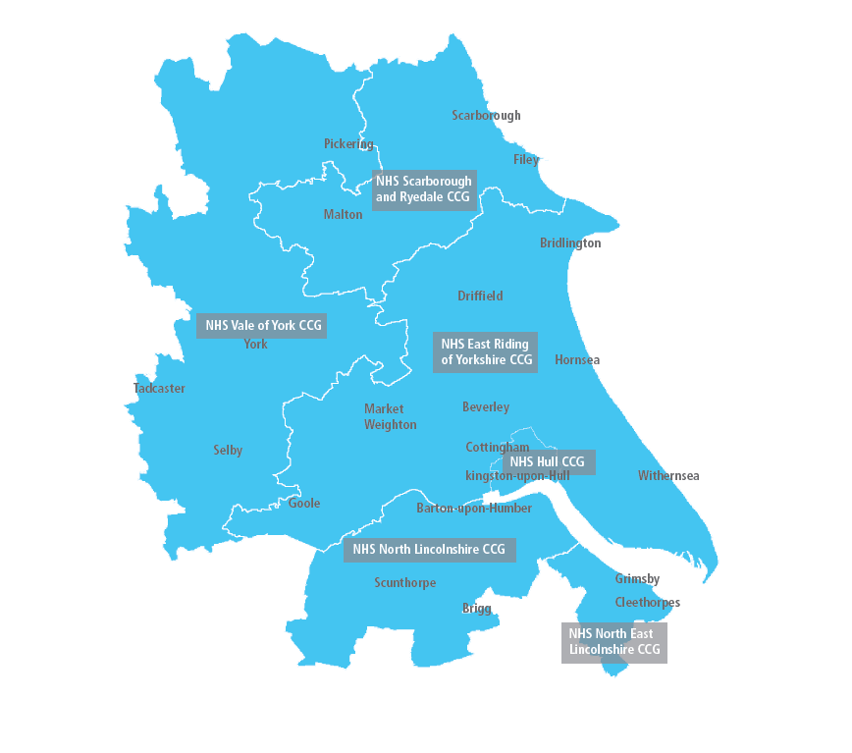

Within this area, there are three acute hospital trusts:

1. Northern Lincolnshire and Goole (NLAG) NHS Foundation Trust
2. York Teaching Hospital NHS Foundation Trust
3. Hull University Teaching Hospitals (HUTH) NHS Trust (Lead site)

***3.2 – Data transfer***

Each of the three trusts identified in section 3.1 hosts a database which records all births within that trust, referred to as the Maternity Services Data Set (MSDS); the MSDS dataset will identify all infants eligible for inclusion in the analysis. Therefore, MSDS data for infants within a defined six month time frame will be requested from each of these organisations and held by Information Services at the lead site (HUTH NHS Trust). An overview of the data to be collected from the MSDS is in section 3.3.

Using the NHS number (from data already obtained from MSDS), additional data for infants born <35 weeks will be requested from the National Neonatal Research Database (NNRD). This will yield information regarding the infants’ health status and some demographic detail (see section 3.3 for details).

Finally, and again using the NHS number, immunisation data will be requested from the Child Health Information Systems (CHIS). The data requested from CHIS will be for the defined six-month period using the NHS numbers from the MSDS data already identified.

At this stage, Information Services at HUTH NHS Trust will have MSDS data for all infants and some additional data from the NNRD for those born <35 weeks. Using NHS numbers, these will then be matched with the immunisation data received from the CHIS; the data set will then be anonymised and sent to the Chief Investigator for analysis. Based on ONS data (ONS, 2017) the sample size should be around 6,000 infants in total, a proportion of which will be classed as preterm (born before 37 weeks) and based on a preterm birth rate of 7.3% (NICE, 2015) this number is expected to be in the region of 420.

An overview of the data transfer process is illustrated in Figure 1 on page 6.

***3.3 Data to be collected***

1. Database(s) 1 – MSDS

The MSDS across the three organisations record data relating to all births and the following mutually collected data will be requested:

|  |  |
| --- | --- |
| Infant details | NHS number  Date of birth  Gender  Birth weight  Gestational age |
| Parental details | Mothers’ date of birth  Number of previous pregnancies/births  Ethnicity |

The MSDS do not consistently record infants’ ethnicity, or mothers’ occupations. It also does not routinely record any paternal data. Next, using the NHS numbers, additional information for infants identified from the MSDS with a gestational age of less than 35 weeks will be sought from the NNRD.

1. Database 2 – NNRD

The following data will be requested from the NNRD:

|  |  |
| --- | --- |
| Infant details | NHS number  Date of birth  Birth weight  Gestational age  Reason for admission  Unit admitted to  Diagnosis at admission  Diagnosis at discharge  Discharged on oxygen  Date of discharge  Date of death |
| Parental details | Mothers’ occupation  Fathers’ date of birth  Fathers’ ethnicity |

1. Database(s) 3 – CHIS

All infants’ immunisation data will be requested for the defined time period based on the NHS number identified by the MSDS, and matched using NHS numbers, so data to be requested will be:

|  |  |
| --- | --- |
| Infant details | NHS number  Date of birth |
| Immunisation data | Date of 8 week scheduled vaccines:  DTaP/IPV/Hib & Hep B, PCV, MenB, Rotavirus  Date of 12 week scheduled vaccines:  DTaP/IPV/Hib & Hep B, Rotavirus  Date of 16 week scheduled vaccines:  DTaP/IPV/Hib & Hep B, PCV, MenB |

The time period of interest is over 6-months; all infants due their first vaccinations (at 8 weeks of age) from 1st January 2018 up to and including 30th June 2018. Therefore, eligible infants to be identified by MSDS data will be those born between 6th November 2017 and 5th May 2018.

Figure 1 illustrates how the data would be requested, linked and managed so that the Chief Investigator is ultimately analysing fully anonymised data.

***Figure 1 – Data management process***

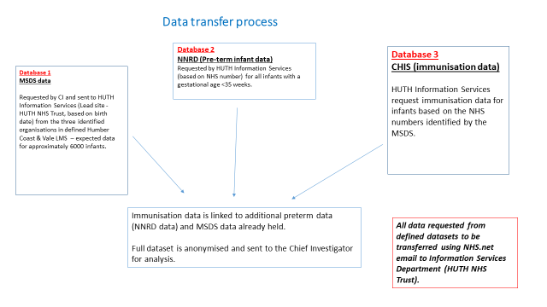

Analysis of these data would address the overall research aim investigating the timeliness of vaccination. The additional variables requested from the MSDS and the NNRD would also facilitate the identification of certain factors associated with timeliness of vaccination in preterm infants.

Following a process of checking, editing and coding, the anonymised data would be analysed using descriptive statistics and relational analyses using SPSS.

1. **Ethics and approvals**

The nature of the project’s design negates the need to obtain informed consent from all individuals whose data are included. For this project, full ethical approval will be sought via the Integrated Research Application System (IRAS). Additionally, the use of secondary data for this study without obtaining informed consent, requires approval from the Confidentiality Advisory Group (CAG) (also sought via the IRAS application). Prior to entering data into the MSDS, CHIS and the NNRD, parental consent is obtained where parents are informed of what data are being collected and why. Additionally, the NNRD is a national Research Ethics Committee approved database (Gale & Morris, 2016). The need to obtain the necessary permissions from the custodians of the datasets is also identified, and this will be sought from the providers of the CHIS departments and MSDS and NNRD host organisations. Prior to undertaking the study, an application for review and approval will also be submitted to the Chief Investigators organisation: The University of Hull, Faculty of Health Sciences.

The CAG guidelines regarding the management of patient identifiable data are to be strictly adhered to; figure 1 illustrates how the datasets would be linked and anonymised by a trusted third party prior to being released to the Chief Investigator.

Even if patient data are anonymised, confidentiality is a specific consideration in terms of data storage and transfer. All electronic and paper versions of information regarding the conduct of the study (applications, approvals and additional correspondence) will be kept on password protected computers and in locked cabinets, accessible only by the Chief Investigator and two supervisors. The anonymised dataset would be kept for a period of five years to allow it to be revisited and even mined should the opportunity of future research arise. The original dataset with identifiers would be held by Information Services for reference. Data transfer to the HUTH NHS Trust Information Services will be via nhs.net accounts. The Information Services Team have been advised on the data management of this project by the Information Governance Team also at HUTH NHS Trust, to ensure that the legal obligations around data transmission and storage are fully adhered to.

***Organisations involved in the project***

Based on the proposed plan, there are several organisations involved and therefore permissions will be requested from the following:

MSDS data – from the hosting organisations of Northern Lincolnshire and Goole (NLAG) NHS Foundation Trust, York Teaching Hospital NHS Foundation Trust and Hull University Teaching Hospitals (HUTH) NHS Trust.

Additional NNRD data – approval from Imperial College London, the custodians of this dataset, has been received.

Immunisation data – there are four CHIS departments in the Humber Coast and Vale STP region:

|  |  |
| --- | --- |
| CHIS | Host Organisation (for R & D purposes) |
| 1.North Yorks | Harrogate and District NHS Foundation Trust |
| 2.ERY & Hull | Humber NHS Foundation Trust |
| 3.North Lincs | NLAG NHS Foundation Trust |
| 4.North East Lincs | North East Lincolnshire Council |

Each of the CHIS host organisations will also be contacted for the required R & D permissions.

1. **Finance & insurance**

There are charges associated with data extraction from the NNRD (approx. £4326) and also for the data storage, linkage and anonymization work to be undertaken by HUTH Information Services (approx. £1500). Funding is being provided by the University of Hull. As sponsors, the University of Hull are also insurers for this project.

1. **Dissemination**

The findings of the study would be disseminated via publications in professional and academic journals, and presentation at conferences. The appropriate use of social media to disseminate these findings would also be used.

**References**

American Academy of Pediatrics (2015) *Red Book Online: Immunization in Preterm and Low Birth Weight Infants.* Available online: (<http://redbook.solutions.aap.org/chapter.aspx?sectionId=88187007&bookId=1484&resultClick=1> [Accessed 07/03/2018].

Australian Government (2015) *The Australian Immunisation Handbook; Groups with special vaccination requirements.* Available online: <http://www.immunise.health.gov.au/internet/immunise/publishing.nsf/Content/Handbook10-home~handbook10part3~handbook10-3-3#3-3-2> [Accessed 07/03/2018].

Gale, C & Morris, I. (2016) The UK National Neonatal Research Database: using neonatal data for research, quality and more. *Archives of Disease in Childhood Practice Edition.* 0, 1-3. doi:10.1136/archdischild-2015-309928.

National Institute for Health and Care Excellence (2015) *Preterm labour and birth.* Retrieved from:

<https://www.nice.org.uk/guidance/ng25/chapter/context> [Accessed 02.07.2018]

Office for National Statistics (2017) *Births in England and Wales: 2016.* Retrieved from: <https://www.ons.gov.uk/peoplepopulationandcommunity/birthsdeathsandmarriages/livebirths/bulletins/birthsummarytablesenglandandwales/2016> [Accessed 02.07.2018]

Public Health England (2017) *Health Protection Report Vol 11, No. 45* Available online: <https://www.gov.uk/government/uploads/system/uploads/attachment_data/file/666735/hpr4517_cover.pdf>[Accessed 07/03/2018].

Public Health Agency of Canada (2015) *Canadian Immunization Guide: Vaccination of Specific Populations, Immunization of infants born prematurely*. Available online: <http://www.phac-aspc.gc.ca/publicat/cig-gci/p03-05-eng.php> [Accessed 07/03/2018].

Salisbury, D. & Ramsay, M. (eds) (2013a) *Immunisation Against Infectious Disease (The Green Book).* London: Public Health England.

Salisbury, D. & Ramsay, M. (eds) (2013b) *Contraindications and special considerations: the green book chapter 6.* Available online: <https://www.gov.uk/government/uploads/system/uploads/attachment_data/file/147824/Green-Book-Chapter-6-v2_0.pdf> [Accessed 07/03/2018].

Salisbury, D. & Ramsay, M. (eds) (2013c) *Immunisation of individuals with underlying medical conditions: the green book chapter 7.* Available online: <https://www.gov.uk/government/uploads/system/uploads/attachment_data/file/309218/Green_Book_Chapter_7_v1_3.pdf> [Accessed 07/03/2018].

Sisson, H. (2017) Vaccination timeliness in preterm infants: An integrative review of the literature. *Journal of Clinical Nursing.* 26(23-24), 4094-4104.

Vohr, B. & Oh, W. (1986) Age of Diphtheria, Tetanus, and Pertussis Immunization of Special Care Nursery Graduates. *Pediatrics,* 77(4), 569-571.

Wariyar, U., Richmond, S. & Morrell, P. (1989) Immunisation state of children born before term in the Northern region. *British Medical Journal,* 299, 1013-1014.

WHO (2017) *Preterm Birth.* Available online: <http://www.who.int/mediacentre/factsheets/fs363/en/> [Accessed 27/03/2018].

WHO (2016) *Immunisation Coverage.* Available online: <http://www.who.int/mediacentre/factsheets/fs378/en/> [Accessed 07/03/2018].

UNICEF (2016) *Protecting Children from Disease.* Available at: <http://www.unicef.org.uk/UNICEFs-Work/What-we-do/Disease/> [Accessed 07/03/2018].