Sample submission:

Before submitting any samples to the facility for processing you need to have a formal quote.

Labelling: This is very important– please use IGF identifiers only.
Please label the side of the plates and adhesive covers with the project tag that you can find on the formal quote e.g. edwards_15-2-21_ribodepletion. No other information is needed.

Sample shipping: We only accept samples in 96-well PCR plates. We won’t accept any samples in Eppendorf tubes or a different type of plate (ie cell culture plates). The samples should be aliquoted vertically; A1-->H1, A2-->H2, etc, with no gaps between the samples.

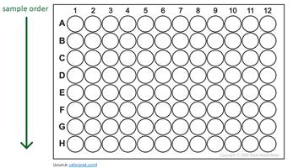
Ensure your plates are covered with suitable plate sealers - qPCR optical covers are not recommended due to poor adhesion.

Quantity: We ask for a minimum of 15μl (more if you have enough sample or if it’s low concentration) and a minimum amount of 300ng.

Quality: For mRNA applications, we require high quality RNA (minimum RIN of 7). For total RNA, we can accept lower RIN scores. We will check this as part of our internal QCs, so we will also ask for a 2nd plate with 5ul of RNA, in order to minimise the free-thaw of the main sample plate.

For RNAseq projects: It’s essential that the samples have been DNAase treated as part of the extraction process. We will perform gDNA checks as part of the initial QC process and if we find the gDNA contamination to be higher than 2%, we’ll do an additional treatment.

