

4th Annual
Weill Cornell Medicine- NHLI
Joint Meeting
H o s t e d b y t h e D i v i s i o n o f P u l m o n a r y
a n d C r i t i c a l C a r e M e d i c i n e


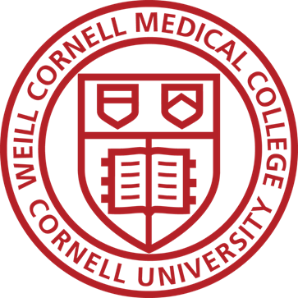

Monday, January 15th, 2024 | 8:00 am-7:00 pm
Tuesday, January 16th, 2024 |9:00 am-12:50 pm

The Paul Wood Lecture Theatre (ground floor)
The National Heart & Lung Institute
Guy Scadding Building
Dovehouse Street
London SW3 6LY

Meeting Description
The Fourth Annual Weill Cornell-Imperial College Joint Meeting is a two-day conference with our peer pulmonary scientists from the UK. Faculty, trainees, and Post-doctoral Fellows from all campuses are invited, with an aim for the entire academic pulmonary community to meet, interact, and foster investigative interactions in an informal setting. There will be a mix of lectures and poster sessions/discussions. The emphasis will be on basic, translational, and clinical investigative studies currently underway throughout WCM in Immunology, Infection, ILD/IPF, COPD, Sleep and Critical Care.

How to reach the Education Centre
National Heart & Lung Institute
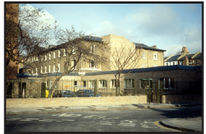
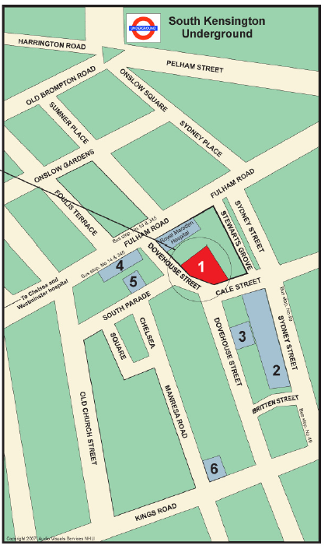

N.H.L.I. Reception
Tel:- 0207 352 8121 ext 3001

Academic Events Office
Tel:- 0207 351 8172

- National Heart & Lung Institute Guy Scadding Building/
Education Centre
Dovehouse Street
- Royal Brompton Hospital Sydney Street
- Royal Brampton Hospital Chelsea Wing (RBH)
- Fulham Wing (RBH)
- South Block
Cystic Fibrosis (RBH)
- Emmanuel Kaye Building, Manresa Road (NHLI).

Nearest Underground Station South Kensington
(On the Piccadilly, District and Circle Lines)

On exiting the Tube Station turn left at the top of stairs, cross the road, walk down Onslow Square (past Prontoprint & Carluccios) into Sydney Place, then Sydney Street, turn right into Cale Street. There are two entrances one on Cale Street & one on Dovehouse Street.

Bus No.49 stops outside the Royal Brompton Hospital, Sydney Street.

Nos 14 & 345 stop near the Royal Marsden Hospital, Fulham Road.

Buses 11,19, 22,211 pass along the Kings Road.

Program

Monday, January 15, 2023

8:00 am- 8:45 am
Breakfast and Registration
Location:

8:45 am
Welcome Remarks
Clare Lloyd, MD
Professor of Respiratory Immunology, NHLI
Wellcome Senior Fellow in Basic Biomedical Sciences

Wisia Wedzicha, MD
Professor of Respiratory Medicine, NHLI

8:50 am
Welcome Remarks
Augustine M.K. Choi, MD
Professor of Medicine
Division of Pulmonary and Critical Care Medicine
Senior VP and Senior Advisor to CEO of NYP

Session I: Infection and Microbiome
Moderator: TBD

8:55 am
Lisa Torres, MD, MS
Assistant Professor of Medicine
Division of Pulmonary and Critical Care Medicine, WCM
Temporal kinetics and leukocyte mitochondrial dysfunction in sepsis-induced immune paralysis

9:15 am
Aran Singanayagam, MD
MRC Clinician Scientist
Group Leader at the Centre for Molecular Bacteriology and Infection
Mechanistic insights into viral susceptibility in obese individuals

9:35 am
Michael Niederman, MD, MACP, FCCP, FCCM, FERS
Professor of Clinical Medicine
Division of Pulmonary and Critical Care Medicine, WCM
Macrolide/Anti-inflammatory Therapy in Community-Acquired Pneumonia

9:55 am
Sanjay H. Chotirmall, MD, PhD
Associate Professor and Provost’s Chair in Molecular Medicine
Vice Dean (Research), Lee Kong Chian School of Medicine, NTU Singapore
Consultant Respiratory Physician, Tan Tock Seng Hospital, Singapore
Integrative microbiomics to understand chronic respiratory disease and exacerbations

10:15 am – 10:30am
Panel Discussion
10:30 am – 10:45 am
Coffee Break

Session II: Disease Trajectory/Early Life Origins
Moderator: Wisia Wedzicha, MD
Professor of Respiratory Medicine, NHLI

10:45 am
Hasina Outtz Reed, MD, PhD
Assistant Professor of Medicine
Division of Pulmonary and Critical Care Medicine, WCM
Lymphatic Dysfunction Models an Autoimmune Emphysema Phenotype of Chronic Obstructive Pulmonary Disease

11:05 am
James Allinson, MD, PhD
Honorary Senior Clinical Lecturer
National Heart and Lung Institute
Early origins of chronic lung disease

11:25 am
Daniel Libby, MD
Clinical Professor of Medicine
Weill Medical College of Cornell University
Pulmonary Consultants of New York, PLLC
The Influence of OncoGene Expression on the Natural History of Non-Small Cell Lung Cancer

Session III: Asthma
Moderator: Mary Choi, MD
Professor of Medicine
Division Nephrology & Hypertension, WCM

11:45 am
Stefan Worgall, M.D, PhD
Chief, Division of Pediatric Pulmonology, Allergy, & Immunology
Professor of Pediatric Pulmonology, WCM

Sphingolipid imbalance and asthma
12:05 pm
Sejal Saglani, MD
MD Title Here
Title Pending

12:25 pm
Chloe Bloom, PhD, BSc, MSc
Clinical Senior Lecturer
Imperial College London and Imperial College Healthcare NHS Trust
Asthma Epidemiology

12:45 pm – 1:45 pm
Lunch/Poster Presentations &
Hospital Tour

Session IV: Immunology
Moderator: Clare Lloyd, MD
Professor of Respiratory Immunology, NHLI
Wellcome Senior Fellow in Basic Biomedical Sciences

1:45 pm
Heather Stout-Delgado, PhD
Assistant Professor of Immunology in Medicine
Division of Pulmonary and Critical Care Medicine, WCM
Impact of Aging on Immune Responses during Influenza Infection

2:05 pm
Regis Joulia, MD
NHLI
Impact of Mast cell activation during early life asthma

2:25 pm
Christopher Parkhurst, MD, PhD
Instructor in Medicine
Division of Pulmonary and Critical Care Medicine, WCM
The Gut-Brain Axis: How the microbiota shape PTSD phenotypes

2:45 pm
Cecilia Johansson, MD
Professor of Mucosal Immunology, NHLI
Title Pending
Session V: COPD
Moderator: Fernando Martinez, MD, MS
Chief, Division of Pulmonary and Critical Care Medicine
Bruce Webster Professor of Medicine, WCM

3:00 pm
Pallav Shah, MD, MB BS, FERS, FRCP
Professor of Respiratory Medicine, National Heart & Lung Institute Imperial College London
Consultant Physician, The Royal Brompton & Harefield NHS Foundation Trust

Update on interventional techniques in COPD

3:20 pm – 3:50 pm
Tea/Coffee Break
Poster Prize Presentations

3:50 pm
William Zhang, MD
Assistant Professor of Medicine
Division of Pulmonary and Critical Care Medicine, WCM
Alveolar Macrophage Iron Overload in Chronic Obstructive Pulmonary Disease: Clinical Significance and Therapeutic Implications

4:10 pm
Louise Donnelly, MD
MD Title Here
Title Pending

4:30 pm
Renat Shaykhiev, MD, PhD
Associate Professor of Medicine
Division of Pulmonary and Critical Care Medicine, WCM
The Unique Biology of Terminal Airway Secretory Cells (TASCs) in Human Lung Aging and Disease

4:50 pm
Lydia Finney, MD
MD Title Here
COPD exacerbation recovery

5:10 pm
Jamuna Krishnan, MD, MBA
Assistant Professor of Medicine
Division of Pulmonary and Critical Care Medicine, WCM
Improving Cardiovascular Comorbidity Management Among Black Adults with COPD

5:30 pm
Peter Calverley MBChB, DSc, FRCP, FRCPE, FMedSci, FERS, ATSF
Emeritus Professor of Respiratory Medicine, University of Liverpool UK
Historical Perspective
6:10 pm
Close

Tuesday, January 16, 2023
8:15 am-9:00 am
Breakfast and Registration

Session I: ILD
Moderator: Gisli Jenkins, MD, PhD
NIHR Research Professor and Margaret Turner Warwick Chair of Thoracic Medicine
Head of Margaret Turner Warwick Centre for Fibrosing Lung Disease, NHLI

9:00 am
Anna Podolanczuk, MD, MS
Assistant Professor of Medicine
Division of Pulmonary and Critical Care Medicine, WCM
Leveraging large cohorts to study pre-clinical pulmonary fibrosis in humans

9:20 am
Gisli Jenkins, MD, PhD
NIHR Research Professor and Margaret Turner Warwick Chair of Thoracic Medicine
Head of Margaret Turner Warwick Centre for Fibrosing Lung Disease, NHLI
Understanding the functional consequences of genetic abnormalities in IPF

9:40 am
Robert Kaner, MD
Professor of Clinical Medicine
Division of Pulmonary and Critical Care Medicine, WCM
Pilot Study of Small Airway Epithelial Gene Expression in Interstitial Lung Diseases by scRNAseq

10:00 am
Phil Molyneaux, MD
Imperial College London
Microbial metabolites drive airway remodelling in Pulmonary Fibrosis

10:20 am
Kerri Aronson, MD, M.S.
Assistant Professor of Medicine
Division of Pulmonary and Critical Care Medicine, WCM
Development of non-pharmacological interventions to improve patient-centered outcomes in interstitial lung disease

10:40 am
NHLI MD Name Here
NHLI
Title Pending

11:00 am
Soo Jung Cho, MD
Assistant Professor of Medicine
Division of Pulmonary and Critical Care Medicine, WCM

Metabolic Dysregulation in Lung Fibrosis

11:20-11:30 am
Coffee Break

Session II: Acute Lung Injury
Moderator: Augustine M.K. Choi, MD
Assistant Professor of Medicine
Division of Pulmonary and Critical Care Medicine
Weill Cornell Medicine
11:30 am
David Price, MD, M.S.
Assistant Professor of Medicine, WCM
Division of Pulmonary and Critical Care Medicine, WCM

Necrotic cell death and vascular injury in acute inflammatory lung injury/ARDS

11:50 pm
Brijesh Patel, MD
Imperial College
Title Pending

12:10 pm
Maria Plataki, MD, PhD
Assistant Professor of Medicine
Division of Pulmonary and Critical Care Medicine, WCM
Investigating Mechanisms of exacerbated Acute Lung Injury in Obesity

12:30 pm
Katherine Lodge
NHLI
Neutrophils in acute lung injury
NHLI

12:50 pm
Closing Remarks

1:00 pm
Departures

Biographies
Hosts:
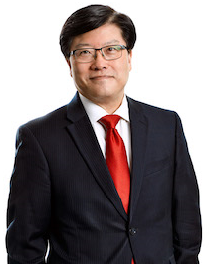
Augustine M.K. Choi, MD
is Professor of Medicine at Weill Cornell Medicine. Previously he served as the Stephen and Suzanne Weiss Dean of Weill Cornell Medicine and Provost for Medical Affairs of Cornell University from 2017-2022. He received his MD from the University of Louisville and completed his Internal Medicine residency at Duke University Medical Center. He then pursued his Pulmonary/Critical Care Medicine fellowship at Johns Hopkins and was a faculty member at Johns Hopkins and at Yale. Dr. Choi served as Chief, Division of Pulmonary, Allergy and Critical Care Medicine at the University of Pittsburgh, before becoming the Parker B. Francis Professor of Medicine at Harvard Medical School and Chief of Pulmonary and Critical Care Medicine at the Brigham and Women's Hospital. He then joined Weill Cornell Medicine in 2013 as the Sanford I. Weill Chairman and Professor of Medicine in the Joan and Sanford I. Weill Department of Medicine and as physician-in-chief of NewYork-Presbyterian/Weill Cornell Medical Center.

Dr. Choi has a longstanding commitment to the training of physician-scientists. His research interest has focused on the regulation and function of stress response genes in response to oxidative stress. He has translated the two decades of basic discoveries made in the signaling pathway and function of HO/CO to human patients with lung and vascular diseases. His research team has recently completed 2 NIH supported Phase I/II clinical trials, in the treatment for human sepsis/ARDS and lung fibrosis. Dr. Choi also has a strong interest in the innovation space, especially in the last decade with the co-founding of Proterris, Inc focused on CO-based therapies in inflammatory human diseases. He is a member of the National Academy of Medicine, American Society of Clinical Investigation, and the Association of American Physicians. He is a recipient of the ATS Recognition Award for Scientific Accomplishments and Amberson Lecture.

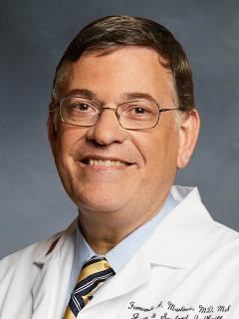
Fernando J. Martinez, MD, MS is Chief of the Division of Pulmonary and Critical Care Medicine at Weill Cornell Medical College in New York City. Prior to this appointment, he was professor of internal medicine and associate chief for clinical research in the Division of Pulmonary and Critical Care Medicine at the University of Michigan Health System, Ann Arbor, Michigan. After graduating from the University of Florida School of Medicine in Gainesville, Florida, he completed a residency in internal medicine at Beth Israel Hospital, Boston, Massachusetts, and a fellowship in pulmonary medicine at the Boston University Pulmonary Center. He received a Master’s in Biostatistics and Clinical Study Design from the University of Michigan School of Public Health.

Professor Martinez’s main research interests include the biological underpinnings and therapeutic approaches to interstitial lung diseases and chronic obstructive pulmonary disease (COPD). He is a member of numerous societies, including the American Thoracic Society, the European Respiratory Society, and the American College of Chest Physicians. He was a member of the Fleischner Society. Previously, he has been a member of the American Thoracic Society Committees which generated guidelines for the management of COPD, respiratory infections, idiopathic pulmonary fibrosis, and cardiopulmonary exercise testing. He is the former chair of the Clinical Problems Assembly of the American Thoracic Society. Professor Martinez is a member of the GOLD Science Committee and sits on a number of editorial boards, including for the American Journal of Respiratory and Critical Care Medicine where he serves as editor in chief.

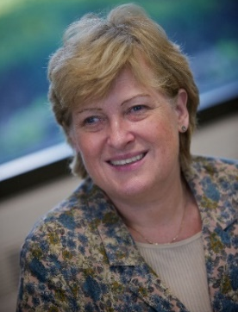
Wisia Wedzicha, MD is Professor of Respiratory Medicine at the National Heart and Lung Institute, Imperial College, UK and Head of the Respiratory Division at Imperial College. She qualified from Somerville College, Oxford University and St Bartholomew’s Hospital Medical College, London. She was elected FMedSci in 2013 and is an NIHR (National Institute of Heath Research) Senior Investigator. She has received the Fellowship of the ERS (FERS) and ATS (ATSF). She received the Helmholtz International Fellow Award in 2014. Professor Wedzicha has a major interest in the causes, mechanisms, impact and prevention of chronic obstructive pulmonary disease (COPD) exacerbations, she directs an active research group specializing in COPD exacerbations and early COPD and has published extensively on this topic. Professor Wedzicha was Editor-in-Chief of Thorax from 2002 to 2010 and is currently Editor in Chief for the American Journal of Respiratory and Critical Care Medicine. She has also been the Lancet Ombudsman and Publications Director for the ERS.

Speakers:

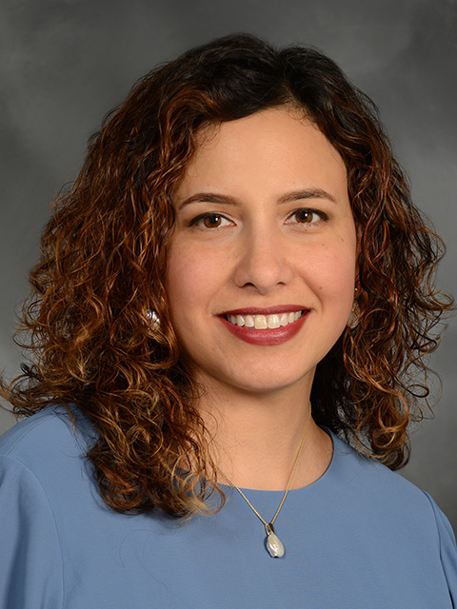
Lisa K. Torres, MD, MS conducts clinical and translational research in endotypes of sepsis, particularly in those who are immune suppressed. This immune paralyzed endotype of patients are at a higher risk for opportunistic infections and mortality. Dr. Torres’ work is focused on understanding alterations in immune cell metabolism and impaired cell signaling. Ultimately, she aims to predict who may develop immune paralysis and identify therapeutic targets to restore normal immune function. Dr. Torres’ is supported by an NIH K23 award from the National Institute of General Medical Sciences. She attends on both the ICU and Pulmonary Consult Services at the Weill Cornell and Lower Manhattan Hospital campuses.

Dr. Torres is an early-career clinical and translational investigator who studies an immune-suppressed endotype of sepsis in critically ill patients. Her work is focused on understanding alterations in immune cell metabolism and impaired cell signaling to identify targetable pathways for future therapies. Dr. Torres is supported by an NIH K23 career-development award from the National Institute of General Medical Sciences. She attends on both the ICU and Pulmonary Consult Services at the Weill Cornell and Lower Manhattan Hospital campuses.
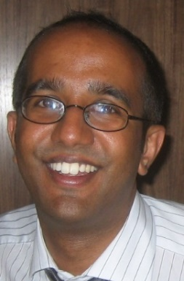
Aran Singanayagam, MD, is an MRC Clinician Scientist Group Leader at Imperial College and Honorary Consultant in Respiratory Medicine. Aran's research program employs a combination of in vitro and in vivo disease models to understand how innate immunity to viral and bacterial pathogens is dysregulated in the context of inflammatory airway diseases.

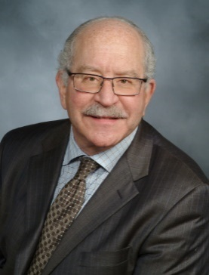
Michael S. Niederman, MD, MACP, FCCP, FCCM, FERS’ interests lie in respiratory tract infections, and include mechanisms of airway colonization, the management of community- and hospital-acquired pneumonia, the role of guidelines for pneumonia, and the impact of antibiotic resistance on the management and outcomes of respiratory tract infections. He has published over 500 peer reviewed or review articles, and has lectured widely, both nationally and internationally. Dr. Niederman served as co-chairman of the committees that created the American Thoracic Society 1993 and 2001 guidelines for the treatment of community-acquired pneumonia and the 1996 and 2005 committees that wrote guidelines for the treatment of nosocomial pneumonia. He was the co-lead author for the 2017 Guidelines for Nosocomial Pneumonia published by the ERS/ESICEM and ESCMID. He was a member of the ATS/IDSA committee that published guidelines for community-acquired pneumonia in 2007. He served for 6 years as a member of the Board of Regents of the American College of Chest Physicians and in 2013 was elected as a Master of the American College of Physicians. He is also an Associate Editor for the European Respiratory Review and for Critical Care , and serves on the editorial boards of Critical Care Medicine, and Intensive Care Medicine. He has previously served on the editorial board of The American Journal of Respiratory and Critical Care Medicine and CHEST.
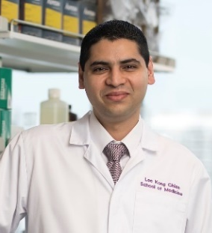
Sanjay Chotirmall, MB BCh BAO (NUI) FRCPI FCCP FRCP is an internationally recognized clinician-scientist with an established translational respiratory research group at the Lee Kong Chian School of Medicine, NTU Singapore. To date, he has performed key work on endo-phenotyping pulmonary infection, including the use of next generation sequencing approaches, in the context of chronic inflammatory respiratory diseases that have led to publications in Nature Medicine, the New England Journal of Medicine (NEJM), the Lancet Respiratory Medicine, the American Journal of Respiratory and Critical Care Medicine and Cell Host and Microbe. He has been appointed Provost’s Chair in Molecular Medicine at NTU Singapore since 2019 and currently serves as Vice Dean (Research) at the Lee Kong Chian School of Medicine and as Deputy Editor at the American Journal of Respiratory and Critical Care Medicine (AJRCCM).


Hasina Outtz Reed, MD, PhD is an Assistant Professor at Weill Cornell Medicine. She received her undergraduate degree from Princeton University and her MD/PhD in Cellular and Molecular Biology from Columbia University. Her clinical training in Internal Medicine and Pulmonary and Critical Care was done at the University of Pennsylvania, where she also conducted her postdoctoral research with Dr. Mark Kahn. In her lab at Weill Cornell, Dr. Outtz Reed studies the role of the pulmonary lymphatic vasculature in lung homeostasis and disease. Dr. Outtz Reed has used animal models to manipulate the pulmonary lymphatics and has shown a direct connection between lymphatic dysfunction and lung injury. Ongoing projects in her lab include investigating mechanisms of lymphatic dysfunction in settings of lung injury, profiling of lung lymphatic endothelial cell heterogeneity during development and in disease, and investigating the mechanisms of lymphatic endothelial cell-leukocyte crosstalk during the inflammatory response. Her research is supported by funding from the NHLBI, Robert Wood Johnson Foundation, and the Manning Family Foundation, the American Thoracic Foundation, and the American Lung Association.

James Allinson, MD, PhD Bio + photo here

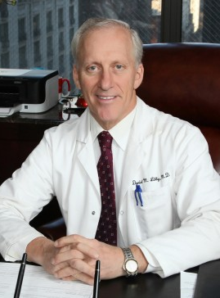
Daniel M. Libby, MD is a Professor of Medicine at Weill Cornell Medical Center and Attending Physician at New York Presbyterian Hospital. He is board certified in Internal Medicine, Pulmonary Medicine, and Critical Care Medicine by the American Board of Internal Medicine (ABIM). He is on the board of Overseers for Weill Cornell Medical Center and a member of the medical board of New York Presbyterian Hospital.

Dr. Libby has performed extensive research on the early detection of lung cancer and is a member of the International Early Lung Cancer Action Project (ELCAP), which made national news in 2006 by demonstrating that lung cancers detected through yearly CT scans had a high likelihood of being cured. He has written numerous original articles, reviews and abstracts on lung cancer, lung nodules, scoliosis and sarcoidosis. Currently, his special area of interests include early detection of lung cancer, COPD, asthma and lung nodules. Dr. Libby is the founder of New York Pulmonary Associates. Dr. Libby was born and raised in Great Neck, NY. After attending undergraduate college at Columbia University, he went on to medical school at Baylor College in Houston, Texas. He returned to New York for his internship, residency and fellowship at New York Presbyterian Hospital – Weill Cornell Medical Center.
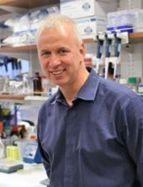
Stefan Worgall, MD, PhD‘s research interests are in pulmonary infections and lung responses relevant to pediatric lung diseases. He leads the pediatric pulmonary and allergy program at Weill Cornell Medicine. His laboratory’s research has centered on mechanisms for lung diseases and pulmonary host responses relevant to children. As a PI or coinvestigator on several NIH-funded grants, he has established strong research collaborations and has a record of successful and productive research projects in an area of high relevance for pediatric respiratory diseases and pulmonary host responses. He is also a member of the WCM Infection & Microbial Pathogenesis Graduate training program.

Sejal Saglani, MD Bio + photo here

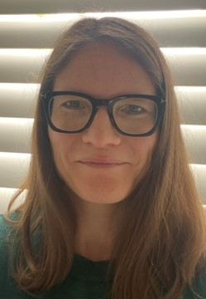
Chloe Bloom, PhD, BSc, MSc is a NIHR Clinician Scientist and group leader at NHLI in Respiratory Epidemiology. The research interests of her group are centered on the use of large clinical datasets to improve the management of respiratory disease, with a focus on adult and pediatric asthma, as well as other respiratory diseases including covid-19 and COPD.

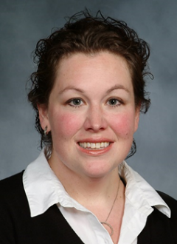
Heather W. Stout-Delgado, PhD’s research is focused on understanding the mechanisms that underlie age-associated changes in cellular and molecular immune signaling in the respiratory and conducting airways of the lung. Her current research interests include: (1) Understanding how the process of aging alters innate immune signaling pathways to bacterial and viral pathogens; (2) Investigating the impact of aging on mitochondria, endoplasmic reticulum (ER), and ER-mitochondrial communication and how these changes contribute to increased host susceptibility to acute lung injury and pneumonia; (3) Examining age-associated alterations in immunometabolism and the impact of these changes on innate immune signaling cascades and cytokine release syndrome development; (4) Developing and characterizing compounds and therapeutic strategies to improve morbidity and mortality in aging populations during primary or secondary pulmonary infections. Special focus for these studies will be on in vitro and in vivo infection models using influenza (H3N2 and H1N1 strains), S. pneumoniae, or S. aureus. Dr. Stout-Delgado’s research is currently funded by two NIH R01 grants, she serves as a mentor on two NIA K08 grants, and is an Associate Program Director of the Pulmonary and Critical Care Medicine T32 grant.

Robert Snelgrove, MD Bio + photo here

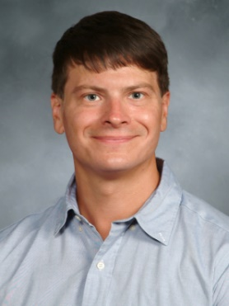
Dr. Christopher Parkhurst MD, PhD, is an Instructor in the Division of Pulmonary and Critical Care Medicine at Weill Cornell where he focuses on understanding the mechanisms that underlie long-term disability after critical illness with a special focus on cognitive decline and mood disorders. He received his undergraduate degree from Cornell University and his MD/PhD in Neuroscience and Immunology as part of the NYU Grossman School of Medicine MSTP. His graduate work focused on microglia-neuronal interaction in the unperturbed adult brain and generated some of the first evidence of a role for microglia in shaping synaptic plasticity and behavior. During this time, he also developed methodology for minimally-invasive imaging of microglia in living mouse brain and identified new interactions between the peripheral immune system and brain leading to synapse loss during CNS autoimmunity. Following graduation, Dr. Parkhurst completed a medical research track Internal Medicine residency followed by a fellowship in Pulmonary and Critical Care Weill Cornell Medicine/New York-Presbyterian Hospital where he served as chief fellow in 2019. As a post-doctoral fellow with Drs. David Artis and Conor Liston, Dr. Parkhurst utilized his training in glial neuroscience and immunology to unravel the complex interaction between the gut microbiota and medial prefrontal cortex function demonstrating a role for microbially-derived metabolites in instructing microglial synaptic engulfment and animal behavior. He has won numerous award for this work including a K08 mentored clinical science career development award from the NIMH and a MIST Scholars award from the NIAID.

As an attending physician in pulmonary and critical care medicine, and director of research at the Weill Cornell Medicine post-ICU clinic, Dr. Parkhurst cares for patients both during the acute phase of critical illness and during recovery. His ongoing work focuses on the complex, prolonged, and disabling constellation of symptoms known as post-ICU syndrome (PICS). Using both translational methodology and animal models, Dr. Parkhurst’s research aims to decipher how divergent states induced by critical illness, including dysbiosis, contribute at the cellular and molecular level to the development and maintenance of PICS pathology.

Cecilia Johansson, MD Bio + photo here

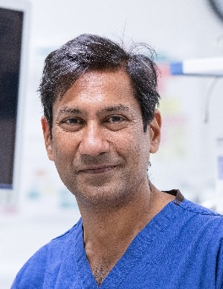
Pallav Shah MD, MB BS, FERS, FRCP is currently Professor of Respiratory Medicine at Imperial College, London, He is a Senior Consultant Physician at the Royal Brompton Hospital. He qualified in Medicine at Guy’s Hospital Medical School, London and trained in pulmonology at the Royal Brompton Hospital.

Professor Shah is active in both the research and the development of new treatments. He has over 250 papers and several books – including his contribution as sectional editor of the thoracic section of Grays Anatomy (39th & 40th editions) and as sectional editor for respiratory section of the Oxford textbook of Medicine (6th edition). He also the author of an Atlas of Flexible Bronchoscopy and chief editor of Essentials of Clinical Pulmonology. He has also been involved in the HERMES education program for the European Respiratory Society. Furthermore, he has been the course director of an interventional bronchoscopy course for the last 20 years which is aimed at training other specialists in some of the new evolving bronchoscopic treatments.

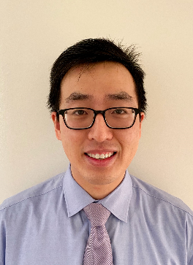
William Zhang, MD is a physician-scientist whose research is focused on understanding the pathogenesis of chronic obstructive pulmonary disease (COPD). Specifically, he is investigating the role of abnormal iron metabolism in mediating the biological processes of early COPD, using both samples from COPD patients as well as disease models. Dr. Zhang's work has been supported by the Stony Wold-Herbert Fund Fellowship, the CHEST Foundation, the American Thoracic Society, the American Lung Association Catalyst Award, the Parker B. Francis Fellowship, as well as the Weill Cornell Medicine JumpStart Program. He is a recent recipient of a K08 Career Development Award from the NHLBI.

Louise Donnelly, MD Bio + photo here

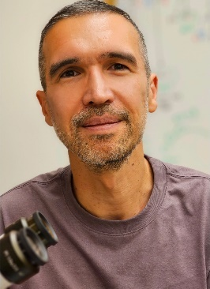
Renat Shaykhiev, MD, PhD’s research is focused on understanding fundamental principles of cellular organization and regeneration of the broncho-alveolar transitional region as a unique niche of lung aging and chronic lung diseases in humans, including chronic obstructive pulmonary disease (COPD), idiopathic pulmonary fibrosis (IPF) and lung cancer. Dr. Shaykhiev’s laboratory addresses this problem at the tissue and cellular levels by employing advanced anatomical, imaging, systems biology and organotypic ex vivo modeling approaches using patient-derived lung tissue samples.

Lydia Finney, MD Bio + photo here

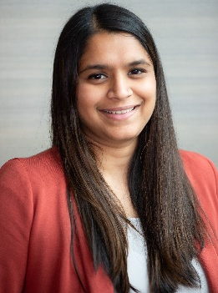
Jamuna Krishnan, MD, MBA is an early-stage investigator who is passionate about developing interventions targeted at overcoming healthcare disparities in chronic respiratory disease. Her long-standing interest in healthcare disparities led her to pursue a combined MD/MBA at the University of Michigan, focused on designing health systems to deliver high quality care for patients with social disadvantage. Her current research program is focused on characterizing gaps in the optimal management of comorbid COPD and cardiovascular disease (CVD) among socially disadvantaged patients. Her research interests are informed by caring for patients in her COPD focused clinic, where she has found that optimal comorbidity management in COPD is complex, requires significant care coordination, and influences outcomes. She is now using both quantitative and qualitative methods to design interventions to improve outcomes in socially disadvantaged populations with comorbid COPD and cardiovascular disease.

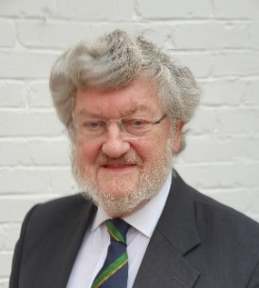
Peter Calverley, MBChB, DSc, FRCP, FRCPE, FMedSci, FERS, ATSF is Emeritus Professor of Respiratory Medicine at the University of Liverpool, UK and continues to work in the Institute of Life Courses and Medical Science. He trained at the University of Edinburgh, was a travelling fellow at the Meakins-Christie Laboratories at McGill University, Montreal 1982–3 and subsequently moved to Liverpool, becoming a full professor in 1995. His research interests focus on the patho-physiology and management of chronic obstructive pulmonary disease He has published over 500 papers and several textbooks as well as lecturing widely on these topics.

Professor Calverley has been an Associate Editor of the European Respiratory Journal and of Thorax and was Associate Editor of the American Journal of Respiratory and Critical Care Medicine from 2015 until 2022. He is currently Editor in Chief of the European Respiratory Monograph. He has chaired the scientific committee of the British Lung Foundation, the British Sleep Society and the Clinical Physiology Assembly of the ERS and was a member of the ERS Executive Committee. He was a founder member of the GOLD initiative for COPD and chaired its Dissemination Committee and Scientific Committee. He was President of the British Thoracic Society in 2006, co-chaired the External Reference Group advising Ministers on the content of the COPD Clinical Service Strategy and chaired the Respiratory Specialty groups of the UK Comprehensive Clinical Research Network until 2015. He currently Chairs the UK BEACON study (British Early COpd Network) researching the origins of COPD in young adults.

He is a Fellow of both the London and Edinburgh Colleges of Physicians and was elected to the Fellowship of the Academy of Medical Sciences in 2011, the European Respiratory Society in 2014, the American Thoracic Society and the Association of Physicians of Great Britain and Ireland in 2020. In 2023 he received the British Thoracic Society medal for outstanding contributions to respiratory medicine.
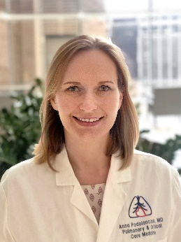
Anna J. Podolanczuk, MD, MS is an Assistant Professors of Medicine at Weill Cornell Medicine and the Associate Director of the Weill Cornell ILD Program. She received her undergraduate degree in Neuroscience from Brown University. She earned her MD from NYU School of Medicine. She completed residency in Internal Medicine and fellowship in Pulmonary and Critical Care Medicine at Columbia University. She has a Masters of Science in Patient-Oriented Research from Columbia’s Mailman School of Public Health. She is an NIH-funded investigator studying novel risk factors for pulmonary fibrosis in humans. Her research program focuses on understanding early or subclinical interstitial lung disease, characterizing imaging and blood biomarkers for early pulmonary fibrosis, the role of environmental exposures, and the connection between cardiovascular disease and pulmonary fibrosis. She is an active investigator in multiple NIH and industry-funded clinical trials of new therapies for pulmonary fibrosis and other interstitial lung diseases.

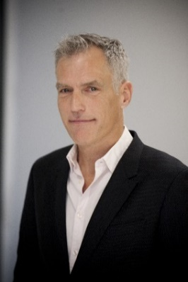
Gisli Jenkins MD PhD is an NIHR Research Professor and holds the Margaret Turner-Warwick Chair of Thoracic Medicine at Imperial College London. He is based at the Guy Scadding Building at the Brompton Campus where he is Head of the Margaret Turner-Warwick Centre for Fibrosing Lung Diseases at the National Heart and Lung Institute. Gisli also holds Honorary contracts with the Royal Brompton and Harefield NHS Foundation Trust and with the Imperial College Healthcare NHS Trust.

Prof Jenkins' research focuses on Interstitial Lung Diseases, and Pulmonary Fibrosis in particular. His team works to understand the biological basis for the development of pulmonary fibrosis and aims to translate this understanding in to improved outcomes for patients. He is the Principal Investigator of a number of longitudinal observational studies including the PROFILE study, the INJUSTIS Study, the UKILD Post COVID ILD study as well as the DEMISTIFI Multi-Morbidity consortium. He is the pulmonary fibrosis working group lead for the Genomics England Clinical Interpretation Partnership in Respiratory Medicine, the PHOSP-COVID study and the HEAL COVID platform study.

Prof Jenkins was awarded the ERS Gold Medal in Interstitial Lung Disease in 2020. In 2022 he became a Fellow of the European Respiratory Society, and appointed President of Action for Pulmonary Fibrosis and has been awarded the BTS Meritorious Service Award for 2022.
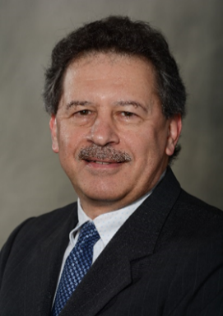
Robert J. Kaner, MD was the was the Principal Investigator of the Weill-Cornell Medicine site of the NIH-sponsored Idiopathic Pulmonary Fibrosis (IPF) Clinical Research Network for which he chaired the Adjudication Committee. He has extensive experience in the phenotyping of subjects with lung disease and their enrollment in research studies. He leads a monthly multidisciplinary ILD conference with Dr. William Travis (MSKCC) and Dr. Chen Zhang (WCM) for the past 15 years. He is the director of the New York Presbyterian Hospital – Weill Cornell Medicine Pulmonary Fibrosis Foundation Clinical Center of Excellence. He participates in clinical trials evaluating various pharmacologic interventions in IPF and other ILDs, sponsored by both NIH and pharma. He leads an ILD biobank, which enhances future translational research opportunities. He leads an observational study to determine the incidence and natural history of ILD following COVID-19 acute respiratory failure.

Dr. Kaner chairs the bronchoscopy sub-study committee of the NHLBI SPIROMICS and SOURCE research networks, which uses RNA-sequencing to evaluate gene expression changes in lung cells associated with smoking and COPD endotypes. He is analyzing the effects of doxycycline on BAL matrix metalloproteinase (MMP) inhibition in HIV-positive individuals with early emphysema, based on his previous translational work. He is also participating in pharmacologic intervention studies in COPD and emphysema sponsored by the ALA, DOD and NIH, including leadership (with Dr. Marshall Glesby) of a Phase II multicenter trial of doxycycline to slow emphysema progression in PLWH. He is the Associate Director of the T32 training program and Associate Fellowship Program Director.
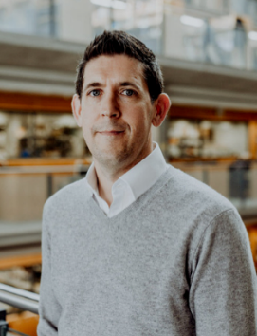
Phil Molyneaux, MD is a Professor of Interstitial Lung disease at Imperial College London. He is the Asthma and Lung UK Chair of Respiratory Research. He is a consultant in Interstitial lung disease and the director of the NIHR Cardiorespiratory Clinical research facility at the Royal Brompton Hospital. He runs an active clinical and translational research program that oversees a team of basic scientists and clinical trial research staff.

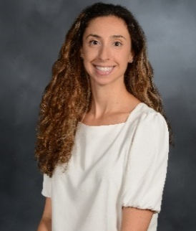
Kerri Aronson, MD, MS is a clinician-scientist and an Assistant Professor of Medicine at Weill Cornell Medicine in NYC, NY. She received her training in Pulmonary and Critical Care Medicine at Weill Cornell and completed a master’s degree in Epidemiology and Health Services Research. She currently leads a research program focused on developing and studying interventions to improve health-related quality of life (HRQOL) and other important patient-centered endpoints in ILD. She has received funding from the Pulmonary Fibrosis Foundation, Scleroderma Foundation, American Lung Association, and National Institutes of Health.

NHLI Speaker Bio + photo here
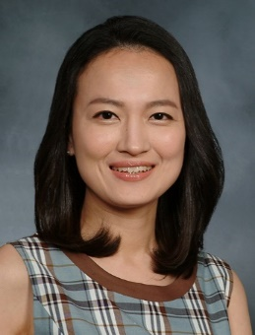
Soo Jung Cho, MD has intensively studied the pathophysiology of pulmonary fibrosis for nearly two decades. Before beginning their clinical journey, they delved into researching the in vivo effector mechanism of TGFβ1 in various pulmonary conditions, including fibrotic lung diseases. Utilizing a unique TGFβ1 overexpression model, they and their team demonstrated the critical role of the transcription factor early growth response 1 (EGR1) in TGFβ1-induced pulmonary fibrosis. Upon transitioning to Weill Cornell Medicine, Dr. Cho spent almost a decade investigating metabolic irregularities in the pathogenesis of idiopathic pulmonary fibrosis (IPF), focusing particularly on biological aging in adult lungs. Their research identified that glucose metabolism, driven by glucose transporter 1 (GLUT1)-dependent glycolysis, influences age-susceptible lung fibrogenesis in murine fibrosis models. Furthering this research, they revealed the regulation of rapid pulmonary fibrosis progression through GLUT1-dependent glycolysis, activated by the AIM2 inflammasome in response to double-stranded DNA. Since then, Dr. Cho's research has progressed into more in-depth investigations linking metabolism and lung diseases. In their recent publications, they have highlighted the importance of cholesterol metabolism in modulating cytokine and chemokine production during acute bacterial infection. Additionally, they have identified the crucial role of cholesterol metabolism in chronic lung fibrosis models. In summary, Dr. Cho is passionately committed to pulmonary fibrosis research and is determined to further our understanding of the metabolic changes influencing IPF pathogenesis.
David R. Price MD, MS is a physician-scientist who focuses on the impact of dysregulated immune responses on the pulmonary vasculature. He completed his residency training at the University of California, Davis Medical Center, and he is a graduate of the Weill Department of Medicine’s Fellowship Program in Pulmonary and Critical Care Medicine, where he served as the Chief Fellow. Dr. Price uses a “human back to mouse” translation approach that spans the basic and clinical science continuum, including novel murine models, innovative translational approaches, and patient phenotypic datasets, to define the role of endothelial injury in inflammatory ARDS. Working with Dr. Augustine M.K. Choi and Dr. Shahin Rafii, Dr. Price has characterized vascular injury and cell death responses in inflammatory ARDS populations, including neutropenic and COVID-19 ARDS.

Bip Patel Bio + photo here

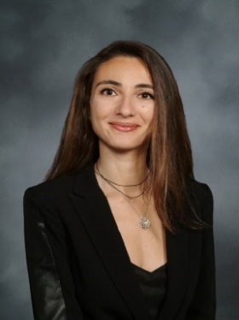
Maria Plataki, MD, PhD’s research is focused on obesity and ARDS, specifically on whether high fat diet induced alterations in lipid metabolism modify responses to acute lung injury (hyperoxia, pneumonia or injurious mechanical ventilation). Dr. Plataki’s research is currently funded by a K08 Award Program from NIH and a DOD Grant.

NHLI Speaker Bio + photo here

Moderators:

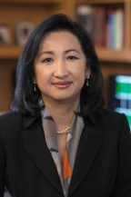
Mary Choi MD’s research focuses on the molecular mechanism(s) of tissue inflammation and fibrosis in the pathogenesis of chronic diseases. Dr. M. Choi’s seminal advances include: cloned and characterized cell surface receptors and identified novel interacting proteins involved in TGF-β1 signaling; delineated downstream intracellular signal transducing pathways that mediate TGF-β1 signals; and eluciated the cellular and molecular regulation of autophagy/mitophagy and necroptosis pathways as potential therapeutic targets to provide cytoprotection in COPD and lung fibrosis. Drs. A. Choi, M. Choi and Martinez collaborate to investigate the molecular mechanisms of tissue injury and the role of mitochondrial DNA in COPD and IPF. Dr. M. Choi serves as the Director of Training Unit in lung and vascular injury of the PCCM’s NIH T32 grant.

Clare Lloyd, MD photo + bio

Administrative/On Site Support:
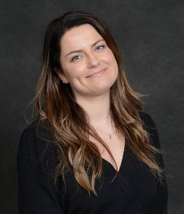
Patrycja Golinska M.S.
Administrative Manager
Division of Pulmonary and Critical Care Medicine
Weill Cornell Medicine

Notes

