NIHR Clinical Research Network
Infectious Diseases National Specialty Lead

Job pack

Introduction
The NIHR Clinical Research Network (CRN) provides the infrastructure that allows high-quality clinical research to take place in the NHS and wider social care environment in England. This includes assisting researchers and funders to deliver their studies in the NHS, and supporting the research community to maximise the value of leading-edge approaches and techniques, so that patients can benefit from new and better treatments. The CRN is a managed network consisting of a broad alliance including Guy’s and St Thomas’ NHS Foundation Trust, five Russell Group Universities, and PA Consulting. It is supported by a national CRN Coordinating Centre (CC) and funded by the Department of Health until March 2022. Alliance university partners provide Cluster leadership delivering national academic and clinical leadership for 31 CRN research specialties along with a focus on emerging technologies and innovation (Table 1). The position of National Specialty Lead provides the opportunity for a high-calibre clinical leader to provide expert advice to the CRN and work with the national and international health and life-sciences industry (non-commercial, pharma, med-tech, diagnostics and biotech) to make the NHS a benchmark of excellence for the research community.

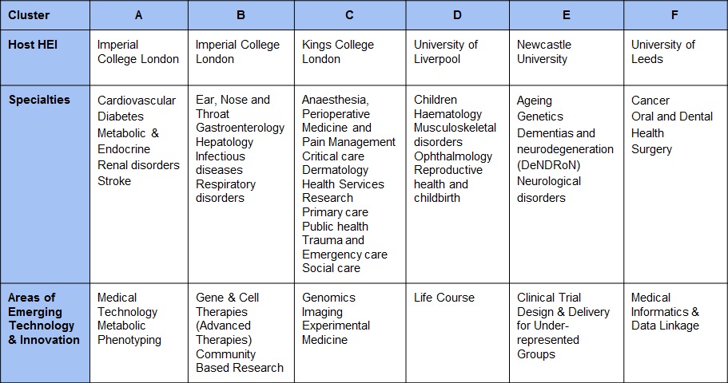
Table 1: Cluster Structure
Applications
To apply please send a CV and a (one page max) statement setting out your vision and suitability for the role via email to tracy.harman@nihr.ac.uk. Confirmation from your employer that they are willing to put in place arrangements to allow you to take on this role would also be useful at this stage.

The deadline for applications is 12 noon on 19th March. The interview will be held on the 7th April in London.

Informal enquiries should be made to Tracy Harman on 0207 594 7932 email: t.harman@imperial.ac.uk
We welcome applications from all sections of the community. Information can be made available in alternative formats.

Job Summary
The National Specialty Leads, in conjunction with the Medical Director, Cluster Leads, and LCRN Clinical Directors are the key clinical academic ambassadors for the NIHR CRN. Post-holders will be credible and competent and have the ability to command the respect of senior stakeholders, internal and external, to the organisation. In conjunction with Cluster Leads and the Business Development and Marketing Directorate, they will proactively develop effective relationships with decision-makers in the public sector, charity and life science funding organisations (non-commercial, pharma, medtech, diagnostics and biotech) and companies to further the aims of the NIHR CRN. With knowledge and experience of the full scope of the NIHR, they will collectively ensure that the NHS is seen as an organisation that excels in the consistent delivery of high quality clinical research. The post-holder will be an experienced strategic clinical research leader; with the ability to lead and develop highly talented clinicians. Displaying the ability to communicate comfortably about and promote the Clinical Research Network on the basis of its performance and delivery, he/she will operate across both commercial and non-commercial research settings. Working with patients, healthcare professionals and academics, the postholder will ensure a focus on a continuing improvement of research experience in the NHS. Providing leadership of the specialty at a national level, they will promote engagement, placement and subsequent delivery of studies with the NIHR CRN. The post-holder must understand NHS research priorities, the needs of their specialty area and have good links to the evolving NHS strategic clinical leadership. In a synergistic partnership with the research delivery team, led by the NIHR CRN CC Research Delivery Director and the Head of Divisional Research Delivery, the post-holder will advise and troubleshoot areas of poor delivery within their specialty from a clinical perspective. Working with NIHR, the local clinical research delivery team and in particular the local specialty lead, he/she will maintain national oversight of the specialty’s portfolio, promoting continued improvements in performance in the delivery of studies through the Clinical Research Specialty Leads, the Divisional Clinical Leads and the Research Delivery Managers based in the 15 LCRNs.

Role Outline

Reports to: NIHR CRN Cluster Lead

Employed by: Current employing organisation
PA reimbursement enabled through Local Clinical Research
Network (LCRN)

PA allocation: Reimbursement of 1 PA to employing organisation

Tenure: From date of appointment to end March 2022, with annual
review

Location: Current place of employment
Post holder will be expected to travel nationally and, on
occasion, internationally

Key Duties and Responsibilities

General
- Provide and coordinate clinical leadership and advice for specialty activities at a national level to maximise research activity, delivery and access to NIHR CRN portfolio studies in the specialty, for example input into study wide feasibility requests
- Act as the key clinical contact for the specialty, advising and representing the NIHR CRN and proactively promoting clinical engagement and awareness of research within the specialty at a national level
- Promote the aims, objectives and successes of the NIHR CRN at national and international levels
- Contribute to national NIHR CRN initiatives, in particular developing and sharing best practice
- Promote the aims, objectives and successes of the specialty and the NIHR CRN at a national level
- Champion a culture of innovation and continuous improvement across the specialty and the NIHR CRN as a whole leading projects and initiatives as appropriate. Encourage the sharing of best practice to reduce and prevent silo working.
- Support the Medical Director, and senior management team of the NIHR CRN to ensure best value for money and appropriate use of resources to deliver optimal specialty performance in light of current national priorities, challenges and opportunities

Clinical Research Leadership
- Provide leadership and support to Specialty Leads, establishing a coherent and effective national network for the specialty
- Chair national clinical meetings of Specialty Leads and contribute to other national clinical leadership groups and events as appropriate
- Provide visible, dynamic and effective senior clinical research leadership, direction and oversight for the specialty both internally and externally to the NIHR CRN
- Champion the importance of delivery for the life sciences industry, promoting the important contribution commercial clinical research makes to the Health and Wealth of the nation
- Ensure the effective continued development and functioning of the CRN specialty supporting LCRN Specialty Leads in their role, promoting clinical engagement and specialty succession planning
- Work with colleagues to direct initiatives to identify and meet the personal development, training and/or induction needs of the Clinical Research Specialty Leads
- Oversee the development of relevant procedures, clinical guidelines and protocols as appropriate, ensuring the NIHR CRN service complies with relevant research and clinical quality standards

Supporting Clinical Research Delivery
- Monitor, report on and seek to influence the volume and balance of studies on the relevant specialty research portfolio providing expert intelligence and advice to Research Delivery teams and other NIHR CRN staff where appropriate
- Identify the clinical strengths capacity and capability of the specialty to ensure the portfolio maximises the ability to offer clinical research opportunities to patients
- Maintain oversight of the national portfolio for the specialty, working nationally to support the timely and effective delivery of the specialty’s research portfolio, liaising with Clinical Research Specialty Leads and Chief Investigators (CIs) of studies as and when necessary
- Support the national coordinating centre (Performance and Research Delivery functions) in the performance management of the CRN including the setting and oversight of the national objectives and targets for the specialty and the assessment of LCRN performance over the annual planning cycle
- Provide clinical input into national specialty-specific business processes including national feasibility assessments for commercial studies (and in the future non-commercial studies), identifying potential sites/investigators that could conduct the study and the assessment of the risks of successful study delivery
- Work proactively with life sciences industry companies in a coordinated manner (both nationally and internationally) to promote engagement with the NIHR CRN and increase the number of commercial studies successfully placed with and delivered through the network
- Take a strategic overview of the national infrastructure required to support the clinical research specialty with an emphasis on identifying and addressing nationwide blocks to successful delivery, sharing examples of good practice across the LCRNs and ensuring that LCRNs make full use of the opportunities to contribute to studies, emerging clinical needs and unrepresented patient populations
- Advise the CRNCC Research Delivery Director and Cluster Director on national issues related to portfolio delivery (e.g. clinical pathways and needs), national infrastructure requirements, and national challenges/ opportunities for research in the specialty. Take responsibility where appropriate and agreed for the resolution of issues relevant to the specialty or across the wider NIHR CRN
- Promote and lead initiatives that encourage incorporation of the patient voice and experience into NIHR CRN approaches to delivery and access to high quality research

Stakeholder Engagement
In conjunction with the Cluster offices:
- Work with external stakeholders (e.g. Royal Colleges and research funders) to develop the national research infrastructure for the specialty and link with portfolio development groups to promote continuity between study development, support and delivery
- Work with other elements of the NIHR’s scientific and academic leadership, and other funders (both within and outwith the UK), to increase the flow of high quality clinical research studies onto the NIHR CRN portfolio
- Develop and maintain effective working relationships with Royal Colleges and other professional clinical associations/bodies relevant to the specialty
- Develop a close relationship with the senior clinical leaders of NHS England as appropriate to the specialty and national representation
- Promote the involvement and engagement of patients, carers and the public in the specialty’s research portfolio
- To engage with NIHR Faculty including CI’s, Senior Investigators

Any other duties commensurate with the role of a senior member of the NIHR CRN

Personal Specification

Attribute | Essential | Desirable
Qualifications & Education | - Registered on the General Medical Council Specialist Register or hold equivalent clinical professional status  - Higher specialist training in a medical discipline or equivalent professional training
Knowledge & Experience | - Experience as a clinical investigator  - Nationally respected opinion leader within their specialty with a breadth of clinical knowledge  - Evidence of managing effective collaborations and partnerships  - Experience of working across complex organisational structures and effective matrix management  - Sound knowledge of how the NHS works  - Knowledge of national systems, structures and processes for supporting clinical research (industry and academic sponsored), in the NHS  - Experience of managing clinical teams through a performance management framework in a clinical setting  - Experience of Committee work, including as Chair | - Experience and evidence of international collaborations  - Experience as an academic investigator  - Executive level experience  - Understanding of the importance of the application of robust business planning and financial management techniques at scale  - Experience as a Chief Investigator of at least one substantial nationwide or international clinical research project(s)
Skills & Abilities | - Evidence of leadership skills that engage motivate and develop a wide range of both clinicians and managers  - Effective facilitator who is able to bring colleagues together to work in a collegiate way for the overall benefit of the national community in which they work  - Well rounded interpersonal skills including the ability to influence and achieve results through other people  - Ability to work with stakeholders at all levels across a range of organisations  - Ability to develop strong and productive working relationships with senior stakeholders  - Ability to demonstrate influence on others and achieve impact in research leadership, delivery & management  - Ability to prepare and deliver presentations and reports to a high standard  - Ability to analyse and interpret highly complex information and to make judgements regarding a range of complex issues  - Commitment to supporting the development of staff and understanding of workforce planning  - Strong problem solving skills  - Ability to support and champion new models of working
Values/Behavioural/Attitudes | - Flexible approach to working  - Highly motivated, with ability to influence and inspire others  - Outcomes focussed  - Demonstrate passion about bringing benefits to patients through the integration of research into the delivery of excellent clinical care within the NHS  - Ability to act as a champion for patients and their interests, ensuring the patients’ voice is at the heart of LCRN activities

