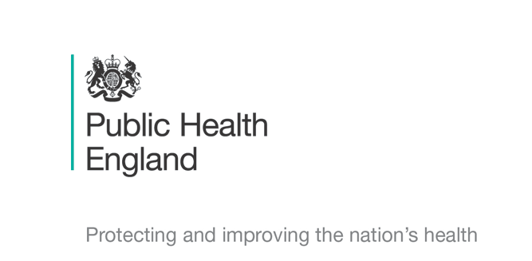


Principal Investigators
Professor Sriskandan, Dr Rebecca Cordery & Dr Miranda Mindlin
Chief Investigator
Prof Shiranee Sriskandan

Schools Transmission Study : COVID-19

Adult/Young Person aged 14-18 Household and School Contacts - Information Leaflet

You are being invited to take part in a research study to help us find the best ways of reducing the spread of COVID-19. Please take time to read this leaflet and ask us if anything is not clear or if you need a translation. Please return the form attached to this leaflet to the Research team specialist as soon as possible, preferably tomorrow, keeping a copy of the main leaflet for your records.

What is the purpose of the study? We want to find out if the coronavirus has been transmitted between young people attending schools even those who are completely healthy so we can provide best guidance to schools and young people in the future.

Why have I been chosen? You attend/work in a school or live in a household where there has been a case of COVID-19. We need to know if the virus has spread from cases that are related to schools. We have chosen specific groups or classes so need as many as possible -preferably all- to take part for the results to be useful. It’s important for us to start the study as soon as feasible and that is why we are asking for your participation today.

Do I have to take part? Taking part is entirely voluntary, however you have been chosen as you are important to the study. If you are happy to take part please read the leaflet carefully, then sign the consent form at the end, tear it off, and return it to the study team. You are free to withdraw your consent at any time without giving a reason. If you change your mind please just contact us, using the information below. You can also tell the public health specialist.

What will happen to me if I take part? Each person taking part will have a PCR swab of their throat and nose, tomorrow or as soon as possible this week, and then weekly for a maximum of 2 more weeks (maximum 3 swabs total) The swab takes about a minute to collect. If you are isolating, we will bring everything you need to your front door, explain how to use the swab, wait, and collect it from you. The swab is rubbed on the back of the throat and then gently rotated just inside the nostril before being placed into a special tube. The study team can do the swab for you if you prefer; we do not need to come indoors to do this but will use PPE (protective equipment). If you are at school, we can do the swab there. We will also ask you to rub a sponge swab on the gums for antibody testing. If you are already doing lateral flow testing, please continue to do so.

What do I need to do to take part? If you are happy to take part please complete and sign the consent form at the end and return it as soon as possible by handing it in, or sending a smartphone image, to the study phone or email.(today if possible)

What are the risks or benefits of taking part? Throat swabs can feel a bit ticklish; some people find that it makes them cough but these feelings are over in an instant. The swabs will be sent to a laboratory to be PCR tested for SARs-CoV-2. You will be notified of your test result. The results of this study could help us to reduce spread and address the current pandemic, and to help prevent future outbreaks. In recognition of your time spent taking part, we would like to offer you a shopping voucher.

WiIl taking part in this study be kept confidential? Yes, your participation in the study and all test results will be confidential. Only the NHS specialists from the study team and PHE will have the details that you provide. If the test is positive, you and your GP will be informed, as well as NHS Test and Trace., and you would need to follow government guidance. Your name would not however be used on any research sample, just a code. For more information about how we look after your data please visit https://www.imperial.ac.uk/medicine/hpru-amr/patient-and-public-information/schools-transmission

What will happen to the results of the study? You will be notified of your test results. We will not test for anything else other than SARs-CoV-2 and a small number of other viruses, bacteria and antibodies. All the swabs will be discarded once they have been tested in the laboratory. At the end of the study we will provide general feedback to affected schools/nurseries but if you would like a copy of any published report please contact us.

Who is organizing and funding the research? The research is being done by Public Health England together with Imperial College London. It is being funded by UKRI. The investigators are Professor Shiranee Sriskandan (Imperial College) and Dr Rebecca Cordery and Dr Miranda Mindlin (Public Health England).

Who has reviewed the study? The research has been peer-reviewed and approved by a nationally-appointed independent NHS research ethics panel.

What if something goes wrong? We do not expect any problems arising from the study itself. If you happen to fall ill during the study, you should consult your General Practitioner (GP) as normal. The results from the study will not help your GP decide how to treat you or your child; your GP will manage you as they would do normally. Please do tell the study team if you become unwell as we would like to know.
We are conducting a separate study on people who are thought to have Coronavirus. In the very unlikely event that you catch Coronavirus, we may ask you to join that study.

Although we do not expect any adverse problems, Imperial College London holds insurance policies which apply to this study. If you experience harm or injury as a result of taking part in this study, you will be eligible to claim compensation without having to prove that Imperial College is at fault. This does not affect your legal rights to seek compensation. If you are harmed due to someone’s negligence, then you may have grounds for a legal action. Regardless of this, if you wish to complain, or have any concerns about any aspect of the way you have been treated during the course of this study then you should immediately inform the Investigator (Shiranee Sriskandan s.sriskandan@imperial.ac.uk). The normal National Health Service complaints mechanisms are also available to you. If you are still not satisfied with the response, you may contact the Imperial AHSC Research Governance and Integrity Team.

The contact details for the study team are given below
TraCK Study Telephone 07597 510347 Email ramlah.junaideen@nhs.net

Thank you for your time.

Mini-copy of consent form for your records

Consent Form: Adults/Young person aged 14-18 Household or School contacts

Please complete then return form to study team by handing in or send image of form by email or text/whatsapp to study team Phone 07597 510347 Email ramlah.junaideen@nhs.net

Study Title: Schools Transmission Study : COVID-19
Principal Investigator: Professor Sriskandan (Imperial) Dr Rebecca Cordery, Dr Miranda Mindlin Public Health England
Chief Investigator: Prof Shiranee Sriskandan, Imperial College London

Please initial the following boxes if you agree:

I have read the Information Leaflet and understand its contents. I have had an opportunity to ask questions

I understand that my involvement is voluntary and I am free to withdraw at any time without giving any reason and without my healthcare or legal rights being affected.

I consent to provide information about my symptoms

I agree to take part in the study and provide weekly throat & nose and gum swabs for a maximum of 3 weeks

Name …………………………………………Age …………Date of Birth……………………

Contact telephone number .………………………………………………

Signed …………………………………….. Date…………………

NB If aged 14 - 18 years, please also ask your parent or legal guardian to countersign

Name of Parent/legal guardian……………………………………

Signed …………………………………….. Date…………………

(For Study team only)
Name of Specialist taking consent…………………………………………………
Signed ………………………………………Date…………………

