While filming raw video clips:
- Keep your recording in landscape mode.
- Try and record against a bright, light background.

STEP BY STEP INSTRUCTIONS ON HOW TO ASSEMBLE YOUR VIDEO
- Save all the videos from your participants somewhere accessible on your Mac, e.g., desktop.

- Amend the subtitle template ppt slides provided to add participants’ names and languages for each individual sentence.

- Export the updated slides into PNG format somewhere accessible on your Mac e.g., desktop. It will save each as an individual file.

- Amend the transition template ppt slides provide to add your institutional details and logos.

- Export the updated slides into PNG format somewhere accessible on your Mac e.g., desktop. It will save each as an individual file.

- Open iMovie and “create new” Movie

- Import media (your videos, transition PNGs and Subtitle PNGs) by clicking on the arrow in the center of the screen or on the top left of the ribbon.

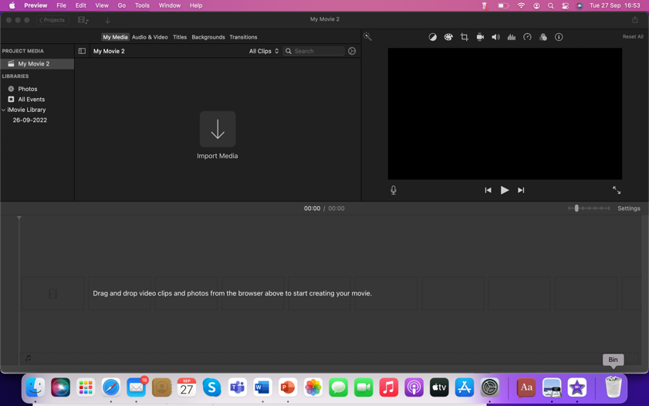
- Arrange transition PNGs in order 1-5 by dragging from the “my media” space at the top of the screen, to the movie editing space at the bottom.

- Insert the relevant raw video clips between each transition, in the same way. In the example below, I have inserted a content video between two transitions by dragging them into the movie editing space.
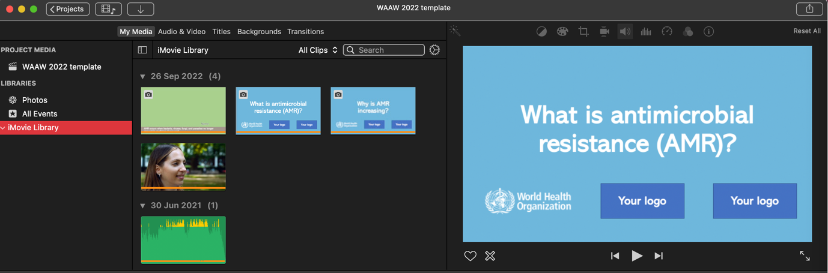
Transition PNG Raw video Transition PNG
10. Next insert the relevant subtitle PNG in parallel with the raw video clips, by dragging and dropping above the video clip. You can drag the PNG subtitle so it is the same length as the video clip
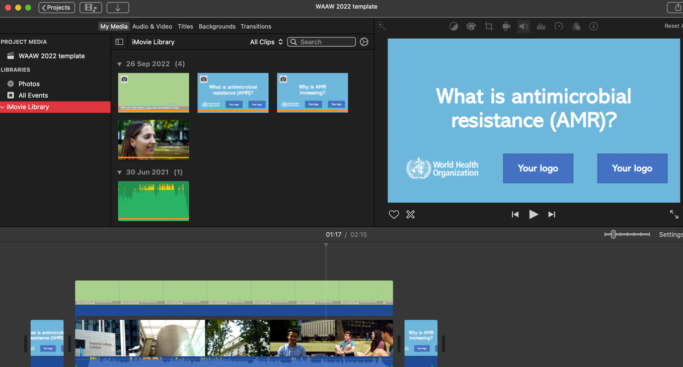
Subtitle PNG dragged and dropped above video

- In the window at top right corner, using the first drop-down menu, click on the arrow next to “cut-away” and choose “Green/blue screen”. 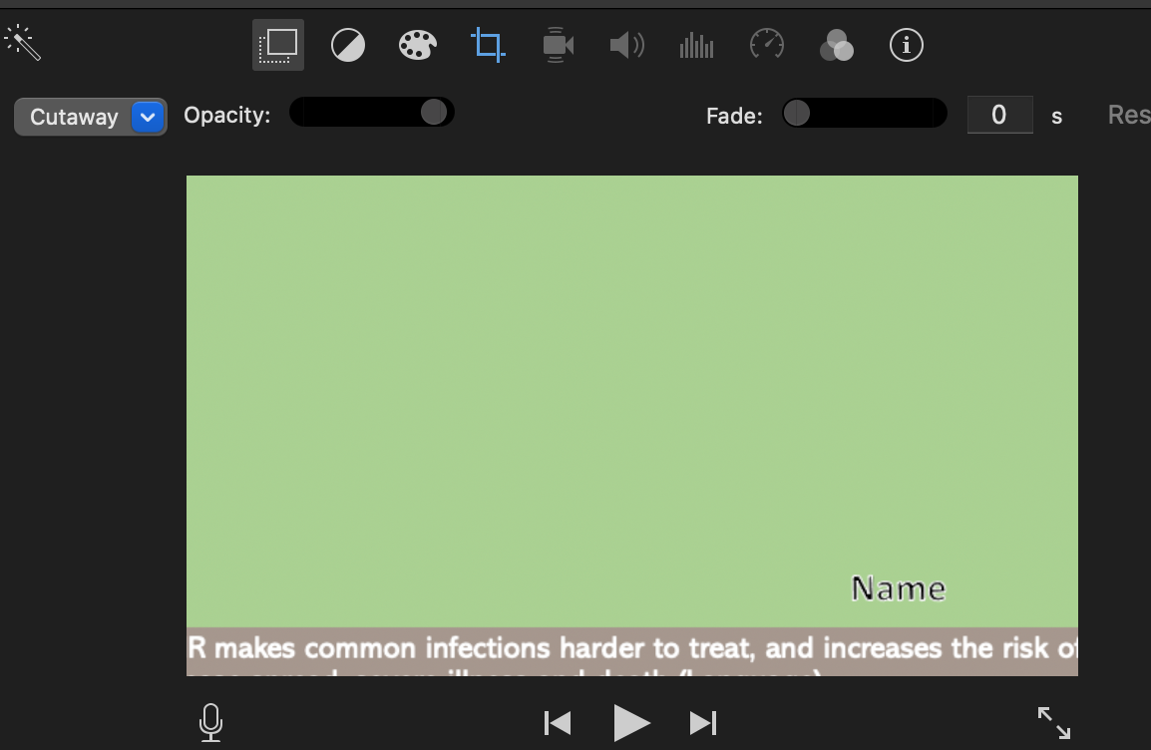
- Next choose “fit” in the fourth tab (style), indicated, so the subtitle stays in the same place.

- Repeat for all videos/subtitles until you have all the messages in the right order between the transitions.

- Now add background music. Go to the top left window (Audio & Video) and choose the music you would like by dragging and dropping the music folder into the media area. Next drag the soundtrack underneath the video. The soundtrack can be extended or shortened by dragging to match the duration of your videos. Note you should try and use music which is not subject to copyright. There is lots of downloadable copy-right free music online.
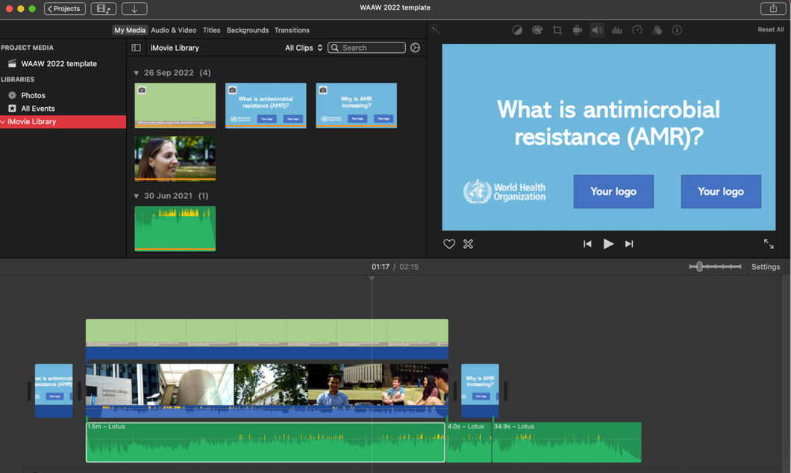
Soundtrack dragged and dropped beneath video

- Alternatively, you can use the sound effects included in iMovie. Click on sound effects, which you will find in the Audio and Video tab, select theme music and choose one. The sound effect audio will be placed underneath the video as as the soundtrack after you select.

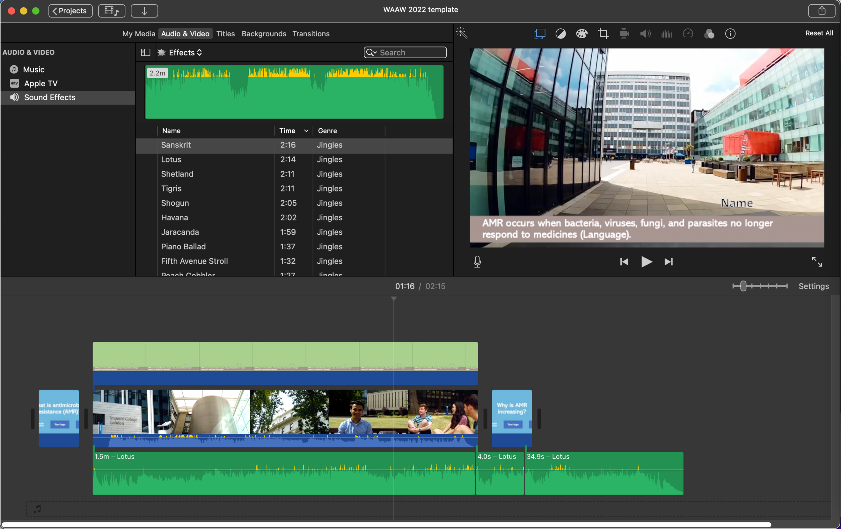

- Next adjust the soundtrack volume so it fades out when the speaking clips are played. To do this, click on one of the speaking clips and go to the top right window, 5th menu along with the speaker icon as indicated. Tick “Lower volume of other clips” and repeat for all video clips.
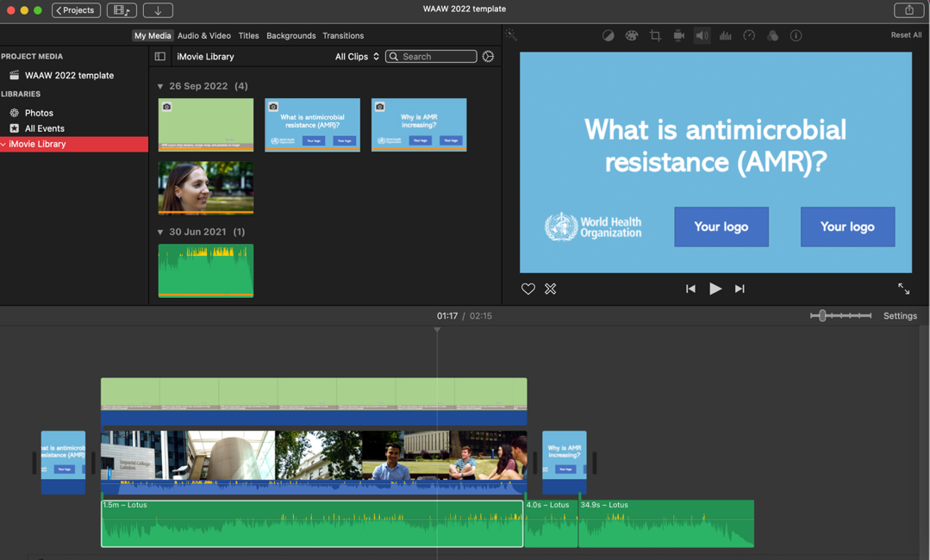

Exporting the product:
After you are done with editing, go to File – Share – File, and choose the quality and format you want to export the end product.
Share on social media with the hashtags #WAAW and #Antimicrobial Resistance
Please tag us in at @HPRU_amr

