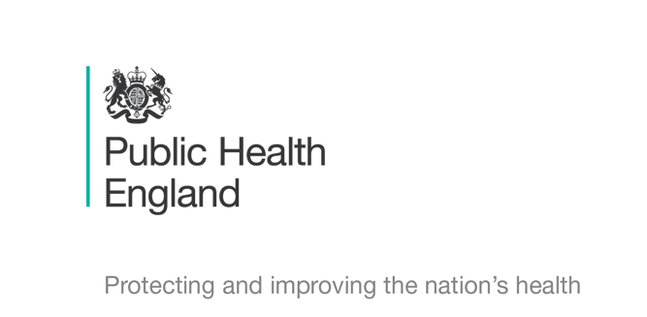



Principal Investigator
Dr Rebecca Cordery
Chief Investigator
Prof Shiranee Sriskandan

Schools Transmission Study : COVID-19
Information leaflet and Assent form for cases of coronavirus-Children and Young People aged over 8 years

We would like to ask you to take part in some research. Please read this with your parents or guardian so you can decide if you want to take part. They should have a longer leaflet to read too.

What’s the research about? It’s about a germ called coronavirus. We want to know if coronavirus can be found in people’s throats, nose, and on the skin when they are unwell and when they are feeling better. It might help us work out how it gets spread about so easily.

Do I have to take part? It’s completely up to you if you take part - just tell your parents or guardian if you don’t want to. And you can change your mind at any time.

What happens if I take part? The public health specialist will take a throat swab, a swab from inside your nostril, a swab from inside your cheek and a hand swab that will be tested for coronavirus. They will also ask you to spit into a pot. They will do the same for two more days this week and two days next week. The specialist will ask if you can collect a sample of faeces (poo) for them. They will then come back to check up on you two more times to take the same tests.

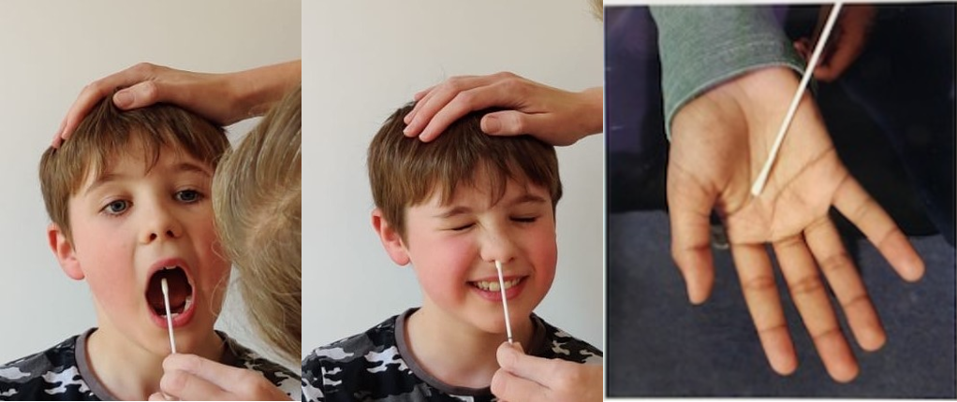
What are throat swabs like? Throat swabs can feel a bit ticklish; some people find that it makes them cough but most people are fine. You might have had one already, at the doctor’s surgery.

What other samples will be taken? When the specialist visits they will ask if they can take swabs from around your house and air samples. They might also ask you to talk or sing in the same room while they collect the air samples!

Will taking part help me or anyone else? Taking part can’t help you directly but the research we do should give us answers that should help us reduce the spread of coronavirus. So you would be helping other children in the future.

Will anyone else know I am taking part in the study? Only you, your parents or guardians, and the public health specialist will know. Its up to you if you tell your friends you are taking part. Everything is kept private.

Who is doing the research and is it OK to do it? The research is being done by doctors and nurses at Public Health England and at Imperial College London. The study has been checked to see that it is run properly.
Coronavirus Study: Assent Form for Children and Young People with Coronavirus aged over 8 years

Please keep this section for your own records

Please circle Yes if you agree.
If you don’t agree, please circle No

- Do you understand what the study is about? |   YES |  |   NO
- Have you had enough information and talked to your parent or guardian? | YES |  | NO
- Do you know it’s OK to stop taking part at any time? | YES |  | NO
- Are you happy take part and have the swabs done? | YES |  | NO
If you are OK to take part, you can write your name below
Your Name ……………………………. Your Age…………….
Date …………………………….

The nurse or doctor running the study needs to sign here too

Research team member name ………………………………….

Signature …………………………………….. Date…………………

Thank you for your time
Coronavirus Study: Assent Form for Children and Young People with Coronavirus aged over 8 years

Please complete and tear off- return this section to the public health specialist as soon as possible

Please circle Yes if you agree.
If you don’t agree, please circle No

- Do you understand what the study is about? | YES |  | NO
- Have you had enough information and talked to your parent or guardian? | YES |  | NO
- Do you know it’s OK to stop taking part at any time? | YES |  | NO
- Are you happy take part and have the swabs done? | YES |  | NO

If you are OK to take part, you can write your name below
Your Name ……………………………. Your Age…………….
Date …………………………….

The nurse or doctor running the study needs to sign here too

Research team member name ………………………………….

Signature …………………………………….. Date…………………

