SPH STUDENT PROJECTS FORM

Project title:

Background & research question/aims:

Methods to be used & data sources:

Expected outcome and impact of the project:

Relevant key references(if applicable):

Primary scientific discipline (e.g. immunology):

Please add 3-5 keywords related to your project to enable searching for projects:
Keyword 1:
Keyword 2:
Keyword 3:
Keyword 4:
Keyword 5:

Note: The College requirement is that at least one of the supervisors should hold an academic post (Lecturer and above) within the School. Teaching Fellows and Research staff can submit and supervise projects, but an academic would normally be expected to be part of the supervision team. Also, at least one of the supervisors should be based within the School of Public Health, but external (co-)supervisors are allowed.

Name of primary supervisor:
Job title and affiliation of primary supervisor:
Contact details of primary supervisor:

Is the Primary Supervisor based in the School of Public Health (this includes part-time posts)? Yes/No

Name of co-supervisor:
Job title and affiliation of co-supervisor:
Contact details of co-supervisor:

Name of co-supervisor (if applicable):
Job title and affiliation of co-supervisor (if applicable):
Contact details of co-supervisor (if applicable):

Would you like the course teams to help you identify a suitable co-supervisor? Yes/No

Main contact person for this project:

Summary of courses
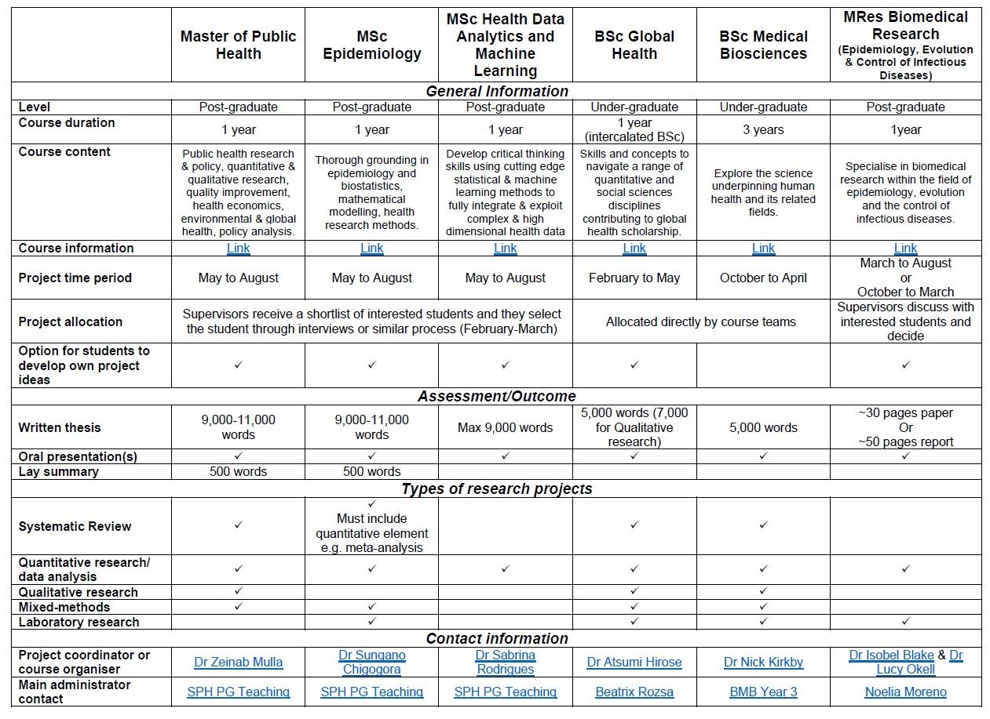

Is this a bespoke project for a named student (i.e. developed in conversation or with a particular student in mind)? Yes/No
If yes, write the name of the student:

The project can be made available to students from multiple courses. Adjustments can be made to the current proposal to suit the student and the course requirements. Please select the course(s) for which you would like to make your project proposal available.
If this is a bespoke project tick only the course of the student the project has been developed for.
Master of Public Health (MPH)
MSc Epidemiology
MSc Health Data Analytics and Machine Learning
BSc Global Health
BSc Medical Biosciences
MRes Biomedical Research (Epidemiology, Evolution & Control of Infectious Diseases)

Type of project:
Systematic review
Quantitative analysis
Qualitative analysis
Mixed methods (Quantitative & Qualitative)
Laboratory
Other (e.g policy analysis project), please specify ………………………………

Which of the following sites will the student primarily be based at for the research? If students don’t need to be placed within your team for a significant amount of time, indicate where supervisors are primarily based.
St Mary’s
Charing Cross
South Kensington
Hammersmith
White City
Chelsea & Westminster
Other (give details):

Please identify three Imperial College members of staff with relevant expertise who would be suitable to mark the project (the primary and co-supervisors cannot mark the project). Note that you don’t need to have discussed this with them; this is to facilitate finding suitable markers. They may be approached by the course teams if required.
1.
2.
3.

Depending on the course and the type of project, there may be some funding available for supervisors or/and students. Please provide the following information.

Would the student need to travel to successfully complete the project? Yes/No
If yes, please provide more details:

Please detail any costs that are essential to the project. For PGT projects, costs up to £500 may be covered by the School of Public Health:

Do you have an F account? Yes / No / n/a

If you have an F account, please provide the cost Centre (e.g. WABC):
If you have an F account, please provide the account code (e.g. F12345):

If you do not have an F account, please provide the name and address of the Department to which a purchase order should be addressed. A purchase order can then be raised by the Faculty Education Office and sent to you. You will then be able to invoice the FEO against that purchase order for the funds to be paid to you.
Full Name (Inc. title):
Work Address:

In the spirit of equal opportunities, the BSc Global Health use this fund to support our Travel Bursary system whereby only the best BSc students (selected based on performance on the course and preparedness for the particular project) are allowed to go on Projects abroad and no selected student will incur any costs for this. Would you be happy for project funds to be transferred into the BSc Global Health travel fund? (This is only applicable to BSc Global Health projects):
Yes/No

Note: Approval/access for any of the below MUST be in place before the student begins the project.

Is access to data currently established? Yes/No
If no, please outline plans to ensure data will be available in good time:

Will the project involve work on human subjects, human tissue or access to confidential patient information? Yes/No
If YES
Has ethical approval been obtained? Yes/No
If no, outline plans to ensure ethical approval will be obtained in good time.

If yes, date approval was granted:
IC REC or IRAS REC number:

Do you need students to have access to a specific research software? Yes/No
If yes, please give details:
Can your team organise access or you require academic office to buy licence?
My team
Academic office

Before commencing their project, should the student take the Good Clinical Practice (GCP) course? Yes/No

Will the student require CERNER access? Yes/No

Will the research involve work done under the Animals (Scientific Procedures) 1986 Act? Yes/No

If YES,
Will the student be required to undergo Home Office training? Yes/No
Are the appropriate project and personal licences in place? Yes/No
Project licence:
Licensee:
Date of issue:
Number:
Personal licence:
Licensee:
Number:

Will the research involve the use of genetically modified tissue? Yes/No
If YES
Has the work been approved by the relevant GM Committee? Yes/No
If YES
Date approval was granted:
Reference Number:

If no ethical approval is required, please comment why (if ‘service evaluation’, describe how that assessment has been reached).

Feel free to add any additional notes that you wish to share about the project.

