Knowledge Mobilisation Plan for the NIHR Health Protection Unit in Radiation Threats and Hazards 2025-2030
Background
The Health Protection Unit (HPRU) in Radiation Threats and Hazards (RTH) is led by Imperial College London in partnership with the UK Health Security Agency (UKHSA), King’s College London and MRC Toxicology Unit, Cambridge, and Institute for Cancer Research. The four research Themes integrate basic science, molecular and cell biology and large-scale population studies as seen in Figure 1.
Theme I - Long term risks associated with uses of ionising radiation. This theme will study Cardiovascular disease incidence following low-dose occupational radiation exposure, as well as the exposure levels and health effects among vascular interventionists and nuclear medicine workers. The late effects of radiotherapy innovations in paediatric cancer patients will also be investigated.
Theme II “Theme II - Mechanisms and biomarkers linking ionising radiation to health effects”. In this theme, we will investigate the biological effects and biomarkers for chronic low-dose occupational radiation exposure and patients receiving radionuclide therapies. The impact of radionuclides on endothelial cell senescence and the effects of ionising radiation on brain function will also be examined. Finally, we will investigate mechanisms of radiosensitivity and radiation-induced cancer.

Theme III “Radiation Releases: Accidents and incidents”. This theme focuses on development of biodosimetry, ad Radiation incident emergency response in both the short and long-term. We will also continue studies on nuclear installations and childhood cancer.
Theme IV “Effects of electromagnetic fields including light exposure and health. Studies will continue in COSMOS, SCAMP and Airwave to look at the health effects associated with non-ionising radiation exposure from mobile phones and other wireless technologies. Ultraviolet radiation effects on health, particularly the cardiovascular systems, will also be investigated.
A key function of the Knowledge Mobilisation Team will be to support the mobilisation of this new evidence to the next users. Knowledge Mobilisation is the process that creates impact via collaboration and knowledge exchange with stakeholders throughout the research lifecyle. Health protection research will not be effective without appropriate knowledge mobilisation.
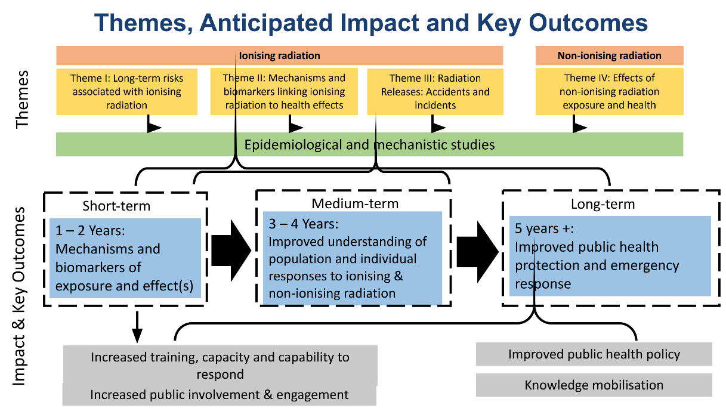
This strategy outlines our approach to mobilise knowledge generated by the HPRUs, and to developing expertise and establishing a culture in partner organisations to improve their capacity to draw on research evidence.

Figure 1. Themes, anticipated impacts and key outcomes of the HPRU in RTH
Knowledge Mobilisation Definition
Knowledge mobilisation (KMb) brings together different communities to share knowledge to catalyse change. Knowledge mobilisation is a two-way process which enables advances in health protection research to create benefits for patients and the public by supporting research-informed decision-making by policy makers, public health practitioners, the public, and other stakeholders.
Effective knowledge mobilisation (Figure 2) involves:
- Facilitation of engagement of researchers with the policy, practice, research and public communities where their research can make a difference.
- Enabling policy, practice, research and communities to have a role in the devising of research questions, to ensure they address important questions in a useful way.
- Enabling researchers to influence decision-making processes in policy, practice and elsewhere through having a 'seat at the table' alongside other approaches to dissemination
- Increasing understanding of research limitations and uncertainties, among those who can use research findings.
- Transferring useful knowledge from other sources to the HPRU.
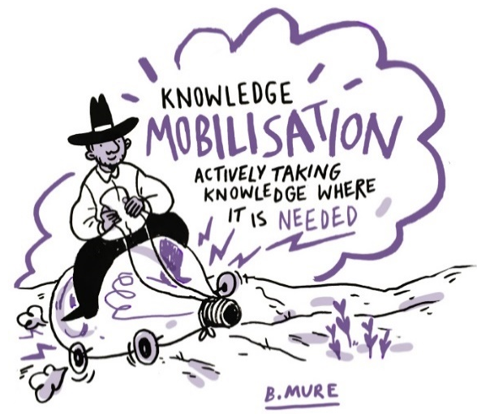
This strategy outlines our approach to mobilising knowledge generated by the HPRU, and to developing expertise and establishing a culture in partner organisations to improve their capacity to draw on research evidence.

Figure 2. Cartoon showing a definition of knowledge mobilisation

Knowledge Mobilisation Aims and Objectives
This tailored strategy for the HPRU has evolved from the previous HPRU in Chemical Radiation Threats and Hazards KMb strategy. It has drawn on:
- Research and experiential knowledge of effective knowledge mobilisation strategies
- Discussions with HPRU-RTH affiliated academic and UKHSA colleagues
- The HPRU-RTH Forward Business Plan
- Discussions with KMb leads from other HPRUs

Accordingly, the four Knowledge Mobilisation aims agreed with the HPRU Directors are:
- Aim 1: Embedding KMb within our research
- Aim 2: Links to government and policy makers
- Aim 3: KMb in practice
- Aim 4: Routes to KMb impact
These four Aims described in more detail in the Objectives table will be achieved by integrating knowledge mobilisation throughout the HPRU using the Theory of Change model (Figure 3) to facilitate change. The objectives are set out to be met in the short term (1-2 years) or the medium-long term (3-5 years), and are colour matched to the theory of change pathway to impact.
This knowledge mobilisation strategy also helps to facilitate the Theory of Change for the HPRU in order to achieve its desired impacts, where we have mapped our pathway to impact through our research outputs and outcomes. Our desired impacts will fall into various categories including societal impact or scientific impacts.
Knowledge mobilization will be embedded into research training for PhD students and Early careers researchers, and built into projects led by senior staff, HPRU-RTH management and monitoring processes through leadership meetings.

Knowledge Mobilisation Objectives Table
Knowledge Mobilisation Aim | Details and objectives | Short Term Objectives 1-2 yrs | Medium-Long Term Objectives 3-5 yrs
1 Embedding KMb within our research | - Consideration of inputs, research activities, outputs and outcomes and the intended impacts by everyone in the HPRU.  - Includes reflection of the Who, Why and What throughout the research process | - Development and publication of a Theory of Change and knowledge mobilisation Plan for the HPRU to aid transparency of research activities  - Attendance at relevant government and advisory committee meetings, e.g. COMARE, ICRP, ICNIRP, to understand issues of concern and to share HPRU outputs.  - Attendance at HPRU meetings to embed KMb. | - Review of activities and identification of potential outputs, intended impacts.  - Ensure the following questions are addressed:  - What is the relevance to patients/public?  - What is the to policy makers/practitioners?  - What is the to healthcare professionals?  - What is the relevance to industry and the non-governmental sector?
2  Links to government and policy makers | - Key stakeholders include UKHSA, DHSC and Government advisory committees. Within these organisations we will identify key individuals.  - Recognition of the importance of engaging with the public as a key stakeholder to ensure that our research meets their needs. | - Stakeholder and next-user mapping exercise with input from HPRU colleagues.  - Establish relationships with government and parliamentary departments and networks.  - Watching brief on research interests to inform communication and dissemination approaches. | - Engagement with PCOG panel.  - Continued identification and engagement of new and emerging stakeholders and end users to establish policy/practical relevance.
3  KMb in practice | - Many researchers will be unfamiliar with KMb and how it is distinctive from communication or dissemination of results.  - We will work with other HPRUs to offer training and support to build capacity and help raise awareness of KMb, its methods, aims and the critical role it can play in maximising the value of research. | - KMb section published on the HPRU website, including KMb strategy.  - Regular attendance at Research Theme Meetings and Management meetings to encourage all to consider KMb throughout the research life-cycle.  - Work with HPRU Research Inclusion (RI) and Public and Patient Involvement and Engagement (PPIE) leads to understand public and training needs. | - Establish and maintain a KMb training programme working with HPRU Specialist leads e.g., Academic Training, Research Inclusion and Public and community involvement, engagement and participation (PCIEP) and the HPRU Research Capacity Development (RCD) Network.  - Session on KMb at HPRU Annual meetings.  - Work with other HPRUs to facilitate mobilisation and contribute to the collective synthesis of knowledge mobilisation case studies across the HPRUs.  - Participate in and share good practice with HPRU KMb Network.
4  Routes to KMb impact | - Demonstration of how research has achieved its intended outcomes and impact.  - Consideration of the significance and reach of the research. | - Measurement of impact e.g. metrics for engagement.  - Use research outputs to support different dissemination methods relevant to end users.  - Use Open science platforms and use of social media. | - Identification of impact case studies  - Evaluation of impact against Theory of change.
Aim 1. Embedding KMb within our research
The HPRU Knowledge Mobilisation Team will work with Theme leads and individual researchers to support the effective planning, implementation and documentation of knowledge mobilisation and impact activities.
Additionally, specific learning needs related to knowledge mobilisation will be identified at induction and subsequently supported on an individual basis and as a group as appropriate. It is expected that many learning needs requiring specific training will be shared across HPRUs and delivered collaboratively through developing resources in the Cross-HPRU Knowledge Mobilisation Network, and the UKHSA Knowledge Mobilisation Community of Practice.
We will engage with potential next- and end-users of the scientific evidence to disseminate knowledge generated through workshops. This will include active collaboration with other HPRUs through the Knowledge Mobilisation Network, and with UKHSA. We will also engage with other researchers and research users nationally and internationally given the general relevance of the intended radiation research.
Participation in the HPRU Knowledge Mobilisation Network and UKHSA Knowledge Mobilisation Community of Practice will help to build capacity by:
- Sharing our learning of what works and what are the challenges in knowledge mobilisation,
- Learning from knowledge mobilisation approaches, experience, and evaluation of other HPRUs,
- Jointly identifying learning needs and developing training materials and events, and
- Participating in joint knowledge mobilisation initiatives as appropriate.
Aim 2. Links to Government and Policy Makers
This will include identification of next- and end-users of our research, and stakeholders for whom the research has potential impact. This includes professionals, industry partners, innovation hubs and the public. It also involves developing relationships with these stakeholders to allow their engagement with the research from planning to dissemination. We will also work with our HPRU Patient and Public Involvement and Engagement Leads and Research Inclusion Leads when considering knowledge mobilisation with the public.
Stakeholder mapping can be conducted to steer knowledge mobilisation activities. By identifying next- and end-users and other stakeholders at the project and theme level, the HPRU-RTH can map and reach out to these groups to facilitate knowledge transfer and identify areas for new work where there are evidence gaps. This may include stakeholder virtual or in-person workshops. Stakeholders already identified include the Department of Health and Social Care and the Department for Environment, Food and Rural Affairs.
Aim 3. Knowledge mobilisation in practice
The Knowledge Mobilisation Team will continue to monitor calls for research and make members of the HPRU aware. They will remain up to date of current research priorities and futures work across government to highlight upcoming areas of interest that may be relevant to the HPRU.
The Knowledge Mobilisation Team will liaise with other Knowledge Mobilisation Teams to similarly share knowledge and identify opportunities for collaboration and knowledge sharing opportunities across the HPRUs. In particular we will engage with the UKHSA communities of practice in: KMb, Evaluation, Behavioural Science and Policy.
Knowledge mobilisation among wider UK Heath Security Agency staff and academic researchers is critical. This will include: development of relationships to support joint working in the area, engaging UKHSA stakeholders in framing the research questions addressed so that results will fit to policy and practice needs, and researcher input into policy and practice innovation and planning informed by research findings and expertise. UKHSA Knowledge and Evidence teams (e.g. Knowledge and Library Services, Research Support and Governance team etc.) have committed to collaboration with HPRUs to mobilise HPRU generated knowledge across UKHSA.
As an expanding area of practice, knowledge mobilisation needs a developing underpinning evidence base. Knowledge mobilisation in health protection and radiation protection in particular may also have some specific aspects.
Proposals for this include evaluation of the changes in the culture and expertise in mobilising knowledge across researchers and other partners, prospective studies of approaches employed and their effects, and observational studies including case studies.
Aim 4. Routes to KMB Impact
HPRUs will evaluate their knowledge mobilisation activity annually, using the NIHR HPRU reporting form process. This will include evaluation of impact, and the measurable change that has occurred through the research and knowledge mobilisation activities.
Where available, supporting evidence will be submitted by researchers to build and strengthen impact case studies.
Examples of impact include but are not limited to:
  - Use of research to inform national guidelines
  - Membership of and contribution to UK Government advisory groups (e.g. SAGE) international advisory groups (e.g., ICRP) or local Government advisory groups (e.g. outbreak management group)
  - Submissions to Parliamentary Select Committees (written or oral), or other parliamentary knowledge exchange activities
All data will be collated annually to report to NIHR and impact case studies will be selected to highlight substantial added value or impact within the HPRU. Reporting will include the following areas:
  - Monitoring of knowledge mobilisation activities and impact
  - Engagement with stakeholders and next-users of research
  - Dissemination and communication of research activity to targeted audiences
  - Capacity building and training in knowledge mobilisation.
Evidenced by new collaborations and projects that otherwise might not have been recognised and the application of knowledge without regard for boundaries.
Planning, implementing and reflections on stakeholder identification and engagement will provide a record for reporting and material to allow improvement in these approaches.

Theory of Change Model
The Theory of Change model below describes the route to impacts using a logic model approach. It is based upon using inputs to develop activities which create outputs and outcomes in order to achieve impact goals.
It is based upon various risk and assumptions to be met in order for the pathway to impact to be realised. Public involvement, research inclusion and training alongside knowledge mobilisation are key strands throughout the pathway. Without effective knowledge mobilisation, these impacts cannot be achieved.

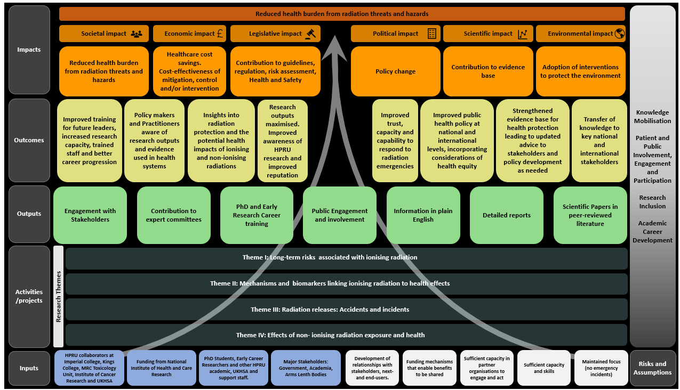

Figure 3. Theory of Change Model for the HPRU in RTH (v0.7 October 2025).
Annex 1
HPRUs - Knowledge Mobilisation Checklist
HPRU Governance and Culture
HPRUs should foster a culture where "impact" is considered from the very outset of every project.
1. How will the HPRU ensure dissemination, KM and Impact is a visible part of the HPRU governance and routine reporting?
Embedding KM across the research cycle
A strong KM approach should be embedded throughout the entire research cycle, influencing everything from the original research question to the final output.
2. How will the HPRU ensure research priorities, design and outputs have been influenced by the needs of evidence users?
Active Collaboration with Evidence Users (including Policymakers)
A consistent finding is the critical importance of strategic stakeholder engagement to maximise the reach and impact of research.
3. Will the HPRU undertake and act upon a strategic stakeholder mapping exercise?
4. Will the HPRU take active steps to strengthen their collaborations with evidence users including policy makers
Communication and Dissemination Strategies
HPRUs have progressively adopted a more strategic and creative approach to communication, tailoring their messages and channels to reach diverse audiences effectively.
5. How will the HPRU ensure a strategic and creative approach to communication ensuring complex findings are made rapidly accessible to key audiences.
Public Engagement
Engaging the public effectively is fundamental to ensuring research is relevant and impactful.
6. How will the KM function work with Patient and Public Involvement and Engagement (PPIE) leads to ensure active engagement of patients and the public across the research cycle including dissemination?
Researcher Training and Development
7. How will the HPRU work collaboratively with other HPRUs, NIHR infrastructure, and UKHSA to develop KM skills and capacity in the HPRU and their researchers?
Evaluation of KM and Measurement of Impact
8. What will the HPRU do to ensure a systematic approach to evaluating the impact of their KM activities?
Addressing common challenges
9. What is the HPRU doing to manage common KM challenges including limited KM resources and a policy environment in flux.

Annex 2
Draft Guidance for the HPRUs in developing their knowledge mobilisation plans
26 June 2025
Knowledge mobilisation includes, but goes beyond, the dissemination of research findings. Knowledge mobilisation (KM) is the process that paves the way to impact via active collaboration with key stakeholders throughout the research cycle. This includes working with the people and organisations who will use or benefit from research (knowledge users). Together, stakeholders share and integrate their knowledge. This creates new insights and understanding about research plans and findings. The ultimate aim is to change practice and policy and have real-world impact.
Over the last five years the HPRUs have demonstrated a deepening understanding of knowledge mobilisation, strategically embedding it throughout the research lifecycle, building robust partnerships, and creatively communicating their findings. This has helped ensure the translation of their research into impactful policy and practice.
This guidance provides a strategic framework for the newly contracted HPRUs to develop their future knowledge mobilisation plans, drawing on the established evidence base for effective knowledge mobilisation, the best practices of the HPRUs over the last five years as well as learning from the newly established NIHR Impact Prizes. It describes how HPRUs can promote knowledge mobilisation in the way they work, manage and communicate their research, as well develop their staff.
HPRU Governance and Culture
Successful HPRUs foster a culture where "impact" is considered from the outset of every project. Some HPRUs have described KM as being in the "DNA" of their unit.
Examples:
● Embedding the KM lead within the HPRU's governance structure, often as part of the management team, with KM a standing agenda item.
● Integrating KM and impact into induction programmes for new staff members, including individual or group discussions led by KM leads, to build a pervasive culture of impact.
● Embedding KM into HPRU internal reporting procedures, requiring research teams to regularly report on KM activities and their potential impact.

Research Design
A strong KM approach is embedded throughout the entire research cycle, influencing everything from the original research question to the final output.
● Ensuring research priorities align to government and other evidence user priorities.
● Design for implementation: Consider the practicalities of implementing the research findings into real-world settings from the initial design phase.
● Generate definitive answers: Conduct rigorous studies and perform systematic reviews and meta-analyses to provide strong evidence.
● Ensure generalizability and validation: Design studies that allow findings to be applied broadly and include external validation exercises where appropriate.
● Build sustainable solutions: Aim to create resources or services that can be integrated into existing healthcare systems, such as national databases, clinical services, or training programs.
Active Collaboration with Evidence Users (including Policymakers)
A consistent finding is the critical importance of strategic stakeholder engagement to maximise the reach and impact of research.
Examples:
● Systematic stakeholder mapping exercises - identifying all potential stakeholders who could be impacted by the research, including policymakers, public health practitioners, healthcare professionals, industry, and the general public.
● Actively engaging key stakeholders in all stages of research, from concept development and design to delivery, analysis, and dissemination.
● Collaborations with government departments and agencies to promote the uptake of generated evidence including-
○ regular researcher participation in policy programme boards and committees
○ seconding HPRU staff into government roles to interpret results and produce relevant analysis.
○ engaging key stakeholders in HPRU activities including offering secondments to develop research skills and understanding.

Communication and Dissemination Strategies
HPRUs have progressively adopted a more strategic and creative approach to communication, tailoring their messages and channels to reach diverse audiences effectively.
Examples:
● Rapidly sharing findings with key decision-makers: Utilize established channels to communicate preliminary and final results to government bodies and national health agencies.
● Creating diverse communication materials: Translating complex research findings into accessible formats for various audiences, including lay summaries, infographics, videos, podcasts, and press releases. Interactive data analysis and visualisation tools can help explain complex findings.
● Engaging with media: Proactively seeking out opportunities for media coverage (e.g., interviews, news articles) to raise public awareness and understanding of the research's importance.
● Developing practical resources: Creating and distributing implementation guidance, toolkits, and web-based tools to facilitate the uptake of research findings into practice.
● Testing evidence and messaging with target audiences to ensure their effectiveness and relevance.
● For analytical tools/outputs: using open-source tools/code to make findings accessible.

These are in addition to traditional dissemination approaches such as
● publishing in high-impact journals and open-access publications
● presenting at conferences and events: engaging with academic peers, clinicians, and other potential users of the research.
Public Engagement
Engaging the public effectively is fundamental to ensuring research is relevant and impactful.
Examples:
● Involving target audiences directly in research, for example, by including them on research steering groups.
● Organising public events, workshops, lectures, and science fairs to engage with the public and disseminate findings, including with under-served communities.
● Developing accessible formats with and for public consumption, ensuring research is understandable and engaging for a broad audience.
● Working closely with Patient and Public Involvement and Engagement (PPIE) leads when planning KM activities with the public.

Researcher Training and Development
HPRUs have developed researchers’ KM skills and capabilities building a workforce that can drive impact. They have worked collaboratively with other HPRUs, NIHR infrastructure, and UKHSA to share best practice and undertake training, particularly through the HPRU Knowledge Mobilisation network. This has included working with UKHSA's Knowledge and Library Services and Local Knowledge and Intelligence Services to develop a KM toolkit.
Examples:
● Integrating KM and impact into induction programmes for all new staff members, with individual or group discussions led by KM leads.
● Provision of KM, dissemination and communications training for researchers, including PhD students and early career researchers (ECRs), through workshops, resources, and signposting to relevant networks.
● Attachments or placements for researchers into relevant practice or policy environments.
● Supporting researchers to undertake dedicated work on KM including evaluation of KM activities.
● Discussing and showcasing KM and impact at HPRU events.

Evaluation of KM and Measurement of Impact
HPRUs have started to build a more systematic approach to evaluating the impact of their KM activities to learn and improve.
Examples:
● Capturing impact effectively through Added Value Examples (AVEs), moving beyond traditional academic outputs to demonstrate broader influence.
● Including metrics on the reach and engagement with target audiences.
● Monitoring the use of developed materials, such as download numbers for open-access resources, to gauge their utility and reach.
● Conducting prospective and observational studies to evaluate KM approaches and their effects, including case studies, to build the evidence base for KM itself.
● Embedding KM in reporting procedures by completing a report template outlining KM activities and their potential impact.

Common Challenges to Consider
The journey of knowledge mobilisation has not been without its hurdles. HPRUs have learned to adapt to several common challenges over the last five years.
Anticipating and addressing these challenges is crucial:
● Variability in demonstrating impact: Some types of research output are more amenable to demonstrating direct impact than others, requiring tailored KM strategies.
● Limited KM resources: Dedicated staff time and budgets for KM can be small, necessitating creative approaches to secure additional funding or integrate KM into existing roles.
● Structural changes: Changes in national public health structures, such as those experienced in the UK, require continuous effort to form new relationships and adapt engagement strategies.
● Stakeholder buy-in: Overcoming challenges in engaging certain stakeholder groups may require targeted outreach and flexible KM strategies to foster their involvement and commitment.

In summary, generating impact from research is a multifaceted process that involves strategic planning, engagement, and effective communication throughout the research lifecycle. Different research areas will require different KM approaches.

